
2022 Oregon PACE DRILL
After Action Report Improvement Plan (AAR/IP)

Background
The Cascadia Mania PACE Exercise was held on January 26, 2022, from 8:00 AM-2:30 PM PST with Emergency Support Function #2 (ESF-2) personnel in person at the Oregon Emergency Communications Center (ECC) in Salem and county ECCs throughout Oregon participating virtually. The ESF-2 was activated and led by William Chapman, Oregon Statewide Interoperability Coordinator (SWIC) and Lisa Gorsuch, Oregon Public Utility Commission. The primary objective of the Exercise was to assess the statewide communications plan and reporting mechanisms, specifically the level of coordination between the ESF-2 and the participating state and local ECCs.

Scenario

A magnitude 9.0 earthquake has hit the coast of Oregon causing the ground to shake for up to 5 minutes, which generates a tsunami wave of between 3 feet and 80 feet that will, depending on the coastal location, reach the coast from 10 to 30 minutes after the earthquake. This impacted earthquake/tsunami area will be more than 140,000 square miles, to include three states, 27 counties, two Federal Emergency Management Agency (FEMA) regions, and British Columbia, Canada. And it is estimated the earthquake will result in 5,800 fatalities and 87,535 injuries and tsunami an additional 8,000 fatalities and 20,000 injuries throughout Washington and Oregon.

Injects
- Public Safety Answering Point (PSAP) and ECC communications throughout Oregon were impacted at different levels with damages ranging from near total to mild, to include:

Physical destruction of network infrastructure

Disruption in supporting infrastructure i.e., electric power, cooling systems and transportation and fuel for backup generators

Network congestion – Communications, especially cellular congested in many areas

Voice, data and internet functionality significantly impaired

Commercial cellular service greatly disrupted in hardest hit areas.

Satellite services minimally impacted due to resilient design
- Each ECC/ Emergency Operations Center given status/injects describing capabilities
- ESF-2 will attempt to contact and obtain status report and critical information from ECCs in accordance with statewide communications plan procedures
- Federal Communications Commission (FCC) to conduct Project Roll Call to determine status of public safety or critical infrastructure systems in Oregon
- CISA/FEMA DEC to support ESF-2

Exercise Objectives
The exercise focused on response and recovery and was designed to evaluate the statewide communications plan and reporting mechanisms. Specifically, the exercise was intended to assess operational communications capabilities and coordination between the ESF-2 and the participating state and local ECCs as follows:
- Determine standardized reporting procedures and types of information ECCs should be collecting and reporting to ESF-2
- Develop a shared understanding of communications methods and how best to communicate
- Provide an opportunity to evaluate the Primary, Alternate, Contingency, and Emergency (PACE) Plan through identification of alternate methods needed to maintain communications throughout the incident
- Determine how best to assimilate new communication technology
- Determine the viability of using ESF-2 personnel to fill gaps and replicating this process no matter who staffs ESF-2
- Assess and document resilient ECC-to-ECC communications (SCIP Objective 4.4)
- Serve as a training opportunity for state and local participants with information collected to be used to update Field Operations Guide (FOG) and to supplement TIC-FOG/Regional Tactical Interoperable Communications Plan (TICP) (SCIP Objective 3.1)

ESF-2 Goals
- Establish communications and provide situational awareness to counties, cities, tribes, and utilities via HSIN
- Assess communication capability of operations centers within impacted areas and identify and deconflict priorities
- Coordinate resources and identify surviving communication capabilities, availability and direct tactical repairs using both typical and atypical means of communication in an austere environment
- Determine support capabilities for local, tribal and NGO partners
- Identifying Telecommunicator Emergency Response Taskforce (TERT) team support as needed for impacted ECCs for future versions of this type of exercise

Federal, State and Local Participating Agencies

- Washington County Consolidated Communications Agency
- Grant County Emergency Communications Agency
- Willamette Valley Communications Center,
- City of Lake Oswego Police Communications,
- Seaside Police Department,
- Clackamas County Communications,
- Wasco County 911,
- Milton-Freewater Police Department,
- Harney County 911 /
- Harney County Emergency Management
- Hood River 911
- Emergency Communications of Southern Oregon
- Lake County 911 Center
- Oregon Office of Emergency Management
- FEMA Region 10
- CISA Region 10

A goal of this drill was to introduce Oregon stakeholders to the type of federal response capabilities they might expect in the days after a Cascadia event. Briefings were provided by Department of Homeland Security’s Cybersecurity and Infrastructure Security Agency (CISA) Emergency Communications Division (ECD), FEMA R10 Regional Emergency Communications Coordinator, the Federal Communications Commission Disaster Incident Reporting System (DIRS), and FirstNet.

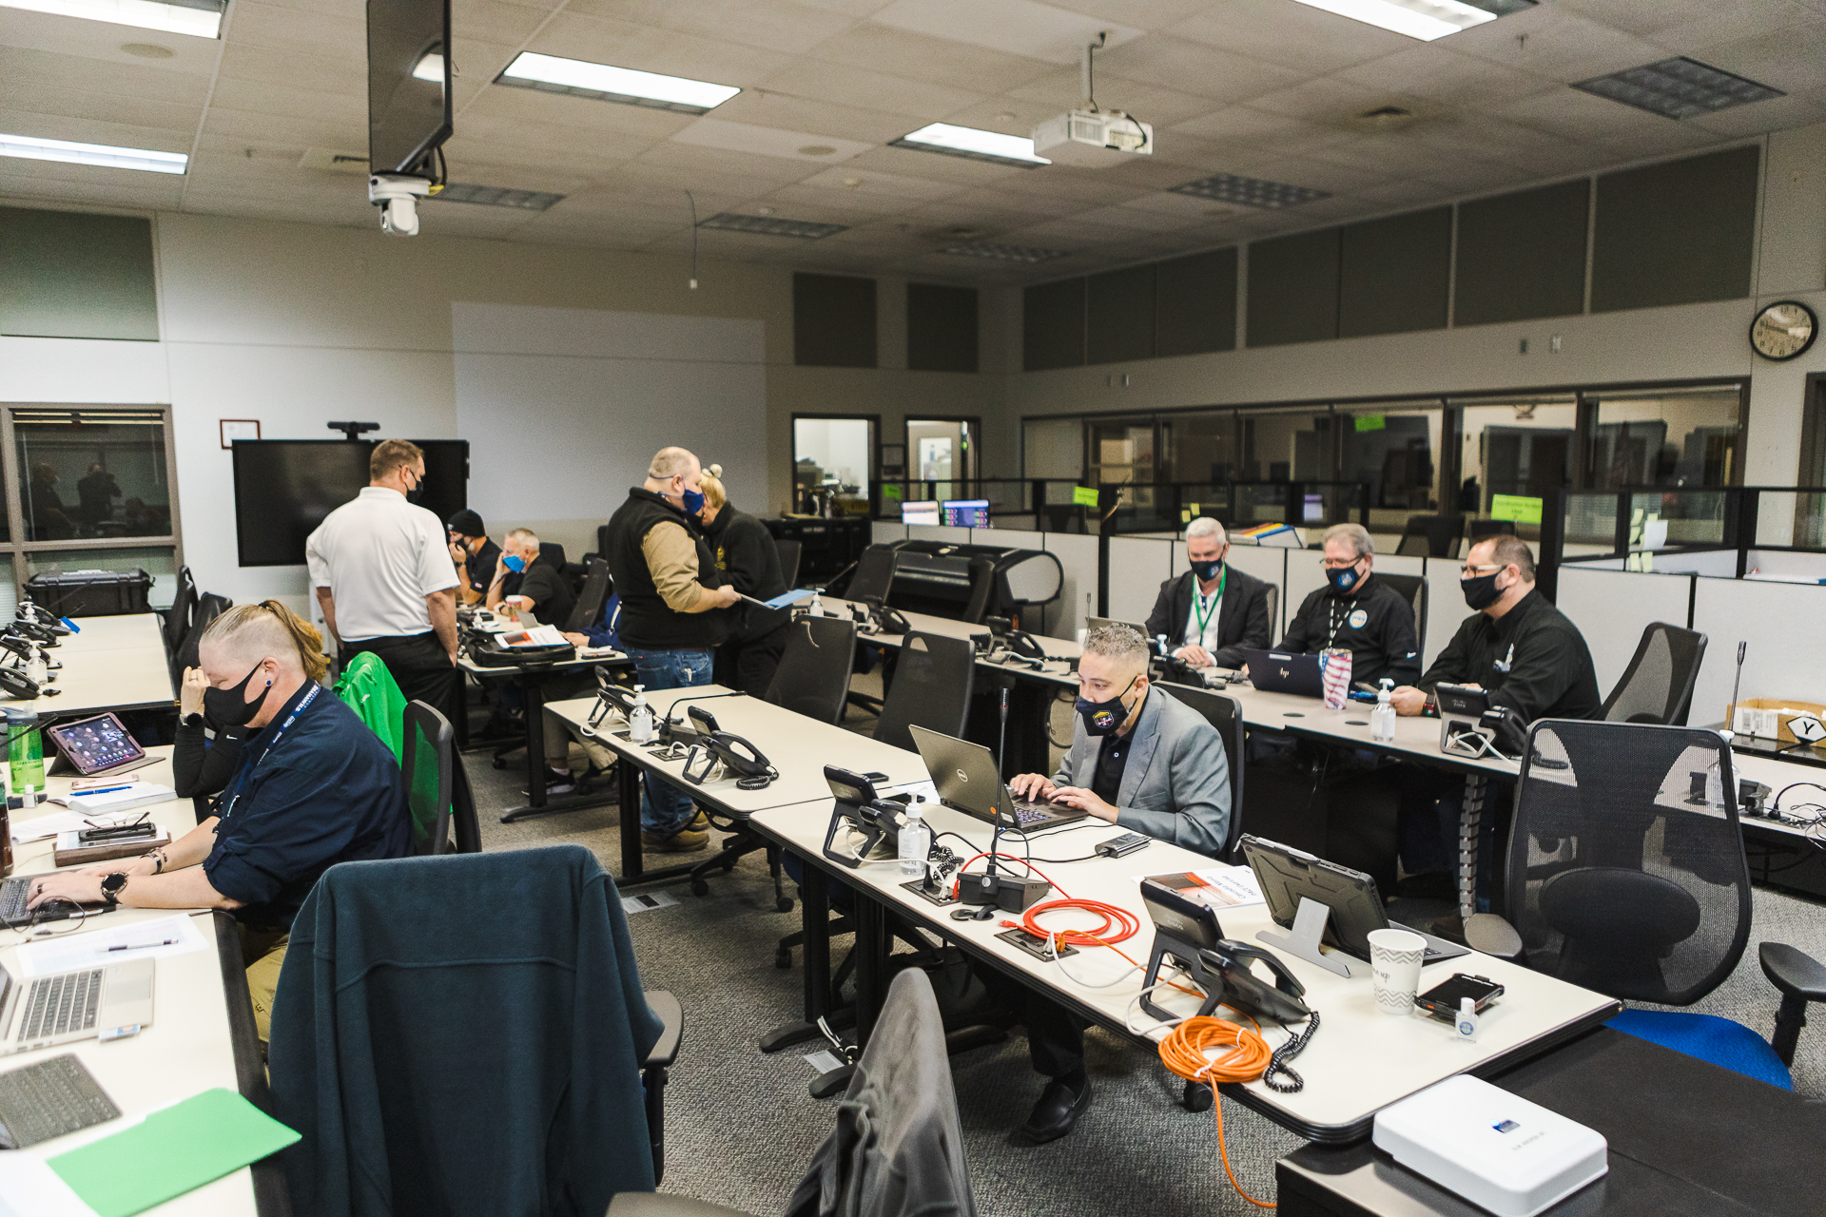

Exercise participants during in the Oregon State ECC during Cascadia Mania 2022. Photo courtesy of Robert Hugi.

PAce exercise Schedule
0800: Set Up
0830: Exercise Briefing
0830: FCC Start Project Roll-call
0900: Phase I: Emergency Communications
1000: Phase II: Contingency Communications
1100: Phase III: Alternate Communications
1200: Phase IV: Primary Communications
1300: Lunch Break
1430: Hot Wash
1530: Breakdown ECC
1630: Wrap up

PHASE 1 – 24 to 48 Hours
WCCCA
Willamette Valley Communications Center
Harney County 911 / Harney County EM
Hood River 911

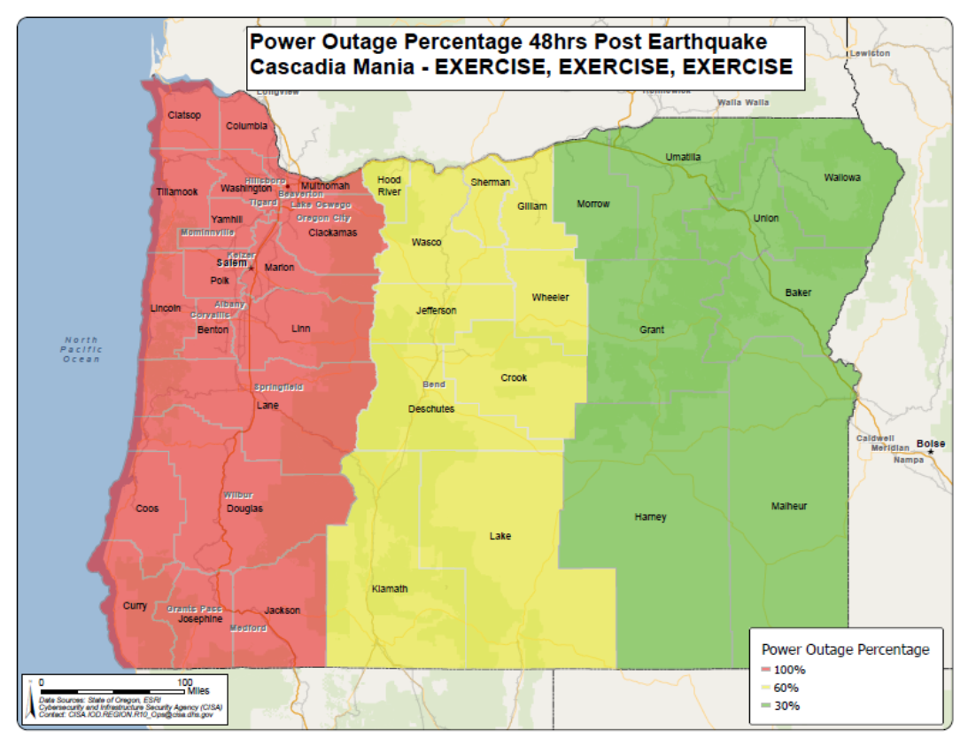

Figure 1: Power Outage Percentage 48hrs Post Earthquake Cascadia Mania

PHASE 2 – 48 to 96 Hours
CCOM
Wasco County 911
Emergency Communications of Southern Oregon

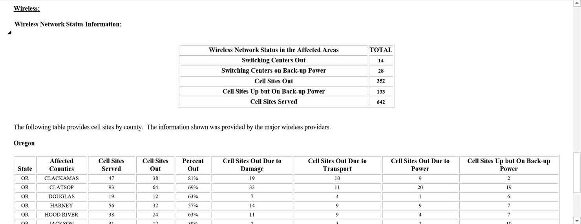

Figure 2: Simulated Disaster Information Reporting System (DIRS)

PHASE 3 – 4 to 7 Days
Seaside Police Department
Lake County 911 Center

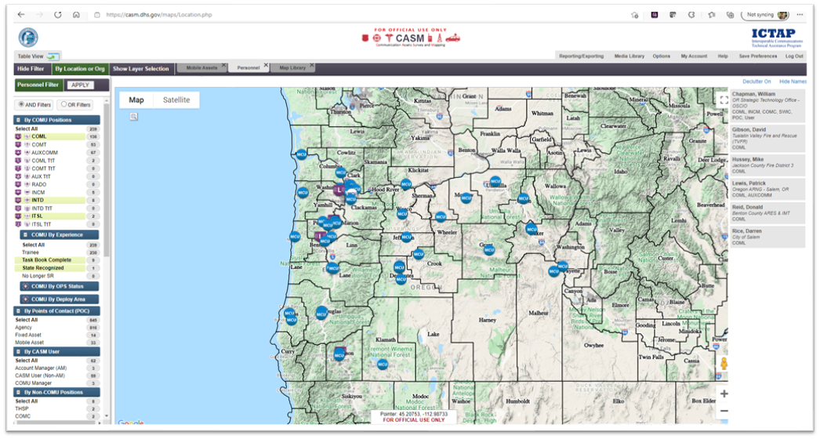

Figure 3: CASM locations

PHASE 4 – 1 Week
Grant County Emergency Communications Agency
City of Lake Oswego Police Communications

Figure 4: Simulated FEMA Support Vehicle Deployment

BUILDING FROM STRENGTHS
- Oregon State Police are a valuable resource for communicating with centers in rural areas
- ESF-2 participation was outstanding with all required agencies present
- Made positive contact with all participating ECCs
- CISA, FEMA Region X and State cooperation and coordination was excellent
- HSIN platform worked well for sharing information
- A PACE (Primary, Alternate, Contingency, and Emergency) Plan was in place for back up communications
- Exercise gave opportunity to walk through capabilities and challenges state had and work on addressing issues
- Oregon attempted to “crack the code” on how the Oregon EOC and Oregon ESF-2 would communicate with multiple 911 dispatch centers across major areas of Oregon to determine operational status in a severely degraded comms environment

Opportunities for Improvement
Satellite Devices
- ESF-2 Leads/Staff have limited access to state owned satellite devices and there is no standardized approach for the deployment of these devices. The State should obtain additional satellite devices and develop a standardized approach for deploying these devices to all ESF leads and critical ECC response personnel during incidents.
- State ECC personnel were unable to directly call out or receive calls from satellite phones. Mechanisms should be put in place to enable ECC personnel to make/receive international calls from satellite phones.
- PSAP personnel were unsure about the use of satellite phones and the role of FirstNet in this process. State should provide guidance regarding the use of satellite phones and the role of FirstNet in this process.
- State should consider installing docking stations in the ECC for satellite devices.
- State needs to improve its capabilities and backup data methods. The State should consider reaching out to Starlink to discuss the possibility of contracting for a pilot project to address these issues.

Cell Coverage
- During the exercise there was ongoing issues with cell phone coverage and congestion in the ECC. The State should work with private carriers to explore avenues for enhancing cell coverage and minimizing congestion during heavy usage periods, particularly during incidents.

Collaborative Software
- Due to the lack of collaborative software, ECC exercise personnel were required to pass around a single laptop in order to edit the exercise spreadsheet of activities. The State should consider purchasing and employing standard software (i.e., teams) for real-time document collaboration and setting up temporary access for users to open and to modify the shared spreadsheet/files.

ESF-2
- The ESF-2 Annex was out of date and needs to be updated, specifically the roles and responsibilities of all ESF-2 personnel.
- As the ESF-2 footprint expands it will quickly exceed the ECC’s capability to host ESF-2 personnel. The State could consider temporarily utilizing the SWIC’s office as a back-up location. However, since the building does not have redundant power/communications, a plan must be developed, and logistics arranged to host personnel in local locations.
- The exercise illustrated the overlap in responsibilities between the OEM Communications Officer and ESF-2 personnel and revealed confusion regarding responsibility for tasking the radio room. An SOP needs to be developed that outlines the roles and responsibilities of both the OEM Communications Officer and ESF-2 personnel to include responsibility for tasking radio room personnel.

WinLink
- The information collected via WinLink appeared at times to be misleading or inaccurate compared to DIRS/info collected from carriers since it did not incorporate all needed information from PSAPs. WinLink reporting procedures and requirements should be reviewed and amended as necessary to ensure uniform collection and reporting requirements.

Basic Communications
- The exercise reinforced the need for participants to continually echo “EXERCISE, EXERCISE, EXERCISE” before and while transmitting on the radio. It also revealed the use of fax machines are still viable and should not be considered as a completely redundant means of communications.
- The exercise revealed the lack of Interoperability channels available to dispatch centers and the need for close coordination regarding their use. In addition, geographic and terrain issues required the state EOCs and ECCs and PSAPs to utilize other methods besides interoperability channels. The State needs to review the current availability of interoperability channels to dispatch centers and the extent to which geographic and terrain issues are impacting interoperability and to determine steps to overcome these issues.

EMAC
- While the ESF-2 leads have a general understanding of EMAC, the Nation’s preeminent state-to-state mutual aid system for facilitating the exchange of services, personnel, and equipment during incidents/emergencies and EMAC request procedures, there is no formally adopted policy for procuring these resources for ESF-2. Therefore, it is recommended the State request an ICTAP EMAC Workshop to familiarize personnel with EMAC and to assist State officials in determining decision-making authority/authorities for requesting EMAC resources and assigning responsibility for handling the formal approval and financial aspects associated with these requests.

PACE PLAN
- A PACE Plan was in place throughout the exercise to facilitate, as needed, the implementation of back up communications. It is recommended future evolutions of this exercise include testing multiple levels of the PACE plan.

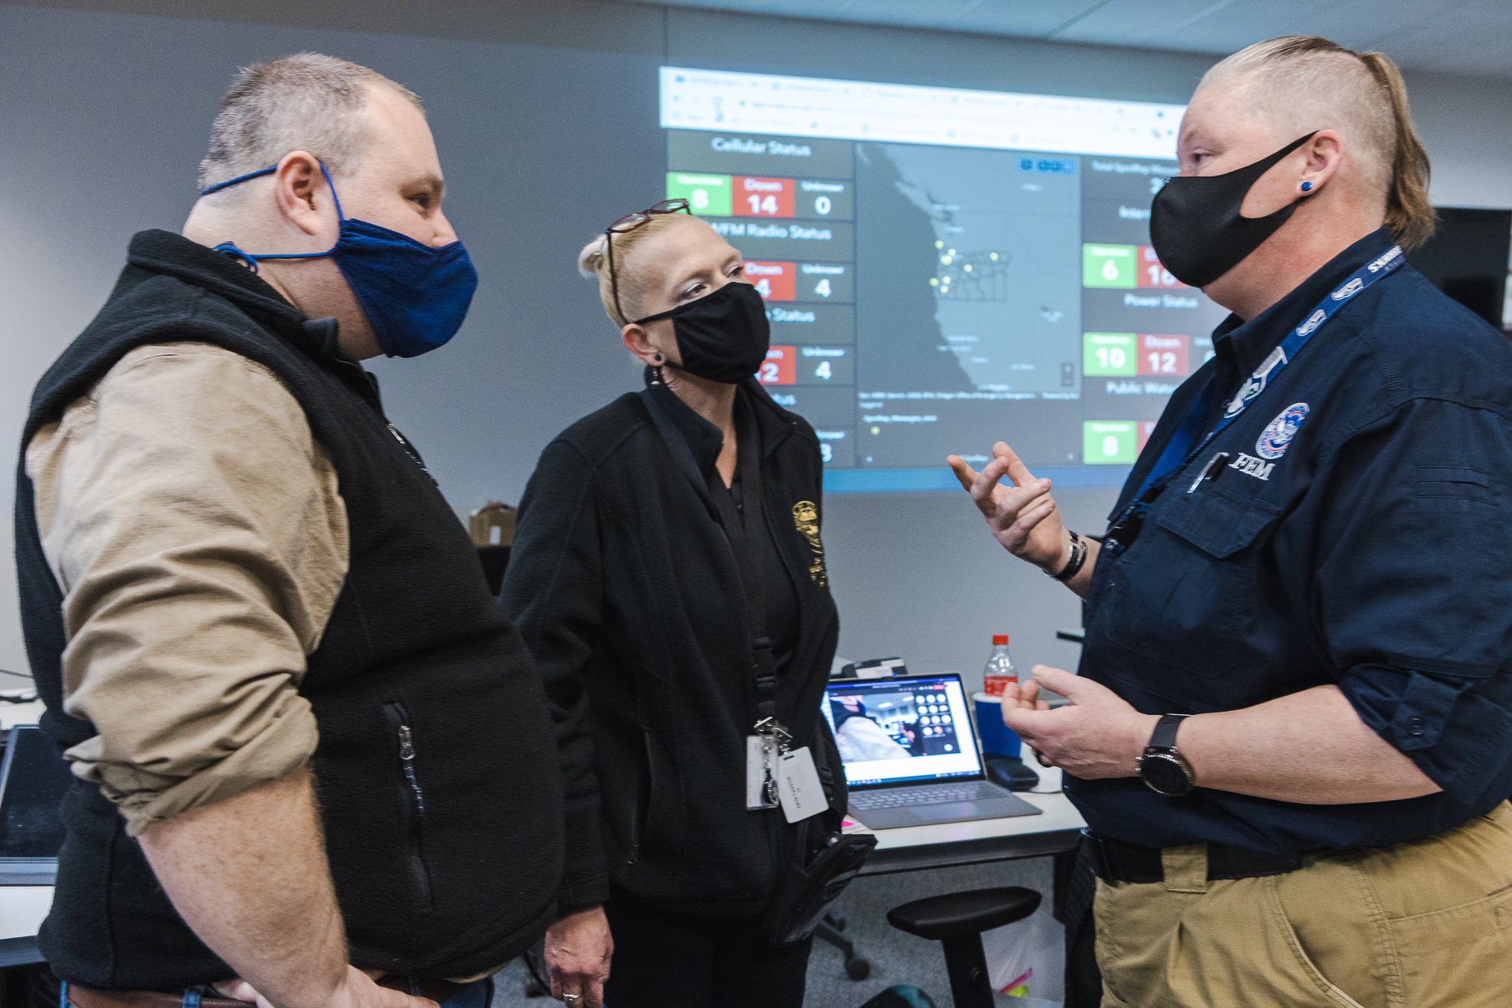

FEMA Region 10 staff conduct simulated ESF-2 needs assessment with Oregon SWIC and ESF-12 Lead during Cascadia Mania 2022. Photo courtesy of Robert Hugi.

CISA Emergency Communications Division
Formerly known as the Office of Emergency Communications (OEC), the Emergency Communications Division (ECD) is part of the U.S. Department of Homeland Security’s Cybersecurity and Infrastructure Security Agency (CISA).

ECD supports the Emergency Communications critical infrastructure sector through the National Emergency Communications Plan (NECP) and the Interoperable Communications Technical Assistance Program (ICTAP), which provides free, expert-led training to Federal, state, local, tribal, and territorial public safety entities. Offerings in the technical assistance catalog range from classroom training to facilitated workshops focused on developing SOPs and program governance. ECD also provides Statewide Communication Interoperability Plan (SCIP) workshops for State and local public safety representatives and stakeholders to collaborate on identifying and implementing strategic goals and objectives for interoperable emergency communications.

For more information about ECD’s technical assistance please visit:
cisa.gov/safecom/ictapscip-resources

