Health & Wellness
2022-2024 Plan
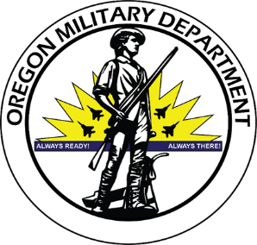
Oregon
Military
Department

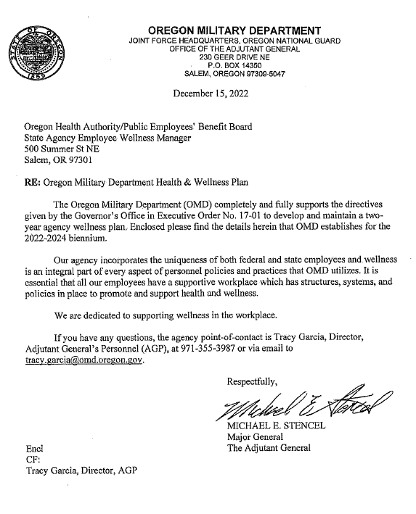
Contents
Introduction 4
Agency Overview 6
1. Agency Leadership 7
2. Current Status 8
3. Data 9
4. Goals, Strategies, and Planned Actions 13
5. Resources 15

Introduction
Executive Order 17-01, State Agency Employee Wellness directs executive branch agencies to establish two-year wellness plans detailing the agency’s objectives and activities to assess and improve employee health.
The Oregon Military Department (OMD) values the employees who provide support to the Oregon National Guard. OMD is committed to promoting and supporting health and wellness of all employees. OMD recognizes that good health and wellness allows employees a higher level of performance at work and home. This in turn, reduces absenteeism and on-the-job injuries, improves moral, and reduces insurance utilization and premiums.

Opportunity
The Oregon Military Department commits to developing, implementing, and evaluating workplace health and wellness opportunities as they become available, as an ongoing effort. We provide access and encourage awareness of the DAS State HR Policy 50-010-06 and OMD Agency Policy AGP-99.200.09 Employee Health & Wellness. The agency will create a Health & Wellness plan on a biannual basis and evaluate changes observed at the end of each biennium for any areas that require more intention focus. Areas identified will be used for future health and wellness plan constructions and a resetting of agency goals related to health and wellness.

Mission Statement
It is the mission of the Oregon Military Department to establish and maintain organizational health by fostering interest and encouraging employees to initiate or expand healthier lifestyles; provide education and resources that offer diverse wellness programs to meet a wide range of personal health needs, increase awareness of factors and resources contributing to well-being; inspire and empower individuals to take responsibility for their own health; encourage a decrease in absenteeism due to illness and stress, and develop a positive culture that is focused on celebrating and improving the quality of life for all employees.

Agency Focus
The Oregon Military Department’s Health & Wellness Plan will include striving to increase the well-being and productivity of all employees, through the enhancement of all aspects of health through resources available to State of Oregon employees and the agency. The agency seeks to increase awareness of positive health behaviors, to motivate employees to voluntarily adopt healthier behaviors, and to provide opportunities and a supportive environment to foster positive lifestyle changes.

Keys to Success
The Oregon Military Department recognizes five (5) key elements of a comprehensive workplace wellness program. The first is having practical and accessible services available, when possible. This includes on-site gyms available at no cost to the employees, lunchtime seminars, reminders about smoking cessation and west lost incentives available through state benefits.
The second element is to bring awareness of the existing support benefits for all State of Oregon employees. This list includes Health Engagement Model (HEM); Better Choices, Better Health, Employee Assistance Program (EAP) Emotional & Behavioral Health; Healthy Team Healthy U; Tobacco Cessation; Virtual Lifestyle Management (VLM); WW (Formally Weight Watchers); No-cost Preventative Services; Flu Shot Information; and Workplace Wellness activities.
The third element is to have a health-conscious work environment. Ways an agency can show support would be to offer healthy food in the cafeteria and vending machines, if available. The environment will foster wellness by being mindful of workplace noise, encouraging regular and appropriate breaks, promoting wellness initiatives, posting signs informing employees of wellness initiatives, and offering access to walking paths, where accessible. Observance of non-smoking policies and statewide requirements to use seat belts in state vehicles would also be posted for awareness.
Fourthly, the agency can integrate wellness with workplace safety, benefits, and human resources within the organization. Employees can be encouraged to participate without conflict with their job. Agency leadership will be encouraged to see it as a cohesive entity, seamless with workplace safety, benefits, human resources, and other infrastructure elements. Incorporating these suggestions into the structure and encouraging employees to make an effort to try to create a lifestyle change provided that when they make that choice, the change becomes the norm for them, individually.
Lastly, the fifth element is for the agency to encourage a supportive social and physical environment for all employees. Annually, State of Oregon employees are offered an opportunity, as an incentive, to update their health screenings through their primary health carrier for a discount offered to them through payroll for the following year. The agency will support employees by encouraging the Manager or Supervisor to consider flexible schedules that allow unpaid time for the employee to participate in healthy activities, as long as there are no obstacles in meeting the needs of the agency per the specific position.
Expected Outcomes
It is anticipated that employees will report that the availability of wellness activities contributes to a positive work environment and healthier behavior. Methods for monitoring and evaluating status will include at least the following: Periodic employee-wide surveys to assess awareness of, participation in, and satisfaction with the efforts made by the agency. Collection of information regarding participation in the various opportunities and awareness activities within each unit on a semi-annual basis. Periodic assessments of how employees have adopted formal and informal healthy behaviors.

Agency Overview
The mission of the Oregon Military Department (OMD) is to provide support for the State of Oregon, the soldiers, airmen, and civilians when there is a need to have a ready force trained to respond to any contingency within the state. OMD is led by The Adjutant General (TAG), appointed by the Governor under ORS 396.150. TAG functions as the OMD Director while also having command of approximately 8,100 Service Members and 449 state employees. Reporting to TAG are subordinate state and federal commands including Adjutant General (AG) Deputy Chief (state); Commander Joint and Domestic Operations (federal); Commander Land Component (federal); and the Commander Air Component (federal).
The Oregon Military Department serves the State of Oregon and the United States. The Oregon National Guard (ORNG) is commanded by the Governor, although the majority of funding is derived from the federal government. OMD’s long- and short-term plans focus on our state mission and the critical support we provide for the citizens of Oregon while, the ORNG maintains effective readiness and response in assistance of the National Military Strategy (NMS). The ORNG’s federal mission and response are interwoven in the agency’s state planning strategies.
The Adjutant General is responsible for command of the Deputy Chief who manages and supports the state civilian workforce existing within the following programs: Adjutant General Installations (AGI), Adjutant General Personnel (AGP), Adjutant General Comptroller (AGC), Oregon Youth Challenge Program (OYCP), STARBASE, Oregon Civil Defense Force (ORCDF), Portland Air National Guard (PANG) Fire Department, Kingsley Field Air National Guard (KFANG) Fire Department, as well as Security Forces (SF) and Civil Engineering (CE) at both Kingsley Field and Portland Air National Guard Bases. The Oregon Office of Emergency Management (OEM) became a standalone agency as of July 1, 2022, now known as the Oregon Department of Emergency Management (ODEM). Prior to that time as part of the Oregon Military Department, the data reflects inclusion of the prior two years, which were managed by the Deputy Chief.
The Oregon Military Department oversees and supports programs related to facility management, construction, and maintenance, environmental control, emergency preparedness and disaster response, educating youth, firefighting services at air bases, wildland fire services statewide, training sites for military soldiers, and a military museum. Internal processes for state employees include but are not limited to human resource management, state and federal budget management, procurement activities, and payroll services. Additionally, when military forces are activated under an order of the Governor or otherwise issued by authority of law in case of invasion, disaster, insurrection, riot, breach of the peace, or imminent danger thereof, and when deemed necessary for the furtherance of the organization, maintenance, discipline or training of the organized militia for ceremonial functions of the state government, or if in the judgment of the Governor the maintenance of law and order is deemed necessary, the agency is responsible for managing human resource and payroll services for these State Active Duty (SAD) members.
The strategic priorities of OMD link the soldiers, airmen, and civilians every day for what they do to support the goals and objectives of our state and nation. By accomplishing our supporting tasks, we provide our State and Nation with trained and ready operational forces while also being effective stewards of our resources as well as building and maintaining partnerships to support the key efforts of our mission and vision. The core of our organization will always be the outstanding people tasked with leading our Service Members and employees. These individuals carry out our strategic plan and ensure its continuous improvement as it adapts to the changes our state and nation face year after year. Through this plan and future iterations, we posture ourselves for the future while remaining…Always Ready, Always There!

1. Agency Leadership

The Leadership at the Oregon Military Department is fully dedicated to ensuring employees have an opportunity to be supported and participate in personal health and wellness opportunities. The agency sees well-being as a priority that fits within the agency’s mission. This commitment to employee wellness is strengthened by leadership engagement in the participation of trainings and health and wellness committee meetings. Leadership understands the importance of including these opportunities when recruiting, engaging, and retaining employees. Productivity is directly affected by the health of the employee and the workplace environment. We believe that our role as leaders is to ensure all of our employees including our management staff are encouraged to be mindful of their own health and recognize they are the role models for those employees they supervise.
Leadership within the Oregon Military Department fully supports the health and wellness initiatives offered to their employees by participating and encouraging others to participate in the agency’s Health and Wellness Committee that meets bi-annually. This workgroup collaborates efforts and shares ideas about promoting health and wellness within the local units and throughout the entire agency. Quarterly, the workgroup sends out the agency’s Health & Wellness Newsletter which includes current, relevant information about how employees can stay engaged in wellness as well as resources that are available to them. Twice during our hottest and coldest months of the year, the workgroup distributes reminders to stay safe during inclement weather and how to stay cool while in the workplace, during the hottest times. Committee members and representatives for the local units who participate in these activities also encourage other staff to engage in conversations about health and wellness during unit meetings, in casual conversations, and through individual activities within their units.
Leadership is at the forefront of our agency’s efforts to encourage, promote, and support health and wellness into the culture and overall workplace experience within the Oregon Military Department. Agency leadership has communicated with staff regularly acknowledging the tremendous workload and stressors employees have to manage and the importance of taking personal care of their emotional and mental health as well as their physical health. Agency management is supportive and encouraging of employees who need to take accrued leave time for mental health purposes. Management supports continued remote work for positions that do not have a direct need to be in the workplace. We understand worker preferences for remote work and the work-life balance as a benefit for some employees. Agency management monitor and adhere to current COVID-19 safety protocols to provide as safe a workplace as possible for employees who are required to be in the workplace.
The agency offers each quarter, a New Employee Orientation (NEO) which includes a review of relevant polices and discussion around health and wellness and safety for employees. This information is an open discussion with the new employees to ensure they have a clear understanding of how the agency supports these areas. Payroll participates in this training and shares benefits as a secondary review of the Public Employees Benefit Board (PEBB) benefits. We show the employees where the website is and review some of the benefits, they have available to them to utilize as appropriate. We believe that a key part of our role as leaders in state government is to create a place where our employees can thrive, succeed, and look forward to work each day, whether they are physically in state office buildings or working remotely. We have confidence that employees in such an environment will provide excellent service to those we serve.

2. Current Status

The Oregon Military Department had some employees begin working remotely as of March 2020 in response to the COVID-19 pandemic, although the majority of our employees remained in the workplace due to the nature of the work, they are responsible for. These employees perform duties such as construction and maintenance for the buildings used by the National Guard members, payroll and human resource processing for State Active Duty (SAD) members, security duties and firefighting services on two air bases. Some administrative staff who could perform duties not associated with a need to maintain security or the physical upkeep of the buildings and properties were identified as remote eligible. This presented an opportunity for establishing meetings in an online platform and increased participation in our meetings that previously required in person attendance.

In January 2021, the agency established a Health and Wellness policy. Along with this, the agency also organized a Health and Wellness Workgroup incorporating individuals across the state as the Oregon Military Department has locations in over 52 sites with facilities on them, four training locations, and two air bases. The workgroup consists of 25 identified individuals with approximately 10 that attend on a regular basis. They meet twice a year to discuss strategies regarding promoting health and wellness in the workplace, specifically for the individual locations.

In response to the COVID-19 pandemic some wellness activities were limited or discontinued such as the use of the workout equipment and the frequency of having blood drives in the buildings. The Health and Wellness workgroup efforts were re-directed to support both in office and remote employees with information on ergonomics, safe workplace practices, and work-from-home arrangements. Oregon’s Work Reimagined made guidelines and tools available for agencies to implement a hybrid workplace model wherever possible and our supervisors were trained in areas to support remote working when applicable. A webpage was developed with information about health and wellness and the resources available for employees to supplement the local bulletin boards in our buildings.

The agency produces quarterly newsletters, two winter and two summer reminder flyers regarding weather conditions and how that affects the health of an individual. These publications include resources for where to find additional information to stay healthy and tips for workplace wellness. Local Health & Wellness Workgroup members support employees by posting the publications on bulletin boards, encouraging conversations about health and wellness, and offering information about available resources. Additionally, the Department of Administrative Services sends out emails that support health and wellness such as the Positivity Project’s blog which is sent to all employees. The Public Employees Retirement System (PERS) sends out reminders to all employees periodically regarding how to maintain financial health. The Public Employees Benefit Board (PEBB) and Uplift Oregon also send out reminders to all employees regarding available benefits for all State of Oregon employees.

The Oregon Military Department’s mission compels us to support health and wellness in the workplace, and we believe that through continued communication, this will continue to be successful. Our leaders are committed to supporting these efforts and our employees are dedicated to the goals of the agency. As an agency who stives to continually strengthen our knowledge about health and wellness through communication, training, and education, we will encourage our employees to utilize the abundant opportunities available to foster healthy work environments. Promoting wellness is an ongoing effort and the basis upon which the Oregon Military Department works to continually provide and improve the environment for employees to succeed in supporting one another in wellness and health.

3. Data

The Oregon Military Department (OMD) has a high level of complexity due to the variation between our approximately 38 armories/readiness centers, four training sites, and existence on two major air bases, and the unique attributes and employee concentrations distributed across the state including many in remote locations. OMD has chosen to use as a baseline for our data. How the effectiveness of our internal initiatives has impacted employees, the evidence-based data from the 2019 State Employee Wellness Survey (completed by over 16,500 state employees), the Canopy (previously known as Cascade Centers) Employee Assistance Program Reports for this period, and the State Accident and Insurance Fund (SAIF) Corporation Coordination information on Worker’s Compensation claims. Combined, these are what we use to evaluate where our employees are within the timelines of the data sets used.

The Oregon Military Department (OMD) provides our State and Nation with trained and ready operational forces while also being effective stewards of our resources. Our goals include building and maintaining partnerships to support the key efforts of our mission and vision. The culture of our agency is to embrace the motto, “Always Ready, Always There!” We encourage our employees to engage in health and wellness activities in support of this attitude.
Chronic Conditions Report

Oregon’s PEBB and their medical providers contracted with Mercer Corporation to compile chronic
health conditions for all enrolled PEBB employees (Providence & Moda) during the period of July 2019
to June 2021. Based on the information from Mercer Corporation, the Oregon Military Department (OMD) showed chronic obstructive pulmonary disease (COPD) at the highest and Congestive Heart Failure (CHF) to be at the lowest within the spectrum.

The report showed an evaluation of an average employee count to be 51,9607 for all employees working for the State of Oregon. Of these employees, the risk score was 149.8. In specific areas the percentages showed (per 1000): asthma at 54.9; congestive heart failure (CHF) at 5.0; chronic obstructive pulmonary disease (COPD) at 6.5; coronary artery disease (CAD) at 18.7; depression at 209.5; diabetes at 156.0; and obesity at 52.4. Percentages are tied to the overall PEBB rates. Example, the rate of diabetes among PEBB employees is 15.6%. The Oregon Military Department is 3.2% lower than the PEBB rate and has an overall 1.90% risk score compared to all total PEBB employees. Risk score is a calculation of a person’s expected cost based on the diagnosis of their claims. Based on each diagnosis, a member is assigned a typical cost value for that diagnosis. Their diagnoses, plus age, and gender are used to calculate the risk score. The difference in risk scores between members translates to the expected difference in their health care costs. Kaiser members are included in the total PEBB report, but the agency breakouts of the data presented in focus, are from Providence and Moda claims only.

Employee Assistance Program Impact Report

The Public Employees Benefit Board (PEBB) July 1, 2019, to June 30, 2020, Employee Assistance Program (EAP) Impact Report for services offered to State of Oregon employees showed the Oregon Military Department as having a total utilization percentage of 3.5% calculated by an average of 427 employees. Of the 15 persons who used the services available, 12 were first time users of the services and five were dependents of the agency’s employees. This information is broken down by years into quarters identified as:

Q1. Quarter 1: July 1 to September 30
Q2. Quarter 2: October 1 to December 31
Q3. Quarter 3: January 1 to March 31
Q4. Quarter 4: April 1 to June 30

July 2019 - June 2020 July 2020 – June 2021
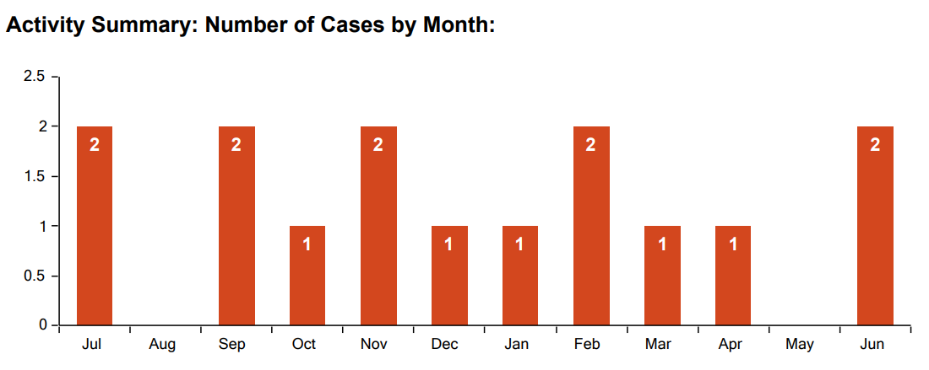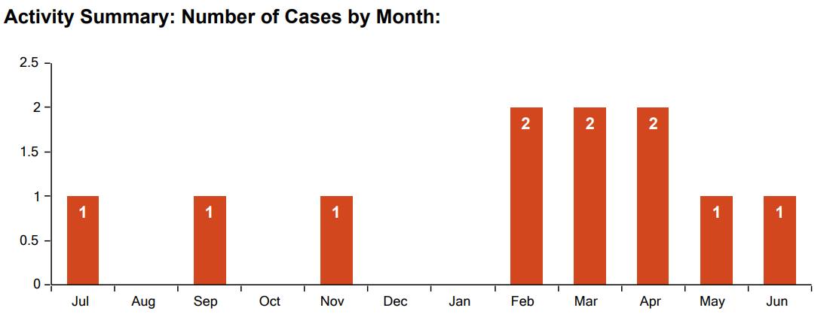

The PEBB July 1, 2019, to June 30, 2020, utilization report of services showed OMD as having a total utilization percentage of 3.5% calculated by an average of 427 employees. For July 1, 2020, to June 30, 2021, report showed OMD as having a total utilization percentage of 2.4% calculated by an average of 463 employees.

The Oregon Military Department supports remote work for positions that do not have a requirement to physically be in the workplace to support the agency’s mission. Many of the positions such as security officers, firefighters, maintenance, and front-line customer service or management duties have limited opportunities for remote working as the majority of the work is completed on site. Other positions that may have the option to work remotely have been identified and are offered the opportunity on an individual basis. Evaluations of our positions for remote work are done on a continual basis using a variety of considerations such as scope of work, needs of the position, and the employee’s performance.

State Accident Insurance Fund Reports

The State Accident Insurance Fund (SAIF) is a not-for-profit worker’s compensation insurance company utilized by State of Oregon agencies. The company provides guidance and services around how to manage and prevent injuries in the workplace. The agency’s SAIF Claims for June 1, 2019, to June 30, 2021, show a total of 27 reported injuries of the average 445 employees. During the two-year period, of the 27 reported, five (5) were denied and four (4) were voided for various reasons. This equates to the agency injury count to be 4% of our employee population or 18 employees.

The injury types found 63% (17) of the claims were nondisabling, 22% (6) left the employee with a permanent partially disability, and 15% (4) were disabling for the employee.

The number of days lost, totaled 496 between 6 employees and the other 21 people reported zero days lost. Of those who reported lost time, the six reported the amounts shown in the chart below. The day’s range from two to 402 within the two-year period, total.

Considering the months that injuries were reported, the data shows January (3) and February (4) 2021 to have the most reported injuries. There were six months in 2020 where the agency had zero reported injuries. Our agency had between zero and 4 reported injuries during the July 2019-June 2021 time frame, in any given month. Overall, during this period, the agency had a total of 27 reported injuries which equates to 9% of our employee population.

The majority of injuries during this time frame were reported as shoulder injuries. These injuries were sustained by lifting files into an overhead cabinet, putting on a turnout jacket, exiting a truck and jerked by the seatbelt which caused a fall, and lifting 30-pound bins. Four were disabling, six were permanently partially disabling, and of the 27 total reported, 17 were nondisabling.

The Oregon Military Department has a total of 52 sites. Of these, 27 reported some form of accident or injury for the July 1, 2019, to June 30, 2021, time frame. The majority were reported by the Klamath Falls, Fire Department who reported seven incidents. Dallas, Medford, Portland Air National Guard Base (PANG) Civil Engineering, and Umatilla all reported a single incident. Klamath Falls Civil Engineering, PANG Fire Department, Redmond, and Camp Rilea had two incidents at each location. Salem and the Oregon Youth Challenge Program (OYCP) had four incidents to report during this span of time. This calculates to 52% of our locations having reported some form of incident during this span of time.

4. Goals, Strategies, and Planned Actions
The Oregon Military Department has a firm foundation on which to continue efforts related to building a robust and effective employee wellness program. The agency has goals to deepen our commitment to a results-oriented workplace wellness program and to design and manage a program that improves the health and productivity of employees, improves morale and loyalty, achieves higher productivity, increases retention, reduces absenteeism, and potentially support improving the overall cost of employer-provided health care. The agency’s Health & Wellness Committee meets twice a year to discuss and evaluate the goals, strategies, and planned actions based on continued efforts to inform employees of available resources, activities at the local levels, and based on employee feedback. The principles that guide our wellness committee operations are based on equity and evidence-based information that is available to our agency.

Equity

The Health Equity Framework from Healthier Together Oregon is the basis for PEBB’s efforts to achieve health equity. The vision: “Oregon will be a place where health and well-being are achieved across the lifespan for people of all races, ethnicities, disabilities, genders, sexual orientations, socioeconomic status, nationalities and geographic locations.”

Prioritized populations include but are not limited to:
• Black, Indigenous, People of Color, and American Indian/Alaska Native People (BIPOC-AI/AN)
• People with low incomes
• People with disabilities (See Guidelines for Disability Inclusion in this document)
• People who identify as LGBTQIA2S+? (Lesbian, Gay, Bisexual, Transgender, Transsexual, Queer, Intersex, Asexual, 2 Spirit, questioning and the countless affirmative other ways in which people may choose to self-identify)
• People who live in rural areas

The Governor’s Office of Diversity, Equity, and Inclusion released a framework that all state agencies could use to center equity and racial justice. Actions in the framework pertinent to wellness efforts include using inclusive communications and ensuring a safe, inclusive, and accessible workplace for everyone. The Oregon Military Department takes into consideration whose voices and perspectives are not at the table when planning and implementing wellness programs and activities. The agency makes every effort to ensure that all voices are part of the decision-making process when we implement agency-wide changes. The committees that are formed both at the agency level and the local levels include employees from the priority populations with consideration to the current employee staff. When communication materials are distributed, the agency includes all employees for the broadest sharing to ensure everyone is included in the messages.

Evidence-based

Evidence-based guidelines are based on the available information. The data provided to our agency through the State Employee Wellness Survey, Canopy (previously known as Cascade Centers) Employee Assistance Program Reports, and the State Accident and Insurance Fund (SAIF) Corporation assists us in making informed decisions on where we need to improve and directs us to areas that will be highlighted in future areas of improvement. The agency has an effective, organized leadership team that supports positive outcomes focused on the employee wellness initiatives to improve health, lower medical costs, increase participation, and employee perception of organizational support for employees’ health and well-being.

Agency Goals

The Oregon Military Department has several goals which include but are not limited to:

- Agency Organization: Strengthening wellness infrastructure within the agency by increasing knowledge and support throughout the agency in areas that promote the success of the agency’s wellness plan.

- Participation: Encouraging employees’ participation in available wellness activities through the resources PEBB offers state employees such as: Canopy; WW (Weight Watchers); Omada; Kaia Health; Healthy You; and through the Kaiser Permanente, Moda Health, and Providence Health plans by offering frequent reminders about the benefits offered by using these resources.

- Organizational Supports: Develop an annual diversity calendar that includes wellness messages to distribute to employees by November 30, 2022. Messages will be developed by the Affirmative Action group and the Health & Wellness Committee collaboratively and include agency leadership input.

- Tobacco Use: Address tobacco use, a primary driver of preventable chronic disease and increased health care costs. Share available cessation resources with employees in the agency’s quarterly wellness newsletter and on the Wellness webpage. Include tobacco-related health statistics (including information on second-hand smoke relative to remote working at home) and a reminder that state properties are tobacco-free.

- Physical Activity: Encourage physical activity and bring awareness of the need to increase levels of physical activity, to prevent or manage chronic disease, and impact health care costs. In the quarterly newsletter, promote opportunities to participate in fitness activities. By 12/31/2022, promote movement in all meetings lasting 90 minutes or longer. Annually, coordinate and promote opportunities for employees to encourage them to participate in the Health Engagement Model (HEM) program to decrease the risk for chronic disease and assist in decreasing in health care costs.

- Healthy Foods: Promote healthy food options and bring attention when events include these types of foods. Promoting healthy foods in highlights and emails that are distributed related to health and wellness. Including healthy choices in the quarterly newsletter that is distributed. Addressing the need for improving nutrition may prevent or manage chronic disease and can impact health care for employees. Share CDC nutrition guidelines and promote the annual Governor’s Food Drive.

- Emotional Health: By December 31, 2022, schedule at least two sessions with Canopy for employees to become more familiar with their services and encourage participation in the resources they offer through their website. Including information in the quarterly New Employee Orientation that highlights resources offered by the Canopy Employee Assistance Program.

5. Resources

PEBB
• Kaiser
• Moda
• Providence
• PEBB Wellness Programs

Agencies and organizations
• Centers for Disease Prevention and Control Workplace Health Promotion
• NIOSH’s Total Worker Health
• Oregon Healthy Workforce Center
• PEBB
• SAIF Integrating health and safety
• Wellness Council of America (WELCOA)
• Department of Administrative Services Work Reimagined

Oregon Military Department Employee Resource Groups (ERGs)

Safety Committee Health & Wellness Committee Affirmative Action Workgroup
Julie Paris, Safety Specialist, Chairperson | Tracy Garcia, Chair | Tracy Garcia, AA Officer, Equity Leader
Cherie Cline, Secretary | Micky Dryden, Co-chair / Coordinator | Micky Dryden, Agency Representative
Tracy Garcia, State Personnel Director | Sara Wassam, Secretary | Sean McCormick, CFO, Lead for COBID Contracting and Procurement
Dave Stuckey, OMD Deputy Chief | Julie Paris, Safety Manager | Shawn Potapoff, Agency Recruiter
Todd Farmer, AGI Director | Melissa Carter, Payroll/Benefits Analyst | David Sutterfield, YCP, Social Media & Advertising Manager
Sean McCormick, AGC Director | Scott Donoho, PANG, Health & Safety Officer | Denise Kortes, STARBASE State Director
Dan Radabaugh, YCP Director | Dan Johnson, Assistant Chief of Fire Prevention | Tim Gilbert, AGI Operations Manager
Andrew Phelps, OEM Director (OEM became an independent agency as of July 1, 2022 – no longer part of the ERGs) | Cira Murray, OEM, Executive Assistant (OEM became an independent agency as of July 1, 2022 – no longer part of the ERGs) | Doug Jimenez, OEM, Auxiliary Communications Program Officer(OEM became an independent agency as of July 1, 2022 – no longer part of the ERGs)

ERGs are voluntary, employee-driven groups organized around the shared interests and backgrounds of members. ERGs promote diversity, equity and inclusion, and support community building, mentorship and learning opportunities. ERGs serve as a communication channel among staff and leadership. The Oregon Military Department’s ERGs are a growing mix of people from different demographic groups.

Mental Health
• Spiritual Resources During the COVID Pandemic from Harvard Divinity School
• Griefshare Find free, in-person grief recovery support group across the country
• NAMI (National Alliance on Mental Illness) Support and education for people affected by mental illness. Helpline: M -F, 10 a.m. – 8 p.m. (ET), 1-800-950-NAMI (6264) or info@nami.org
• NAMI National Warmline Directory
• Mental Health America (MHA) Addressing the needs of those living with mental illness and to promoting the overall mental health of all Americans.
• Anxiety and Depression Association of America (ADAA) Current treatment and research information and access free resources and support.
• American Foundation for Suicide Prevention (AFSP) Raises awareness, funds scientific research and provides resources and aid to those affected by suicide.
• FindYourWords Mental health stigma reduction public health campaign
• The Unlonely Project. Building community in social isolation

Behavioral Health
• Schizophrenia and Related Disorders Alliance of America (SARDAA) Offers recovery through support programs, education, collaboration, and advocacy.
• Depression and Bipolar Support Alliance (DBSA) Education to help people with diagnoses and their loved ones to know what mood disorders are, and what can be done for treatment and management.
• American Autism Association Help for families and individuals affected by autism.
• National Eating Disorders Association (NEDA) Dedicated to supporting individuals and families affected by eating disorders.

Addiction
• Alcoholics Anonymous International fellowship of men and women who have had a drinking problem
• Al-Anon and Alateen Mutual support group for people whose lives have been affected by someone else’s drinking.
• Celebrate Recovery Christ-centered, 12 step recovery program
• Refuge Recovery Buddhist-oriented recovery program
• Self-Management and Recovery Training (SMART) Secular sobriety support group for people with a variety of addictions
• Shatter Proof™ Dedicated to ending the devastation addiction causes families
• Double Trouble in Recovery 12 step program for people managing both a substance use disorder and mental illness
• CheckUp & Choices Moderate drinking program focused on reducing alcohol and drug programs, but not requiring abstinence like AA and NA.
• Narcotics Anonymous Recovery from the effects of addiction

Hotlines
• The National Sexual Assault Telephone Hotline: Call 1-800-656-HOPE (4673) to connect with a trained staff member in your area
• The Steve Fund: Young people of color can text “STEVE” to 741741 to connect with a trained crisis counselor, 24 hours a day, 7 days a week
• The Trevor Project Resources: If you’re a young person in crisis, feeling suicidal, or in need of a safe and judgement-free place to talk call 1-866-488-7386, instant-message a counselor on their website, or text “START” to 678678, 24 hours a day, 7 days a week,
• Trans Lifeline: Call 1-877-565-8860 24 hours a day, 7 days a week. Trans Lifeline is a trans-led organization

