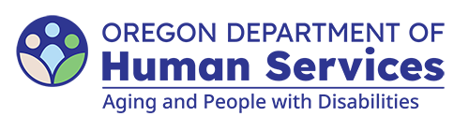
Aging and People with Disabilities
Medicaid Services and Supports

Tribal Navigator Referral
Updated: April 10, 2026

Individual’s information
Name: Prime: Date of referral:
Physical address:
County: City: State: Zip:
Mailing address:
City: State: Zip:
Phone: Email:
Tribal affiliation: Has the affiliation been verified? Yes No
Summary of reported needs:
Safety concerns:

Referring branch / staff information
Case manager’s name: Branch:
Phone: Email:
You can get this document in other languages, large print, braille or a format you prefer free of charge. Contact the Aging and People with Disabilities at apd.ltss@odhs.oregon.gov or 503-945-5600. We accept all relay calls.
Aging and People with Disabilties
Medicaid Services and Supports
500 Summer St. NE, E-10
Salem, OR 97301-1076
503-945-5600
odhs.info@odhs.oregon.gov
www.oregon.gov/odhs

