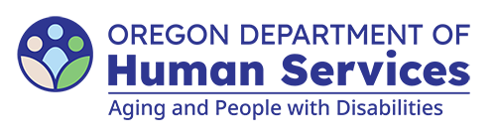
Aging and People with Disabilities
Medicaid Services and Supports

Tribal Navigator Mental Health Referral
Updated: April 10, 2026

Individual contact information
Name: |  |  |  | Prime:
Phone: | Gender: |  | DOB:
Best time to contact: AM PM Mon. Tues. Wed. Thurs. Fri.
Emergency contact: |  | Phone:
Interviewer: |  | Date:
Case management program completed by: Elder Services Peer support

Reason for referral
______________________________________________________________________________________________________________________________________________________________________________________________________________________________________________________________________________________________________________________________________________________________________________________________________________________________________________________________________________

Case managerment needs
In ranked order of urgency, what case management resources are requested?
Food | Cultural support | Housing
In-home assistance | Transportation | Cell phone access
Financial assistance | Social support | Employment
Medical care coordination | Mental health therapy coordination | 2SLGBTQ+ support
A and D services coordination | Psychiatric medication management | Other (please specify) ________________________

You can get this document in other languages, large print, braille or a format you prefer free of charge. Contact the Aging and People with Disabilities at apd.ltss@odhs.oregon.gov or 503-945-5600. We accept all relay calls.
Aging and People with Disabilties
Medicaid Services and Supports
500 Summer St. NE, E-10
Salem, OR 97301-1076
503-945-5600
odhs.info@odhs.oregon.gov
www.oregon.gov/odhs

