
Aging and People with Disabilities (APD)
Medicaid Services and Supports

Risk Assessment Comment, Mitigation and Monitoring Templates
Updated: March 24, 2026

Use of templates
Case managers should use the standardized documentation templates in this reference guide when documenting risk assessments and backup plans in Oregon ACCESS (OA) for in-home service eligible individuals.
Note: For individuals residing in community based care (CBC) facilities, complete a limited risk assessment. In the comment box document that the facility assumes responsibility for all identified risks and serves as the backup plan. Risk assessments for individuals in nursing facilities are not required.
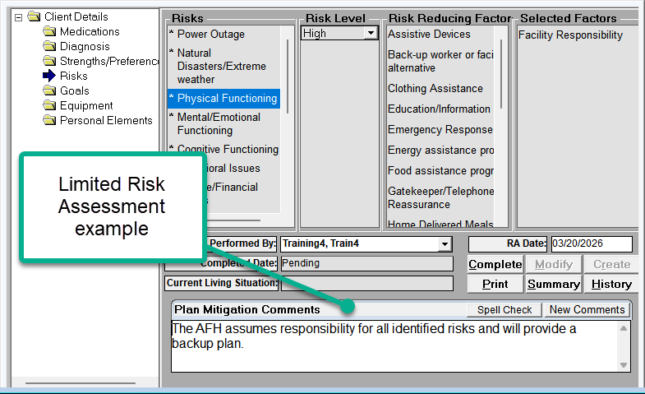

Risk assessment comment box template
Copy the following templates into the risk assessment comment box in OA and replace [bracketed text] with case-specific information.
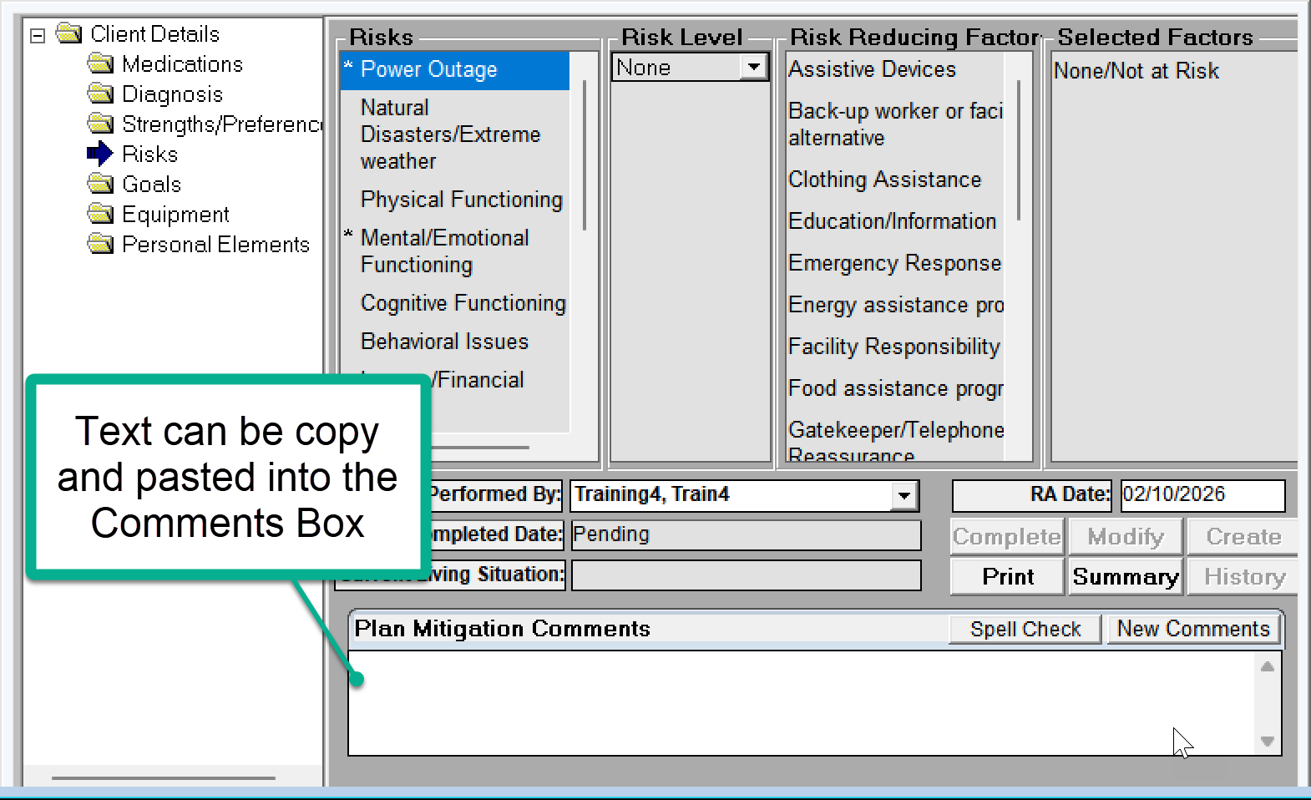

No or low risk(s) identified risk level
Risk concern: [Provide detailed information on any assessed risk concern(s) provide current status of previously assessed risk.]
Backup plan: [Indicate a person to provide a backup support in the event a scheduled provider is suddenly unable to provide care, or assistive devices are suddenly unavailable. Include the contact’s name and phone number of the backup provider and/or natural support.]

Medium or high risk(s) identified risk level
Risk concern: [Provide detailed information on any assessed risk concern(s), provide current status of previously assessed risk.]
Risk mitigation plan: [Work with the individual/Consumer-Employer Representative to lower risk concern(s). Document the mitigation strategies used to help lower risk. Document if the plan is updated. If mitigation strategies are not identified, document why.]
Individual/CE rep understanding/acceptance of plan: [Document the individual/rep understanding and agreement or disagreement with the plan.]
Backup plan: [Indicate a person to provide back up support in the event a scheduled provider is suddenly unable to provide care, or assistive devices are suddenly unavailable. Include the contact’s name and phone number of the backup provider and/or natural support.]

Case narration: risk mitigation and monitoring template
Copy the applicable standardized documentation template into the Case Narration text box in OA and replace [bracketed text] with case-specific information.
Use of these templates ensures all required elements are documented and promotes consistency.
These templates below do not apply to individuals in CBC facilities.
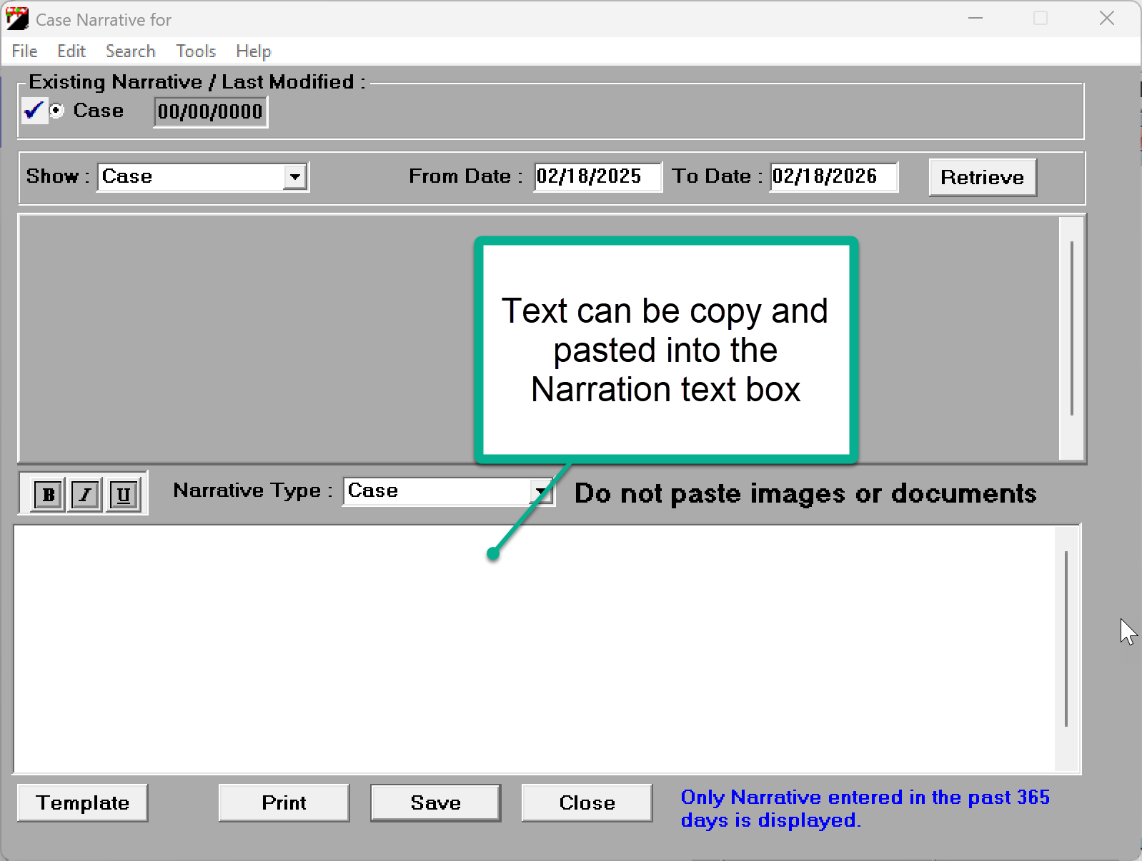

Direct case management: Risk mitigation and monitoring contact template
Direct contact-risk monitoring
Contact date: [mm/dd/yyyy]
Contact made with: [Individual or Consumer-Employer Representative. (737 Form)]
Review of assessed risk and mitigation plan: [If a high/medium risk is previously documented, or there is a new high/medium risk, discuss the concern and review the current mitigation plan status. Update mitigation strategies if needed. If there are low or no risks, document that risks were reviewed with the individual and there are no new/additional risk concerns.]
Individual/CE rep understanding/acceptance of plan: [Document the individual/rep understanding and agreement or disagreement with the plan.]
Review of current backup plan: [Document that the back-up plan was reviewed and updated if appropriate and that contact information is accurate. Refer to risk assessment.]
Risk assessment updated as appropriate: [Indicate if risk assessment was updated or if there are no changes. Refer to risk assessment for details.]

Need this document in another format?
You can get this document in other languages, large print, braille or a format you prefer free of charge. Contact ODHS at apd.ltss@odhsoha.oregon.gov or at 503-945-5600 (voice/text). We accept all relay calls.

