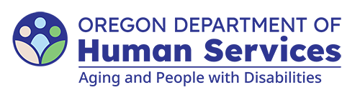
Aging and People with Disabilities
Medicaid Services and Supports

Monthly service payments

Click or tap to enter a date

Client name
c/o Authorized representative/Guardian
Mailing address
City State Zip code

Dear Name of PACE participant:

Effective Jan. 1, 2026, you may be required to contribute monthly towards the cost of your care while you are enrolled in PACE services. You will receive a separate notice for the monthly contribution amount.

You are responsible for paying room and board to the community-based care (CBC) facility each month. Your room and board payments are due to the CBC provider or bookkeeper by the fifth day of each month.

Effective Click or tap to enter a date you must pay $Insert dollar amount for monthly room and board (paid to the facility bookkeeper)
Remit payment to: Name/address of facility
Attn: Bookkeeper

Please contact me if you have any questions.

Sincerely,
Case manager name
Phone number
You can get this document in other languages, large print, braille or a format you prefer free of charge. Contact the Aging and People with Disabilities at apd.ltss@odhs.oregon.gov or 503-945-5600. We accept all relay calls.
Aging and People with Disabilties
Medicaid Services and Supports
500 Summer St. NE, E-10
Salem, OR 97301-1076
503-945-5600
odhs.info@odhs.oregon.gov
www.oregon.gov/odhs

