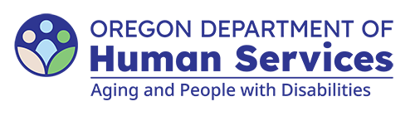
Aging and People with Disabilities
Medicaid Services and Supports

Independent Choices Program (ICP) Budget Review Narration Template
Updated: March 18, 2026
- ICP six-month budget review completed on Click or tap to enter a date.
- Six-month review period: Click or tap to enter a date. - Click or tap to enter a date.
- ICP checking account bank statements and checkbook register reviewed: Click or tap here to enter text.
- The items and amounts on the ICP Budget Worksheet match the items/amount listed on the checking account bank statements and checkbook register: Click or tap here to enter text.
- The participant (has/has not) been paying their taxes appropriately.
- If not, are they required to pay taxes and why not? Click or tap here to enter text.
- Has the participant paid their portion of the WBF at least annually? Yes/No
- Items/concerns discussed with the participant and/or their ICP Representative include: Click or tap here to enter text.
- Next six-month budget review to be completed on: Click or tap to enter a date.

This section should not be included in the narration.
You can get this document in other languages, large print, braille or a format you prefer free of charge. Contact the Aging and People with Disabilities at apd.ltss@odhs.oregon.gov or 503-945-5600. We accept all relay calls.
Aging and People with Disabilties
Medicaid Services and Supports
500 Summer St. NE, E-10
Salem, OR 97301-1076
503-945-5600
odhs.info@odhs.oregon.gov
www.oregon.gov/odhs

