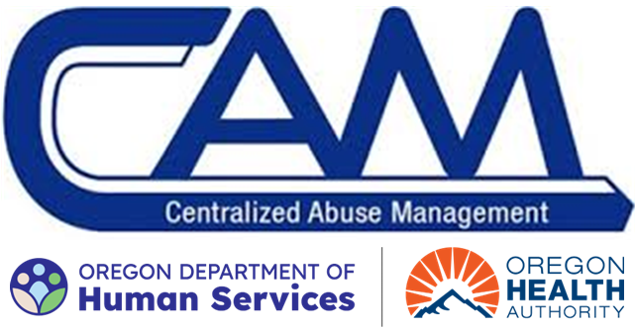
CAM ODDS Access Request Form

This Form is For Management Use Only

CAM Access Request: ☐ Add Access ☐ Modify Access ☐ Remove Access
Program: ☐ DD SI Only ☐ CIIS ☐ DD Central Staff ☐ State Child Res
Note: If access to Child Cases is needed, please fill out the OTIS CAM Access form, which can be found in Knowledge in CAM and send form via email to OTIS.CAM for approval.

General User Information:
First Name: Enter Name Middle Name: Enter Name Last Name: Enter Name
Agency: Enter Agency Name Title: Enter Title Email: Enter Email
Address: Enter Address Phone: Enter Phone Number
User ID Number (OR#/P#): Enter OR Number or P Number
Counties: Enter Counties

User’s Manager Name: Enter Name
Manager’s User ID (OR#/P#): Enter OR Number or P Number

Multi-Factor Authentication (MFA) Device: Please select the device staff will be using for Multi Factor Authentication (MFA).
Mobile App |  | Security Key
☐ Microsoft Authenticator | OR | ☐ Yubico’s YubiKey
☐ Salesforce Authenticator |  | ☐ Google’s Titan Security Key
☐ Google Authenticator
☐ Authy by Twillo
Access Justification and Additional Notes:
Provide a complete description of work user will do in CAM. If working with multiple counties, please indicate duties for each.
User Type: Choose type
CAM Profile: Choose profile
CAM Role: Choose role
Program: Choose Program
Responsible Counties: Enter Counties.

Pre-Approved Permissions Set(s):
☒ View Knowledge Articles ☒ Lightning ☒ Multi-Factor Authenticator ☒ Create Reports

User’s Supervisor Signature/Approval:
Supervisor Approving Access: Enter Supervisor Name
Date: Click or tap to enter a date.

Access requests must be emailed from the approving supervisor to CAM.Support@odhsoha.oregon.gov

