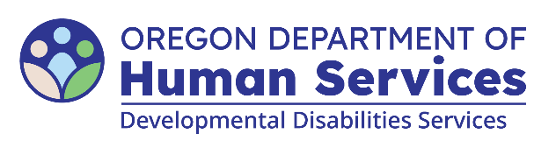
Licensing Fee Schedule
  - Including Foster Licensure
  - and Certification Fee Schedule

Agency Certification Application
Initial and Renewal Application | $500 plus the endorsement fees
Renewal is every 2 years. Expiration date can be found on the agency certification.

Endorsements
Endorsement Application | Initial and Renewal Fees
24-Hour Residential Services (Adult & Children) | $0* see below per capacity
Employment Services | $100
Supported Living Program | $100
Community Living Supports - Standard Model Agency | $100
Community Living Supports - Employer Model Agency | $100
Direct Nursing Services | $0 - No Fee
Professional Behavior Supports | $0 - No Fee
Endorsements are paid with the initial and renewal applications.
You may add an endorsement between applications and will still be required to pay the fee.

24-hour Residential License Applications (Adult & Children)
Initial Application | Fee*
Clackamas, Multnomah, or Washington County | $75 per capacity
All other counties | $50 per capacity
Renewal Application | Fee
All Counties | $50 per capacity
Capacity Increase | Fee
All Counties | $50 per additional capacity
Per capacity is based on how many people may live in the home.
Example: if you ask for a capacity of 3 you will pay 3x times amount above. *Renewal is every 2 years. Expiration date can be found on license.

Host Homes
Initial Application | Fee
All Counties | $0 - No Fee
Renewal Application | Fee
All Counties | $50 per home
Renewal is every 2 years. Expiration date can be found on license.

Foster (Adult & Children)
Adult Initial Application | Fee
Clackamas, Multnomah, or Washington County | $75 per capacity
All other Counties | $50 per capacity
Adult Initial Application | Fee
All Counties | $50 per capacity
Adult Capacity Increase | Fee
All Counties | $50 per capacity
Children’s Initial & Renewal Application | Fee
All Counties | $0 - No Fee
Renewal is every 1 year for Adult Foster and every 2 years for Children Foster.
The expiration date can be found on the license.

You can get this document in other languages, large print, braille or a format you prefer free of charge. Contact the Office of Developmental Disabilities Services at dd.licensing@odhsoha.oregon.gov or 503-945-7800. We accept all relay calls.

