Sexuality Education Made Simple
A Teacher’s Guide for K-12 Health and Sexuality Education
January 2020

Table of Contents
Acknowledgements 2
Introduction to this Guide 4
Introduction to Sexuality 4
Introduction to Sexuality Education 4
Oregon Human Sexuality Education Law and Policy 6
2016 Health Education Standards 8
Equity in Education 9
Unit One: Skills and Approaches for Sexuality Education 10
Overview 10
Inclusivity in the Sex Ed Classroom 10
Sexuality Education for Students with Disabilities 11
Additional Resources for Creating Developmentally Appropriate Lessons: 12
Creating a LGBTQ-Inclusive Classroom Environment 13
Trauma-Informed Education 17
Family Engagement: Involving Families and Caregivers in Sexuality Health Education 18
Opt-Out Practices 21
Community Engagement: Stakeholder’s Roles 22
Student Engagement 22
Culturally Responsive and Inclusive Classrooms 23
Lesson planning for Sexuality Education 26
Utilizing Guest Speakers for Sexuality Education 29
Unit Two: Core Concepts of Sexuality Education 31
Overview 31
Teaching Anatomy 31
Teaching Consent 32
Teaching Media Literacy in the Classroom 32
Healthy Teen Relationships 34
Child Abuse Prevention Education 35
Understanding Mandatory Reporting Laws 37
Answering Student Questions 37
Appendix A 42
Frequently Asked Questions 42
Appendix B 48
Endnotes 54

Acknowledgements
The Oregon Teacher Training Institute would like to thank all of the individuals who devoted time and effort to improving the health and well-being of students in the state of Oregon. This guide was developed by a committed team of experts, community members, educators, and others, including:

Emma Arnesty-Good, Sexuality Education Fellow, Oregon Department of Education.
Kristin Blomberg, Health Education Specialist/Erin’s Law Teacher on Special Assignment, Hillsboro School District.
Sally Blackwood, MA, LPC, Prevention Educator, CARES Northwest.
Liliana Cabrera, Community Outreach and Education Coordinator, Planned Parenthood Columbia Willamette.
Danise Elijah, BA, Prevention Educator, CARES Northwest.
Angie Foster-Lawson, MEd, Sexuality Education Analyst, Oregon Department of Education.
Molly Franks, MPH, Youth Sexual Health Equity Program, Multnomah County Health Department.
Daniel Gallo, Health Educator, Eugene School District 4J.
Lydia Giersch, Student, University of Oregon.
L. Kris Gowen, PhD, EdM, Co-founder of Beyond the Talk (beyondthetalk.net).
Sasha Grenier, MPH, CHES, Sexuality Education Specialist, Oregon Department of Education.
Daniel Guilfoyle, Youth Wellness Educator and Advocacy Manager at the Native American Youth And Family Center.
Leah Haas, MSW, CSWA, My Future-My Choice Program Analyst, Oregon Department of Human Services, Beyond the Talk, Co-Founder
Shelagh Johnson, Youth Sexual Health Coordinator, Oregon Health Authority, Public Health Division, Adolescent & School Health Program.
Kristen Jensine, Student, Portland State University.
Ashley Lin, Student, Union High School.
Jennifer Melo, Education Programs Manager, Planned Parenthood Columbia Willamette.
Meg Foster, Prevention Program Coordinator, The Oregon Attorney General’s Sexual Assault Task Force.
Vanessa Peña-La Torre, MPH, CHES, HEALTH for K-5 Program Manager, Portland Public Schools.
Elizabeth Sampedro, MPH, My Future-My Choice Program Analyst, Oregon Department of Human Services.
Lisa Yamashita, Staff Development and Curriculum Coordinator, Medford School District.

Introduction to this Guide
Since 2009, Oregon law has required that school districts teach comprehensive sexuality education (CSE) that is age-appropriate, evidence-based, medically accurate, culturally inclusive and based in positive youth development. This guide has been written to support schools in fulfilling this challenging task by providing tools and information for sexuality educators.
Well-qualified, trained and confident teachers are essential to this important work. Educators need the skills to be able to reach learners, communicate with individuals and groups and feel comfortable when discussing human sexuality. Even someone who is trained to educate learners in another topic area would need additional professional development to teach the unique topic of human sexuality.

Introduction to Sexuality
The Sexuality Information and Education Council of the United States (SIECUS) defines human sexuality as encompassing the sexual knowledge, beliefs, attitudes, values and behaviors of individuals. Its various dimensions include anatomy, physiology and biochemistry of the sexual response system; identity, orientation, roles and personality; and thoughts, feelings and relationships. Sexuality is influenced by ethical, spiritual, cultural and moral concerns. All persons are sexual beings in the broadest sense of the word. (SIECUS, 2018).
Sexuality includes many things: feelings about ourselves, roles we play in society and reproduction. Sexuality is more about who we are than what we do (ASPSH, 2003).
Figure 1 illustrates the distinct, yet interrelated dimensions of sexuality. This shows how sexuality is an expansive term that pertains to more than biology and behavior. Sexuality education supports young people in understanding how these dimensions influence their relationship with themselves and each other. All of these dimensions combine to make up our total sexuality.
Figure 1. Adapted from Exploring the Dimensions of Human Sexuality, 6th ed. (Burlington, MA: Jones & Bartlett Learning, 2017)

Introduction to Sexuality Education
Comprehensive sexuality education is a curriculum-based process of teaching and learning about the emotional, physical and social aspects of human sexuality and healthy relationships. Sexuality education teaches that sexuality is a normal part of being human. It aims to normalize conversations about sexual health, so that youth are not stigmatized or embarrassed when asking trusted adults questions or seeking out help when they need it.
Many research studies have shown that when we teach about healthy relationships and healthy sexuality early and consistently, sexual and reproductive health outcomes improve. Young people wait longer to have sex, have fewer partners, take fewer risks and use condoms and contraception more.
Feelings and beliefs about sexuality education vary across communities. However, an overwhelming majority of people support school-based sexuality education. Parents of middle and high school students demonstrated overwhelming support (89% in middle school and 98% in high school).
Some parents and caregivers feel that sexual health should not be taught in school. Some adults are concerned that teaching children about sexuality will lead to unhealthy behaviors and early sexual initiation. Some families have religious or cultural beliefs that characterize sexuality as an inappropriate topic to discuss openly. For these reasons, it is critical to effectively engage families in planning and implementing sexuality education that meets education standards and responds to cultural and community values. Approaches to sexuality education have changed dramatically in the past decades and vary across cultures, so families may benefit from opportunities to learn and engage in dialog about new methods and content.
Educators should be thoughtfully trained to provide medically accurate and age-appropriate information. Educators must understand the reasons for sexuality education, their community context and concerns that may arise.
Educators should be comfortable explaining the different aspects of sexuality and its connections to socio-emotional well-being and mental health. Educators and other school staff that promote sexuality education should feel confident reaffirming that sexuality education’s focus is not to teach sexual technique or the mechanics of intercourse, but rather to support young people in making decisions that align with their values and lead them to healthy and happy adolescence and adulthood.
Oregon follows the most current research in requiring comprehensive sexuality education. For example, a new review of U.S. sexuality education policies and programs published in the Journal of Adolescent Health in 2017 “reaffirms the harms of abstinence-only-until-marriage programs and the importance of investing in comprehensive sexuality education… It presents evidence on abstinence-only programs' potential harms, as well as the efficacy and benefits of more comprehensive sexuality education programs.” Abstinence-only education places young people at increased likelihood of pregnancy and STIs once they do become sexually active.
Likewise, leading public health and medical professional organizations, including the American Medical Association, the American Academy of Pediatrics, the American College of Obstetricians and Gynecologists, the American Public Health Association, and many more, support comprehensive sex education.
Public education in Oregon has a responsibility to provide well-rounded and equitable education for all students. Health education is a critical piece of meeting these priorities. School health programs can help ensure that students are safe, healthy and ready to learn every day.
The Oregon Department of Education (581-22- 2050) requires equitable instruction, based on the most current evidence, to provide young people with the skills to delay sexual initiation, prevent unintended pregnancies, promote their own health and reduce sexual violence and harassment.
An Oregon Health Authority 2016 online survey of Oregon’s 197 School Districts found that, out of a total of 65 responses, the three most frequent barriers to implementing sexuality education were: lack of training (42%), lack of dedicated funding (38%) and lack of curriculum guidance (35%). The three most common resources needed were state curriculum guidance (58%), teacher trainings (49%) and dedicated funding (38%).

Oregon Human Sexuality Education Law and Policy
The Human Sexuality Law (2009), The Healthy Teen Relationship Act (2013), the Child Sexual Abuse Prevention Law (2015) and the new sexual health education standards approved by the Oregon State School Board in 2016 coalesce to form the Oregon Department of Education’s Comprehensive Sexuality Education (CSE) policy.These policies maintain that:
- School districts and community-based organizations should function as partners with parents/caregivers in providing sexuality education.
- Education must be culturally inclusive.
- Sexuality is a natural and healthy part of being human.
- Young people have the right to age-appropriate information about health, sexuality and relationships.
- Sexuality education should be based in positive youth development and not be shame- or fear- based.
Oregon Revised Statute (ORS) 336.455 requires that “each school district shall provide age-appropriate human sexuality education courses in all public elementary and secondary schools as an integral part of the health education curriculum.” The law goes on to describe that instruction must, “enhance students’ understanding of sexuality as a normal and healthy aspect of human development,” “be medically accurate,” and “comprehensive.”
Each school district, per Oregon Administrative Rule (OAR) 581-022-2050, must outline the delivery of this required content in its comprehensive plan of instruction. This plan provides the blueprint for how students will receive this content, “from kindergarten through grade 12 in 4 sessions per year.” The comprehensive plan of instruction should be developed collaboratively, with, “parents, teachers, school administrators, local health department staff, other community representatives and persons from the medical community who are knowledgeable of the latest scientific information and effective education strategies… in alignment with the Oregon Health Education Standards and Benchmarks, cooperatively.” According to the OAR, local school boards shall approve the plan of instruction and require that it, “be reviewed and updated biennially in accordance with new scientific information and effective education strategies.”
Oregon Policy Key Terms
Age-appropriate means curricula designed to teach concepts, information, and skills based on the social, cognitive, emotional, experience and developmental level of students.
Culturally inclusive means using materials and instructional strategies that respond to culturally diverse individuals, families and communities in a respectful and effective manner.
Medically accurate means information that is established through the use of the scientific method. Results can be measured, quantified and replicated to confirm accuracy, and are reported or recognized in peer-reviewed journals or other authoritative publications.
Curriculum can’t be shame or fear based. Shame or fear based means terminology, activities, scenarios, context, language and/or visual illustrations that are used to scare, blame, devalue, ignore and/or disgrace students for any reason.
Positive family communication and involvement helps students learn to make responsible, respectful and healthy decisions.
Affirmative consent is an essential component of healthy sexual behavior. Course material shall promote positive attitudes and behaviors related to healthy relationships and encourage active student bystander behavior.
Inclusive materials means using language and strategies that are responsive to the needs of diversity of communities, including students and families of color, those who identify as LGBTQ, those who have experienced trauma, and those who are differently abled.
Oregon Administrative Rule (OAR) 581-022-2050
The Healthy Teen Relationship Act (2013): “Each School district shall adopt a policy that establishes procedures for school employees to respond to incidents of teen dating violence.”
Erin’s Law: Child Sex Abuse Prevention (2015): Each school district board shall adopt a child sexual abuse prevention instructional program for students K-12 as well as professional training for school personnel and parents. For more information on this law and sex abuse prevention strategies, view this fact sheet regarding sex abuse prevention instruction.
The Human Sexuality Education Act: Each school district shall teach an age-appropriate, comprehensive plan of instruction focusing on human sexuality education for elementary and secondary education.

2016 Health Education Standards
Approved by the State Board of Education in 2016, the Health Education Standards provide consistency in what is taught to students across Oregon to ensure equity in achievement and health. The standards are closely aligned with the National Sex Education Standards (NSES), which were drafted by the Future of Sex Education Initiative (FoSE). The NSES identify seven topics that should be covered in a comprehensive sexuality education curriculum:anatomy and physiology, healthy relationships, STDs and HIV, personal safety, pregnancy and reproduction, puberty and adolescent development, and identity.
These new Health Education Standards expand on the required knowledge and skills related to comprehensive sexuality education. The eight overarching Health Education Standards include:
- Standard 1: Students will comprehend concepts related to health promotion and disease prevention to enhance health.
- Standard 2: Students will analyze the influence of family, peers, culture, media, technology, and other factors on health behaviors.
- Standard 3: Students will demonstrate the ability to access valid information, products, and services to enhance health.
- Standard 4: Students will demonstrate the ability to use interpersonal communication skills to enhance health and avoid or reduce health risks.
- Standard 5: Students will demonstrate the ability to use decision-making skills to enhance health.
- Standard 6: Students will demonstrate the ability to use goal-setting skills to enhance health.
- Standard 7: Students will demonstrate the ability to practice health-enhancing behaviors and avoid or reduce health risks.
- Standard 8: Students will demonstrate the ability to advocate for personal, family, and community health.
Oregon’s Comprehensive Sexuality Education standards and performance indicators are among the most thorough in the United States. Under each of the eight standard areas, specific performance indicators, similar to learning objectives, outline the required student knowledge and skill areas by grade level. The performance indicators clearly list out age-appropriate topics that school districts must provide instruction on. For example,
HE.1.K.4 Name reproductive body parts, using proper anatomical terms, and stages in the basic growth processes of all people.
refers to the fourth performance indicator at the kindergarten grade level, under the overarching Health Education Standard 1.
A complete list of all Health Education Standards can be found on the Oregon Department of Education website. Similarly, the Oregon Attorney General’s Sexual Assault Task Force has developed helpful resources that illustrate a list of performance indicators by content area and required grade (See Appendix B.)

Equity in Education
The Oregon Department of Education has a vision of educational equity and excellence for every child in Oregon. The attainment of a quality education strengthens all Oregon communities and promotes prosperity to the benefit of us all. It is through educational equity that Oregon will make progress towards becoming a place of economic, technologic and cultural innovation.
Students of color make up over 30% of our state and will continue to grow as a percentage of the state’s population. An opportunity and achievement gap persists between our growing populations of communities of color, immigrants, migrants and low income rural students with our more affluent white students. Systematic racism and other social determinants of health have a disproportionately negative impact on the sexual and reproductive health outcomes of youth of color in Oregon. Many students are underserved by our education and health care systems because of the embedded conscious and unconscious bias, stereotyping and racism.
As our diversity grows and our ability to meet the needs of these students remains stagnant or declines, we limit the opportunities of everyone in Oregon.
As you use this guide, please consider how best to serve all students in the classroom, keeping in mind race, ethnicity, English language proficiency, socio-economic status, gender, sexual orientation, ability and geographic location.
We hope this guide can provide culturally responsive education, which recognizes diverse cultural characteristics of learners as assets. Culturally responsive teaching empowers students intellectually, socially, emotionally and politically by using cultural referents to impart knowledge, skills and attitudes. It is our responsibility as health and sexuality educators to serve every learner with the resources that they need to thrive.

Unit One: Skills and Approaches for Sexuality Education

Overview
Sexuality education encompasses a wide range of issues relating to the biological, physical and socio-emotional aspects of sexuality. Unit One of this guides intends on providing educators with information on the skills and approaches necessary for the instruction of these issues.
Sexuality and healthy relationships education requires a specific set of skills that include navigating diverse topics and questions, building a welcoming classroom space and utilizing participatory techniques.
Doug Kirby, PhD, a leading expert on adolescent sexual health, created a list of effective program characteristics published in 2007:
- Focuses on specific behavioral outcomes.
- Addresses individual values and group norms that support health-enhancing behaviors.
- Focuses on increasing personal perceptions of risk and harmfulness of engaging in specific health risk behaviors, as well as reinforcing protective factors.
- Addresses social pressures and influences.
- Builds personal and social competence.
- Provides functional knowledge that is basic, accurate, and directly contributes to health-promoting decisions and behaviors.
- Uses strategies designed to personal information and engage students.
- Provides age- and developmentally appropriate information, learning strategies, teaching methods, and materials.
- Incorporates learning strategies, teaching methods, and materials that are culturally inclusive. Provides adequate time for instruction and learning.
- Provides opportunities to reinforce skills and positive health behaviors.
- Provides opportunities to make connections with other influential persons.
- Includes teacher information and plan for professional development and training to enhance effectiveness of instruction and student learning.
This section of the guide provides recommendations for implementing these approaches into sexuality education in Oregon.

Inclusivity in the Sex Ed Classroom
To effectively teach sexuality education, educators must navigate the diversity of views and lived experiences with their students while being careful not to perpetuate fear and shame.
In sexuality education it is important to recognize that students come to the subject material with a great variety of knowledge and perspectives. Differences in family structure, religious background, physical and emotional development, trauma history, sexual orientation, gender identity, and sexual history can all impact the way students engage with sexual health education. Instruction that acknowledges the diversity of experience and backgrounds in the classroom helps students cultivate comfort with the material and belonging in the classroom.
Before planning your lesson, become familiar with your communities’ diverse social, political and cultural practices. This could mean connecting with parent/caregiver groups, collaborating with community groups and/or learning about past efforts to teach sexuality education in the school or community.
Use this information to adapt your curriculum to be culturally relevant to your students. For example, if religion plays a large role in your school community, consider mentioning the views of that institution and how they may align with the content of health education. Develop instructional approaches using a strengths-based approach by building on and connecting to the community’s values, knowledge and traditions.
If you do tailor your lesson plans to respond to a dominant culture within your school’s community, remember that public schools will always have students who don’t fit the dominant narrative. For that reason, as much as possible, try to vary gender, family structure and sexual orientation in examples, and use inclusive language, such as “family” or “caregivers” instead of “mom and dad.” Change names in scenarios and role-plays to use names that are not typically associated with a particular gender, and that reflect the cultural communities that attend your school.
Teaching sexuality education is an opportunity to reflect on the personal values, beliefs, biases and experiences you may bring to the classroom. Because Oregon law requires that you provide medically-accurate, comprehensive sexuality education, this could mean providing information to your students about STI-prevention and birth control even though you believe teenagers should not be sexually active. Awareness and teaching standards related to gender identity and sexual orientation have changed dramatically in the past decade. This content is new for many teachers. Seeking out training and support can help teachers ensure they are meeting the needs of all students.
Create an open and welcome environment in your classroom by promoting a culture of collaboration and inclusion and identifying and condemning negative behaviors such as bullying and discrimination. For example, at the beginning of the course, brainstorm with your students and make a list of positive group norms for your class that would create a supportive and inclusive group culture. Actively disrupt derogatory comments, and help students hold each other accountable to the established group agreements. Include age-appropriate norms about taking space and making space, protecting people’s privacy, recognizing there is a right time and right place for conversations about sexuality, being present and avoiding judgmental language.

Sexuality Education for Students with Disabilities
Students who are differently abled are often left out of sexuality education which can create educational gaps in critical skills. Learning about puberty changes, forming healthy relationships and other key sexuality education topics are crucial to helping youth who experience disability have a positive experience of their sexuality, promoting healthy behavior and outcomes and preventing abuse.
Many resources provide useful frameworks and tools for approaching classrooms with students with disabilities. Research shows that behaviors such as, “misjudgment of others’ motives, lack of sexual knowledge, a tendency to show compliance with and affection toward others and limited communication abilities,” often put youth with special needs at risk.
The Future of Sex Ed’s National Teacher Preparation Standards for Sexuality Education state that a successful sexuality education teacher will:
- Demonstrate the ability to create a safe and inclusive classroom environment for all students.
- Describe how students’ diverse backgrounds and experiences may affect students’ personal beliefs, values and knowledge about sexuality.
- Demonstrate the ability to select or adapt sexuality education materials that both reflect the range of characteristics of the students and community and respect the visible and invisible diversities that exist in every classroom.
teacher Preparation Standards
Becoming familiar with the specific needs of students will help inform instructional methods. Using such methods can reaffirm that sexuality is an integral part of being human, regardless of a person’s developmental abilities. Here are a few steps educators can take to create learning environments that include all students:
- Contact the parent or caregiver of youth who are known to have a disability to get a sense of the youth’s learning style, strengths and challenges. This information will help you adapt existing programs and workshops to maximize every participant’s success.
- Inquire about attention span, sensory sensitivities, socialization skills and other relevant aspects of the youth’s disability.
- Ask about accommodations that have proven helpful to the youth in a school setting.
- Become familiar with any individualized supports and assistive technology the youth may use, and do this early enough so you will have time to prepare and implement any adaptations.
- Choose an approach that supports all participants’ learning while addressing the specific needs of youth in the group who have disabilities.

Additional Resources for Creating Developmentally Appropriate Lessons:
Our Whole Lives, Sexuality Education — A program created by the Universalist Unitarian Association for teaching comprehensive K-12 sexuality education in both faith and non-faith settings. They offer tools, approaches and curriculum for teaching sexuality education to a diverse group of students. “Taking a Special Needs Approach” by Melissa Keyes DiGioia outlines specific approaches for teaching sexuality education to students facing intellectual, autism-related, and attention-related disabilities.
Multnomah County Health Department — The Sexual Health Equity for Individuals with Intellectual/Developmental Disabilities (SHEIDD) project provides resources and guidelines for supporting the sexuality of young people experiencing intellectual and/or developmental disabilities,.

Creating a LGBTQ-Inclusive Classroom Environment
What does it mean to identify as LGBTQ+? The term LGBTQ stands for Lesbian, Gay, Bisexual, Transgender and Questioning, but includes the many variations of sexual orientation and gender identity that exist beyond “heterosexual” and “cisgender.” While members of the LGBTQ+ communities face a unique and diverse array of issues, the term LGBTQ+ has often been used to politically unite a group of people who have faced similar societal exclusion, marginalization and gender-based violence.
A history of discrimination, exclusion and violence against LGBTQ+ individuals means that LGBTQ+ students often face discrimination and bullying in their schools. As a result, LGBTQ+ youth experience higher rates of suicide, self-harm, substance abuse and mood and anxiety disorders. Because of these outcomes, it is crucial that teachers, administrators and staff create a learning environment where LGBTQ+ understand their sexuality, “as a normal and healthy aspect of human development.”1
To understand students who identify as LGBTQ+, it’s helpful to learn some key concepts related to gender and sexual orientation. While gender and sexual orientation are related, there are important differences.
What is gender? Gender is often used interchangeably with the term “sex.” However, it is important for teachers, staff and administrators to understand the nuance in these two terms to better support students who do not conform to binary identities and expressions.
- Assigned Sex (noun) – Assigned sex is a label given at birth by a medical professional. It is determined by a person’s combination of hormones, chromosomes and genitals. Sometimes, this is referred to as “biological sex;” however, this term does not convey the complexity of biological indicators. Increasingly, research in endocrinology is showing gender differences in brain activity that do not correlate with anatomical reproductive structures such as a penis or a vagina.
For instance, recent research shows that the brain activity of transgender people closely resembles that of their gender identity and not their assigned sex. The term “biological sex” also fails to recognize the existence of intersex people, who historically have been surgically altered as infants to look exclusively “male” or “female.”
- Gender Binary (noun) – The idea that there are only two genders, male and female, and that a person must strictly fit into one category or the other.
- Gender Identity (noun) – A person’s internal sense of being a man, woman, both, neither, or another gender. Most people typically begin to develop and express their own gender identity between the ages of two and four.
- Gender Expression (noun) – This dimension of gender is related to how a person communicates their gender to the world (hairstyle, clothing, mannerisms, etc.) and how, in turn, society receives and attributes gender. Gender expression can also include appearance, name, and pronouns, and does not necessarily correspond to sex assigned at birth or gender identity.
Often, gender expression is dictated by gender roles, which expect men to conform to behaviors coded as “masculine” and women to conform to behaviors coded as “feminine.” Differentiation between genders are enforced by gender norms, “which prescribe differential status, power, access to resources and expected behaviors (including in relationships) according to culturally appropriate expectations for males and females.” Research shows that enforcing gender norms can lead to adverse health outcomes for people of all genders, usually with the most negative outcomes faced by girls and women.
Other useful vocabulary related to gender:
Androgynous (adj.) – A way to describe gender expression that is neither distinguishably masculine nor feminine in presentation.
Cisgender (adj.) – A term used to describe a person whose sex assigned at birth matches their gender identity.
Transgender (adj.) – A term used to describe a person whose sex assigned at birth does not match their gender identity. Also used as an umbrella term to include gender identities outside of the gender binary. Note that transgender is an adjective used to describe someone’s identity. It is considered harmful to use this term as a noun or to make it plural (-s) or past tense (-ed).
Transition (noun) – A term used to refer to the process—social, legal, and/or medical—one goes through to affirm one’s gender identity. This may, but does not always, include taking hormones; having surgeries; and changing names, pronouns, identification documents, and more. Many individuals choose not to or are unable to transition for a wide range of reasons both within and beyond their control. The validity of an individual’s gender identity does not depend on any social, legal, and/or medical transition; the self-identification itself is what validates the gender identity. ¹⁶
Two-spirit (adj.) – A term used within some Indigenous communities, encompassing cultural, spiritual, sexual and gender identity. The term reflects complex Indigenous understandings of gender roles, spirituality, and the long history of sexual and gender diversity in Indigenous cultures. Individual terms and roles for Two-Spirit people are specific to each nation.¹⁴
Gender Fluid (adj.) – A term used to describe an individual whose gender identity changes and fluctuates based on their current understanding of themselves.
Non-binary/Genderqueer (adj.) – Describes a person whose gender identity falls outside the gender binary. Sometimes used to describe the spectrum of non-binary gender identities.
Intersex (adj.) – Intersex is an umbrella term for unique variations in reproductive or sex anatomy. Variations may appear in a person’s chromosomes, genitals, or internal organs like testes or ovaries. Some intersex traits are identified at birth, while others may not be discovered until puberty or later in life.¹⁵
Sexual Orientation (noun) – How a person characterizes their sexual, emotional, and/or other attractions to other people. Transgender and gender nonconforming people may have any sexual orientation. It is important to note that while a sexual orientation label may change over time as a person comes to better understand themselves, sexual orientation is not a choice.
Some useful vocabulary related to sexual orientation:
Asexual (adj.) – A sexual orientation that describes a person who experiences little or no sexual attraction to others. Also an umbrella term for a spectrum of asexual identities.
Bisexual (adj.) – A sexual orientation that describes a person who is emotionally and/or sexually attracted to people of their own gender and people of other genders.
Gay (adj.) – A sexual orientation that describes a person who is emotionally and/or sexually attracted to people of their own gender or similar genders. Often used by women or feminine-oriented people.
Heterosexual (straight) (adj.) – A sexual orientation that describes people who are emotionally and/or sexually attracted to people of a different gender or genders.
Lesbian (adj.) – A sexual orientation that describes a person who is emotionally and/or sexually attracted to people of their own gender or similar genders. Often used by women or feminine-oriented people.
Pansexual (adj.) – A sexual orientation that describes a person who is emotionally and/or sexually attracted to people of all genders or regardless of gender.
Here, we have separated gender and sexual orientation to focus on specific understanding. However, these concepts are connected in important ways. Unequal gender roles are often enforced by heterosexuality as a gender norm — a man is not a man unless he is attracted to and dominant over women, and a woman is not a woman unless she is attracted and subservient to men. We know this isn’t true. Gender identity does not depend on conformation to heterosexuality. Students today are increasingly open about being attracted to people of the same gender. However, our society often enforces harmful gender roles by treating heterosexuality as default or normal. It is important for teachers, administrators and staff to include the diversity of gender identity and sexual orientations in sexuality education, so that we can reduce the adverse health effects created by exclusion, bullying and inequity experienced by LGBTQ+ students.
Some useful vocabulary that relates to both gender and sexual orientation:
Queer (adj.) – An umbrella term used by some to describe people who think of their sexual orientation or gender identity as outside of societal norms. Some people view the term queer as more fluid and inclusive than traditional categories for sexual orientation and gender identity. Due to its history as a derogatory term, the term queer is not embraced or used by all members of the LGBTQ community.
Questioning (adj.) – A term that describes a person who is exploring their identity or unsure which identity label best describes their gender identity or sexual orientation.
To create an environment in which all students feel acknowledged and validated in their health sexuality classes, use language and relevant examples that recognize the spectrum of gender, gender/sexual identities and expressions and sexual orientations.
- Reflect on your personal values and beliefs, and strive to remain unbiased in the classroom.
- Educate yourself about gender, gender identities and gender expressions and sexual orientations.
- When teaching about anatomy and physiology, use language that reflects the spectrum of gender identities and expressions. For example, when talking about pregnancy, use language such as, “A baby develops in a uterus” instead of “A baby develops in a woman’s uterus.” In earlier grades, teachers could say “Most women have vulvas,” to acknowledge someone can identify as a woman even if they don’t have a vulva.
- Be intentional about your use of pronouns in the classroom. Try using “they” instead of “he/she” or avoid pronouns altogether.
- Connect with support from fellow staff, administrators and other local organizations.
- Demonstrate support for all students with posters or artwork that shows diversity of relationship types and gender expressions.
- Support your school’s Gender Sexuality Alliance (GSA) and other LGBTQ inclusion initiatives.
Refrain from using a person’s gender expression to label or guess their gender identity. Have an open, honest and safe conversation with your students to encourage understanding and empathy.
Other Gender Affirming Practices
Transgender and gender non-conforming students often experience mis-gendering by teachers, staff and administrators, anxiety when using public restrooms or general lack of safety on school grounds and campuses. In the classroom, try to employ gender-affirming practices such as using a mix names in pronouns in class activities that clearly show diverse genders and relationship configurations. Research shows that mis-gendering someone can have a severe negative psychological impact on the person who identifies as transgender.
If you make a mistake by misidentifying a person's pronouns, correct yourself in a polite manner while trying not to cause a scene. If someone else may make a mistake as well, correct them politely.
How do I know which pronouns to use? Normalize respectful use of pronouns by asking everyone to introduce themselves with the name and pronoun they want to use in class. However, many students who are transgender may not feel comfortable in some spaces to announce their pronouns, which may be perceived as “outing” them. In many classrooms, it may be best to provide a private avenue to share pronouns.
Please note that introducing pronouns may be a new concept for many students. Refer to materials at the end of this section for helpful instructional tools and approaches to introduce, explain, and discuss pronouns with students.
Avoid using the phrase “preferred pronoun.” Like “sexual preference,” it implies that it is what someone wants, but it is not their true pronoun orientation. Refer to everyone by their name or use “they/them” pronouns until you’ve had a chance to ask. Someone might view their pronouns as a personal, private or sensitive thing. By modeling sharing our own pronouns, and asking everyone to share, we avoid putting any particular student on the spot. Using students’ correct name and pronouns, especially transgender students, has been linked to lowering severe symptoms of depression, suicidal thoughts and suicide attempts.
LBGTQ+ students face a unique and diverse set of issues in classroom and school settings. To educate yourself further, please visit the websites below.
- Gay, Lesbian and Straight Education Network (GLSEN) is an organization that strives to educate communities on LGBTQ+ topics as well as help cultivate safer spaces for LGBTQ+ students.
- Advocates for Youth, LGBTQ Resources for Professionals

Trauma-Informed Education
What is Trauma? Trauma is defined by the Substance Abuse and Mental Health Services Administration (SAMHSA) as “an event, series of events, or set of circumstances that is experienced by an individual as physically or emotionally harmful or life threatening and that has lasting adverse effects on the individual’s functioning and mental, physical, social, emotional, or spiritual well-being.” Trauma can be an acute event like a car crash. Trauma can also be ongoing, such as abuse, neglect, homelessness, domestic violence or violence in their communities. Experiencing racist, transphobic or homophobic harassment or microaggressions at school can be another source of trauma.
Students who have experienced trauma are at risk for negative sexual health outcomes. Awareness is increasing that trauma-informed schools are becoming essential to meeting student’s developmental, emotional and physical needs. Trauma-informed classrooms can also help alleviate the impact of trauma on sexual health decision making.
Additionally, ongoing exposure to trauma can negatively affect students’ education experience and educational outcomes. Teachers, staff members and families are responsible for ensuring that all students experience school as a safe and positive learning environment.
Understanding Adverse Childhood Experiences
Adverse Childhood Experiences (ACEs) are one way to measure the impact of some forms of trauma on students. Research from the National Survey on Children’s Health has documented that 47% of children in the U.S. have experienced at least one ACE in the last year. Almost 22% have experienced more than two ACEs in the last year. Some examples of ACEs are:
- Physical, emotional and sexual abuse
- Physical or emotional neglect
- Intimate partner violence; violence against a parent or family member
- Household substance abuse
- Household mental illness
- Divorce or separation
- Incarcerated family member
These experiences can impact students greatly in school and outside of school. Behaviors associated with the compounding impact of multiple ACEs are avoidance, negative thinking, constant state of arousal, difficulty focusing on schoolwork, chronic health issues, lower GPA, high rate of absences and increased suspensions and expulsions.
Tips for Establishing a Trauma-Informed Classroom
While creating a system of trauma-informed schools can seem daunting, there are simple actions that teachers can take to aid their students. A system of trauma-informed classrooms requires support from all levels of a school, including the teachers, administration and staff, including school nurses.
- Maintain usual routines. Be sure to alert students if there is a change in the routine.
- Allow students choices.
- Normalize self-care, such as asking for breaks.
- Create and use group agreements.
- Be sensitive to environmental cues that can trigger traumatized students.
- Teach relaxation and body awareness skills.
- Acknowledge to students that talking about bodies and sexuality can be upsetting to people who had experiences with sexual trauma.
- Acknowledge and educate about the history of race and gender-based violence, including institutional violence.
- Seek out support from school administration when creating systemic change.
Resources for Trauma-Informed Education
Cardea’s Guide to Trauma Informed Sex Ed
Trauma-Informed Approach and Trauma Specific Interventions

Family Engagement: Involving Families and Caregivers in Sexuality Health Education
Families play an important role in supporting and advocating for their children’s health and development. Research shows that public support for sex education in the U.S is overwhelming. Nationally, as of 2017: 93.5% of parents feel it is important to have sex education taught in schools. U.S. parents see such courses and content adding to, and not replacing, their discussions at home. They say that their children need both to be taught about delaying the onset of intimate sexual relationships until they are mature and responsible and also given the information and skills they need to use condoms and contraception when they do choose to become sexually active.
According to OAR 581-22-2050, “parents, teachers, school administrators, local health department staff, other community representatives and persons from the medical community who are knowledgeable of the latest scientific information and effective education strategies shall develop the plan of instruction…”
Family engagement in schools is a mutual responsibility in which schools and other community organizations are committed to reaching out to engage families in meaningful ways, and families are committed to actively supporting their children’s and adolescent’s health and learning (CDC). Successful family engagement leads to positive learning outcomes such as higher graduation rates, better attendance and helps to promote self-efficacy among youth. Research has also shown that family engagement supports young people avoiding unhealthy behaviors such as sexual risk behaviors and tobacco, alcohol and other drug use.
Finally, OAR 581-22-2050 requires that district instruction must “encourage positive family communication and involvement and helps students learn to make responsible, respectful and healthy decisions.”
Here are some potential key elements to promoting family engagement in sexual health education:
- Engage families through activities and community events. Prioritize connections with groups that schools often do not serve as well: families of color, immigrants and refugees, families of students with disabilities.
- Reflect on potential barriers that may interfere with the ability of students’ families to take part in parent engagement activities, and address strategies to reduce these barriers. This can include access to childcare, transportation language barriers, etc.
- Demonstrate to families (caregivers, religious mentors, etc.) the importance of comprehensive sexuality education and the role it plays in enhancing a person’s health and well-being.
- Include families in discussions and maintain connections.
- Set realistic and attainable goals for students, families and yourself.
- Provide families with supplemental resources they can utilize and reference throughout the school year.
Parent/caregiver support for school-based sex education is overwhelmingly positive. National surveys show that over 90 percent of community members indicate they want children to receive comprehensive, medically accurate, age-appropriate sex ed. Sexuality education can be a very sensitive subject for many people, partly due to misconceptions of the content that it includes. It is important to demonstrate transparency when it comes to teaching sex ed, so that families have an accurate sense of what comprehensive, age-appropriate and medically accurate instruction looks like. School staff can build trust with parents and caregivers by openly sharing complete information on individual lessons. Parents/caregivers can also be important allies in sexuality education, by complimenting lessons at home, answering questions, and offering instruction on the values and beliefs that are particular to them.

Research has found when parents communicate with their children around sexuality it leads to positive outcomes, including better contraception use and lower sexual risk behaviors. Research also shows that teens actually want their parents’ instruction. However, studies show that many parents find talking about healthy relationships and physical development challenging. This section of the guide offers some tips for engaging parents/ caregivers in effective teaching.
Figure 2

First, contact families early about the new material. Transparency with parents and families allows for more discussion to occur and will help maintain positive connections. Be prepared with resources to help acquaint the parents/caregivers with sexuality information. There are resources online and in your community that can provide information, videos, and tips on how parents can talk with their children.
School staff and educators can consider hosting an evening event for parents, such as a sexuality education preview meeting, for families who want to learn more or are uncomfortable with the topic. This is the best way for families to decide if this material is what they want for their child and it encourages conversation between families and the teacher.
It’s important to note, however, that to meaningfully engage communities in a discussion about sexuality education, school districts will have to be thoughtful about outreach and access. For example, information that is sent out to families may require translation into different languages. Many parents also may need child care support to attend, or may have challenges with transportation.
Finally, many communities many not feel welcome in the school environment, due to traumatic events and other experiences from their lives. This is important to consider while planning for community outreach and events. It may be a good idea to reach out to community-based organizations who can provide guidance and support. Considering approachability and accessibility is critical to engaging the parents and families of traditionally underserved families. See Figure 2.
After parent and/or community events, remain available for any families to express their concerns and to offer them more information on CSE.

Opt-Out Practices
Despite engaging with parents, they may still decide to opt their child(ren) out of sexuality education instruction, and that’s ok. According to Oregon Law, parents can opt their children out of any or all sexuality education components. However, parents cannot opt their children out of the entire health course or program without written documentation of a religious or disability-related reason. In those cases, parents would also have to demonstrate to the school district how they would be complying with the Health Education Standards with alternative instruction.
Figure 3
When parents do opt out, offer resources to encapsulate some of the information taught in the lessons that students will miss.
Tips for writing a parental notification letter
- Explain what you will be teaching in clear terms. Including the sources of your educational materials will add to transparency.
- Explain why you are teaching comprehensive sexuality education and how you chose your materials. What are the benefits? What are the outcomes?
- State family options for lesson/class non-participation. Is it one lesson/class or many? Do they need to be picked up from school or go to another classroom?
- Have the option to opt-out in explicit terms.
- Remain available for respectful discussion if families are interested to learn more.
Resources for Parent Engagement and Opt-Out
Advocates for Youth
Parent Engagement: Strategies for Involving Parents in School Health

Community Engagement: Stakeholder’s Roles
Communities can play a large role in supporting the health and well-being of young people. When communities work together to support positive youth development inside and outside classrooms, young people are empowered to make decisions that are right for them and their future. Community buy-in for sex ed is also critical to developing collaborative school district policy and to supporting administration and educators in implement effective programs. Learning about all the communities that the district serves is essential. Exploring points of connection with traditionally underserved communities can begin to build trust and support from those most affected by health disparities and inequities. See Figure 3.
Community partners can lend their expertise and share their resources. Partners may include local departments of health, Planned Parenthood, LGBTQ resource centers, culturally specific organizations, domestic and sexual violence programs and others.
By involving a diversity of community members in developing the school district’s comprehensive plan of instruction, they can ensure that materials are not discriminatory, biased or fear-based. Consulting experts on human sexuality or adolescent development can ensure medically-accurate information. Community leaders can connect sexuality education concepts to community values and priorities. Religious leaders can also further the education of values such as respect for human dignity and making healthy decisions.
Additionally, community partners can provide expertise and services to school districts. For example, confidential advocates from your local domestic violence program or sexual assault response center may be able to provide confidential support to students who need it. LGBTQ resource centers may be able to provide training for teachers to build safer, more inclusive classrooms for students who may be more likely to be bullied or feel isolated in class.

Student Engagement
Sexuality education is most effective when it is responsive to young people’s needs and interests. When students steer discussions, ask questions and feel validated in their experiences, classroom lessons remain relevant to their lives. When youth feel heard and respected, they are more likely to engage with material, leading to learning and retention. This looks different from grade to grade.
Student engagement in sexuality education also requires that students who are gender diverse or LGBQ+ are also actively included in class material and instruction. Examples and case studies used in class should include same-sex relationships as well as non-binary gender identities.
Recognizing and utilizing young people’s strengths promotes positive outcomes by building on their sense of self, resiliency skills, and leadership strengths. Including young people as partners in their education leads to positive educational outcomes.
Similarly, relying on student contributions also can ensure that material remains age-appropriate. If students’ lived experiences lead to questions and discussions, educators can provide the information that can help keep them healthy and safe.
Here are some ways that students can aid in teaching sex ed:
- Have students regularly discuss why sexuality education is important to them, as well as which specific topics are important to them.
- Provide space for students to ask questions, including an anonymous question box.
- At the beginning of the year or sex education unit, gauge their level of understanding in the topics.
- Utilize peer-to-peer education when appropriate.
- Guide students to learning with open ended questions, such as “How do you ask someone if you can hug them?” or “What do you do if someone does something to you that you feel uncomfortable with?”
- Allow student input on lessons and materials.
- Allow students to do their own research on topics interesting to them.

Culturally Responsive and Inclusive Classrooms
Culture is the lens through which people see and make sense of the world, so it is important to consider and celebrate the diversity of cultures represented in a classroom of students. How students learn about their identities, sexuality, and health are all influenced by the languages they speak, the values they hold, and the belief systems they grow up in—in a word: culture.
What is culture? According to Merriam-Webster, culture is “the customary beliefs, social forms, and material traits of a racial, religious, or social group”. More broadly, culture encompasses the knowledge, traditions, customs, celebrations, practices, norms, beliefs and values of people that make their social environments meaningful. It ranges from oral histories passed between generations, to traditional dances and celebrations, to common cold home remedies and assumptions of life that guide our actions. Culture is frequently thought to be specific to race or ethnicity. However, it also includes often-invisible identities, such as our ability, sexuality, social class, neurodivergence, and gender identity. These many identities, and others not listed, impact how, if, and what we choose to talk about in sexuality education.
Best practices. To create a classroom environment in which all students feel welcome and accepted, it is imperative to avoid making assumptions when entering the classroom. Some tips to keep in mind include:
- Be aware of generational and cultural differences. Understand that many assumptions and values pass between generations, resulting in different perspectives of what is acceptable to be taught in school versus the home. As a result, school staff may need to initiate conversations with families and students in different ways. Consider a variety of approaches, in conjunction with parent, student, and community groups. It is essential to be transparent, ensure that information is accessible to all, and to create platforms for meaningful exchange.
- Acknowledge and celebrate the variety of cultural beliefs, lived experiences, and values in the room. Become familiar with the various cultures and backgrounds of students in the classroom. Tt is important to take some time to learn more about their values, customs, stories, sayings, idioms, myths, and traditions.
  - When students present a strong values-based question or conflict, refer to the values question protocol and enforce the need to respect peers and others—regardless of differences.
- Use culturally-specific stories, traditions, and names for classroom examples when developing curriculum, homework assignments, and role-play situations – this practice weaves different identities into everyday conversations.
- Use media that represents the cultures and people you have in the room. Use images, videos, and stories that speak to a wide range of cultural backgrounds and experiences.
  - Be aware of how stereotypes depict certain identities in an inaccurate and harmful way. It is important to be aware of how the larger social and political climate can have negative and unsafe effects on students in the classroom.
  - Ensure that classroom resources and guest speakers come from a variety of backgrounds and celebrate diversity.
- Create a space, whether through assignments or activities, for students to tell their stories and contribute to their learning. Use inquiry-based teaching methods where students can question normative values.
- Ask students what they want to talk about and ensure there are anonymous ways for students to provide feedback and ask questions.
  - Some examples may include using a question box, setting up a “parking lot” list where students ask questions for later, or having students vote on topics they would like to explore.
  - Many students, and especially those that come from resilient communities, have already internalized society's stigmas related to their identities. If students don't see their concerns represented or do not feel like their voice is considered, they're more likely to tune out, shut down, and fall through the cracks.
- Treat diversity positively and use the diversity of lived experiences and perspectives in the classroom as a resource. There is commonality in lived experiences, but keep in mind that diversity exists even among people who share identities.
  - Do not expect students to become representatives of their identity. Students who come from underserved communities often feel judged as spokespeople for their whole group and not as individuals.
- Foster a sense of community in the classroom. Work with students to establish shared ground rules to ensure all students feel heard and respected in the classroom community. Be sure to model adherence to those ground rules.
- Empower students to take the lead in their learning by connecting their own experiences with the lessons of the day. Allow students to come up with their own role-plays, scenarios, or homework assignments to teach key concepts to their peers.
- Engage community and parents whenever possible. Be aware of cultural resources in the community and be proactive in connecting students who may benefit from them.

Self-awareness practices. While culture is not exclusive to race or ethnicity, large disparities in educational performance exist between black and brown students and white students. This achievement gap is heightened when educators do not relate or identify with the background or culture of their students. Additionally, black and brown students are disciplined at higher rates than their white counterparts. It is important to take steps to acknowledge and become aware of held biases, ideals, and messages. Some tips include:
- Check your biases and stigmas. Consider the exploring the messages, stereotypes, and ideals you learned as a young person.
- If a student shares their name/pronouns, honor their identity and use them.
- Minimize assumptive language (which can cause feelings of alienation) and practice an affirming attitude for students from culturally diverse backgrounds. Remember, students of all backgrounds believe what their teachers say about them.
- Challenge racial and cultural stereotypes and other systems of oppression. It is necessary to understand that racial inequities do exist in schools, educational institutions, and systems. They have existed and have been unquestioned for generations.
- Accept discomfort in the learning process. It is impossible to completely understand another’s culture and lived experience, but continuing to learn is essential in the process of advocating for students. Feeling challenged and uncomfortable is okay and a normal experience as any person learns.
- Understand and recognize that each person is comfortable with a different level of sharing. Some students may be very willing and excited to share aspects of their culture, but others may not feel comfortable sharing stories or experiences, or may take more time to do so.
- Be mindful of activities that require students to share their personal background information. For many students, it can also be very uncomfortable for teachers to expect students to share their vulnerable stories without first building a personal connection or are willing to share their own personal stories.
Resources
To learn more about how to create a culturally responsive and inclusive classroom, please visit these following resources:
- Education Northwest Teachers Guide: http://educationnorthwest.org/sites/default/files/resources/culturally-responsive-teaching-508.pdf
- The Education Alliance, Brown University: Culturally Responsive Teaching: https://www.brown.edu/academics/education-alliance/teaching-diverse-learners/strategies-0/culturally-responsive-teaching-0
- Edutopia: Culturally Responsive Teaching:
https://www.edutopia.org/topic/culturally-responsive-teaching

Lesson planning for Sexuality Education
Designing age-appropriate instruction
ORS 336.455 states that sexuality education instruction shall be developmentally and age-appropriate. This means that content:
- Must be taught at a level that students can comprehend
- Will lead to healthy behaviors
Although this guidance may seem subjective, many research studies help guide educators and administrators to determine age-appropriate content and approaches. Please refer to the 2016 Health Education Standards for a complete list of age appropriate topics by grade level.
Please note that classroom teachers can select instruction methods and approaches that meet the needs of their students. For example, a standard that requires teaching first graders about preventing communicable diseases can be a lesson about handwashing or avoiding sharp objects. Educators are encouraged to adapt their approaches depending on what they know about the students in their class, without losing sight of the lesson objectives and state standards
Community, parent/caregiver and student engagement is vital to understanding a bit more about what content will be meaningful for students. When students are involved in learning, they can ask the questions that reflect the issues they are encountering in everyday life. Student engagement can help steer the conversation to age-appropriate topics through discussions and use of the question box. We also know that when young people have their questions answered, they are often satisfied and do not ask questions beyond their understanding level.
Some ways to ensure age-appropriateness include:
First:
- Follow the Oregon Health Education Standards.
- Pre-assess student understanding of topics and themes.
- Ask students what they want to know.
Second:
- Start slowly, introducing basics.
- Explain key vocabulary.
- Check in on comprehension.
- Start as early as possible in the student’s schooling or in any given year, so that students can develop comfort with the material and have time to form their own questions
Third:
- Share factual information, including risks.
- Encourage questions, and use a question box.
- Build on knowledge and understanding to more complex subjects.
You can refer to this Lesson Planning Worksheet as you create or adapt lessons.

Lesson Planning Worksheet
Learning objective: |  | Subject area(s):
Pre-planning considerations
Laws and policies |  | Community engagement
Education standards: |  | Parent/caregiver engagement and notification:
School district policy: |  | Community resources:
Plan of instruction: |  | Student engagement:
Lesson outline
Student pre-work: |  | Teaching method(s):  How are you using culturally responsive methods to build off student strengths?
Learning activity(ies):

Adaptations for differing learners:

Total duration: | Material list: |  | Classroom setup:
Method of assessment:
Out of class practice/work:
Lesson details
Duration | Activity
 | Introduction
 | Closure

Utilizing Guest Speakers for Sexuality Education
Some schools and teachers may choose to bring in guest speakers to host sessions on sexuality education and healthy relationships. The below guidance describes requirements for guest speakers and presentations.
- Content Requirements
Prior to any presentations, please review all guest speaker materials, which may include slides, scripts, videos, and activities. Guest speakers must comply with the statutes and administrative rules governing instructional in sexuality education: the Human Sexuality Law (ORS 336.455), the Healthy Teen Relationships Act (HB 4077), the Child Sexual Abuse Prevention Education Law (ORS 336.059) and the Division 22 Human Sexuality Education Rule (OAR 581-022-2050).
Materials must be:
- Medically Accurate
- Not fear or shame based
- Comprehensive
- Inclusive
- Compliant with Oregon laws and educational standards

- Medically Accurate
Guest speakers should utilize lessons and teaching methods aligned with current sexual health education research. Presenters must share only medically accurate information that does not use fear or shame as an instructional tool. Medical accuracy means that the preponderance of research published in peer-reviewed journals supports the messages, theories, and concepts included in the presentations.
- Not fear or shame based
Guest speakers should use evidence-informed practices. Guest speakers should not use scare tactics, gender stereotypes, disparaging messages about condoms and other contraceptives, perpetuate stereotypes, or shame or belittle students. Instruction that predominantly relies on messages that cause students to be scared, apathetic, or disgusted by health or social outcomes is not permitted. Health information should focus on accurate information and positive skill building that empowers learners to make the best decisions for themselves based on their own goals and values.
- Comprehensive
Guest speakers must provide information that falls under the umbrella of comprehensive sexuality education, which teaches that sexuality is a natural and healthy component of human development. Although abstinence can be taught as the healthiest and safest option, it cannot be taught at the exclusion of other content areas that support young people with information on healthy sexuality and relationships. This means that sexual violence prevention, STI prevention, and unintended pregnancy prevention must be taught alongside abstinence. Additionally, messages cannot shame students who may have already had sexual experiences.
- Inclusive
Guest speakers must provide inclusive sexuality education. Sexuality education content and approaches should acknowledge the oppressive systems and histories that have negatively impacted many students and communities. This means that guest speakers may not present content that is racist, sexist, homophobic, transphobic, xenophobic, or heterocentric. Guest speakers must also use instructional approaches and content that are culturally responsive and acknowledges the value and diversity of students, family structures, and communities.
- Compliant with Oregon Laws and Educational Standards
School districts should demonstrate how guest speakers meet state law governing instruction in sexuality education and contribute to meeting Oregon’s Health Education Standards (2017). The Standards outline specific content areas that must be covered by each grade in public education. School districts should refer to these Standards when reviewing guest speaker content.
When considering a guest speaker, determine whether:
- The presenter’s materials are comprehensive and NOT abstinence-only.
- The presenter’s content has been vetted for medical accuracy.
- The presenter’s content been vetted for inclusion around race, gender, and sexual orientation.
- The presentation includes positive skill-building messages and does NOT rely on fear-based messages.
- The presenter’s materials are inclusive of LGBTQIA students and families.
- The presentation and approach is sensitive to students who have experienced sexual abuse and other trauma.
- The presentation’s content been aligned to Oregon Laws and Health Standards.

- Process requirements
School district administration and staff must consider and follow local school district policies that pertain to classroom instruction and school building guests. Guest speakers and materials should be:
- Approved in the district’s policies and plans
- Shared with parents/caregivers
- Supervised by teachers
- Coordinated with by school staff

- Approved in Sexuality Education Plan of Instruction
All sexuality education instructional materials should be included in the district’s Comprehensive Plan of Instruction, as required by OAR 581-22-2050. The School District Board must approve these Plans of Instruction every 2 years. If Guest speaker materials are not included in the Plan of Instruction, they are considered supplemental materials. Supplemental instructional materials that are used in addition to the approved curriculum must follow school district policies for approval. Refer to your school district policies for using supplemental instruction.
- Shared with parents/caregivers
According to OAR-581-22-2050, everything that is included in the district’s Plan of Instruction must be provided to parents/caregivers in advance for an opportunity to opt-out. Guest speakers who wish to present in a public institution must also follow these same rules.
- Supervised by teachers
Licensed classroom educators should remain in the classroom during guest presentations, to ensure safety and adherence to Oregon sexuality education policies.
- Coordinated with by school staff
Guest speakers must communicate and coordinate with school staff, following school procedures for school building guests. These may include registration, safety, and emergency protocols.
When considering a guest speaker, review whether:
- The guest speaker’s presentation was approved and included in the district’s Plan of Instruction.
- Parents/caregivers have been given an opportunity to learn about the guest speaker’s content.
- A teacher will be present during the presentation.
- Appropriate school staff has coordinated with the guest speaker to ensure compliance with school building protocols.

Unit Two: Core Concepts of Sexuality Education

Overview
Unit Two of this guide will provide educators with an understanding of core concepts in sexuality education. This section will explore effective practices in teaching major topics in K-12 sexuality and healthy relationships education.

Teaching Anatomy
Teaching anatomy effectively empowers students to make healthier decisions. It helps people feel knowledgeable and confident about their bodies. By normalizing conversations about bodies, we minimize stigma and shame. It creates freedom to ask questions or get help when needed. In relationships, people can more clearly communicate their desires and boundaries.
When reporting abuse, it is crucial that students have the confidence and knowledge to express the abusive or inappropriate behavior. For example, it is much easier to understand a child when they use anatomically correct vocabulary such as “vulva,” “penis” etc. versus slang terms like “cookie,” or “wee-wee.”
Here are some tips for teaching anatomy:
- When possible, discuss, inform, or coordinate an event to introduce topics to families.
- Normalize terms such as “penis,” “vagina,” “vulva” and “testicles” by using them often, without embarrassment. Practicing on your own can help.
- Use images that show a range of skin tones.
- Be gender inclusive. Start anatomy lessons with a review of the difference between “assigned sex” and “gender identity.” Refrain from speaking in absolutes. Change phrases from “Girls have vaginas” to “Some girls can have vaginas.”
- Incorporate relaxation strategies into the lesson or otherwise encourage self-care. For some people, this lesson can bring up past trauma.
- Establish ground rules with your class about the power of jokes and the power of words.

Teaching Consent
It is never too early to teach young people to think critically about boundaries, healthy relationships and consent. The discussions should start early in life, as well as be ongoing, age-appropriate and engaging.
Teaching students to acknowledge and respect other people’s boundaries can work to prevent sexual assault. It also gives young people the skills to make healthy decisions and acknowledges the power that one has over their own body and actions.
Here are some ways that you can participate in consent education:
- Create partnerships with teachers, administrators and community organizations that foster a shared vision of what consent and respect mean.
- Exercise trauma-informed practices.
- Teach students how to ask for permission and to exercise their right to say “No,” as well as “Yes.”
- Expand on consent to being a full understanding and agreement to an event by using age-appropriate analogies. (e.g., “Can I touch your hair?” “Do you want to play chase?”)
- Model behavior that acknowledges student privacy and past trauma.
- Practice activities that foster empathy and respect for all people.
- Discuss ways to look out for the health of your peers, and which resources to use when help is needed.

Teaching Media Literacy in the Classroom
According to the American Academy of Pediatrics, “more than 75% of TV programs contain sexual content, but only 14% mention risks or responsibilities.” The role of the trusted educator is to support young people to access the information they need to be informed. Media literacy skills promote the critical analysis of social media, music, movies, television and other forms of media.
It is most effective to integrate media literacy into a comprehensive sexual health curriculum rather than teaching it as a standalone topic. This is why media literacy is peppered throughout the sexual health standards and sexual health curricula.
According to Oregon’s health education standards, addressing how media can influence health behaviors begins in kindergarten. Addressing ways technology can impact health begins in the 3rd grade. By 6th grade, the standards become more explicit about linking media influences to healthy sexuality. Middle school performance indicators mandate that students understand the impact of technology and social media on various types of relationships. By high school students should be able to analyze the impact of technology on personal, family and community health.
Developing skills to become critical media consumers helps young people be more aware of the media’s influence and create healthier habits that are in support of mental health, relationships and sexuality.
Components of media literacy include:
- Accessing information from a variety of media sources, including music, TV shows, movies, advertising, social media, viral videos, apps, texting, video games and memes.
- Analyzing and exploring messages portrayed in the media. Help students think critically about what the key ideas are, why the messages were included and what the author’s goal was.
- Supporting students becoming well-informed media consumers by analyzing the credibility of the information, its original source and the purpose of its creation.
- Learning which online resources are medically accurate resources for sexual health information.
- Learning why pornography may not be an accurate depiction of sexuality and why these images can reinforce unhealthy messages.
- Understanding how media messages contribute to societal norms that impact our understanding of gender, violence, relationships and sexuality.
- Taking media literacy skills beyond critical thinking by integrating advocacy. Encourage students to contribute to changing the dominant narrative.
- Understanding how frequent and casual messaging about sex in the media can create pressure around sexual decision making.
- Learning how to create media responsibly and understanding its potential long-term impact. This includes texting, social media posts and creating videos.
- Understanding the motivations for sexting and how consent plays an important role in the creation of this content. Evaluating media’s messages against one’s ethical and moral principles and life experiences. It’s important to help students understand they may interpret media messages differently depending on their own biases, values and identities.
Media Literacy Sample Lessons
Elementary School Level:
- Common Sense Media: Rings of Responsibility
- Common Sense Media: Going Places Safely
Middle School Level:
- My Future-My Choice: Media and Other Influences
- 3Rs Curriculum: Being a Sex Ed Sleuth
- 3Rs Curriculum: Being Smart Staying Safe Online
- 3Rs Curriculum: Talking without Speaking
- My Future-My Choice: Sexually Explicit Media
High School Level:
- 3Rs Curriculum: Using Technology Respectfully and Responsibly
- 3Rs Curriculum: Trust it or Trash it?
- 3Rs Curriculum: Fantasy or Reality?

Teaching students to recognize bias and to effectively filter information is essential in sex education. Leading students to critically question dominant messages regarding gender roles, race, sexual violence, intimacy and other norms will help students make decisions that are best for them.
Demonstrating skills to recognize and use reliable information will help them to access health and safety information on their own.

Healthy Teen Relationships
The Healthy Teen Relationships Act (2013) was passed to prevent teen dating violence, interpersonal violence, domestic violence, and other forms of violence. The Act requires that educators include healthy relationships instruction in middle and high school. It also mandates that each school district adopt a policy addressing teen dating violence. OAR 581-022-1440 defines a healthy relationship as “one in which both people feel a healthy sense of ‘self.’ Each person feels harmonious when spending time with the other person. Two individuals try to meet each other’s needs, and each can ask for help without fear of criticism.”
The Oregon Health Education Standards include specific and age-appropriate information about engaging students in learning about healthy relationships.
In a 2011 survey conducted by the Oregon Health Authority of high school students and educators, it was found that students wanted more information on healthy relationship topics, such as communication, trust, respect for self and others, self-esteem, as well as physical and emotional boundaries. They also wanted teachers to include information and examples of good and healthy relationships and not to focus only on unhealthy relationships. Participants also thought it was important to know how to end relationships in a safe and healthy way.
Partnering with domestic and sexual violence advocates can be a helpful approach in planning for instruction on healthy teen relationships. Creating a partnership with a local agency that already provides prevention education and has a curriculum can be supportive.
Oregon has 52 community-based nonprofit domestic and sexual violence programs across the state who can provide expertise. To find out more about those advocate organizations, visit the links below.
Resources to teach Healthy Teen Relationships
Oregon Coalition Against Domestic and Sexual Violence
Oregon Attorney General’s Sexual Assault Task Force

Child Abuse Prevention Education
According to the Oregon Healthy Teens Survey, one out of five Oregon students experience sexual assault before the age of 18, with higher rates among marginalized youth, including youth in foster care, LGBTQ youth, youth of color, youth experiencing homelessness, youth in the juvenile justice system and youth experiencing disabilities. One out of two females experience sexual assault in their lifetime, and one out 10 males experience sexual violence before they are 18.
Erin’s Law or Senate Bill 856, Child Sex Abuse Prevention requires that each school district board shall adopt a child sexual abuse prevention instructional program for students in kindergarten through grade 12 (OAR 581- 022-1440). School districts must implement a minimum of four lessons per year (equal or greater to a standard class period) for each grade K-12. Instruction and material must be age appropriate, medically accurate, not shame or fear based, and build on itself. School districts also must provide a professional training component for administrators, teachers, other school personnel and parents. This must include trauma informed instruction and services.
Selection of guidance for child abuse education in elementary and middle school:
- When teaching, use medically accurate and anatomically correct language for all body parts. (i.e. penis, vulva).
- Support students to identify what touches feel comfortable and safe. For example, showing affection at home, school or with a stranger.
- Emphasize how everyone has the right to say who touches their body, when and how, and if someone does not respect these rights, students need help from an adult.
- Emphasize that secrets about touching are never ok.
- Model and role-play healthy communication with adults and students. However, consider student privacy, past trauma, and consent when implementing role-plays and modeling.
- State that it is never a child’s fault if an older kid or adult touches them in an unsafe way.
- Have children identify parents, school staff and other adults they can talk to if they are feeling uncomfortable.
- Encourage children to “keep telling” until they get the help they need to make the problem stop.
- Demonstrate ways students can respond when someone is being bullied, harassed or sexually abused.
- Discuss how healthy communication relates to respecting personal boundaries.
- Teach effective communication skills, including ways to express needs and desires as well as listening and respecting those of others.
- Model and practice empathy for everyone, regardless of how they look, dress, speak, learn etc.
- Teach, model, and emphasize healthy strategies to cope with rejection and disappointment.
Selection of guidance for child abuse prevention education in high school:
- Define consent as an affirmative yes when no is a viable option.
- Focus on defining, analyzing and discussing characteristics of a healthy relationship.
- Discuss and access medically accurate resources related to healthy relationships and violence prevention.
- Examine how healthy communication relates to respecting personal boundaries.
- Teach effective communication skills, including ways to express needs and desires as well as listening and respecting those of others.
- Teach, model, and emphasize healthy strategies to cope with rejection and disappointment.
- Model and practice empathy for everyone, regardless of how they look, dress, speak, learn, etc.
- Include digital communication (texting, social media, sharing pictures and videos) in discussions regarding consent, healthy relationships, and communication.
- Discuss things that may create a power imbalance in a relationship.
- Discuss how to recognize when someone may be under the influence or otherwise unable to give consent.
Erin’s Law Tip-Sheets
K-12 Guidance:
https://www.oregon.gov/ode/students-and-family/healthsafety/Documents/k12guidance.pdf
Staff:
https://www.oregon.gov/ode/students-and-family/healthsafety/Documents/schoolstafftipsheet.pdf
Parent/Caregiver:
https://www.oregon.gov/ode/students-and-family/healthsafety/Documents/parenttipsheet.pdf

Understanding Mandatory Reporting Laws
On September 11, 2018 Oregon Attorney General Rosenblum issued an opinion that clarified mandatory reporting requirements in schools.
This opinion was issued after Oregon school districts began requiring teachers (and other mandatory reporters of abuse) to report any sexual conduct that involved anyone under age 18, even in the case of consensual behavior between adolescents close in age. In the opinion issued by the Department of Justice, the Attorney General asserted that “the law does not require every instance of sexual conduct involving an adolescent to be reported as child abuse.”
Although Oregon Law does define the age of consent as 18, the “age-gap defense” applies to cases where that the “lack of consent was due solely to…. being less than a specific age” and that participants were “less than three years” apart. In the opinion published in September of 2018, the Department of Justice articulates that sexual conduct between participants less than three years apart is not inherently harmful to the child and does not need to be reported if no other factors make the conduct a crime or otherwise qualify as “abuse.”
However, it was clearly noted that each instance of sexual conduct involving a minor must be seriously considered by the mandatory reporter. If the conduct was likely harmful to the minor, it must be reported, regardless of the possibility of the age-gap defense.

Answering Student Questions
Responding to student questions is an important part of sexual health education and allows students to better understand and apply the material being introduced. Students should be encouraged to ask questions during class or anonymously using a question box. It is recommended that the teacher gather question box questions after each class and spend time preparing answers, rather than answering each question from the question box on the spot.
When responding to students’ questions it is important to answer accurately and without judgment. With all questions, first affirm the asker. Begin with statements like, “thank you for asking this,” “that is a great question,” and “a lot of people wonder about this.” This encourages students to keep asking questions. If you have the answer to a students' question, share it within the age-appropriate standards of your school’s program. Students may also be encouraged to ask a parent or caring adult (e.g., mentor, religious leader, family physician, school nurse or counselor) for further discussion, especially for questions regarding personal values.
If you do not have the answer, don’t be afraid to say, “I’m not sure.” You might decide to refer them to an appropriate resource, or find accurate and relevant information to address their concerns. It’s important to know which resources will provide accurate information, especially if those resources are online. Gather a list of trustworthy, informative age-appropriate resources that you can share with your students.
Students may have more questions. Remain available to follow up. Consider ending your answer with a statement that encourages curiosity and affirms that you can provide more resources, if necessary. Also when appropriate, encourage students to follow up with a parent or trusted adult to continue exploring this topic.
Question Box
Anticipate the following types of questions:
1. Requests for information
2. "Am I normal" questions
3. Permission-seeking questions
4. Shock questions
5. Value questions

Requests for Information
If you know the answer, fine. If not, it's okay to say, "I don't know," and then refer the student to the appropriate source.
Is the question, although informational, one which you consider inappropriate for classroom discussion? Problems can be avoided if you have established in the context of the classroom ground rules, such as an agreement like:
"All questions are valid. However, I will have to make the final decision about the appropriateness of each question for total class discussion. If you turn in a question anonymously which I choose not to answer, it is not because it is a bad question. I may feel that it is not of interest to all students or that I am not prepared to lead a class discussion around that issue. Please see me at the end of class if this happens so that I can try to answer your question privately."
“Am I Normal?” Questions
These questions generally focus on adolescent concerns about their bodies and the emotional and physical changes they are experiencing.
Validate their concern, e.g., "Many young people worry that…" and provide information about what they can expect to happen during the adolescent years. Refer them to parents, clergy, family physicians, community resources and school counselors for further discussion if appropriate.
Permission-seeking Questions
These come in two common forms, and may seek your permission to participate in a behavior, e.g.: "Is it normal…?" or "Did you...when you were growing up?"
Avoid the use of the word "normal" when answering questions. Present on material that is medically and legally established. Discuss the moral, religious and emotional issues that many people believe, making sure a range of perspectives are covered. Refer students to parents/caregivers and clergy for discussion of moral/religious questions.
Establish in the content of class ground rules, such as an agreement related to discussion of personal behavior: "We will have no discussion regarding personal behavior during class."
If and when you get a question about your personal behavior, you can remind students of this ground rule and redirect the discussion to one of the pros and cons (religious, moral, medical, emotional, legal, interpersonal, etc.) of the particular behavior in question. Again, refer students to parents and clergy for further discussion of moral/ religious questions.
Shock Questions
Remind students of the class ground rule related to appropriate questions for classroom discussion. Sometimes the shock comes not from the content of the question, but the vocabulary or slang utilized. You can reword the question to defuse it, especially if you have previously established in the context of class ground rules, a rule related to vocabulary, such as: "In this class I will be trying to balance two conflicting goals: I want to communicate with you. Sometimes you may not know the correct word for something you have a question about. Use whatever word you know to ask that question and I will answer using the correct (acceptable) word."
Value questions
To answer value-laden questions, it is important to make the distinction between universal values and non-universal values. When students ask questions that relate to universal values, it’s important to reinforce those values. However, when answering questions that ask about non-universal values, it’s important to give factual information and facilitate a discussion, as opposed to stating your personal beliefs.
Figure 4
Universal values: This describes a belief that is commonly held. For example, most, if not all, people believe it’s wrong to forcing someone to have sex. This doesn’t mean rape and sexual assault don’t happen, but most people could agree that it’s wrong. A few more examples include: Knowingly spreading disease is wrong; elementary school age children should not have sex; and taking care of your reproductive health is important.
Non-universal or personal values: These are values for which there is no consensus. Non-universal values are often influenced by religion, bias, different experience, and culture. These topics deal with non-universal values: sex outside of marriage, birth control, masturbation, cohabitation, abortion, what age and under what circumstances it's ok to start having sex and menstrual products.
Following the Values Questions Protocol can help us answer student questions which may be value-based. Students may be asking you to help them sort out their own values, so remember A.N.S.W.E.R.
- Affirm the student for asking the question.
“That is a really good question and I’m glad you asked it.”
- Note that it’s a question about values, not facts (if it is one).
“That’s a belief question meaning many people, families and religions believe differently about that topic.”
- State the facts (if there is any).
“Before we look at beliefs, let’s examine a few facts. The facts are…”
- What is the range of values or beliefs?
“Different people believe things about _________.” (Depending on the age group you may ask the students “What do you think some people believe?”) For younger student students it’s best to just state the range of beliefs.
Here the teacher has two jobs: (1) to ensure that as complete a range of beliefs as possible is described, and (2) to ensure that each belief position is expressed in as fair and even-handed a way as possible, preferably in the way the person who holds it would describe it if he/she were there.
- Encourage talking to family, faith leaders, and/or other trusted adults.
“Since people have such different beliefs about this topic, I would encourage you to find out what your family believes and maybe talk other trusted adults you know.”
- Remain available and check if you answered the question.
“I hope I answered your question. If you need more information, or have other questions about this, please let me know.”
Additional Resources for Effectively Responding to Students’ Questions
Classroom Management: Answering Students’ Questions

Appendix A

Frequently Asked Questions
1. What is comprehensive sexuality education?
- Comprehensive sexuality education is a curriculum-based process of teaching and learning about the emotional, physical and social aspects of human sexuality and healthy relationships.

- Sexuality Education aims to equip children and young people with knowledge and skills that will empower them to:

- Realize their health, well-being and dignity;
- Develop respectful social and sexual relationships;
- Consider how their choices affect their own well-being and that of others;
- Understand and ensure the protection of their rights throughout their lives.

2. What does “comprehensive” mean?
- Comprehensive means complete, medically accurate, and age-appropriate.
- Comprehensive does not mean that young people are encouraged (or taught how) to have sex; it teaches that most adults will have sexual relationships in their lives, and the fact that it takes learning throughout life from trusted adults to promote that these relationships are healthy, safe, and happy.
- Comprehensive sexuality education includes the most important information to prevent sexual violence and promote health.
- This key component of comprehensive sexuality education is to support young people to choose abstinence as the safest way to prevent STIs and unintended pregnancy, but also provide the skills and knowledge necessary to equip them to make healthy and safe decisions.

3. What does sexuality health include?
- Sexual health is a broad area, and is about so much more than what we usually think of as sexuality.
- Oregon’s Health Education sexuality education standards address sexual as a lifelong process, linked to the basic human needs of having friendships and relationships, displaying and receiving affection, feeling valued and loved and sharing thoughts and feelings.
- The standards cover socio-emotional learning concepts including:
- Body image,
- Media literacy,
- Decision-making,
- Gender roles,
- Healthy relationships, and
- Communication.
- The standards cover sexual and reproductive health issues, including but not limited to:
- Sexual and reproductive anatomy and physiology,
- Puberty and menstruation,
- Reproduction,
- Modern contraception, and
- Sexually transmitted infections.

Although some of these topics may be challenging to teach, they are important to support the safety, health, and well-being of students.

4. How can I be sure this content is appropriate for my child?
- Oregon Laws and education standards require that all content is age-appropriate. Age-appropriate means that curricula are responsive to the changing needs and capabilities of children and young people as they grow.
- The ‘mechanics’ or ‘technique’ of reproduction is never emphasized—the focus of sexuality education is on healthy sexual behaviors and the importance of healthy and equal relationships.
- Based on the age and development of learners, sexuality education addresses relevant topics when it is most timely for their health and well-being.
- Oregon standards are grade specific and reflect the most current research, as well as the National Health Education Standards.

5. Why is sexuality an appropriate topic of learning for young children?
- ‘Sexuality’ can be understood as a core dimension of being human which includes:
  - Understanding the human body,
  - Emotional connection and love,
  - Gender,
  - Intimacy, and
  - Reproduction.
- Sexuality education teaches that sexuality is a normal part of being human, so that children are not ashamed or embarrassed of asking trusted adults questions or seeking out help when they need it.
- It works! Many research studies have shown that when sexuality education is taught early and consistently, it contributes to young people waiting longer to have sex, having sex less often, having fewer partners, taking fewer risks and using condoms and contraception more often.
- Abstinence-only education does not work. Studies have also shown that abstinence-only education is ineffective for all above outcomes.

6. Why does sexuality education require that gender identity and sexual orientation be taught in the classroom?
- Teaching these topics supports inclusion and respect, prevents violence and encourages the learning and overall health and well-being of all students—especially those who may identify as lesbian, gay, bisexual, queer, non-gender binary, or transgender, (LGBTQ)— by affirming that all students are deserving of dignity, respect and inclusion.
- Research has shown that students who identify as lesbian, gay, bisexual, queer, non- gender binary or transgender (LGBTQ) experience higher rates of bullying, sexual assault and other traumas. These student populations also experience higher rates of depression, pregnancy, suicidal ideation and anxiety. This leads many of these young people to drop out of school or be chronically absent.
- Schools need to eliminate these bias-based threats and make schools safer for everyone.
- Teaching and modeling inclusivity, appreciation of diversity, and respect inside and outside of the classroom makes schools and all students safer.
- Many children start expressing their gender identity in early childhood and it is the responsibility of public education to provide safe places for all students, regardless of their gender expression or identity, so they can learn and grow.
- ODE’s Guidance for Creating Safe Environments for Transgender Students and Oregon’s Equality Act reaffirm this commitment to serving all students.
- All students, no matter their sexual orientation, should be treated with dignity and respect and supported in pursuing learning, health and academic success.

7. Can parents opt their children out of certain sexuality education components?
- Sexuality Education standards are included in the mandatory Health Education Standards. Health Education is a core subject in Oregon, and its instruction is required by every public school in Oregon.
- It is important for the health and safety of children to be in school for all health education components, including socio-emotional learning, healthy relationships and sexuality education. It is encouraged that if a parent finds a portion of the content to be inappropriate, that they opt out only of that portion and not the entire curriculum.
- According to Oregon Law, parents can opt their children out of any or all sexuality education components. However, parents cannot opt their children out of the entire health course or program without written documentation of a religious or disability-related reason. In those cases, parents would also have to demonstrate to the school district how they would be complying with the Health Education Standards with alternative instruction.

8. How does sexuality education address socio-emotional learning and mental health concepts?
- Sexuality education focuses on teaching the foundations of socio-emotional wellbeing, not just teaching about bodies and preventing STIs.
- Social and emotional learning is the process of learning the knowledge, attitudes and skills necessary to understand and manage emotions, set and achieve positive goals, feel and show empathy for others, establish and maintain positive relationships and make responsible decisions.
- Sexuality education teaches skills related to building safe and positive relationships, understanding and accepting differences, challenging bias, resolving conflict and making healthy decisions.
- Oregon’s Health Standards include instruction requirements that cover respect, healthy communication, active listening, identifying personal values, self-assertion and goal setting.

9. How does sexuality education work to prevent sexual violence and assault?
- Studies have shown that teaching sexuality education contributes to preventing sexual violence and gender-based discrimination.
- Sexuality education supports young people in recognizing what makes relationships healthy and unhealthy, and how to get help from trusted adults when they need it.
- Students learn the names of their body parts and that they have a right to decide who can and can’t touch their bodies. This knowledge and set of skills empower students to communicate what makes them uncomfortable, talk about their experiences and concerns and ask trusted adults questions without shame or embarrassment.
- Sexuality education also supports young people to build stronger and healthier relationships at all ages of development. This is done through socio-emotional skill building, such as healthy communication, respect, self-assertion and challenging bias.

10. How big of a problem is sexual violence in Oregon?
- In Oregon, over 1 in 8 students experience teen dating violence before age 18. 1 in 2 women in Oregon experience sexual assault in their lifetimes. Sexual violence is a huge issue in Oregon that public education has a responsibility to face.
- The rates are higher among girls and LGBTQ students.
- Despite misconceptions, boys also experience teen-dating violence far too frequently: more than 1 out of 10 boys experience sexual violence before the age of 18.

11. How big of a problem are sexually transmitted diseases in Oregon?
- Sexually transmitted diseases are Oregon's most frequently reported infections and account for almost two-thirds of all reportable diseases.
- Sexually transmitted infections have been increasing dramatically in the past few years in Oregon.
- Adolescents and young adults between 15-24 years of age have the highest infection rates.
- Most sexually transmitted diseases, if not identified and managed appropriately, can cause serious complications. Women and newborns bear an inordinate share of complications.

12. Are condom demonstrations required in schools?
- Condom education is an effective way to help youth use condoms correctly and consistently when they begin to have sex. It has shown to be a best practice in health promotion.
- Oregon Sexuality Education standards require students to know how to use a condom. In 6th grade, students must “identify” the steps to use a condom. In 7th, they should be able to “describe” the steps. In 8th they must “demonstrate the steps,” and in 12th grade, students should be able to “demonstrate the steps to correctly use a condom and/or other barrier methods.”
- The average Oregonian starts having sex around age 17—but at least 8% start having sex in 8th grade. This means that young people need the knowledge and skills to stay safe in middle school.
- Condom use among adolescents is inconsistent. Adolescents are more likely to experience condom failures, and these failures discourage condom use.
- Evidence shows that educating youth about condoms does not make them more likely to start having sex. In fact, condom education is associated with a lower likelihood of sexual involvement.

13. What happens if a school district does not teach Oregon’s Health and Sexuality Education standards?
- Schools, in order to get public funding, must comply with Oregon Department of Education’s Division 22 Standards. This includes teaching the Health Standards and performance indicators.
- If a school does not comply with the law, a parent or concerned community member could file a complaint with the school, school district or ODE. The complaint process for each School District is available on their website, as well as on the ODE website.

References:
- Oregon Department of Education; 2016; Oregon Health Education Standards, http://www.oregon.gov/ode/educator-resources/standards/health/Documents/2016ORHEStandardstable.pdf
- Oregon Sexuality Education Policy, ORS 336.455; 2009: Oregon Human Sexuality Education Law, OAR 581-022-1440: Oregon Human Sexuality Education Administrative Rules
- Oregon Department of Education; 2016; Guidance to Support School Districts Creating a Safe and Supportive Environment for Transgender Students: https://bit.ly/2rp0pAM
- United Nations Educational, Scientific, and Cultural Organization; 2018; International technical guidance on sexuality education: an evidence-informed approach
- Oregon Youth Sexual Health Partnership, Oregon Office of the Governor; 2015; Oregon Youth Sexual Health Plan, YSH Plan 5-year update, http://www.oregon.gov/oha/PH/HealthyPeopleFamilies/Youth/YouthSexualHealth
- Oregon Health Authority; 2017; Oregon Healthy Teens Survey http://www.oregon.gov/oha/ph/BirthDeathCertificates/Surveys/OregonHealthyTeens/Pages/index.aspx
- Oregon Safe Schools and Communities Coalition; 2017; Oregon Safe Schools Report https://www.oregonsafeschools.org
- Human Rights Campaign; Glossary of Terms: https://www.hrc.org/resources/glossary-of-terms
- Taking a Special Education Approach, Melissa Keyes DiGioia https://www.uua.org/sites/live-new.uua.org/files/owl_specialed.pdf
- Centers for Disease Control and Prevention. Developing a Scope and Sequence for Sexual Health Education, Atlanta: CDC; 2016
- National Association of Mental Illness; LGBTQ: https://www.nami.org/Find-Support/LGBTQ
- The University of Texas at Austin: https://news.utexas.edu/2018/03/30/name-use-matters-for-transgender-youths-mental-health
- Transstudent, Definitions: http://www.transstudent.org/definitions/
- Two-Spirit. (n.d.). Retrieved June 3, 2020, from http://www.phsa.ca/transcarebc/trans-basics/two-spirit
- Intersex Definitions - interACT: Advocates for Intersex Youth. (n.d.). Retrieved June 3, 2020, from https://interactadvocates.org/intersex-definitions/
- Transition Definition: PFLAG. Retrieved August 4, 2021, from https://pflag.org/glossary

Appendix B
Visualization charts of Oregon Health Education Standards by Oregon Attorney General’s Sexual Assault Task Force can be downloaded at: http://oregonsatf.org/resources/other/
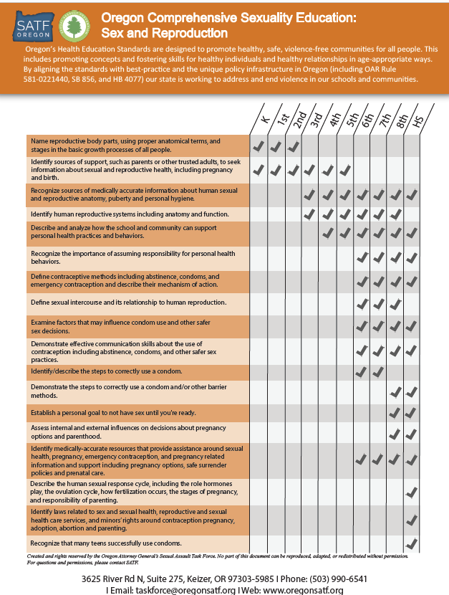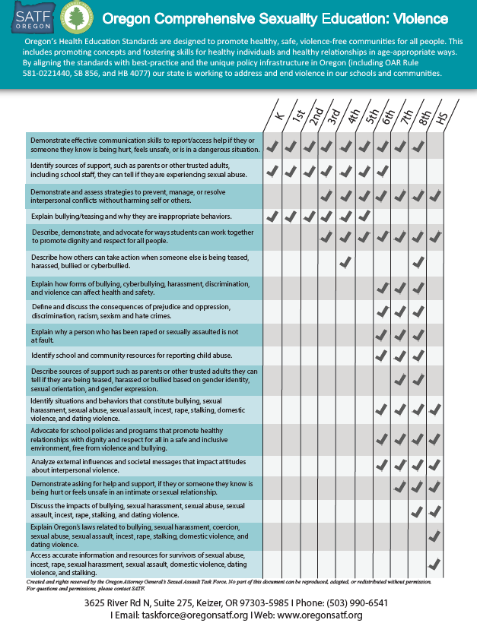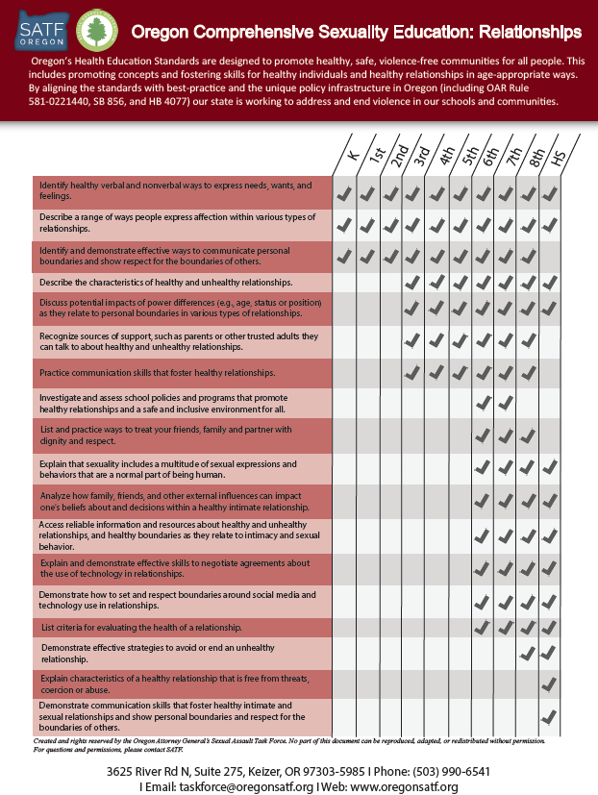
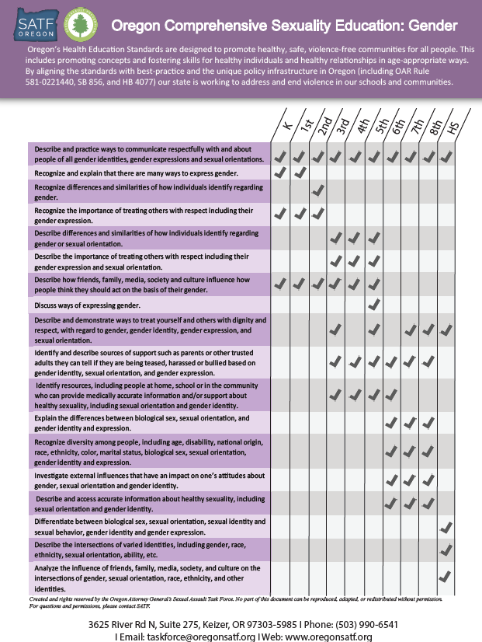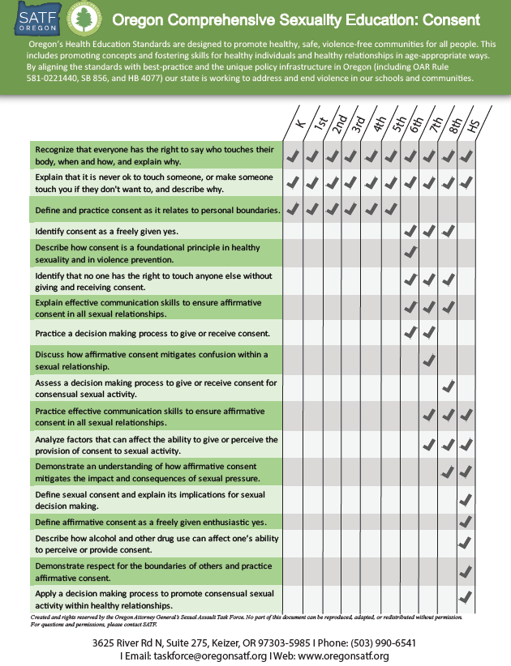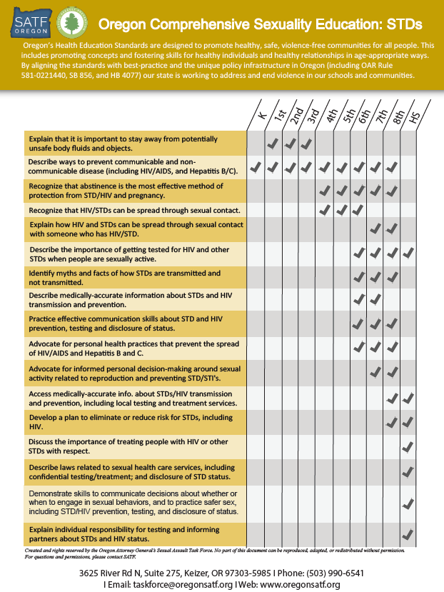

Endnotes

Merriam-Webster. Definition of culture. https://www.merriam-webster.com/dictionary/culture
American Sociological Association. https://www.asanet.org/topics/culture
Concept to Classroom. Inquiry-Based Learning. https://www.thirteen.org/edonline/concept2class/inquiry/index.html
Gov. of Western Australia. Department of Health. Question Box Set-Up. https://gdhr.wa.gov.au/guides/what-to-teach/question-box
The Education Alliance. Brown University. https://www.brown.edu/academics/education-alliance/teaching-diverse-learners/student-centered-instruction
The Hechinger Report. Oct. 23, 2018. https://hechingerreport.org/opinion-the-racial-disparities-in-our-schools-are-extreme/
United Nations Educational, Scientific and Cultural Organization (2016), http://www.unaids.org/sites/default/files/media_asset/ITGSE_en.pdf
https://www.ncbi.nlm.nih.gov/pmc/articles/PMC5495344/
Santelli, J., Kantor, L.M., Grilo, S. et al. Abstinence-only-until-marriage: An updated review of US policies and programs and their impact. J Adolesc Health. 2017; 61: 273–280 https://www.jahonline.org/article/S1054-139X(17)30297-5/fulltext
Guttmacher Institute, https://www.guttmacher.org/fact-sheet/facts-american-teens-sources-information-about-sex
Oregon Administrative Rule (OAR) 581-022-2050
www.futureofsexed.org/compsexed.html
https://www.oregon.gov/ode/educator-resources/standards/health/Pages/default.aspx
https://www.ode.state.or.us/superintendent/priorities/final-equity-lens-draft-adopted.pdf
Kirby, D. Rolleri, L.A, Wilson, M.M. Tools to assess characteristics of effective sex and STD/HIV Education Programs (TAC)
Multnomah County Health Department, The Sexual Health Equity for Individuals with Intellectual/Developmental Disabilities (SHEIDD) project, https://multco.us/school/sexual-health-youth-developmental-disabilities
Keyes DiGioia, Melissa. “Taking a Special Education Approach - UUA.org.” A Special Needs Approach — OWL, Unitarian Universalist Association, www.uua.org/sites/live-new.uua.org/files/owl_specialed.pdf.
Russell, Stephen T and Jessica N Fish. “Mental Health in Lesbian, Gay, Bisexual, and Transgender (LGBT) Youth” Annual review of clinical psychology vol. 12 (2016): 465-87.
European Society of Endocrinology. "Transgender brains are more like their desired gender from an early age." ScienceDaily. ScienceDaily, 24 May 2018, www.sciencedaily.com/releases/2018/05/180524112351.htm
Gender Identity Development in Children, Jason Rafferty. 9/18/2018. https://www.healthychildren.org/English/ages-stages/gradeschool/Pages/Gender-Identity-and-Gender-Confusion-In-Children.aspx
Implications of the Global Early Adolescent Study's Formative Research Findings for Action and for Research, Chandra-Mouli, Venkatraman et al. Journal of Adolescent Health, Volume 61, Issue 4 , S5 - S9, https://www.jahonline.org/action/showCitFormats?pii=S1054-139X%2817%2930358-0&doi=10.1016%2Fj.jadohealth.2017.07.012
Oregon Health Authority (2018). 2017 Oregon Healthy Teens Survey: 2017 OHT State Report February, 2018. Portland, OR. https://www.oregon.gov/oha/PH/BIRTHDEATHCERTIFICATES/SURVEYS/OREGONHEALTHYTEENS/Documents/2017/2017_OHT_State_Report.pdf
Russell, Stephen T., et al. “Chosen Name Use Is Linked to Reduced Depressive Symptoms, Suicidal Ideation, and Suicidal Behavior Among Transgender Youth.” Journal of Adolescent Health, vol. 63, no. 4, 30 Mar. 2018, pp. 503–505. Science Direct, doi:10.1016/j.jadohealth.2018.02.003.
Substance Abuse and Mental Health Services Administration. (2014). SAMHSA's Concept of Trauma and Guidance for a Trauma-Informed Approach. HHS Publication No. SMA 14-4884. Rockville, MD: Substance Abuse and Mental Health Services Administration.
Cardea, Guide to Trauma Informed Sex Ed http://www.cardeaservices.org/resourcecenter/guide-to-trauma-informed-sex-education
Ellis, Wendy, and Olga Acosta Price. “Student Trauma Is Widespread. Schools Don't Have to Go It Alone.” Education Week, 20 June 2018, www.edweek.org/ew/articles/2018/02/26/student-trauma-is-widespread-schools-dont-have-to-go-alone.html.
https://siecus.org/wp-content/uploads/2018/08/On-Our-Side-Public-Support-for-Sex-Ed-2018-Final.pdf
https://siecus.org/wp-content/uploads/2018/08/On-Our-Side-Public-Support-for-Sex-Ed-2018-Final.pdf
Hacker KA. Listening to youth: teen perspectives on pregnancy prevention. Journal of Adolescent Health 2000; 26(4): 279-88.
https://www.acf.hhs.gov/programs/opre/resource/synthesis-of-research-and-resources-to-support-at-risk-youth
Sexuality, Contraception, and the Media, The Council on Communications and Media, Pediatrics Sep 2010, 126 (3) 576-582; DOI: 10.1542/peds.2010-1544
Oregon Health Authority, Comprehensive Sexuality Education Assessment, 2012
https://www.ocadsv.org/
The Oregon Healthy Teens Survey, 2017, https://www.oregon.gov/oha/PH/BIRTHDEATHCERTIFICATES/SURVEYS/OREGONHEALTHYTEENS/Documents/2017/2017_OHT_State_Report.pdf
Family life Education Issues, published by Network Publications, Santa Cruz, CA. 1981 Family Life and Sexual Health, Special Education: Secondary F.L.A.S.H. Public Health–Seattle & King County, Family Planning Program, © 1986, revised 2006, www.kingcounty.gov/health/flash

