Restraint & Seclusion Incidents Collection Manual
May 2025
Oregon Department of Education
Office of Enhancing Student Opportunities
255 Capitol Street NE
Salem, OR 97310-0203

It is the policy of the State Board of Education and a priority of the Oregon Department of Education that there will be no discrimination or harassment on the grounds of race, color, religion, sex, marital status, sexual orientation, national origin, age or disability in any educational programs, activities or employment. Persons having questions about equal opportunity and nondiscrimination should contact the Deputy Superintendent of Public Instruction at the address above; phone 503-947-5740; or fax 503-378-4772.

Table of Contents
Table of Contents i
What’s New 1
May 2025 1
General Information 2
Introduction 3
Important dates 3
Contact List 3
Training & Materials 3
Listserv 4
Data Collection Contacts Information 4
Restraint & Seclusion OARs 6
ODE Help Desk & Data Security and Privacy Overview 7
Contact Information 7
Services 7
Help Desk vs. Data Team – who to call? 7
ODE Help Desk: What to Expect 7
Data Security and Privacy 8
Student Data Security: Handle With Care 8
ODE Policies 8
Information Security Questions 8
Navigating the Restraint & Seclusion Incidents Collection 9
Login Information 9
Reporting and Coding Records 11
File Upload 11
Web Submission 12
Serious Bodily Injury 15
Correcting Errors 16
Verification Process 17
Correcting Audits during the Review Window 21
Secure File Transfer 24
Frequently Asked Questions: Restraint and Seclusion Incidents Collection 28
Appendix 31
Restraint and Seclusion Incidents File Format 31

What’s New
This section outlines changes to the Restraint and Seclusion Incidents Collection for 2024-2025.

May 2025
- The Economically Disadvantaged Flag is now optional.
- SSID Core Field changes:
  - Data Element changes:
    - Rename American Indian Tribal Membership Code to Tribal Affiliation Code (TrbAfflnCd). This code indicates Tribal affiliation through self-identification, such as being enrolled in, a descendant of, or affiliated with, a tribe recognized by the federal government.
  - Language of Origin changes:
    - Add Dari (prs) code 6590
    - Add Krio (kri) code 7000
    - Update Pashto (pus), code 3720, to be Pashto/Pushto
    - Remove Aramaic (arc) code 0210

General Information
The Oregon Department of Education utilizes the following collections to obtain Restraint and Seclusion data:
Restraint and Seclusion Incidents Collection
The Restraint and Seclusion Incidents Collection is a student level collection. This collection ensures compliance with required annual reporting detailing the use of restraint and seclusion by public education programs. This manual provides an overview and guidance concerning the data to be reported. See OAR 581-021-0568 and OAR 581-022-2267.
Seclusion Rooms Collection
The Seclusion Rooms Collection is an institution level collection that provides a mechanism for reporting that compliance standards are met for the structural and physical requirements of rooms designated to be used for seclusion. This collection is detailed in the Seclusion Rooms Manual.
See OAR 581-022-2667(1)(f) and 581-021-0568
Restraint and Seclusion Technical Assistance
Training and other Technical Assistance for the use of Restraint and Seclusion is located on the School Discipline and Restraint & Seclusion webpage.

Introduction
The purpose of this document is to be an easy reference tool for individuals responsible for reporting data related to the Restraint and Seclusion Incidents Collection. If an error is located anywhere in this manual or if it does not provide the guidance necessary to answer a specific data collection question, please feel free to inform any of the staff on the Contact List. It is extremely important that data submitted for all collections are accurate, valid, and reliable.
Icon | Description
 | An information circle indicates an informational note.
 | A light bulb indicates a useful tip.
 | A warning triangle indicates a warning and the user should use caution.

Important dates
Regular Collection Opens 5/29/2025 Closes 7/11/2025
Review Window (Audit) Opens 8/21/2025 Closes 9/15/2025

Contact List
Lisa Joy Bateman Education Specialist (503) 569-2951 lisajoy.bateman@ode.oregon.gov
Jackie McKim Research Analyst (971) 240-0234 jackie.mckim@ode.oregon.gov
Cynthia Garton Research Analyst (503) 508-7492 cynthia.garton@ode.oregon.gov
Maxwell Swope Research Analyst (971) 208-0259 maxwell.swope@ode.oregon.gov
Amanda Claycomb Research Analyst (503) 931-8003 amanda.claycomb@ode.oregon.gov
Cara McMurry Research Analyst (503) 689-2783 cara.mcmurry@ode.oregon.gov

Training & Materials
Training and Other Technical Assistance for the use of Restraint and Seclusion located at the School Discipline and Restraint & Seclusion webpage.
The Collection manual, training video and PowerPoint presentation for the collection is located at the Collection page.

Listserv
Staff who submit and maintain Discipline data will be added to the Discipline and Restraint/Seclusion GovDelivery Listserv. If you should not be on this list or if you wish to be added to this list, please contact a staff member on the Contact List.

Data Collection Contacts Information
The Office of Enhancing Student Opportunities uses the IDEA Data Manager web application for maintaining various Listserv lists so ODE knows who to contact if we have any questions. It is important that each agency maintain the most up-to-date information in the IDEA Data Manager. It is the responsibility of each agency to update their agency contact information when there is a staff change.

Important - Please Read
Eight Rules for Submitting Timely & Accurate Data
- Keep your data up to date at all times. The more up to date the data, the less time it will take to prepare data for submission.
- Read all the instructions and documentation related to the data collection.
- Submit data as early as possible, but do not rush! Technology, weather, and other factors can suddenly keep a district from being able to submit data on the final day.
- Join the Special Education Data Submitters Listserv and read all messages carefully. To join, please contact a staff member.
- Train at least one backup person to submit, validate, and correct data for each data collection. Key people may get sick, injured, or leave without notice. Do not forget to have the district security administrator grant appropriate permissions to the backup staff member.
- Backup the data often to a secure location other than the hard drive (e.g. network drive or disk). Technological mishaps are sometimes unavoidable and frequently lead to loss of data.
- Make a plan. Use the Schedule of Due Dates to plan your data submission calendar.
- If you have questions, contact the data collection owner at the ODE as soon as possible. ODE data owners are here to help you.
Following these rules throughout the year will help reduce the risk of your district becoming late and/or inaccurate.

Restraint & Seclusion OARs
581‐021‐0550
Definitions: Restraint and Seclusion
581‐021‐0553
Use of Restraint and Seclusion in Public Education Programs
581‐021‐0556
Procedures Regarding Restraint and Seclusion
581‐021‐0563
Approval of Restraint and Seclusion Training Programs for School Staff
581‐021‐0566
Required Use of Approved Restraint and Seclusion Programs
581‐021‐0568
Standards for Seclusion Rooms
581‐021‐0569
Use of Seclusion Cells Prohibited
581‐021‐0570
Complaint Procedures
581‐015‐2181
Functional Behavioral Assessments
581‐022‐2267
Annual Report on Use of Restraint and Seclusion

ODE Help Desk & Data Security and Privacy Overview

Contact Information
ODE Helpdesk ODE.Helpdesk@ode.oregon.gov (503) 947-5715

Services
ODE Help Desk can

- Provide technical assistance with how to submit your data
- Check to see if your data has been submitted
- Provide assistance with questions about access rights and permissions
ODE Help Desk can not
- Submit your data for you
- Make changes to your data
- Answer content area questions

Help Desk vs. Data Team – who to call?
Question | Answer
How to report a student? | Data Team
Why won’t my data submit? | Data Team (will refer to the Help Desk if needed)
Audit/Error Corrections? | Data Team
How can I get a new user added? | ODE Help Desk

ODE Help Desk: What to Expect
The ODE Help Desk is at ODE.Helpdesk@ode.oregon.gov or (503) 947-5715

Data Security and Privacy

The student data that you collect, handle, and submit is protected student data governed by:
- Family Educational Rights and Privacy Act (FERPA) (34 CFR Part 99)
- Oregon Identity Theft Protection Act
- And in some cases, the Health Insurance Portability and Accountability Act (HIPAA), such as the transfer of records between agencies
Consequences: Loss of protected data can have financial impact to your school, district, or ESD, including fines and cost of remediation!

Student Data Security: Handle With Care
Basic tips to protect student level data:
- Use Secure File Transfer. Never send information that would identify an individual student via email, not even to the ODE Help Desk or a member of the Data Team. Emails sent to and from the ODE are considered public record.
  - In order to provide information to ODE, it is advisable to send only the student’s SSID number.
  - Never send students’ name, birth date, telephone number, grade or anything else that could be used to identify a specific student.
  - On ODE’s Secure File Transfer users can send secure documents to ODE Staff.
- Never share your username and password
  - You are responsible for everything done in the system using your username and password
  - Avoid storing your password in an obvious place (desk drawers, under keyboards, sticky notes on monitors are all bad places to store passwords)
- Use a Passphrase instead of a Password
  - Passphrases are sentences you can remember and include spaces and punctuation.
  - Example: Trust the force, Luke!
  - Example: Scotty, beam us up.
- Lock your computer monitor (Window key +L) when you leave your desk
  - Avoid leaving your monitor open and unattended
- Never store or transport student data on an unencrypted thumb drive/flash drive
  - Portable drives are one of the biggest risk factors for losing large volumes of data
The privacy and security of student data depends upon you.
People are the most important part of information security

ODE Policies
Handling Confidential Information
Information Asset Classification

Information Security Questions
Contact ODE Chief Information Security Officer and Team at ODE.Infosec@ode.oregon.gov.

Navigating the Restraint & Seclusion Incidents Collection
The Restraint and Seclusion Incidents data collection opens May 29, 2025 and closes July 11, 2025. The review window for the collection opens August 21, 2025 and closes September 15, 2025. The review window is the period during which corrections can be made to the data submission.

Login Information
Access your applications list from the ODE District site at https://odedistrict.oregon.gov/Pages/default.aspx. Select the button labeled Central Login Application.
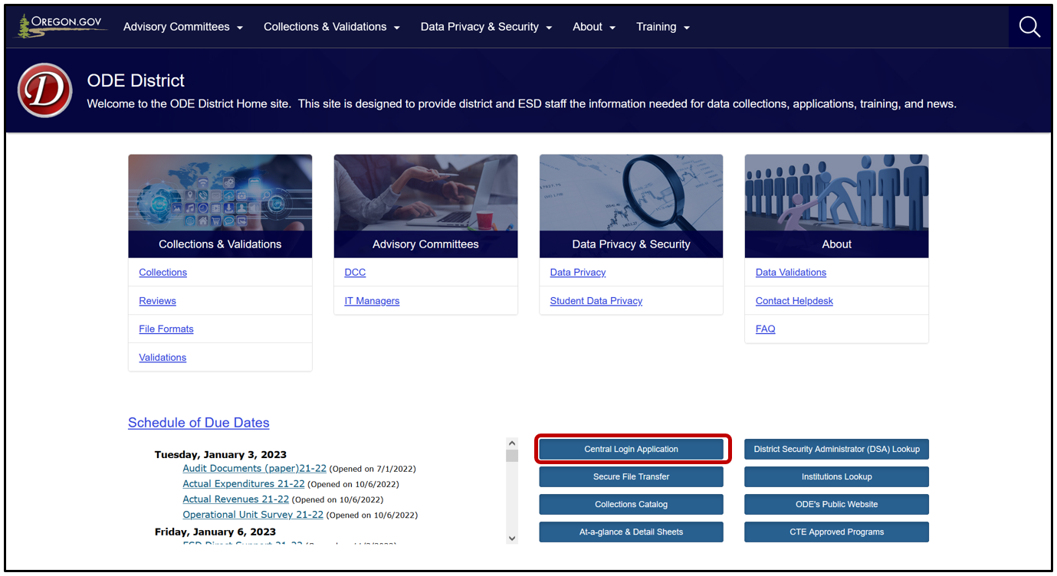
Logging in takes Users to their Applications List, (yours might appear differently). Users must only log in as the School District, ESD or EI/ECSE to report records. Do not use a school to report records. Select the School District, ESD or EI/ECSE in the Application List, e.g., “Consolidated Collections – School District.”
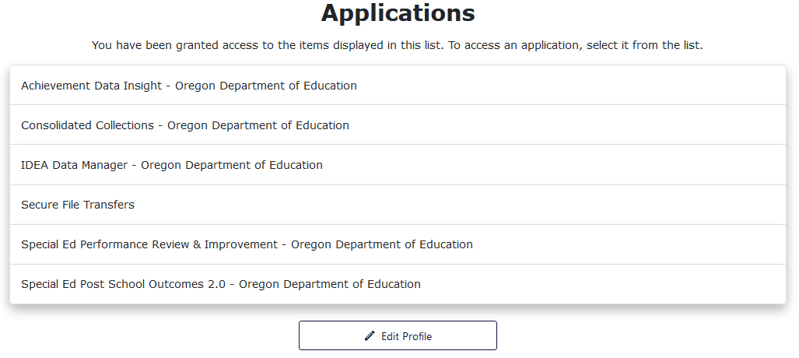
From the Applications list, click on Consolidated Collections.
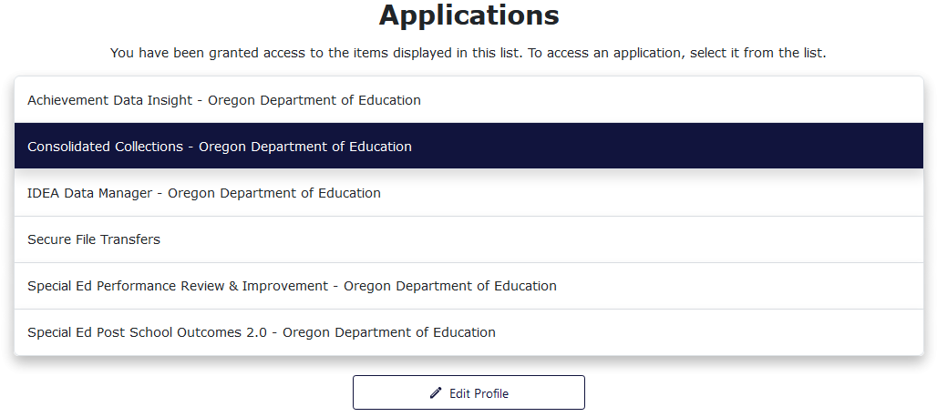
Users should see a screen that looks similar to this:
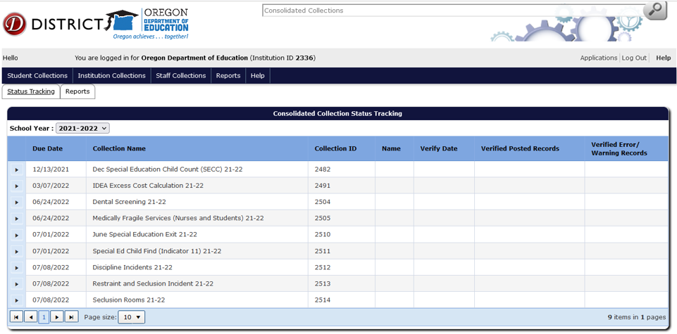
The list of collections users see will depend on the collections they have permissions to view and/or modify. If a user does not see the specific collection for which they are submitting data, they will need to contact their District Security Administrator for Modify permissions and Submitter permissions.
Below is an overview of the process for submitting records for the Restraint and Seclusion Incidents Collection. For detailed instructions on how to navigate Consolidated Collections, see the OESO Consolidated Collections User Guide. Note that each collection will display the applicable collection year in the title.

Reporting and Coding Records
Restraint/Seclusion Incidents data need to be submitted by all districts, including those with no incidents to report. Restraint/Seclusion Incidents need to be reported for all students, not only those on IEPs.
Reminder: Use the School District, ESD, or EI/ECSE login to report records. To submit data, hover your mouse over Student Collections. A drop menu will appear, containing a list of open collections. When ready to submit, hover over the collection name, in this case, Restraint and Seclusion Incidents. A fly-out menu will appear with two options: File Upload and Web Submission.
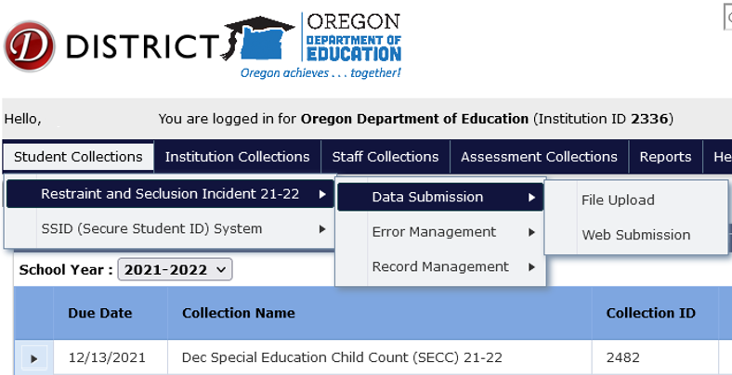

File Upload
The File Upload menu option takes you to an upload screen. Click on Browse (may look different depending on browser) to locate the file containing Restraint and Seclusion Incidents records. The file can be in .CSV or .XML format. After selecting the file, click Upload.
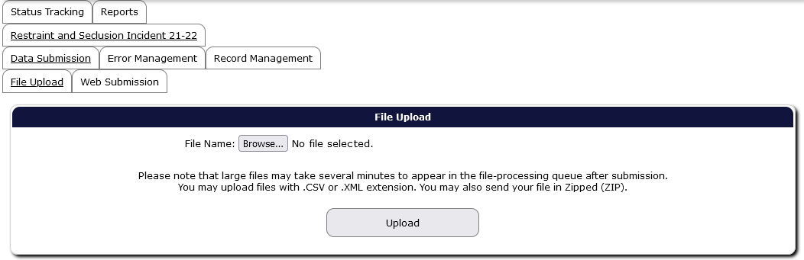
A File Upload dialog box will appear. Select the submission file and then click the Open button. Finally, click the Upload button in the File Upload screen to submit the file to ODE. If the upload is successful, the screen will display information boxes with information on the file and processing status. Consolidated Collections will notify users by email when the validation processing is complete.
Note: users are not finished submitting data to ODE until all errors are corrected AND the verification reports have been verified. Please see the sections Correcting Errors and Verification Process.

Web Submission
The Web Submission menu takes you to a search screen. Search for a student using one of the options to search by SSID, Last Name, etc. and then click Search.
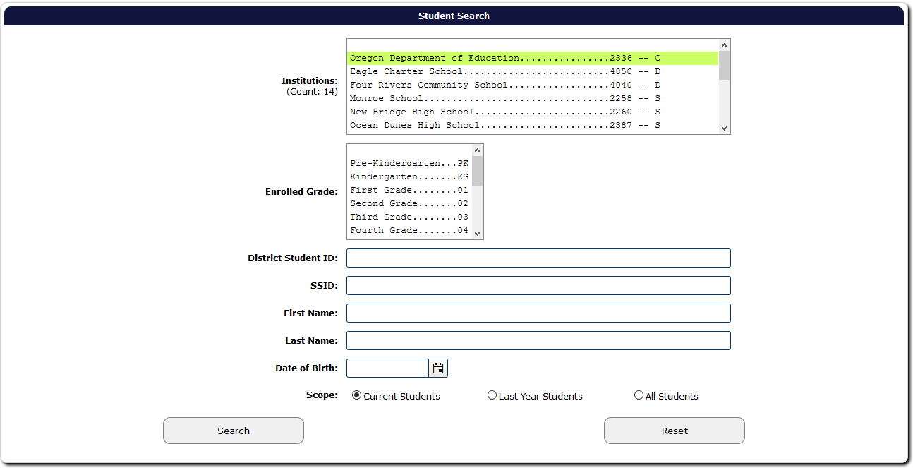
After clicking Search, the application will generate a list of student(s) that meet the search criteria. Click the green checkmark to open the student record.
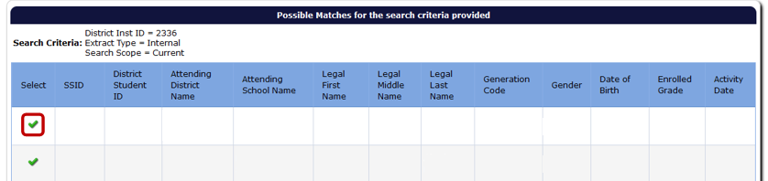
The application will open a data entry screen for the selected student. The top half of the screen contains fields for the Restraint and Seclusion Incidents collection. The bottom of the screen are core fields, such as the student’s personal, demographic, and program data. Required fields are indicated with a red asterisk.
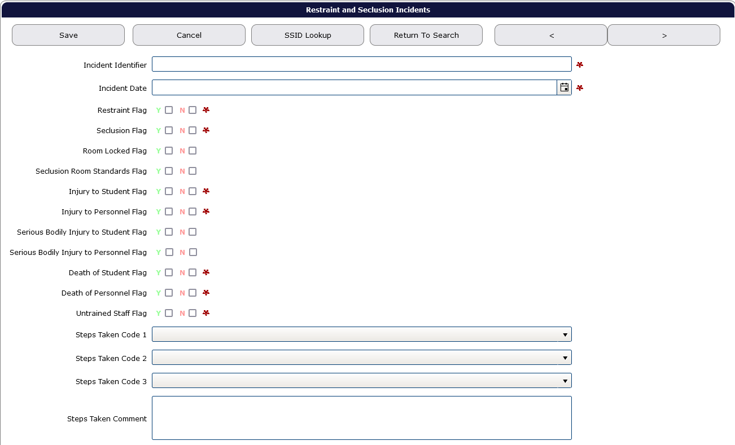

Restraint and Seclusion Fields
Incident Identifier (required)
This is an alphanumeric code of the district’s choosing that is unique and assigned exclusively to this incident. Example: Identifier could start with the school’s Institution ID number, followed by a space, followed by a number beginning with 1.
Incident Date (required)
This is the date the incident occurred and can be typed in MM/DD/YYYY format or chosen from a calendar using the calendar icon to the right of the field. “MM” is the two-digit month, “DD” is the two-digit date of the month and “YYYY” is the four-digit year.
Restraint Flag (required)
Indicates whether the incident involved restraint of the student or not. Y for Yes and N for No.
Seclusion Flag (required)
Indicates whether the incident involved seclusion of the student or not. Y for Yes and N for No.
If the Seclusion Flag is Y, the following fields require a response:
Room Locked Flag will indicate whether the seclusion occurred in a locked room. Seclusion in a locked room is illegal. For reporting purposes, a locked room is defined as one where the door has a physical lock, latch, or bolt that prevents exit. Locked rooms do not require human interaction to keep it secured (e.g., controlled by a physical key or a key code). Rooms that require human action to maintain closure, such as doors with magnetic or other release mechanisms that necessitate a person to maintain lock engagement, are not considered "locked rooms" for reporting purposes.
Seclusion Room Standards Flag
Indicates the room that a seclusion occurred in meets all standards for seclusion rooms as per OAR 581-021-0568. Choose Y to indicate the seclusion occurred in a standard room or choose N to indicate that the seclusion occurred in a non-standard room.
Injury to Student Flag
Flag indicating that the use of restraint or seclusion resulted in injury of a student.
Injury to Personnel Flag
Flag indicating that the use of restraint or seclusion resulted in injury of a staff member.
Serious Bodily Injury to Student Flag
Flag indicating that the use of restraint or seclusion resulted in the reported serious bodily injury of a student. This flag is a modifier of the Injury to Student Flag.
Serious Bodily Injury to Personnel Flag
Flag indicating that the use of restraint or seclusion resulted in the reported serious bodily injury of a staff member. This flag is a modifier of the Injury to Personnel Flag.
Death of Student Flag
Flag indicating that the use of restraint or seclusion resulted in the death of a student.
Death of Personnel Flag
Flag indicating that the use of restraint or seclusion resulted in the death of a staff member.
Untrained Staff Flag (required)
Indicates whether the staff member(s) involved were trained in an ODE approved training program or not. Y for untrained staff member(s) involved and N for only trained staff member(s) involved. The district or program must select from an ODE approved training program list. See OAR 581-021-0563.
Steps Taken fields
These three drop-down menus allow the user to select from a list of steps taken by the public education program to decrease the use of restraint and seclusion for each student that was placed in restraint or seclusion more than 10 times in the course of a school year.
Steps Taken Comment field
Allows the user to indicate steps taken that are noted as “other” or not included as drop-down menu selection options.
When completed, remember to click one of the Save buttons, located at the top and bottom of the page.

Serious Bodily Injury
Because the Serious Bodily Injury Flags modifies the Injury flags:
- If a student or staff is reported as having an injury, but not a Serious Bodily Injury, then the Injury to Student/Personnel Flag is Yes, then the Serious Bodily Injury to Student/Personnel Flag is No.
- If there is a Serious Bodily Injury to the student or staff, then both Student/Staff Flag is Yes and Serious Bodily Injury to Student/Personnel Flag is Yes.
- If multiple staff involved in a restraint/seclusion incident are injured, where there is an injury to a staff and a Serious Bodily Injury to another staff member, then both Student/Staff Flag is Yes and Serious Bodily Injury to Student/Personnel Flag is Yes.
- Please remember that Serious Bodily Injury to both students and staff have additional 24 hours reporting requirements under SB 1024 (2023).

Correcting Errors
Once all data has been loaded, the next step is to correct errors. To view and correct errors, hover your mouse over Student Collections in the top menu bar. From the drop menu, hover over Restraint and Seclusion Incidents, then from the fly out menu, hover over Error Management, and then click on Review Errors.
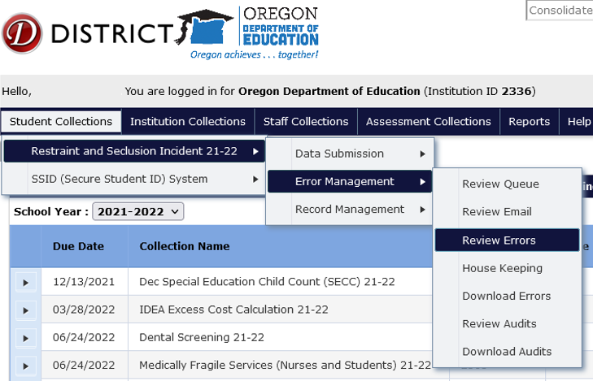
The Error Screen shows a list of errors by type, count and description. The Error Count is the number of records with the Error Type. Click the triangle expand button, in the row of the Error Type you wish to correct, which expands to show the records with that type of error.
This expanded screen contains a table with demographic information, a green check mark to access the record, a red “x” to delete the record, the values causing the error, and the column names for these values.
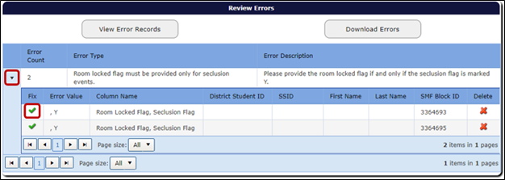
Clicking the green check mark will open the record. The top of the record will display each validation error for the record. Consolidated Collections puts a red outline around the field that contains a validation error. If there is more than one validation error, each field that is in error will be outlined in red.
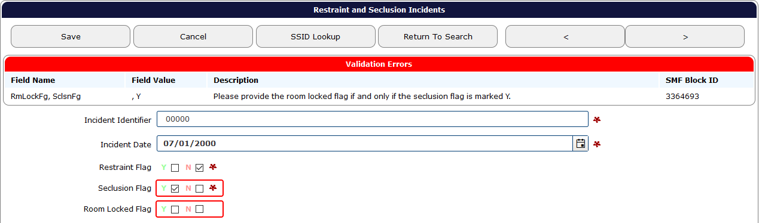
After fixing each error, click the Save button, located at the top and bottom of the record, which will clear the error. After clicking Save, the system will produce a green “Record Saved” message. The system will revalidate the entire record, to check for any further errors.
If there is more than one error in the Error Type, the system will keep the Error Type expanded. Once all errors are fixed, the record will post to Record Management.

Verification Process
The final step is verifying the submission. ODE cannot consider the collection complete until the submitting district verifies it as complete. All districts (even districts with no restraint/seclusion incidents for the 2024-2025 school year) are required to complete the verification process on the Status Tracking tab. Reminder: this action must be completed under the School District, ESD, or IE/ECSE login as the agency accountable for ensuring accurate data submission.
From anywhere in the Consolidated Collections application, click the Status Tracking tab to go to the list of collections. Make sure the School Year dropdown displays the correct school year. This dropdown will automatically advance to the next school year on July 1. If the 2024-2025 collection closes on July 11 and is verified after June 30, 2025, when users arrive at the Status Tracking page, the dropdown will show 2025-2026 and all the collection names on will end with “25-26.” Use the School Year drop menu to change the collection year to 2024-2025. The example below uses 2023-2024 collections.
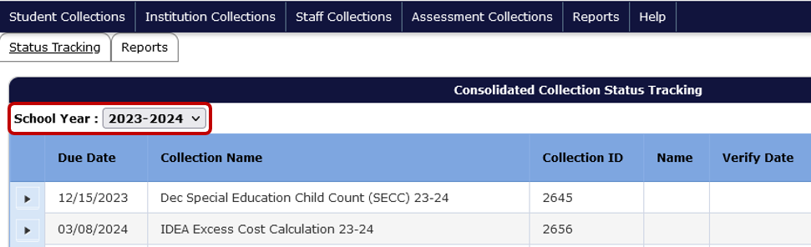
Click the black expand arrow next to the Restraint and Seclusion Incidents collection to access the Verification Reports.
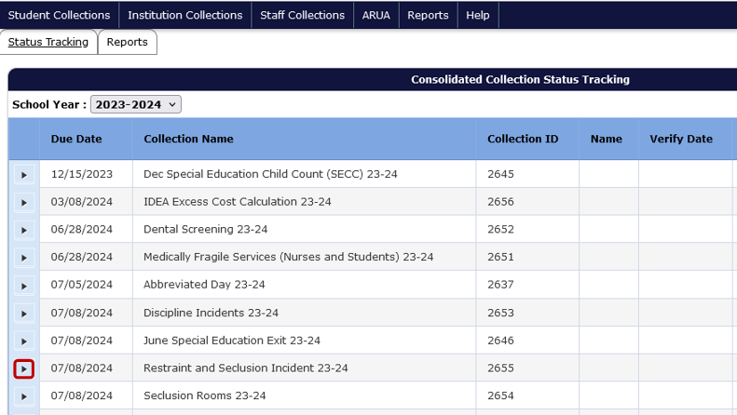If all errors have not been cleared, the below message will appear. See Correcting Errors before continuing.
Similarly, if all audits have not been cleared, the below message will appear. See Correcting Audits during the Review Window before continuing.
Each collection has different verification reports. Each report displays aggregated data in tables.
- Restrained/Secluded Verification
- Gender Verification
- Demographic Verification
- Race/Ethnicity Verification
- Incidents Verification
- Injury or Death Verification
After clicking on the black expand arrow next to the collection, users will see the following screen. Clicking the checkboxes next to each verification report displays the data tables to be reviewed and verified by the user. The red “X” in the Current Status column indicates the report has not been verified. Review each verification report to ensure the count of records is correct.
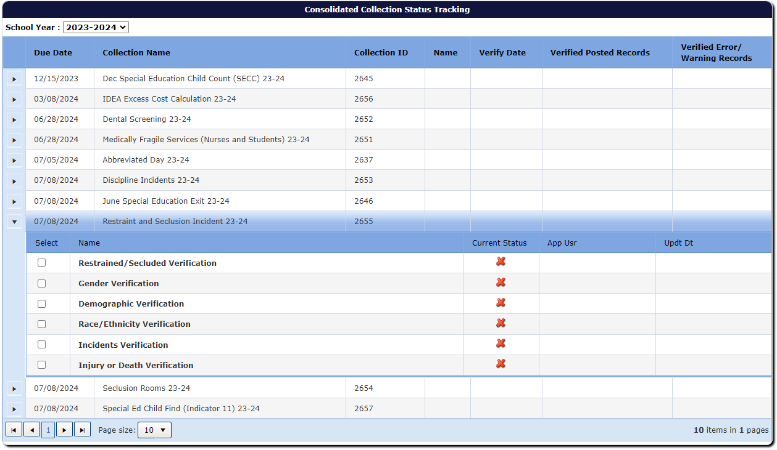
After selecting the checkbox, the screen will display the aggregated data with options for approving the report and exporting the data to Excel. Next, click the Approve Report button. Users verify each report one at a time.
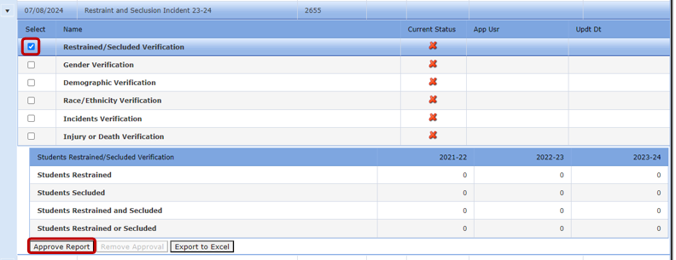
Once the user clicks Approve Report, the approved report’s status changes from the red “X” to a green checkmark and gives users the option of removing the approval. Removing the approval changes the green checkmark back to a red “X.”
As users verify, the system adds the user’s name and date of verification in the row for each report. The system also displays the user’s name and date in the row for the collection name, but there is a delay and it may display after the second report. Warning: system will display name and time in the collection name row, even when not all reports are verified.
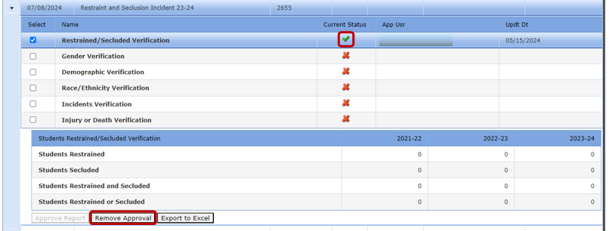Continue through the list of reports until all Verification Reports are approved.

Correcting Audits during the Review Window
Audits are messages from ODE concerning the data. The Review Window opens August 21, 2025 and closes September 15, 2025. To review and address audits, and to make corrections during the review window, log into the ODE District site as before and hover over Student Collections drop menu, then hover over Review: Discipline Incidents 24-25, then from the fly out menu hover over Error Management, and then click on Review Audits. The example below uses Discipline Incidents 21-22.
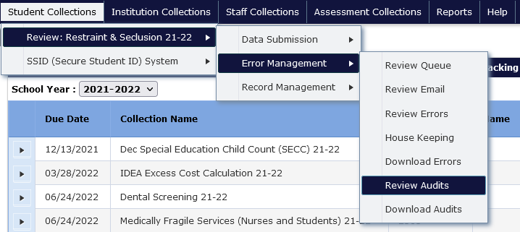
Like the Review Errors screen, the Audit Screen shows a list of audits by type the count of each type, and an audit description, if there are any audits for your district. The Audit Count is the number of records that have that respective audit type. Audit Type indicates the type of potential error. Audit Description provides a broad description of the audit. A student’s record may have multiple audits and appear under more than one audit type.
To access and audit, click the triangle expand button, in the row of the Audit Type you wish to correct, which expands to show the records with that type of audit.
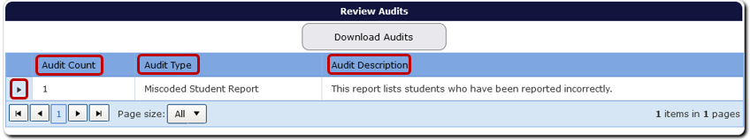
This expanded audit detail screen contains a table with student demographic information, audit comment, a green check mark to access the record, and a red “x” to delete the record.
In audit details, the Comment is a message from ODE staff, indicating why the record is flagged as an error or warning. If the record needs a correction, click on the green check mark under the Fix column. This will allow users to review the record.
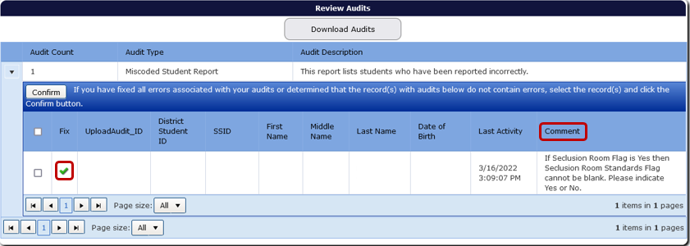
Once corrected, click the Save and Confirm button. This will save the corrections, and the system will remove the record from the audit list. The Last Activity column will reflect the date and time the last change was made.
The Cancel button will undo any changes made to the record. The Return to Search takes the user back to the audit list, with the respective Audit Type expanded.
If the audit description is unclear, contact an ODE staff member.
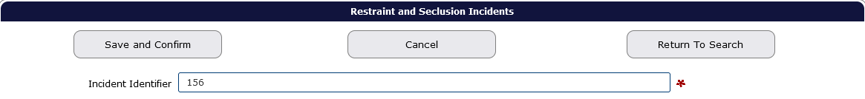
If the record is correct, users can confirm the record by clicking the Save and Confirm button while in the record. Or, if on the Audit List page, users can click on the box for the record, to the left of the Fix column, and then click the Confirm button. Users should not confirm any record(s) until they are sure it is not an error. When users Confirm a record, it disappears from the audit report permanently.
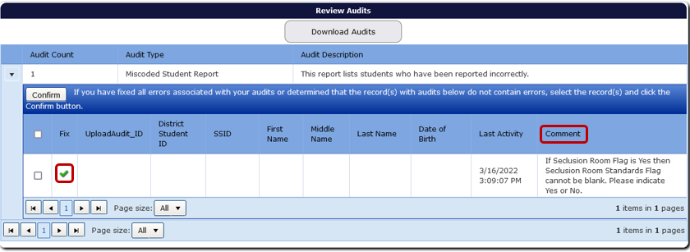
Users can also confirm all audits for the Audit Type, by clicking on the Select All box next to the Fix column, and then clicking the Confirm button. Do not Save and Confirm any records until you are sure there are no errors. When records are confirmed, they will disappear from the report.
If the audit comment is unclear or the user is unsure how to resolve it, please contact an ODE staff member for assistance. It is best not to confirm an audit if the user is unsure what it is. If the audit is regarding an error, this could lead to inaccurate data.

Secure File Transfer
To send personally identifiable information to ODE staff, use Secure File Transfer. Go to the District Home page, and in the center right-hand side beneath Applications, select Secure File Transfer.
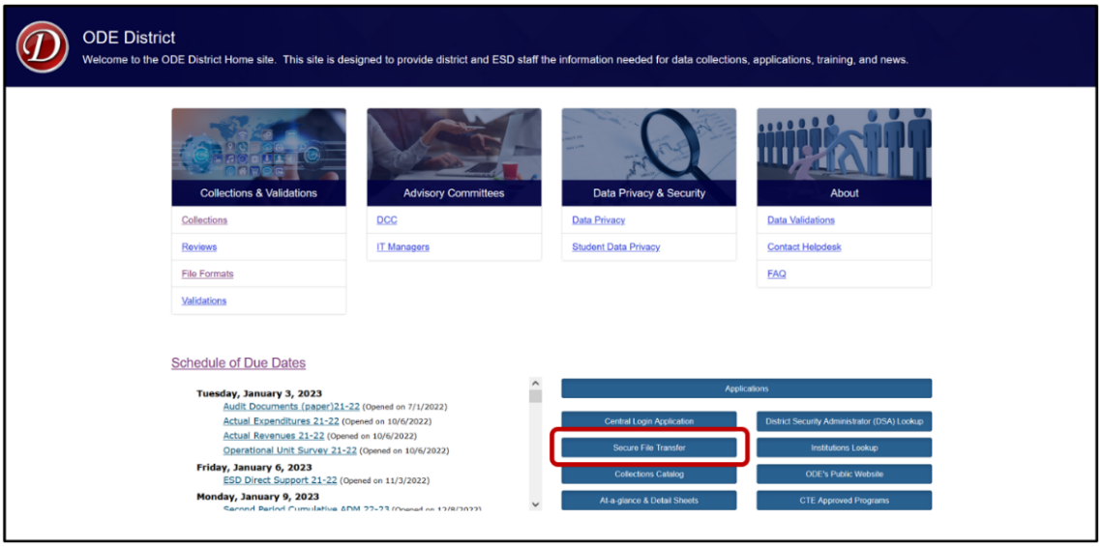
Secure File Transfer is behind a secure log in. The system will open a new tab to the Central Login page. Login to the District website by entering your User Name and Password, then press enter or click on the Login button.
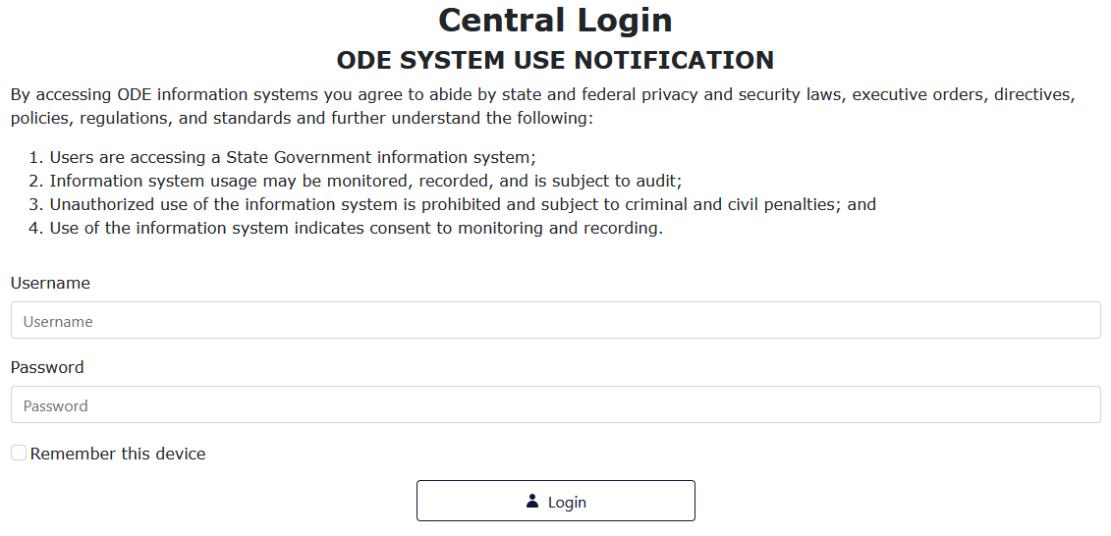

After signing in, users will be taken to their Applications List. Select Secure File Transfer.
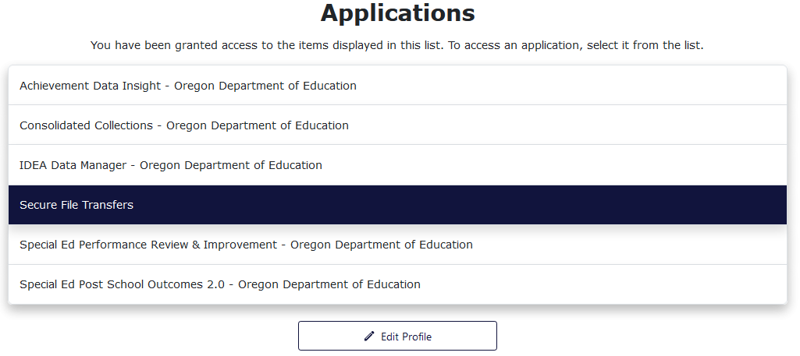
On the Secure File Transfer page, type the recipient’s email address. Click the To button to search the list of recipients. To select an email to add to the recipient list, click on the name or email address, then click Add Email.
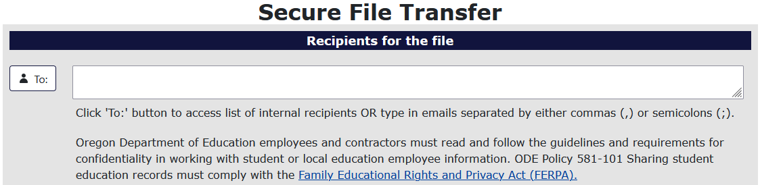To add the file to be sent, select the Select File button.
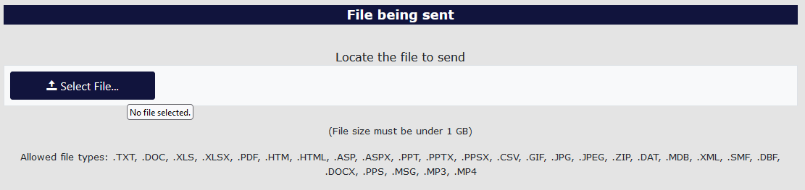
Find the desired file and select it. To select the file there are two methods. For the first method, users select the desired file, and then select the Open button in the window. For the second method, users double click the desired file.
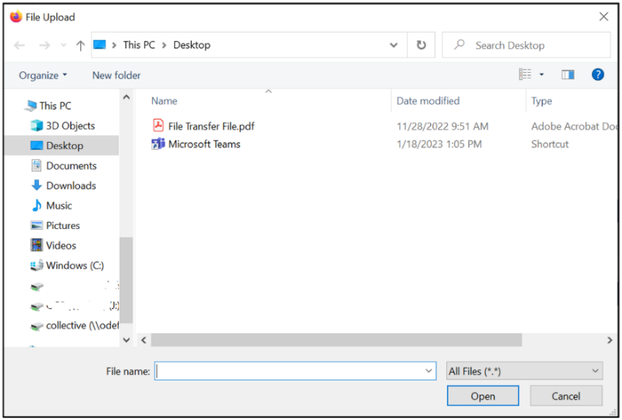
Users can type a message at the bottom of the page to add context and or anything else necessary for the recipients to know. This section is best thought of as the body of an email.
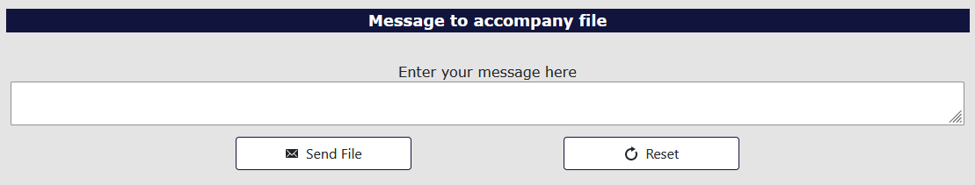
Finally, to send the file, select the Send File button.
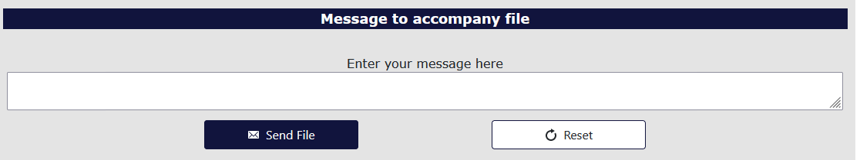
The recipient will receive an email with a web link. This link will take the recipient to a Secure File Transfer page on the ODE District website. They will enter their email address, the same address the user selected, and click the Submit Email Address button. The page will generate a Download button for the recipient to click, which downloads a zip file of the document the user sent.
If the recipient does not have a Central Login account, use the Link to external users section at the bottom of the screen.
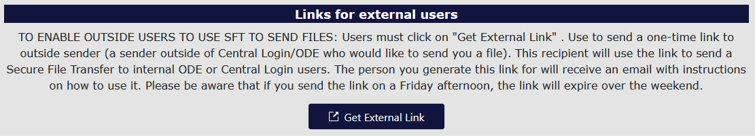
The system will generate a popup for users to enter the external repent email and message. Click the Generate External Link to send the secure file.
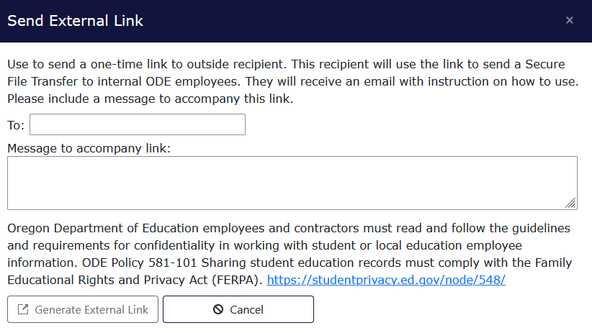

Frequently Asked Questions: Restraint and Seclusion Incidents Collection
Q: How do I log into the district site?
A: Visit the ODE’s District webpage. Your site security administrator must give you permissions to access individual ODE Collections.
Q: Where do I find the Restraint and Seclusion Incidents Collection once I have logged into the site?
A: From the Application List, select Consolidated Collections, then the Student Collections drop menu. When the collection and review windows are open, Restraint and Seclusion Incidents will appear in the drop menu.
Q: Where do I find the User Guide document for the Consolidated Collections?
A: See the Consolidated Collections Student-Level Collections User Guide⁷ at the District website, or the ESO Consolidated Collections User Guide.
Q: What is the best way to submit data for my district?
A: Smaller schools and districts may want to submit the data through the ODE’s web submission process which allows submitters to enter each student record. Larger schools and districts will likely prefer to use the file upload process.
Q: How do I submit online through the web submission process?
A: Please see the section on Web Submission for information on submitting one record at a time for this collection.
Q: How do I upload files to the ODE for the Restraint and Seclusion Incidents Collection?
A: Please see the section on File Upload for information on uploading files to the collection.
Q: How can I see the successfully submitted records?
A: Go into the Restraint and Seclusion Incidents Collection and follow the steps below to view or print your current restraint and seclusion records.
- Hover over Student Collections, then Restraint and Seclusion Incidents 24-25
- Hover over Record Management, then click on Record Maintenance
- Leave the search parameter fields blank and click the Search button. The institutions field is defaulted to the submitting agency.
- Consolidated Collections will generate a list of all records submitted.
Q: What are Demographic Errors?
A: Demographic errors occur when a student record has three or more mismatches compared to the student’s record in SSID. In the record’s error screen, the fields in error will have a red outline. The Validation Errors message at the top of the record will display the fields in error in the Field Name column, as well as the incorrect value plus the SSID values in the Field Value column.
Q: What do I do when I receive an error that indicates a student is merged to another SSID?
A: The cause of this error is one student with two SSIDs. To fix this error, please work with district staff that works with the SSID system.
Q: How do I do a Production Download?
A: From Consolidated Collections, click the Reports tab, located next to the Status Tracking tab
- In the Collection column, click on Restraint and Seclusion Incidents.
- In the Report Year column, click on the applicable collection year.
- In the Report Column, select Production Download Report.
- The system will generate an email to your email address, which contains a secure file link.
  - On the generated web page enter your email address and the page will generate a Download icon.
  - Click the icon to access the Production Download Report file.
Q: Will I need to enter data for a student who does not have an IEP?
A: Yes. You must enter Restraint and Seclusion information for all students. This includes students with and without IEPs.
Q: Do I need to enter data about a student’s disability?
A: Please use the special education flag to indicate whether the student was participating in an Individualized Education Plan (IEP/IFSP) on the incident date. Primary disability information is not a data element.
Q: Will the system allow me to indicate if both restraint and seclusion are involved in a single incident?
A: Yes. For each incident entered, the user is able to use two different flags within the record to indicate if the incident involved either restraint, seclusion or both.
Q: If a student is restrained multiple times within a close time period, is this documented and counted as one incident?
A: Incidents close in time separated by periods of de-escalation must be counted individually.
Q: What is the Steps Taken Code?
A: The Steps Taken Code is used to indicate the steps taken to decrease the use of restraint and seclusion for students restrained and secluded more than 10 times during the school year. OAR 581-022-2267 requires reporting of what steps have been taken by the public education program to decrease the use of restraint and seclusion for each student who was placed in restraint or seclusion more than 10 times. For example, if a student is restrained eight times and secluded two times, for a total of 10 times, then Steps Taken is required.
Q: What is the Seclusion Room Standards Flag?
A: Flag indicating the room that a seclusion occurred in meets all standards for seclusion rooms as per OAR 581-021-0568. Choose Y to indicate the seclusion occurred in a standard room or choose N to indicate that the seclusion occurred in a non-standard room.
Q: When is the best time to complete my Restraint and Seclusion Incidents data report and submit it to the ODE?
A: Agencies are required to have all Restraint and Seclusion Incidents data reported to ODE by 11:59 p.m. on July 11, 2025. Agencies are encouraged to start the reporting process when the collection opens on May 29, 2025 in order to correct any errors and verify that the data is correct before the collection closes. Please do not delay in starting the reporting process as this could result in inaccurate and untimely data submission.
Q: My district has no restraint and seclusion incidents to report. Do I need to complete a report?
A: Yes. All districts must complete the Restraint and Seclusion Incidents Data Collection. The Restraint and Seclusion Incidents Data Collection system has a verify button on the Consolidated Collection Status Tracking home page that all districts must use to validate their submitted data. Agencies can use the Verify button to indicate zero incidents to report.
Q: Are there reporting requirements pertaining to restraint and seclusion in addition to the ODE state collection?
A: Yes. OAR 581-022-2667(2)(a) requires each entity that has jurisdiction over a public education program to make its annual report about restraint and seclusion available in the following ways:
- To the public at the entity's main office and the website of the entity;
- The school board or governing body overseeing the entity;
- If the entity is an education service district, the component school districts of the education service district; and if the entity is a public charter school, the sponsor of the public charter school.
- Parents and guardians of students in a public education program shall be advised at least once each school year about how to access the report.
Exception: Entities can suppress counts published in their annual reports to safeguard student confidentiality (see FERPA). Suppression rules for data are usually outlined in each agency’s policies.
Q: What are the additional reporting requirements pertaining to death or Serious Bodily Injury related to restraint and seclusion in addition to the ODE state collection?
A: Serious Bodily Injury or Death of a Student
If serious bodily injury or death of a student occurs in relation to the use of restraint or seclusion, oral notification of the incident must be provided immediately to a parent or guardian of the student and to the Department of Human Services. Required written notification of the incident must be provided within 24 hours of the incident to the Department of Human Services.
Serious Bodily Injury or Death of Personnel
If serious bodily injury or death of personnel of a public education program occurs in relation to the use of restraint or seclusion, written notification of the incident must be provided within 24 hours of the incident to the district superintendent, to the Superintendent of Public Instruction and, if applicable, to the union representative for the affected party. The 24-hour reporting portal to the Superintendent of Public Instruction is located on the collection page.
Q: I need access to the collection, how do I contact my District Security Administrator?
A: If you do not know who your District Security Administrator is, go to the District Home page, on the right-hand side beneath the applications button, and select District Security Administrator (DSA) Lookup. On the Search for Security Administrator page, enter an institution ID or District Name, then click the Search button.

Appendix

Restraint and Seclusion Incidents File Format

Row | Column | Field Name | Data Element Name | Width | Data Type | Zero Padded | Required | Data Element Description
1 | A | ChkDigitStdntID | Secure Student Identifier (SSID) | 10 | int | Y | Y | ODE assigned Secure Student Identifier (SSID) with a trailing check digit.
2 | B | DistStdntID | District/Local Student Identifier | 10 | varchar | N | N | Identifier, assigned by the district, used to uniquely identify the student.
3 | C | ResdDistInstID | Resident District Institution Identifier | 10 | int | Y | Y | ODE assigned Institution Identifier for the Resident District. The District responsible for the education of the student and also is the basis on which the State School Fund, the Common School Fund, and the County School Fund are distributed to local districts. Special provisions apply as defined in ORS 339.133, 338.155(1), and 338.165.
4 | D | ResdSchlInstID | Resident School Institution Identifier | 10 | int | Y | Y | ODE assigned Institution Identifier for the Resident School. The School responsible for the education of the student and also is the basis on which the State School Fund, the Common School Fund, and the County School Fund are distributed to local districts. Special provisions apply as defined in ORS 339.133, 338.155(1), and 338.165.
5 | E | AttndDistInstID | Attending District Institution Identifier | 10 | int | Y | Y | ODE assigned Institution Identifier for the Attending District. The District where the student is receiving instruction and where state assessments are administered.
6 | F | AttndSchlInstID | Attending School Institution Identifier | 10 | int | Y | Y | ODE assigned Institution Identifier for the Attending School. The School where the student is receiving instruction and where state assessments are administered.
7 | G | InstFill | Institution Filler | 20 | varchar | N | N | Reserved for future use.
8 | H | LglLNm | Legal Last Name | 50 | varchar | N | Y | Legal last name of the student.
9 | I | LglFNm | Legal First Name | 40 | varchar | N | Y | Legal first name of the student.
10 | J | LglMNm | Legal Middle Name | 40 | varchar | N | N | Legal middle name of the student.
11 | K | GnrtnCd | Generation Code | 4 | varchar | N | N | Name suffix of the student (i.e. Jr., II, III).
12 | L | PrfrdLNm | Preferred Last Name | 50 | varchar | N | N | Preferred last name of the student.
13 | M | PrfrdFNm | Preferred First Name | 40 | varchar | N | N | Preferred first name of the student.
14 | N | PrfrdMNm | Preferred Middle Name | 40 | varchar | N | N | Preferred middle name of the student.
15 | O | BirthDtTxt | Date of Birth | 8 | datetime | Y | Y | Date the student was born.
16 | P | GndrCd | Gender Code | 1 | char | N | Y | Code indicating the gender of the student.
17 | Q | HispEthnicFg | Hispanic/Latino Ethnic Flag | 1 | char | N | Y | Indicates a student of Cuban, Mexican, Puerto Rican, South or Central American, or other Spanish culture or origin, regardless of race. The term, “Spanish origin,” can be used in addition to “Hispanic or Latino.”
18 | R | AmerIndianAlsknNtvRaceFg | American Indian/Alaskan Native Race Flag | 1 | char | N | Y | Indicates a student having origins in any of the original peoples of North and South America (including Central America), and who maintains tribal affiliation or community attachment.
19 | S | AsianRaceFg | Asian Race Flag | 1 | char | N | Y | Indicates a student having origins in any of the original peoples of the Far East, Southeast Asia, or the Indian subcontinent including, for example, Cambodia, China, India, Japan, Korea, Malaysia, Pakistan, the Philippine Islands, Thailand, and Vietnam.
20 | T | BlackRaceFg | African American Race Flag | 1 | char | N | Y | Indicates a student having origins in any of the black racial groups of Africa.
21 | U | WhiteRaceFg | White Race Flag | 1 | char | N | Y | Indicates a student having origins in any of the original peoples of Europe, the Middle East, or North Africa.
22 | V | PacIslndrRaceFg | Native Hawaiian/Other Pacific Islander Race Flag | 1 | char | N | Y | Indicates a student having origins in any of the original peoples of Hawaii, Guam, Samoa, or other Pacific Islands.
23 | W | RaceFill | Race Filler | 1 | char | N | N | Reserved for future use.
24 | X | LangOrgnCd | Language of Origin Code | 4 | varchar | Y | Y | Code indicating the first language spoken in an individual's home in their early or earliest childhood. One's first language or native language.
25 | Y | SSN | Partial Social Security Number | 4 | varchar | Y | N | Last four (4) digits of the Social Security Number of the student.
26 | Z | EnrlGrdCd | Enrolled Grade Code | 2 | char | Y | Y | Code indicating the enrolled grade level of the student; or a grade level assigned to an ungraded student based on student age.
27 | AA | Addr | Street Address | 45 | varchar | N | Y | Street Address of the student's primary residence.
28 | AB | City | City | 20 | varchar | N | Y | City where the student's primary residence is located.
29 | AC | ZipCd | Zip Code | 5 | varchar | Y | Y | First five digits of the postal Zip Code of the student's primary residence.
30 | AD | Zip4Cd | Zip Plus Four Code | 4 | varchar | Y | N | Plus four portion of the postal zip code of the student's primary residence.
31 | AE | ResdCntyCd | Resident County Code | 2 | varchar | Y | Y | Code indicating the county of legal residence of the student's parent or legal guardian or the county of residence of an emancipated minor student.
32 | AF | Phn | Phone Number | 10 | varchar | N | N | Phone Number (Area Code, Prefix, and Exchange) of the student.
33 | AG | TchrFill | Teacher Filler | 50 | varchar | Y | N | Reserved for future use.
34 | AH | HSEntrySchlYr | High School Entry Cohort School Year | 4 | varchar | Y | N | School year the student entered high school in the format XXYY. (i.e. 0809 for the 2008-2009 school year). Indicates the ninth grade cohort group associated with the student.
35 | AI | Fill | Student Filler | 16 | varchar | N | N | Reserved for future use.
36 | AJ | EconDsvntgFg | Economically Disadvantaged Flag | 1 | char | N | N | Indicates student eligibility for a Free or Reduced Lunch program.
37 | AK | Ttl1Fg | Title I Flag | 1 | char | N | N | Indicates the student is being served in a Title I Targeted Assisted School (TAS). Does NOT include students served in a Title I School Wide Program (SWP).
38 | AL | SpEdFg | Special Education Flag | 1 | char | N | Y | Indicates student participation in an Individualized Education Plan (IEP/IFSP).
39 | AM | Sect504Fg | Section 504 Flag | 1 | char | N | N | Indicates student eligibility for Section 504 services
40 | AN | MigrntEdFg | Migrant Education Flag | 1 | char | N | Y | Indicates student participation in a program designed to assure that migratory children receive full and appropriate opportunity to meet the state academic content and student academic achievement standards.
41 | AO | IndianEdFg | Indian Education Flag | 1 | char | N | N | Indicates student participation in a program designed to meet the unique educational and culturally related academic needs of American Indians.
42 | AP | ELFg | English Learner Flag | 1 | char | N | N | Indicates a student who is an English Learner.
43 | AQ | DstncLrnFg | Distance Learning Flag | 1 | char | N | N | Indicates student participation in a distance learning program or a program that includes online coursework.
44 | AR | HomeSchlFg | Homeschooling Flag | 1 | char | N | N | Indicates that the student is registered to receive homeschool instruction.
45 | AS | TrnstnProgFg | Transition Program Flag | 1 | char | N | N | Indicates a Special Education student of high school or post high school age (up through the age of 21) who has not graduated with a regular diploma and are not working towards a regular or modified diploma.
46 | AT | AltEdProgFg | Alternative Education Program Flag | 1 | char | N | N | Indicates that the student has been placed by the district in an Alternative Education Program(s) based on criteria described in OAR 581-022-1350 (5).
47 | AU | TrbAfflnCd | Tribal Affiliation Code | 3 | char | Y | N | Indicates Tribal affiliation through self-identification, such as being enrolled in, a descendant of, or affiliated with, a tribe recognized by the federal government.
48 | AV | TAGFg | Talented and Gifted Flag | 1 | char | N | N | Indicates that the student is identified as Academically Talented or Intellectually Gifted as determined by school district policy.
49 | AW | AddnLangCd | Additional Language Code | 4 | Varchar | Y | N | Code indicating any additional language a student uses to communicate that is not the language of origin.
50 | AX | DemogFill | Demographic Filler | 11 | varchar | N | N | Reserved for future use.
51 | AY | IncdntID | Incident Identifier | 10 | varchar | N | Y | A unique identifier for each incident of restraint and/or seclusion.
52 | AZ | IncdntDt | Incident Date | 8 | datetime | Y | Y | The date the restraint and/or seclusion occurred.
53 | BA | RstrntFg | Restraint Flag | 1 | char | N | Y | Flag indicating that the incident involved restraint.
54 | BB | SclsnFg | Seclusion Flag | 1 | char | N | Y | Flag indicating that the incident involved seclusion.
55 | BC | RmLockFg | Room Locked Flag | 1 | char | N | N | Flag indicating that seclusion occurred in a locked room.
56 | BD | UntrndStfFg | Untrained Staff Flag | 1 | char | N | Y | Flag indicating that at least one staff member administering restraint or seclusion during this incident was not trained.
57 | BE | StepTkn1Cd | Steps Taken Code 1 | 3 | varchar | Y | N | Code indicating the steps taken to decrease the use of restraint and seclusion for students restrained or secluded more than 10 times during the school year.
58 | BF | StepTkn2Cd | Steps Taken Code 2 | 3 | varchar | Y | N | Code indicating the steps taken to decrease the use of restraint and seclusion for students restrained or secluded more than 10 times during the school year.
59 | BG | StepTkn3Cd | Steps Taken Code 3 | 3 | varchar | Y | N | Code indicating the steps taken to decrease the use of restraint and seclusion for students restrained or secluded more than 10 times during the school year.
60 | BH | StepsTknCmnt | Steps Taken Comment | 5000 | varchar | N | N | Comment for additional or "other" steps taken.
61 | BI | SclsnRmStndrdMetfg | Seclusion Room Standards Flag | 1 | Char | N | N | Flag indicating the seclusion room meets all standards for seclusion rooms as per OAR 581-021-0568
62 | BJ | InjuryToStdntFg | Injury to Student Flag | 1 | char | N | Y | Flag indicating that the use of restraint or seclusion resulted in injury of a student.
63 | BK | InjuryToPrsnnlFg | Injury to Personnel Flag | 1 | char | N | Y | Flag indicating that the use of restraint or seclusion resulted in injury of a staff member.
64 | BL | DthOfStdntFg | Death of Student Flag | 1 | char | N | Y | Flag indicating that the use of restraint or seclusion resulted in the death of a student.
65 | BM | DthOfPrsnnlFg | Death of Personnel Flag | 1 | char | N | Y | Flag indicating that the use of restraint or seclusion resulted in the death of a staff member.
66 | BN | SrsBdlyInjuryStdntFg | Serious Bodily Injury to Student Flag | 1 | char | N | Y | Flag indicating that the use of restraint or seclusion resulted in the reported serious bodily injury of a student. (Required if Incident Date >= 1/1/2024)
67 | BO | SrsBdlyInjuryPrsnnlFg | Serious Bodily Injury to Personnel Flag | 1 | char | N | Y | Flag indicating that the use of restraint or seclusion resulted in the reported serious bodily injury of a staff member. (Required if Incident Date >= 1/1/2024)

Division 22 Requirement See OAR 581-022-2267 Each entity that has jurisdiction over a public education program shall make its annual report about restraint and seclusion available to: The public at the entity's main office and the website of the entity; The school board or governing body overseeing the entity; If the entity is an ESD, the component school districts of the ESD; and If the entity is a public charter school, the sponsor of the public charter school. In addition, parents and guardians of students in a public education program shall be advised at least once each school year about how to access the report.
https://odedistrict.oregon.gov/CollectionsValidations/Collections/Pages/default.aspx
https://odedistrict.oregon.gov/Pages/default.aspx

