Discipline Incidents Collection Manual
May 2025
Oregon Department of Education
Office of Enhancing Student Opportunities
255 Capitol Street NE
Salem, OR 97310-0203

It is the policy of the State Board of Education and a priority of the Oregon Department of Education that there will be no discrimination or harassment on the grounds of race, color, religion, sex, marital status, sexual orientation, national origin, age or disability in any educational programs, activities or employment. Persons having questions about equal opportunity and nondiscrimination should contact the Deputy Superintendent of Public Instruction at the address above; phone 503-947-5740; or fax 503-378-4772.

Table of Contents
What’s New 1
May 2025 1
General Information 2
Purpose 2
Introduction 2
Important dates 2
Contact List 2
Training & Materials 3
Listserv 3
Data Collection Contacts Information 3
ODE Help Desk & Data Security and Privacy Overview 5
Contact Information 5
Services 5
Help Desk vs. Data Team – who to call? 5
ODE Help Desk: What to Expect 5
Data Security and Privacy 6
Student Data Security: Handle With Care 6
ODE Policies 6
Information Security Questions 6
Navigating the Discipline Incidents Collection 7
Login Information 7
Submitting Data to the Discipline Incidents Collection 9
File Upload 9
Adding an Action for File Upload 10
Web Submission 10
Discipline Incident Fields 11
District Discipline Incident Identifier (Required) 11
Discipline Incident Date (Required) 11
Discipline Action Date (Required) 12
Discipline Action Type Code (Required) 12
Primary Offense Type Code (Required) 12
Secondary and Tertiary Offense Type Code 12
Violent Criminal Offense Arrest Flag 12
Primary Weapon Type Code 12
Secondary and Tertiary Weapon Type Code Fields 12
Discipline Modifier Code 12
Primary Disability Field (Required if Special Education Flag is marked Y) 13
Discipline Days 13
Interim Services Flag 13
Add Action 14
Correcting Errors 14
Verification Process 16
Correcting Audits during the Review Window 20
Coding Records 23
General remarks 23
How to Report More Complex Discipline Incidents 24
Multiple Incidents resulting in a single Discipline Action 24
A Single Incident resulting in more than one Discipline Action Type 24
Incidents Occurring at Programs 24
Discipline Incidents Occurring at a Program 24
Special Education Students 25
Removals for less than 10 consecutive or cumulative days 25
Removals for Less than 10 Consecutive Days but More Than 10 Cumulative Days or Removals for More than 10 Consecutive Days 25
Secure File Transfer 26
Frequently Asked Questions 30
File Layout 34
Appendices 39
Codes 39
Discipline Action Type 39
Discipline Modifier 39
Offense Type 40
Weapon Type 42
Enrolled Grade Code 43
Disability Code 43
Unsafe School Choice Option 44
Definitions 46
A - E 46
F - O 47
S - T 47

What’s New
This section outlines changes to the Discipline Collection for 2024-2025.

May 2025
- Change Shortened Weapons Expulsion to Shortened Firearm Expulsion
- Update Business Rule for Shortened Weapons Expulsion to be only for firearm types:
  - 11 – Handgun
  - 12 – Shotgun/Rifle
  - 13 – Other Type of Firearm (e.g., Bombs, Grenades, or Starter Pistols)
- SSID Core Field changes:
  - Data Element changes:
    - Rename American Indian Tribal Membership Code to Tribal Affiliation Code (TrbAfflnCd). This code indicates Tribal affiliation through self-identification, such as being enrolled in, a descendant of, or affiliated with, a tribe recognized by the federal government.
  - Language of Origin changes:
    - Add Dari (prs) code 6590
    - Add Krio (kri) code 7000
    - Update Pashto (pus), code 3720, to be Pashto/Pushto
    - Remove Aramaic (arc) code 0210

General Information

Purpose
Public entities with jurisdiction over public programs and receiving funds under Every Student Succeeds Act (ESSA) and/or the Individuals with Disabilities Education Act (IDEA) are required to report all disciplinary incidents that result in in-school or out-of-school suspension, expulsion or removal to an interim educational setting. The purpose of the Discipline Incidents collection is to collect student level discipline incidents data from these entities, including districts, ESDs, EI/ECSE Programs, and State Operated Programs.
The data is primarily used to satisfy federal reporting requirements under the ESSA, IDEA, and Gun Free Schools Act (GFSA) and to guide districts and agencies in their improvement activities. Statewide Discipline data is published annually in the Oregon IDEA Data Reports and the Oregon Statewide Report Card. Other data can be found in the Discipline Media Files and the At-A-Glance Special Education Profiles.

Introduction
The purpose of this document is to be an easy reference tool for individuals responsible for reporting data related to the Discipline Incidents Collection. If this manual does not provide the guidance necessary to answer a specific data collection question, please contact ODE collection staff. It is extremely important that data submitted for all collections are accurate, valid, and reliable.
Icon | Description
 | An information circle indicates an informational note.
 | A light bulb indicates a useful tip.
 | A warning triangle indicates a warning and the user should use caution.

Important dates
Regular Collection Opens 5/29/2025 Closes 7/11/2025
Review Window (Audit) Opens 8/21/2025 Closes 9/15/2025

Contact List
Lisa Joy Bateman Education Specialist (503) 569-2951 lisajoy.bateman@ode.oregon.gov
Jackie McKim Research Analyst (971) 240-0234 jackie.mckim@ode.oregon.gov
Cynthia Garton Research Analyst (503) 508-7492 cynthia.garton@ode.oregon.gov
Maxwell Swope Research Analyst (971) 208-0259 maxwell.swope@ode.oregon.gov
Amanda Claycomb Research Analyst (503) 931-8003 amanda.claycomb@ode.oregon.gov
Cara McMurry Research Analyst (503) 689-2783 cara.mcmurry@ode.oregon.gov

Training & Materials
The Collection manual, training video and PowerPoint presentation for the collection is located at the Discipline Collection page.
Training and Other Technical Assistance for Discipline is located at the School Discipline, Restraint and Seclusion webpage. The Collection manual and file layout are located on the District Collection page.

Listserv
Staff who submit and maintain Discipline data will be added to the Discipline and Restraint/Seclusion GovDelivery Listserv. If you should not be on this list or if you wish to be added to this list, please contact a staff member on the Contact List.

Data Collection Contacts Information
The Office of Enhancing Student Opportunities uses the IDEA Data Manager web application for maintaining various Listserv lists so ODE knows who to contact if we have any questions. It is important that each agency maintain the most up-to-date information in the IDEA Data Manager. It is the responsibility of each agency to update their agency contact information when there is a staff change.

Important - Please Read
Eight Rules for Submitting Timely & Accurate Data
- Keep your data up to date at all times. The more up to date the data, the less time it will take to prepare data for submission.
- Read all the instructions and documentation related to the data collection.
- Submit data as early as possible, but do not rush! Technology, weather, and other factors beyond district control can suddenly keep a district from being able to submit data on the final day.
- Join the Special Education Data Submitters Listserv and read all messages carefully.
- Train at least one backup person to submit, validate, and correct data for each data collection. Key people may get sick, injured, or leave without notice. Do not forget to have the district security administrator grant appropriate permissions to the backup staff member. Your District’s Security Administrator can be found on the ODE District website.
- Backup the data often to a secure location other than the hard drive (e.g. network drive or disk). Technological mishaps are sometimes unavoidable and frequently lead to loss of data.
- Make a plan. Use the Schedule of Due Dates to plan your data submission calendar.
- If you have questions, contact the data collection owner at the ODE as soon as possible. ODE data owners are here to help you.
Following these rules throughout the year will help reduce the risk of your district becoming late and/or inaccurate.

ODE Help Desk & Data Security and Privacy Overview

Contact Information
ODE Helpdesk ODE.Helpdesk@ode.oregon.gov (503) 947-5715

Services
ODE Help Desk can

- Provide technical assistance with how to submit your data
- Check to see if your data has been submitted
- Provide assistance with questions about access rights and permissions
ODE Help Desk can not
- Submit your data for you
- Make changes to your data
- Answer content area questions

Help Desk vs. Data Team – who to call?
Question | Answer
How to report a student? | Data Team
Why won’t my data submit? | Data Team (will refer to the Help Desk if needed)
Audit/Error Corrections? | Data Team
How can I get a new user added? | ODE Help Desk

ODE Help Desk: What to Expect
The ODE Help Desk is at ODE.Helpdesk@ode.oregon.gov or (503) 947-5715

Data Security and Privacy

The student data that you collect, handle, and submit is protected student data governed by:
- Family Educational Rights and Privacy Act (FERPA) (34 CFR Part 99)
- Oregon Identity Theft Protection Act
- And in some cases, the Health Insurance Portability and Accountability Act (HIPAA), such as the transfer of records between agencies
Consequences: Loss of protected data can have financial impact to your school, district, or ESD, including fines and cost of remediation!

Student Data Security: Handle With Care
Basic tips to protect student level data:
- Use Secure File Transfer. Never send information that would identify an individual student via email, not even to the ODE Help Desk or a member of the Data Team. Emails sent to and from the ODE are considered public record.
  - In order to provide information to ODE, it is advisable to send only the student’s SSID number.
  - Never send students’ name, birth date, telephone number, grade or anything else that could be used to identify a specific student.
  - On ODE’s Secure File Transfer users can send secure documents to ODE Staff.
- Never share your username and password
  - You are responsible for everything done in the system using your username and password
  - Avoid storing your password in an obvious place (desk drawers, under keyboards, sticky notes on monitors are all bad places to store passwords)
- Use a Passphrase instead of a Password
  - Passphrases are sentences you can remember and include spaces and punctuation.
  - Example: Trust the force, Luke!
  - Example: Scotty, beam us up.
- Lock your computer monitor (Window key +L) when you leave your desk
  - Avoid leaving your monitor open and unattended
- Never store or transport student data on an unencrypted thumb drive/flash drive
  - Portable drives are one of the biggest risk factors for losing large volumes of data
The privacy and security of student data depends upon you.
People are the most important part of information security

ODE Policies
Handling Confidential Information
Information Asset Classification

Information Security Questions
Contact ODE Chief Information Security Officer and Team at ODE.Infosec@ode.oregon.gov

Navigating the Discipline Incidents Collection
The Discipline Incidents data collection opens May 29, 2025 and closes July 11, 2025. The review window for the collection opens August 21, 2025 and closes September 15, 2025. The review window is the period during which corrections can be made to the data submission.

Login Information
Access your applications list from the ODE District site at https://odedistrict.oregon.gov/Pages/default.aspx. Select the Central Login Application button.
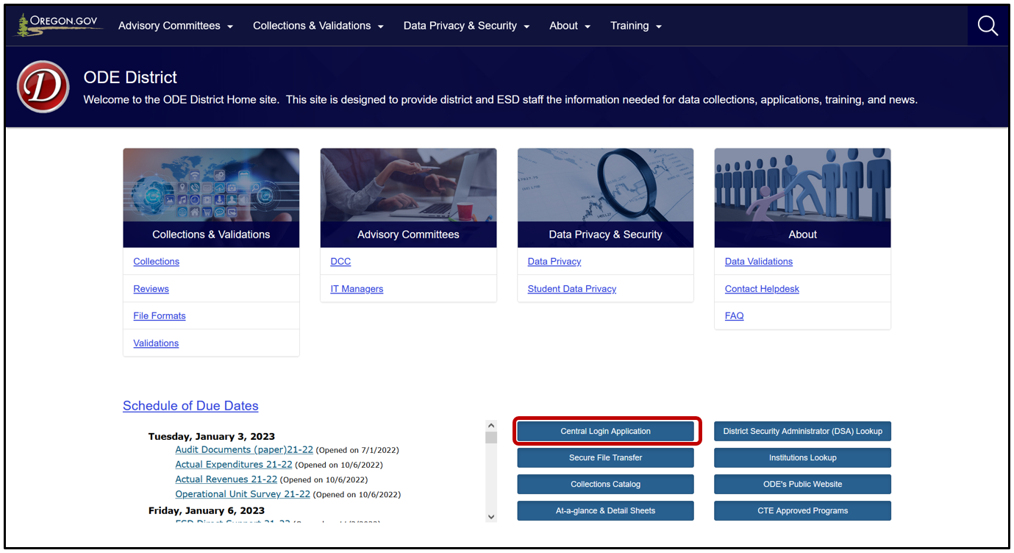
Logging in takes Users to their Applications List, (yours might appear differently). Users must only log in as the School District, ESD or EI/ECSE to report records. Do not use a school to report records. Select the School District, ESD or EI/ECSE in the Application List, e.g., “Consolidated Collections – School District.”
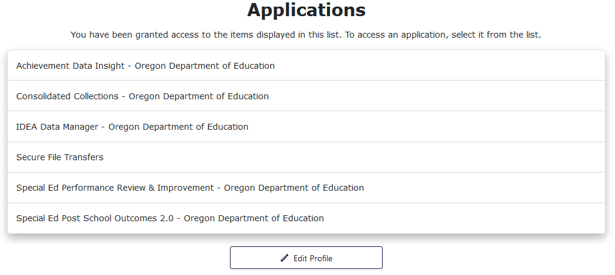
From the Applications list, click on Consolidated Collections.
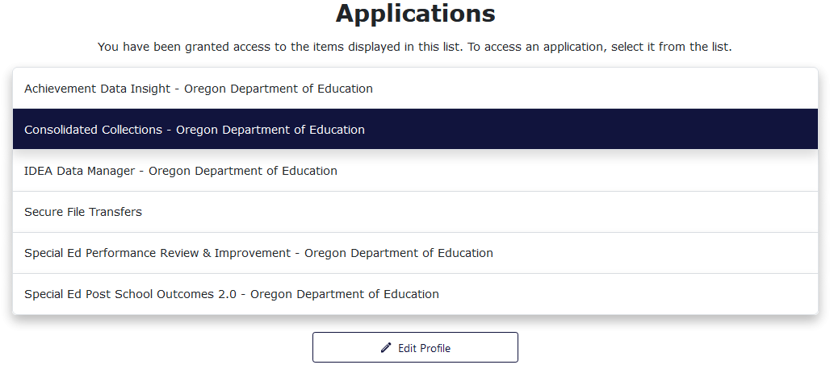
Users should see a screen that looks similar to this:
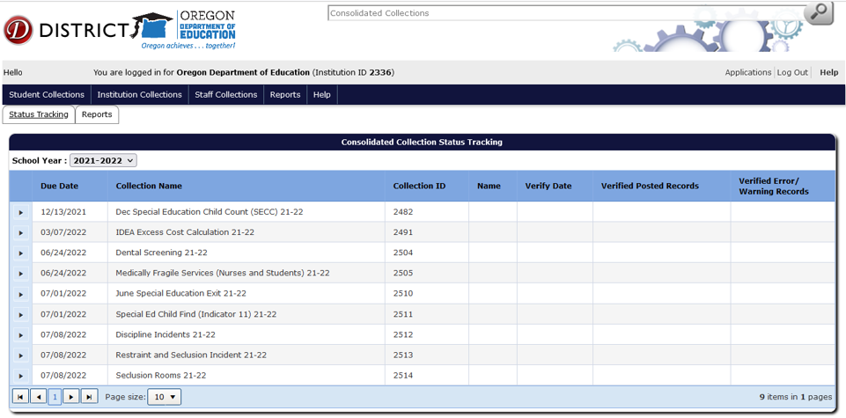
The list of collections users see will depend on the collections they have permissions to view and/or modify. If a user does not see the specific collection for which they are submitting data, they will need to contact their District Security Administrator for Modify permissions and Submitter permissions.
Below is an overview of the process for submitting records for the Discipline Incidents Collection. For detailed instructions on how to navigate Consolidated Collections, see the OESO Consolidated Collections User Guide. Note that each collection will display the applicable collection year in the title.

Submitting Data to the Discipline Incidents Collection
Discipline Incidents data need to be submitted by all districts, including those with no incidents to report. Discipline Incidents need to be reported for all students, not only those on IEPs.
Reminder: Use the School District, ESD, or EI/ECSE login to report records. To submit data, hover your mouse over Student Collections. A drop menu will appear, containing a list of open collections. When ready to submit, hover over the collection name, in this example case, Discipline Incidents. A fly-out menu will appear with two options: File Upload and Web Submission. This example uses 2021-2022.
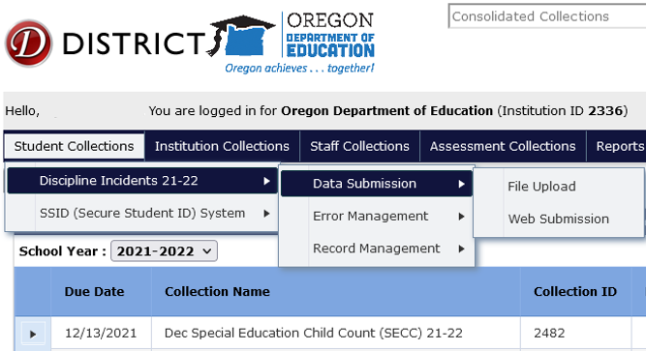

File Upload
The File Upload menu option takes you to an upload screen. Click on Browse (may look different depending on browser) to locate the file containing Discipline Incidents records. The file can be in .CSV or .XML format. After selecting the file, click Upload.
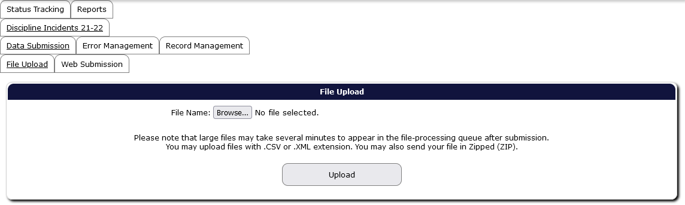
A File Upload dialog box will appear. Select the submission file and then click the Open button. Finally, click the Upload button in the File Upload screen to submit the file to ODE. If the upload is successful, the screen will display information boxes with information on the file and processing status. Consolidated Collections will notify users by email when the validation processing is complete.
Note: users are not finished submitting data to ODE until all errors are corrected AND the verification reports have been verified. Please see the sections Correcting Errors and Verification Process.

Adding an Action for File Upload
If a user determines there is a second action for a record, but it was not in the upload file, users can do a web submission to add the second action. To add the second discipline action, follow the Web Submission process to add an additional discipline action.
If the user needs to look up the Discipline Incident ID, the Discipline Incident Date and/or the Discipline Action Date, hover over Student Collections, then Discipline Incidents. In the fly-out menu, hover over Record Management and then click on Record Maintenance, then search by SSID. The Record Maintenance screen can also be used to verify that the two discipline actions are present in the system.

Web Submission
The Web Submission menu option takes you to a search screen. Search for a student using one of the options to search by SSID, Last Name, etc. and then click Search.
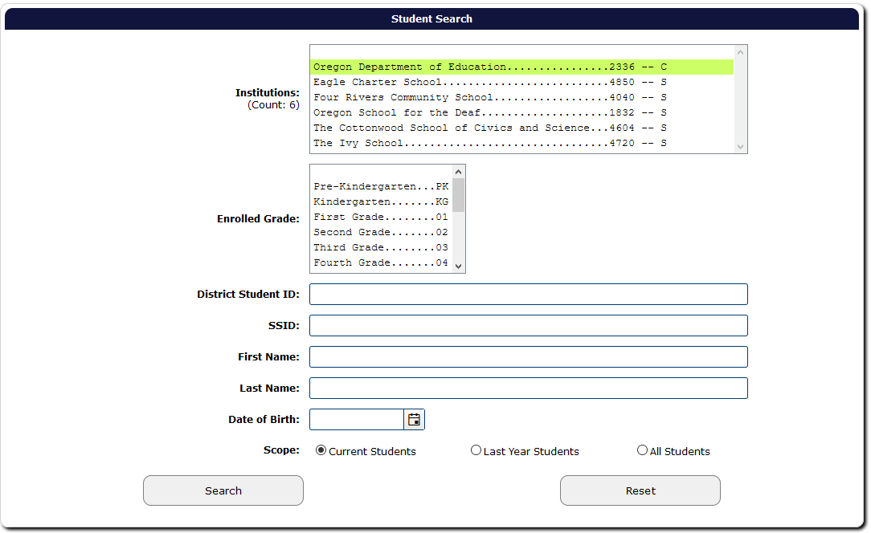

After clicking Search, the application will generate a list of student(s) that meet the search criteria. Click the green checkmark to open the student record.
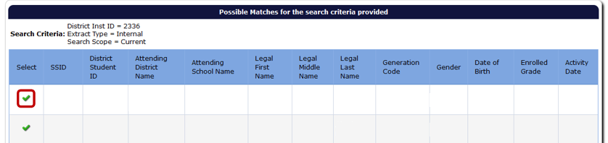
The application will open a data entry screen for the selected student. The top half of the screen contain fields for the Discipline Incidents collection. The bottom of the screen are core fields, such as the student’s personal, demographic, and program data.
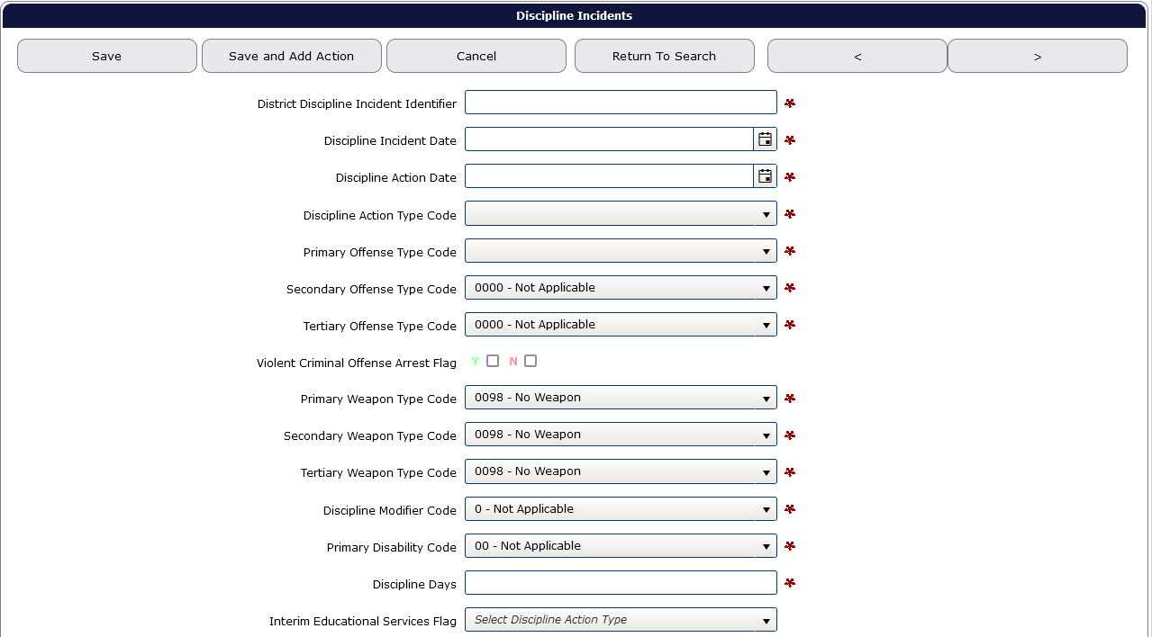

Discipline Incident Fields

District Discipline Incident Identifier (Required)
This is a unique identifier assigned by the district for each discipline incident. It consists of up to ten characters (numbers and/or letters) and is meaningful to the district. In most cases, the district’s local data system will determine the numbering sequence. If there are multiple students involved in one discipline incident, use the same District Discipline Incident Identifier for each student.

Discipline Incident Date (Required)
This is the date the incident occurred. Must contain a valid date in the format of MMDDYYYY, where “MM” is the two-digit month, “DD” is the two-digit date of the month, and “YYYY” is the four-digit year. Must be the same date or any date prior to the Discipline Action Date. Enter the date in MMDDYYYY format or use the small calendar icon at the right of the field. The date the discipline incident occurred must be from July 1 to June 30 of the reporting year.

Discipline Action Date (Required)
Date that disciplinary action was taken against the student as a result of the incident. Must also contain a valid date in the format of MMDDYYYY. Discipline Action Date may or may not fall on the same date as Discipline Incident Date. The Discipline Action Date cannot precede the corresponding Discipline Incident Date. Enter the date in MMDDYYYY format or use the small calendar icon at the right of the field.

Discipline Action Type Code (Required)
This code indicates the type of disciplinary action taken by the school. See Discipline Action Type Table in the Appendices.

Primary Offense Type Code (Required)
This code describes the primary offense carried out by the student during the incident. See Primary Offense Type Table in the Appendices.

Secondary and Tertiary Offense Type Code
These codes describe secondary and tertiary offenses perpetrated by the student during the incident, if any. These fields default with “Not Applicable.” Find the list of codes in the Offense Type Table in the Appendices.
If a student is involved in one incident resulting in multiple offenses, use the Secondary and Tertiary Offense Type Code fields. Do not enter multiple records for the student for a single incident.

Violent Criminal Offense Arrest Flag
This field indicates that the incident resulted in the student's arrest for a violent criminal offense, including: assault; manufacture or delivery of a controlled substance; sexual crimes using force, threatened use of force or against an incapacitated person; arson; robbery; hate/bias crime; coercion; or kidnapping. When schools expel a student due to the commission of a violent criminal offense on school grounds for which police/officials arrested the student, districts must mark this flag Y.

Primary Weapon Type Code
These codes describe the primary weapon in the student's possession during the incident, if any. This field defaults with “No Weapon.” Please see the Weapon Type Table in the Appendices for the list of codes.

Secondary and Tertiary Weapon Type Code Fields
This code describes a secondary and tertiary weapon in the student's possession during the incident, if any. These fields default with “No Weapon.” Please see the Weapon Type Table in the Appendices for the list of codes.

Discipline Modifier Code
This code describes special circumstances that may modify the disciplinary action taken. Only use this code in two circumstances. 1) When a student had a firearm, but was not expelled for a full school year (Discipline Modifier Code 1); or 2) when an Administrative Law Judge (ALJ) removes the student (Discipline Modifier Code 2). When a student’s Discipline Modifier Code is 2, the special education flag must be marked Y. See the Discipline Modifier Table in the Appendices for a list of options.
Removal by an Administrative Law Judge (Discipline Modifier Code 2) is rare and is for special education students only. When selecting Discipline Modifier Code 2, the special education flag must be marked Y.

Primary Disability Field (Required if Special Education Flag is marked Y)
This code indicates the primary disability (eligibility) of the student with an IEP. Select the appropriate code from the drop-down list of special education disability codes. See Disability Code Table in the Appendices.

Discipline Days
This field collects the number of school days associated with the disciplinary action taken. Any removal for more than half of a scheduled school day is counted as a full day, and removal for half of the day or less is counted as a half day. (ORS § 339.250(10).) This field contains an explicit decimal point. When doing a File Upload, discipline days that include half days should be entered as a decimal (e.g., 5.5 for five and a half days), and whole numbers can be entered with or without the decimal (e.g., either 5 or 5.0 will work for five days).

Interim Services Flag
This field indicates whether the district provided interim educational services during the discipline days to enable the child to continue to participate in the general education curriculum and/or to progress toward meeting goals set out in the student's IEP, although in another setting.
If the Discipline Action Code is: | Then the Interim Services Flag options are:
1 – Expulsion | Y or N
2 – In-School Suspension | Y
3 – Out of School Suspension | Y or N
5 – Removed to an Alternate Educational Setting | Y

Add Action
When there are two discipline action types for one incident, for example, both in-school and out of school suspension assigned, users will fill out the Web Submission record screen with the first Discipline Action Type, then click Save and Add Action. Note the Discipline Days field will only include the count of days for the first action.
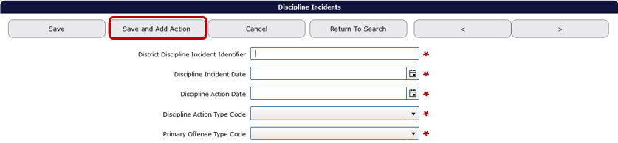
The system will update the screen to allow users to enter the second Discipline Action Type, Discipline Days and Interim Education Services flag. All other fields are not editable and will be grey. Note the Discipline Days field will be for the count of days assigned for the second action.
For adding an action during a file upload, follow Adding an Action for File Upload.

Correcting Errors
Once all data has been loaded, the next step is to correct errors. To view and correct errors, hover your mouse over Student Collections in the top menu bar. From the drop menu, hover over Discipline Incidents, then from the fly out menu, hover over Error Management, and then click on Review Errors.
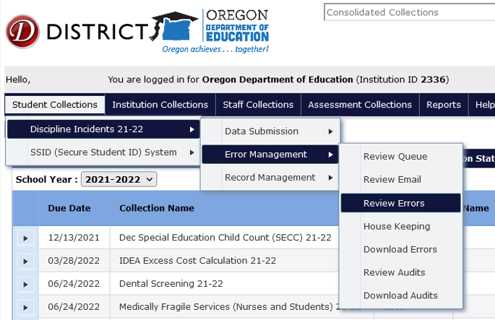
The Error Screen shows a list of errors by type, count and description. The Error Count is the number of records with the Error Type. Click the triangle expand button, in the row of the Error Type you wish to correct, which expands to show the records with that type of error.
This expanded screen contains a table with demographic information, a green check mark to access the record, a red “x” to delete the record, the values causing the error, and the column names for these values.
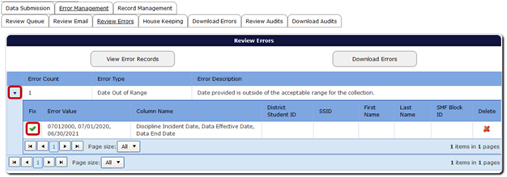Clicking the green check mark will open the record. The top of the record will display each validation error for the record. Consolidated Collections puts a red outline around the field that contains a validation error. If there is more than one validation error, each field that is in error will be outlined in red.
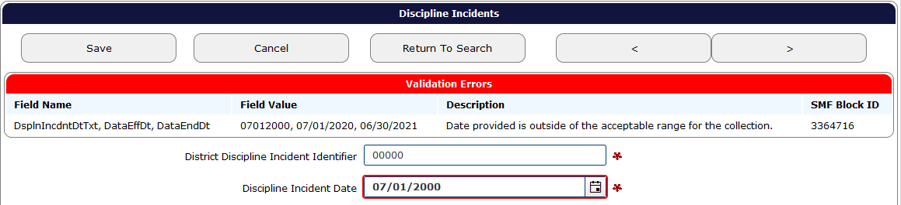
After fixing each error, click the Save button, located at the top and bottom of the record, which will clear the error. After clicking Save, the system will produce a green “Record Saved” message. The system also will revalidate the entire record, to check for any further errors.
If there is more than one error in the Error Type, the system will keep the Error Type expanded. Once all errors are fixed, the record will post to Record Management.

Verification Process
The final step is verifying the submission. ODE cannot consider the collection complete until the submitting district verifies it as complete. All districts (even districts with no student discipline incidents for the 2024-2025 school year) are required to complete the verification process on the Status Tracking tab. Reminder: this action must be completed under the School District, ESD, or IE/ECSE login as the agency accountable for ensuring accurate data submission.
From anywhere in the Consolidated Collections application, click the Status Tracking tab to go to the list of collections. Make sure the School Year dropdown displays the correct school year. This dropdown will automatically advance to the next school year on July 1. If the 2024-2025 collection closes on July 11 and is verified after June 30, 2025, when users arrive at the Status Tracking page, the dropdown will show 2025-2026 and all the collection names on will end with “25-26.” Use the School Year drop menu to change the collection year to 2024-2025. The example below uses 2023-2024 collections.
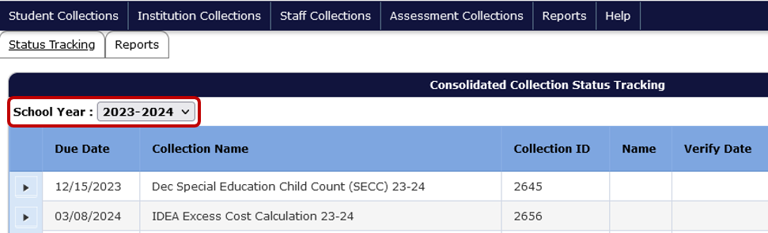
Click the black expand arrow next to the Discipline Incidents collection to access the Verification Reports.
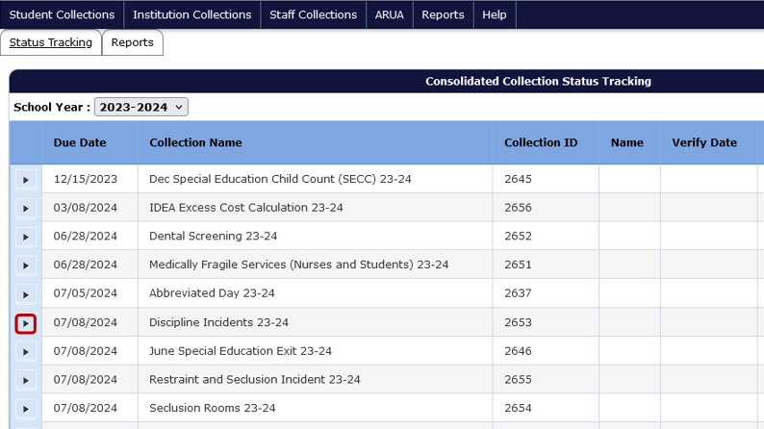
If all errors have not been cleared, an uncorrected errors message will appear. See Correcting Errors before continuing.
Similarly, if all audits have not been cleared, an uncorrected audits message will appear. See Correcting Audits during the Review Window before continuing.
Each collection has different verification reports. Each report displays aggregated data in tables.
- Discipline Action Type Verification
- Grade Verification
- Race/Ethnicity Verification
- Disability Status Verification
- Gender Verification
- >10 Days Cumulative Verification
  - This is a report of students who have cumulative suspension(s) and/or expulsion(s) greater than 10 days in a school year. If a student’s race/ethnicity or disability status changes from one incident to another, that student will be listed in more than one row for a given action type. However, the Total Students row will not count a student more than once, and as such will only display the total count of students.
    - Example: a student is not in Special Education in the fall, then is placed in Special Education in the winter, and has two incidents leading to in school suspension, one in fall and one in spring. That student will be counted in the In School Suspension for Students with Disabilities, and counted in the In School Suspension for Students without Disabilities.
    - The Total Students for In School Suspension would then display 1.
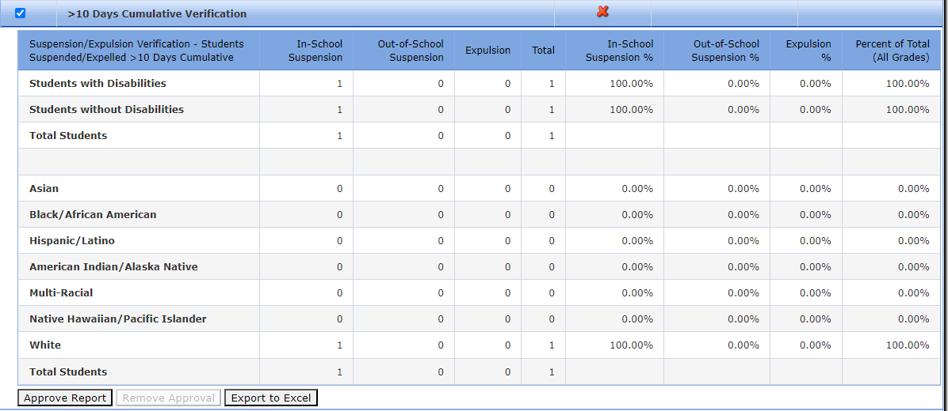
After clicking on the black expand arrow next to the collection, users will see the following screen. Clicking the checkboxes next to each verification report displays the data tables to be reviewed and verified by the user. The red “X” in the Current Status column indicates the report has not been verified. Review each verification report to ensure the count of records is correct.
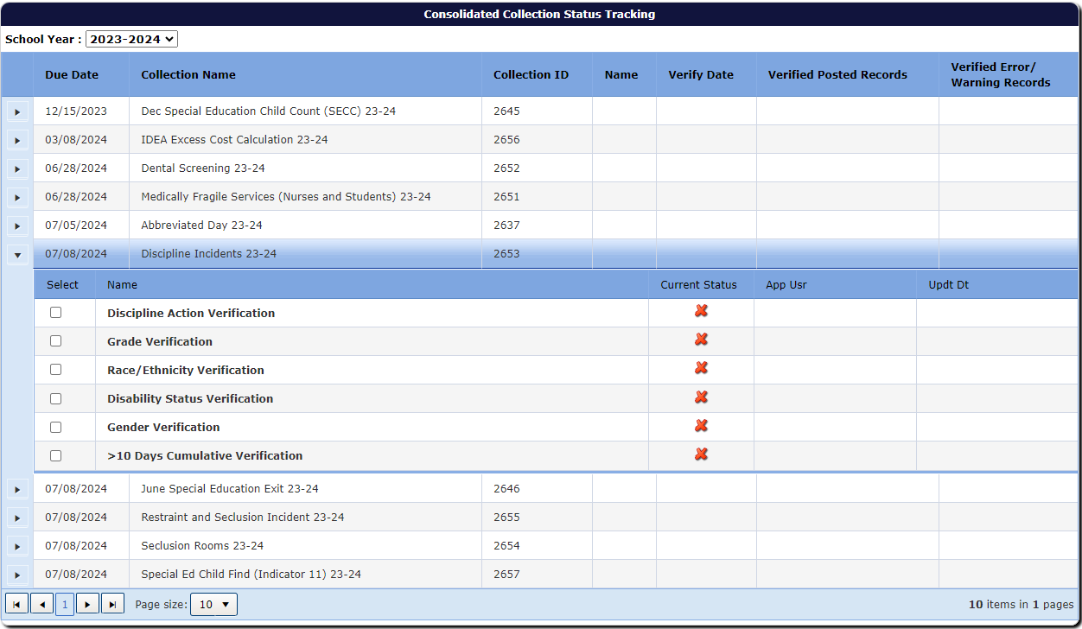
After selecting the checkbox, the screen will display the aggregated data with options for approving the report and exporting the data to Excel. Next, click the Approve Report button. Users verify each report one at a time.
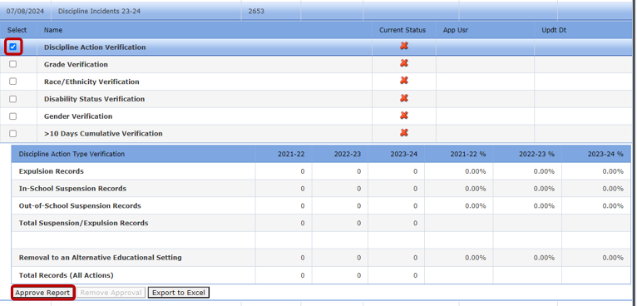
Once the user clicks Approve Report, the approved report’s status changes from the red “X” to a green checkmark and gives users the option of removing the approval. Removing the approval changes the green checkmark back to a red “X.”
As users verify, the system adds the user’s name and date of verification in the row for each report. The system also displays the user’s name and date in the row for the collection name, but there is a delay and it may display after the second report. Warning: system will display name and time in the collection name row, even when not all reports are verified.
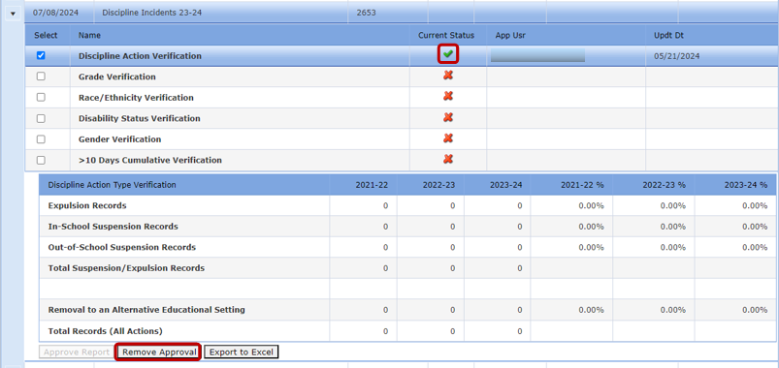
Continue through the list of reports until all Verification Reports are approved.

Correcting Audits during the Review Window
Audits are messages from ODE concerning the data. The Review Window opens August 21, 2025 and closes September 15, 2025. To review and address audits, and to make corrections during the review window, log into the ODE District site as before and hover over Student Collections drop menu, then hover over Review: Discipline Incidents 24-25, then from the fly out menu hover over Error Management, and then click on Review Audits. The example below uses 2021-2022 collections.
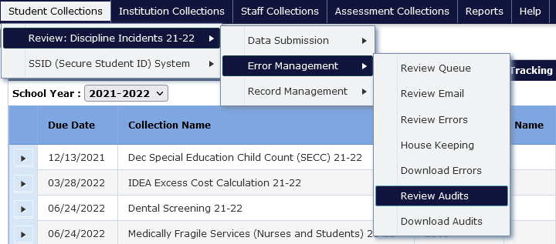
Like the Review Errors screen, the Audit Screen shows a list of audits by type the count of each type, and an audit description, if there are any audits for your district. The Audit Count is the number of records that have that respective audit type. Audit Type indicates the type of potential error. Audit Description provides a broad description of the audit. A student’s record may have multiple audits and appear under more than one audit type.
To access and audit, click the triangle expand button, in the row of the Audit Type you wish to correct, which expands to show the records with that type of audit.
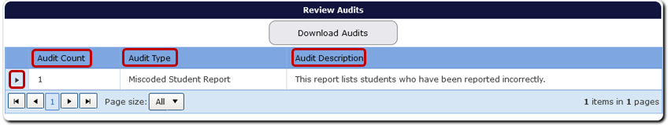
This expanded audit detail screen contains a table with student demographic information, audit comment, a green check mark to access the record, and a red “x” to delete the record.
In audit details, the Comment is a message from ODE staff, indicating why the record is flagged as an error or warning. If the record needs a correction, click on the green check mark under the Fix column. This will allow users to review the record.
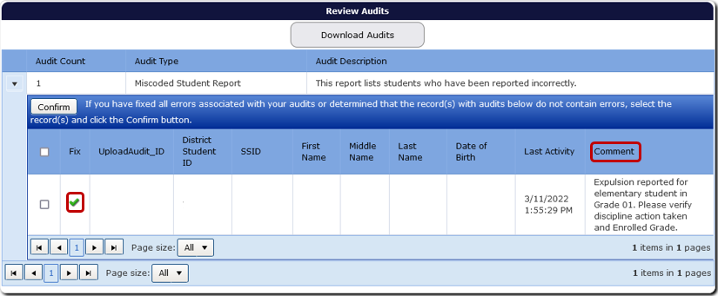
Once corrected, click the Save and Confirm button. This will save the corrections, and the system will remove the record from the audit list. The Last Activity column will reflect the date and time the last change was made.
The Cancel button will undo any changes made to the record. The Return to Search takes the user back to the audit list, with the respective Audit Type expanded.
If the audit description is unclear, contact an ODE staff member.
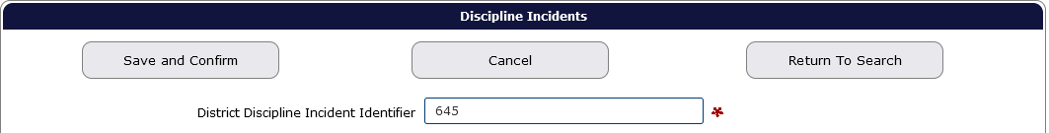
If the record is correct, users can confirm the record by clicking the Save and Confirm button while in the record. Or, if on the Audit List page, users can click on the box for the record, to the left of the Fix column, and then click the Confirm button. Users should not confirm any record(s) until they are sure it is not an error. When users Confirm a record, it disappears from the audit report permanently.
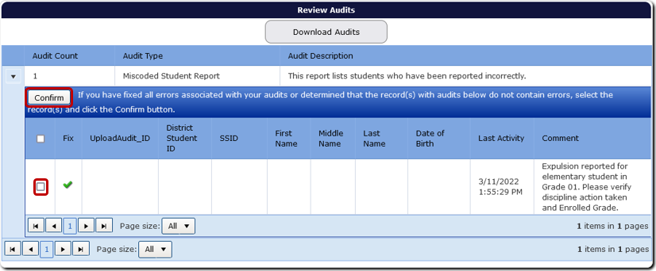
Users can also confirm all audits for the Audit Type, by clicking on the Select All box next to the Fix column, and then clicking the Confirm button. Do not Save and Confirm any records until you are sure there are no errors. When records are confirmed, they will disappear from the report.
If the audit comment is unclear or the user is unsure how to resolve it, please contact an ODE staff member for assistance. It is best not to confirm an audit if the user is unsure what it is. If the audit is regarding an error, this could lead to inaccurate data.
After clearing all audits, users will go to the Status Tracking to confirm the collection has been verified. See Verification Process.

Coding Records

General remarks
The Discipline Incidents Collection needs to be submitted by all districts, including those with no incidents to report (see Verification Process for more information). In addition, these data need to be reported for all students, not only those on IEPs.
It is important to keep clear the distinction between a discipline incident and a student record. The Discipline Incidents Collection is a student level collection: each record pertains to a single student for a single incident. A student can have multiple discipline incidents during a school year, and each should be recorded separately. Please note also that multiple students may be involved in a single incident. In that case, each student is entered as a separate record, but the Discipline Incident ID is the same for each student involved.
It is also true that a discipline incident may result from a sequence of actions, each of which could be subject to discipline, but only one of which is the primary or ultimate cause of the discipline. For example, a student could engage in misbehavior and not be disciplined, then engage in misbehavior again, and be disciplined once for both behavioral incidents. This is recorded as a single discipline incident.
It is likely that most incidents will be straightforward: a single student is disciplined for a single offense. The examples are meant to clarify more complex incidents.
If you encounter any difficulties reporting these data, just reach out to one of the ODE staff contacts.

How to Report More Complex Discipline Incidents

Multiple Incidents resulting in a single Discipline Action
Definition: A student is involved in more than one incident over one or more school days. The discipline action taken is based on these multiple related incidents.
Coding Example 1:
Scenario: A student is involved in three separate incidents over one or multiple days within a close timeframe. The school took no action for the first two incidents. The final incident resulted in an Out of School Suspension for the student. The previous two incidents and the final incident of misbehavior were used to determine the discipline action taken.
Reporting: The district should not report the first two incidents since no action was taken for either when they occurred. The Primary Offense should be the code that mostly closely matches the details of the final incident. Report Secondary or Tertiary Office codes if they differ from the Primary Offense Code and were used to determine the disciplinary action.

A Single Incident resulting in more than one Discipline Action Type
Definition: A student is involved in one discipline incident. There was more than one discipline action type taken related to the incident.
Coding Example:
Scenario: A student is involved in a discipline incident. The school took the discipline action of In- School Suspension for the first day and an Out of School Suspension for the following two days.
Reporting: The district should report this incident and include both discipline actions taken. To do so, report the incident including the first discipline action type (In-School Suspension) taken with the corresponding number of associated days (one). Then click the Save and Add Action button, enter the different Discipline Action Type Code (Out Of School Suspension), with a different number of associated days (two), and with the appropriate Interim Education Services flag. The system will retain the District Discipline Incident Identifier.

Incidents Occurring at Programs

Discipline Incidents Occurring at a Program
Coding Example 1:
Scenario: A student is involved in an incident at a program attached to or run by a public school within the district. The program does not have an institution ID.
Reporting: Report the Attending School ID as the school responsible for the program.
Coding Example 2:
Scenario: A student is involved in an incident at a program (public or private) not attached to or run by a public school within the district. The program does not have an institution ID.
Reporting: Report the Attending School ID as the Attending School District.
Coding Example 3:
Definition: Oregon School for the Deaf (OSD) is a state operated residential or day program for students who are deaf or hard of hearing. The Oregon Department of Education's Office of Enhancing Student Opportunities oversees the Oregon School for the Deaf (OSD). OSD will report the record.
Scenario: A student is involved in an incident at the Oregon School for the Deaf.
Reporting: Attending School ID as (1832) OSD and the Attending School District ID as (2336) Oregon Department of Education.

Special Education Students
Definition: A student is eligible for special education per IDEA on the day the discipline incident occurred. The district responsible for FAPE can be the district where the parent of guardian resides if not an inter-district transfer or open enrollment slot in another district, attending district for an inter-district transfer or an open enrollment slot, the district where the charter school attended is located or the district of origin serving a foster care student.

Removals for less than 10 consecutive or cumulative days
Scenario: A student currently eligible for special education per IDEA is involved in one or more incidents resulting in an action that removes them from the school for less than 10 consecutive days. If more than one incident, all of the student’s removals total less than 10 cumulative days.
Reporting: The district responsible for FAPE reports a record for each incident that resulted in a disciplinary action with the appropriate Primary Disability code and the Special Education Flag as Yes. Note that reportable incidents that occur when a student is no longer eligible for special education should be submitted with the Special Education Flag as No and Primary Disability as Not Applicable.

Removals for Less than 10 Consecutive Days but More Than 10 Cumulative Days or Removals for More than 10 Consecutive Days
Reporting: Report a record for each incident that resulted in a disciplinary action. Report the removal days for each record as imposed for each disciplinary action.
Important! Additional procedures apply in instances of discipline for students who have been found eligible for special education and for students for whom the school is deemed to have knowledge that the child might have a disability (i.e., students who have not yet been found eligible but the school had a basis of knowledge of a disability).
Please consult Guidance Regarding Discipline for Special Education (20 U.S.C § 1415(k), 34 CFR §§ 300.530-300.536 and OAR 581-015-2400 through 581-015-2445)

Secure File Transfer
To send personally identifiable information to ODE staff, use Secure File Transfer. Go to the District Home page, and in the center right-hand side beneath Applications, select Secure File Transfer.
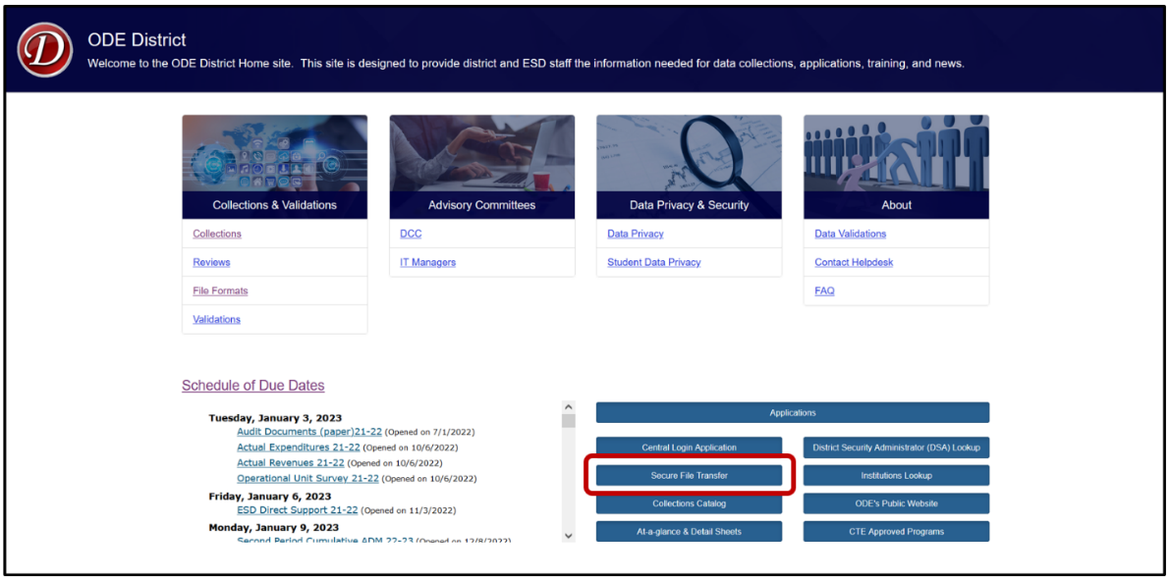
Secure File Transfer is behind a secure log in. The system will open a new tab to the Central Login page. Login to the District website by entering your User Name and Password, then press enter or click on the Login button.
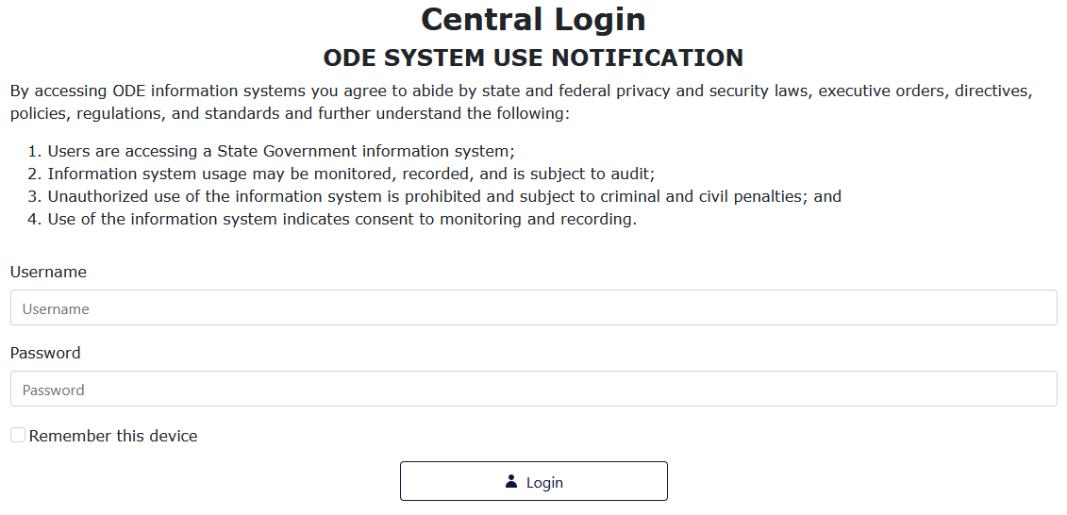

After signing in, users will be taken to their Applications List. Select Secure File Transfer.
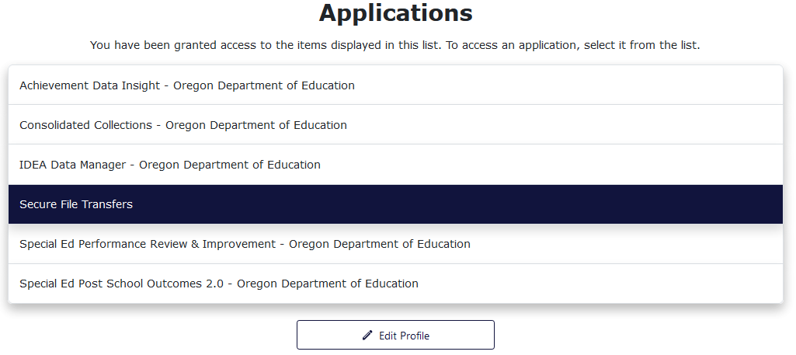
On the Secure File Transfer page, type the recipient’s email address. Click the To button to search the list of recipients. To select an email to add to the recipient list, click on the name or email address, then click Add Email.
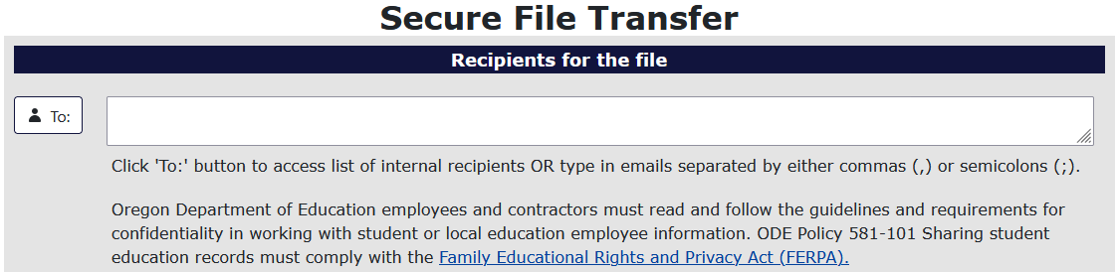To add the file to be sent, select the Select File button.
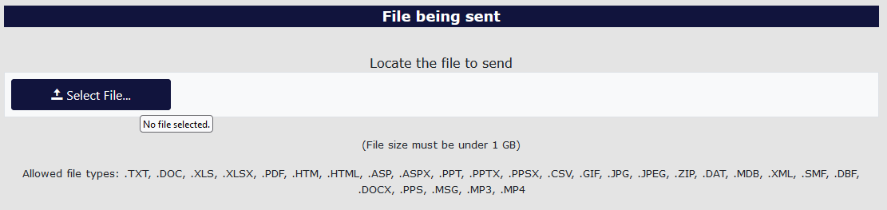
Find the desired file and select it. To select the file there are two methods. For the first method, users select the desired file, and then select the Open button in the window. For the second method, users double click the desired file.
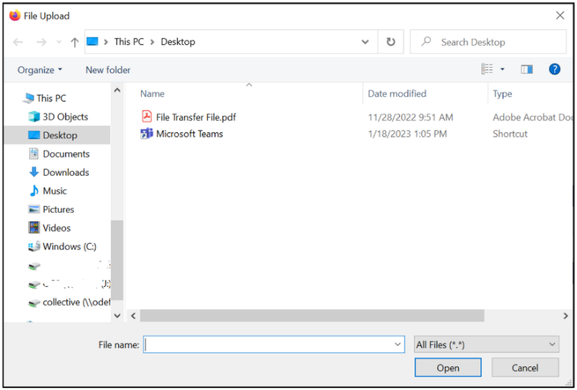
Users can type a message at the bottom of the page to add context and or anything else necessary for the recipients to know. This section is best thought of as the body of an email.
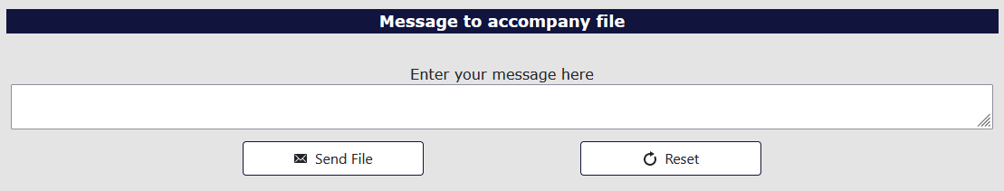
Finally, to send the file, select the Send File button.
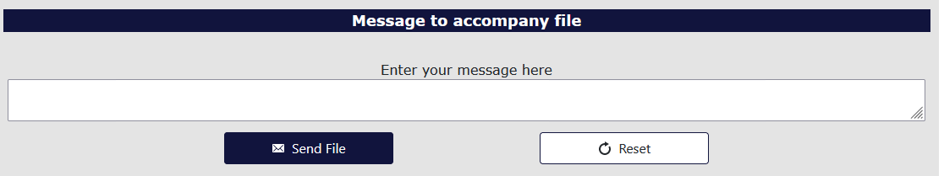
The recipient will receive an email with a web link. This link will take the recipient to a Secure File Transfer page on the ODE District website. They will enter their email address, the same address the user selected, and click the Submit Email Address button. The page will generate a Download button for the recipient to click, which downloads a zip file of the document the user sent.
If the recipient does not have a Central Login account, use the Link to external users section at the bottom of the screen.
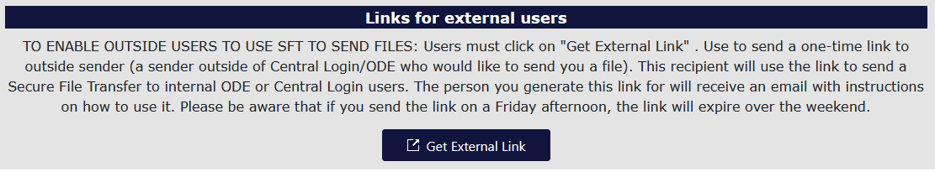
The system will generate a popup for users to enter the external repent email and message. Click the Generate External Link to send the secure file.
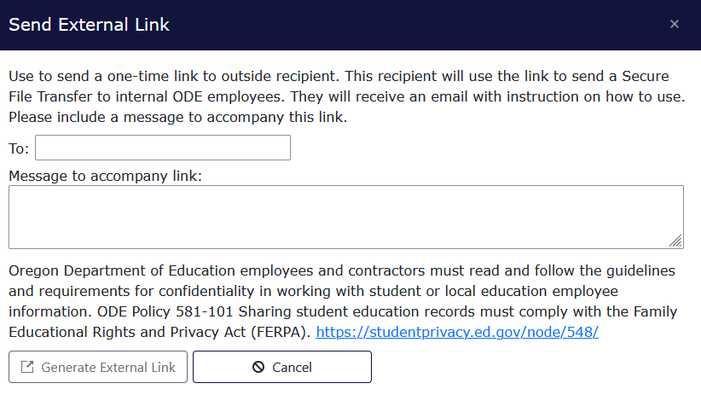

Frequently Asked Questions
Q: How do I log into the district site?
A: Visit ODE’s District webpage. Your District’s Security Administrator must give you access and permissions for the Discipline Incidents Collection.
Q: How do I locate my District Security Administrator?
A: If you do not know who your District Security Administrator is, go to the District Home page, on the right-hand side beneath Applications, and click District Security Administrator (DSA) Lookup . On the Search for Security Administrator page, enter an institution ID or District Name, then click the Search button.
Q: Where do I find the Discipline Incidents Collection once I have logged into the site?
A: From the Application List, select Consolidated Collections, then the Student Collections drop menu. When the collection and review windows are open, Discipline Incidents will appear in the drop menu.
Q: Where do I find the User Guide document for the Consolidated Collections?
A: See the Consolidated Collections Student-Level Collections User Guide on the District website, or the ESO Consolidated Collections User Guide.
Q: What is the best way to submit data for my district?
A: If your district has small schools, they may want to submit the data through the ODE’s web submission process. Larger schools and districts will likely prefer to use the file upload process.
Q: How do I submit online through the web submission process?
A: Please see the section on Web Submission for information on submitting one record at a time for this collection.
Q: How do I upload files to the ODE for the Discipline Incidents Collection?
A: Please see the section on File Upload for information on uploading files to the collection.
Q: How can I find another district’s Institution ID number?
A: 1. Go to the Institutions Lookup page
2. In the second field, for Institution Name, enter the school district name; and click Search
Q: How can I see the successfully submitted records?
A: Go into the Discipline Incidents Collection and follow the steps below to view your current discipline records.
- Hover over Student Collections, then Discipline Incidents 24-25
- Hover over Record Management, then click on Record Maintenance
- Leave the search parameter fields blank and click the Search button. The institutions field will be defaulted to the submitting agency.
- Consolidated Collections will generate a list of all records submitted.
Q: What are Demographic Errors?
A: Demographic errors occur when a student record has three or more mismatches compared to the student’s record in SSID. In the record’s error screen, the fields in error will have a red outline. The Validation Errors message at the top of the record will display the fields in error in the Field Name column, as well as the incorrect value plus the SSID values in the Field Value column.
Q: What do I do when I receive an error that indicates a student is merged to another SSID?
A: The cause of this error is one student with two SSIDs. To fix this error, please work with district staff that works with the SSID system.
Q: How do I do a Production Download?
A: From Consolidated Collections, click the Reports tab, located next to the Status Tracking tab.
- In the Collection column, click on Discipline Incidents.
- In the Report Year column, click on the applicable collection year.
- In the Report Column, select Production Download Report.
- The system will generate an email to your email address, which contains a secure file link.
  - On the generated web page enter your email address and the page will generate a Download icon.
  - Click the icon to access the Production Download Report file
Q: Will I need to enter data for a student who does not have an IEP?
A: Yes. You must enter Discipline Incident information for all students.
Q: What is an administrative law judge?
A: An Administrative Law Judge (“ALJ”) works through the Office of Administrative Hearings. “Removal by ALJ” is a rare occurrence. An ALJ for removal purposes differs from an officer who conducts district hearings for suspensions and/or expulsions.
Q: Do I need to enter data about a student’s disability?
A: Yes. If the Special Education Flag is marked Y then the Primary Disability Code must be a valid code from the drop-down menu. The Special Education Flag should only be marked Y to indicate student participation in an Individualized Education Plan (IEP/IFSP).
Q: How do we report discipline records for a student attending a program at the district office not associated with a school?
A: If the student is attending a program at the district office, and is not associated with any building in the district, use the district code in the School ID field.
Q: Do I need to enter the exact number of discipline days for an expulsion?
A. Yes. Discipline days are entered for all disciplinary actions—expulsions, suspensions, and removals. ODE reports the total number of discipline days to the federal government and uses them to calculate information for district Systems Performance Review & Improvement (SPR&I). Incident days are school days.
Q: How do we count discipline days for a student expelled for an entire school year?
A: For all disciplinary actions—expulsions, suspensions and removals—report the number of school days imposed with the discipline action. For example, if expelling a student for one year from a school that has 175 school days per year, then record the student’s discipline days as 175 days, even if some of the days served occur the next school year.
Q: If multiple students are involved in one incident for which there are multiple expulsions and/or suspensions, does the incident only count once?
A: There will only be one District Discipline Incident ID used for the incident involving multiple students. However, there will be multiple records, one for each student disciplined, and each record will have the same District Discipline Incident ID.
Q: What is the system default for the Interim Service Flag?
A: The Interim Service Flag depends on the selected Discipline Action type. Removal to an Alternative Educational Setting and In-School Suspension will only populate a Y for Interim Services. For expulsions and out-of-school suspensions, you may select a Y or N for Interim Services as appropriate.
Q: How are students counted when their disciplinary action extends beyond June 30, 2025?
A: The incident and all the days of removal imposed for the discipline action are counted in the school year that the incident occurred. If a student is expelled, suspended, or removed during the current school year (2024-2025) but their discipline days extend past June 30, 2025, the discipline days are counted as part of the 2024-2025 collection. Please account for discipline days that carry into the 2025-2026 school year.
Q: If a student leaves (moves, drops out, etc.) before serving the time given them for a discipline action, do we still report the incident?
A: Yes. This collection is intended to document a district’s discipline actions. If the student dropped out or otherwise left and avoided those actions, the district will still report the record and all information regarding the incident, including the discipline action and all days imposed, whether served or not.
Q: When is it appropriate to use the “removal to an Interim Alternative Educational Setting (IAES)” code?
A: In an IAES, the student continues to receive instruction, albeit in a different location. For students who receive special education services, there are three scenarios where IAES may be employed:
- Placement by school personnel for violation of a code of conduct (not more than 10 days) (34 CFR 300.530(b))
- Placement by school personnel for “special circumstances” (up to 45 school days) for weapons, drugs, infliction of serious bodily injury upon another person (34 CFR 300.530(g))
- Placement by a hearing officer [administrative law judge] because of substantial likelihood of injury to child or others (34 CFR 300.532(b)(2)(ii))
* “Hearing officer” means administrative law judge, not the person authorized to hear expulsion cases for a district.
Q: What if the student refuses to attend alternative interim services that are offered?
A: The district is required to offer interim services starting day 11 of exclusion from school in a given year for a student with special needs, which should be documented from your meeting with the parent/student. If services are offered, a Y (Yes) is marked for Interim services whether or not the student actually attends the services to be provided.

Q: If a student is suspended and then expelled, how do I code the incident(s)?
A: Report the incident as an expulsion and report the total number of days the student was removed from the educational environment, including the days they were suspended.

Q: If a student is suspended out-of-school and another, separate, incident occurs while the student is serving out-of-school suspension that warranted an expulsion, how do I code the incident?
A: Report the out-of-school suspension to include the total number of days the student was serving the suspension up to the day of the expulsion incident. Then report the expulsion incident as a separate incident with its own District Discipline Incident ID.
Q: Will the system allow me to enter half-day suspensions?
A: Yes. The File Upload and Web Submission permit entry of discipline days in amounts of half-days (decimal increments of 0.5, e.g. 0.5, 1.0, 1.5, 2.0, 2.5, etc.).
Q: What about vaping?
A: If the vaporizer device contains a drug that is nicotine/tobacco, please utilize code 3300: Tobacco (Possession or Use- Possession), which is use, distribution, or sale of tobacco products. If the vaporizer device contains a drug that is not nicotine/tobacco, please utilize code 1600: Drugs Excluding Alcohol and Tobacco (Illegal Drug Possession, Sale, Use/Under the Influence).
Q: When is the best time to complete my Discipline Incidents data report and submit it to ODE?
A: Districts/schools are required to have all Discipline Incidents data submitted by the time the collection closes on July 11, 2025. Districts/schools are encouraged to start the reporting process when the collection opens on May 29, 2025 in order to correct any errors and verify that the data is correct before the collection closes. Please do not delay in starting the reporting process as this could result in inaccurate and/or untimely data submission.
Q: My district has no Discipline Incidents data to report. Do I need to complete a report?
A: Yes. All districts must complete the Discipline Incidents data collection. Consolidated Collections has a verify button on the Status Tracking page that all districts must use to validate they have submitted data. Click the expand triangle button next to the collection name to access the verification button.

File Layout
Row | Column | Field Name | Data Element Name | Width | Data Type | Zero Padded | Required | Data Element Description
1 | A | ChkDigitStdntID | Secure Student Identifier (SSID) | 10 | int | Y | Y | ODE assigned Secure Student Identifier (SSID) with a trailing check digit.
2 | B | DistStdntID | District/Local Student Identifier | 10 | varchar | N | N | Identifier, assigned by the district, used to uniquely identify the student.
3 | C | ResdDistInstID | Resident District Institution Identifier | 10 | int | Y | Y | ODE assigned Institution Identifier for the Resident District. The District responsible for the education of the student and also is the basis on which the State School Fund, the Common School Fund, and the County School Fund are distributed to local districts. Special provisions apply as defined in ORS 339.133, 338.155(1), and 338.165.
4 | D | ResdSchlInstID | Resident School Institution Identifier | 10 | int | Y | Y | ODE assigned Institution Identifier for the Resident School. The School responsible for the education of the student and also is the basis on which the State School Fund, the Common School Fund, and the County School Fund are distributed to local districts. Special provisions apply as defined in ORS 339.133, 338.155(1), and 338.165.
5 | E | AttndDistInstID | Attending District Institution Identifier | 10 | int | Y | Y | ODE assigned Institution Identifier for the Attending District. The District where the student is receiving instruction and where state assessments are administered.
6 | F | AttndSchlInstID | Attending School Institution Identifier | 10 | int | Y | Y | ODE assigned Institution Identifier for the Attending School. The School where the student is receiving instruction and where state assessments are administered.
7 | G | InstFill | Institution Filler | 20 | varchar | N | N | Reserved for future use.
8 | H | LglLNm | Legal Last Name | 50 | varchar | N | Y | Legal last name of the student.
9 | I | LglFNm | Legal First Name | 40 | varchar | N | Y | Legal first name of the student.
10 | J | LglMNm | Legal Middle Name | 40 | varchar | N | N | Legal middle name of the student.
11 | K | GnrtnCd | Generation Code | 4 | varchar | N | N | Name suffix of the student (i.e. Jr., II, III).
12 | L | PrfrdLNm | Preferred Last Name | 50 | varchar | N | N | Preferred last name of the student.
13 | M | PrfrdFNm | Preferred First Name | 40 | varchar | N | N | Preferred first name of the student.
14 | N | PrfrdMNm | Preferred Middle Name | 40 | varchar | N | N | Preferred middle name of the student.
15 | O | BirthDtTxt | Date of Birth | 8 | datetime | Y | Y | Date the student was born.
16 | P | GndrCd | Gender Code | 1 | char | N | Y | Code indicating the gender of the student.
17 | Q | HispEthnicFg | Hispanic/Latino Ethnic Flag | 1 | char | N | Y | Indicates a student of Cuban, Mexican, Puerto Rican, South or Central American, or other Spanish culture or origin, regardless of race. The term, “Spanish origin,” can be used in addition to “Hispanic or Latino.”
18 | R | AmerIndianAlsknNtvRaceFg | American Indian/Alaskan Native Race Flag | 1 | char | N | Y | Indicates a student having origins in any of the original peoples of North and South America (including Central America), and who maintains tribal affiliation or community attachment.
19 | S | AsianRaceFg | Asian Race Flag | 1 | char | N | Y | Indicates a student having origins in any of the original peoples of the Far East, Southeast Asia, or the Indian subcontinent including, for example, Cambodia, China, India, Japan, Korea, Malaysia, Pakistan, the Philippine Islands, Thailand, and Vietnam.
20 | T | BlackRaceFg | African American Race Flag | 1 | char | N | Y | Indicates a student having origins in any of the black racial groups of Africa.
21 | U | WhiteRaceFg | White Race Flag | 1 | char | N | Y | Indicates a student having origins in any of the original peoples of Europe, the Middle East, or North Africa.
22 | V | PacIslndrRaceFg | Native Hawaiian/Other Pacific Islander Race Flag | 1 | char | N | Y | Indicates a student having origins in any of the original peoples of Hawaii, Guam, Samoa, or other Pacific Islands.
23 | W | RaceFill | Race Filler | 1 | char | N | N | Reserved for future use.
24 | X | LangOrgnCd | Language of Origin Code | 4 | varchar | Y | Y | Code indicating the first language spoken in an individual's home in their early or earliest childhood. One's first language or native language.
25 | Y | SSN | Partial Social Security Number | 4 | varchar | Y | N | Last four (4) digits of the Social Security Number of the student.
26 | Z | EnrlGrdCd | Enrolled Grade Code | 2 | char | Y | Y | Code indicating the enrolled grade level of the student; or a grade level assigned to an ungraded student based on student age.
27 | AA | Addr | Street Address | 45 | varchar | N | Y | Street Address of the student's primary residence.
28 | AB | City | City | 20 | varchar | N | Y | City where the student's primary residence is located.
29 | AC | ZipCd | Zip Code | 5 | varchar | Y | Y | First five digits of the postal Zip Code of the student's primary residence.
30 | AD | Zip4Cd | Zip Plus Four Code | 4 | varchar | Y | N | Plus four portion of the postal zip code of the student's primary residence.
31 | AE | ResdCntyCd | Resident County Code | 2 | varchar | Y | Y | Code indicating the county of legal residence of the student's parent or legal guardian or the county of residence of an emancipated minor student.
32 | AF | Phn | Phone Number | 10 | varchar | N | N | Phone Number (Area Code, Prefix, and Exchange) of the student.
33 | AG | TchrFill | Teacher Filler | 50 | varchar | Y | N | Reserved for future use.
34 | AH | HSEntrySchlYr | High School Entry Cohort School Year | 4 | varchar | Y | N | School year the student entered high school in the format XXYY. (i.e. 0809 for the 2008-2009 school year). Indicates the ninth grade cohort group associated with the student.
35 | AI | Fill | Student Filler | 16 | varchar | N | N | Reserved for future use.
36 | AJ | EconDsvntgFg | Economically Disadvantaged Flag | 1 | char | N | N | Indicates student eligibility for a Free or Reduced Lunch program.
37 | AK | Ttl1Fg | Title I Flag | 1 | char | N | N | Indicates the student is being served in a Title I Targeted Assisted School (TAS). Does NOT include students served in a Title I School Wide Program (SWP).
38 | AL | SpEdFg | Special Education Flag | 1 | char | N | Y | Indicates student participation in an Individualized Education Plan (IEP/IFSP).
39 | AM | Sect504Fg | Section 504 Flag | 1 | char | N | N | Indicates student eligibility for Section 504 services
40 | AN | MigrntEdFg | Migrant Education Flag | 1 | char | N | N | Indicates student participation in a program designed to assure that migratory children receive full and appropriate opportunity to meet the state academic content and student academic achievement standards.
41 | AO | IndianEdFg | Indian Education Flag | 1 | char | N | N | Indicates student participation in a program designed to meet the unique educational and culturally related academic needs of American Indians.
42 | AP | ELFg | English Learner Flag | 1 | char | N | Y | Indicates a student who is an English Learner.
43 | AQ | DstncLrnFg | Distance Learning Flag | 1 | char | N | N | Indicates student participation in a distance learning program or a program that includes online coursework.
44 | AR | HomeSchlFg | Homeschooling Flag | 1 | char | N | N | Indicates that the student is registered to receive homeschool instruction.
45 | AS | TrnstnProgFg | Transition Program Flag | 1 | char | N | N | Indicates a Special Education student of high school or post high school age (up through the age of 21) who has not graduated with a regular diploma and are not working towards a regular or modified diploma.
46 | AT | AltEdProgFg | Alternative Education Program Flag | 1 | char | N | N | Indicates that the student has been placed by the district in an Alternative Education Program(s) based on criteria described in OAR 581-022-1350 (5).
47 | AU | TrbAfflnCd | Tribal Affiliation Code | 3 | char | Y | N | Indicates Tribal affiliation through self-identification, such as being enrolled in, a descendant of, or affiliated with, a tribe recognized by the federal government.
48 | AV | TAGFg | Talented and Gifted Flag | 1 | char | N | N | Indicates that the student is identified as Academically Talented or Intellectually Gifted as determined by school district policy.
49 | AW | AddnLangCd | Additional Language Code | 4 | char | Y | N | Code indicating any additional language a student uses to communicate that is not the language of origin.
50 | AX | DemogFill | Demographic Filler | 11 | Varchar | N | N | Reserved for future use.
51 | AY | SECCPrimDsbltyCd | Primary Disability Code | 2 | char | Y | Y | Code indicating the primary disability (eligibility) of the student.
52 | AZ | DsplnDtTxt | Discipline Action Date | 8 | datetime | Y | Y | Date that disciplinary action was taken against the student as a result of the incident, may or may not be the same as the Discipline Incident Date.
53 | BA | DsplnActnTypCd | Discipline Action Type Code | 1 | char | N | Y | Code describing the disciplinary action taken against the student as a result of the incident.
54 | BB | DistIncdntID | District Discipline Incident Identifier | 10 | varchar | N | Y | Identifier, assigned by the district, used to uniquely identify the incident leading to disciplinary action(s).
55 | BC | PrimOffnsTypCd | Primary Offense Type Code | 4 | varchar | Y | Y | Code describing the primary offense perpetrated by the student during the incident.
56 | BD | SecOffnsTypCd | Secondary Offense Type Code | 4 | varchar | Y | Y | Code describing a secondary offense perpetrated by the student during the incident.
57 | BE | TertOffnsTypCd | Tertiary Offense Type Code | 4 | varchar | Y | Y | Code describing a tertiary offense perpetrated by the student during the incident.
58 | BF | PrimWpnTypCd | Primary Weapon Type Code | 4 | varchar | Y | Y | Code describing the primary weapon in the student's possession during the incident.
59 | BG | SecWpnTypCd | Secondary Weapon Type Code | 4 | varchar | Y | Y | Code describing a secondary weapon in the student's possession during the incident.
60 | BH | TertWpnTypCd | Tertiary Weapon Type Code | 4 | varchar | Y | Y | Code describing a tertiary weapon in the student's possession during the incident.
61 | BI | DsplnModCd | Discipline Modifier Code | 1 | varchar | Y | Y | Code describing special circumstances that may have modified the disciplinary action taken.
62 | BJ | DsplnDays | Discipline Days | 5 | numeric | Y | Y | Number of school days associated with the disciplinary action taken. Partial Discipline Days are always rounded up to the nearest half day.
63 | BK | IntrmSrvcFg | Interim Educational Services Flag | 1 | char | N | N | Indicates whether the district provided interim educational services during the discipline days to enable the child to continue to participate in the general education curriculum and/or to progress toward meeting the goals set out in the student's IEP, although in another setting. (IDEA 300.101(a) and 300.530(d))
64 | BL | VlntCrmnlOffnsFg | Violent Criminal Offense Arrest Flag | 1 | char | N | N | Indicates that the incident resulted in the student's arrest for a violent criminal offense, including: Assault; Manufacture or delivery of a controlled substance; Sexual crimes using force, threatened use of force or against an incapacitated person; Arson; Robbery; Hate/Bias crime; Coercion; or Kidnapping.
65 | BM | DsplnIncdntDtTxt | Discipline Incident Date | 8 | datetime | Y | Y | Date that disciplinary incident occurred, may or may not be same as Discipline Action Date.
66 | BN | DsplnFill | Discipline (Dspln) Filler | 50 | varchar | N | N | Reserved for future use.

Appendices

Codes

Discipline Action Type
Code | Name | Description | Effective | End
1 | Expulsion | An action taken by a local educational agency to remove a child from his/her regular school for disciplinary purposes for a period lasting longer than the permitted out-of-school suspension period allowed by the local educational agency policy. | 07/01/2018
2 | In-School Suspension | Instance in which a child is temporarily removed from his/her regular classroom(s) for disciplinary purposes but remains under the direct supervision of school personnel. | 07/01/2007
3 | Out-of-School Suspension | Instance in which a child is temporarily removed from his/her regular school for disciplinary purposes to another setting (e.g., home, behavior center). | 07/01/2007
5 | Removal to an Alternative Educational Setting | Instance in which school personnel (not the IEP team) order the removal of a student with a disability from the student's current educational placement to an appropriate interim alternative educational setting for not more than 45 school days. | 07/01/2007

Discipline Modifier
Code | Name | Description | Effective | End
0 | Not Applicable | Not Applicable | 07/01/2007
1 | Shortened Firearm Expulsion | Duration of the firearms expulsion was modified (in writing) to be less than one year by the chief administering officer of the local educational agency (superintendent of the district). ORS 339.250 (7) | 07/01/2024
2 | Removal By Administrative Law Judge | Removal was ordered by an administrative law judge (ALJ) because the child exhibits behavior that is substantially likely to result in injury to the child or others. | 07/01/2007

Offense Type
Code | Name | Description | Effective | End
0 | Not Applicable | Not Applicable (Not available for Primary Offense field) | 7/1/2007
1000 | Alcohol (liquor law violations: possession, use, sale) | Violation of laws or ordinances prohibiting the manufacture, sale, purchase, transportation, possession, or consumption of intoxicating alcoholic beverages or substances represented as alcohol. | 7/1/2007
1100 | Arson (Setting a Fire) | To unlawfully and intentionally damage, or attempt to damage, any school or personal property by fire or incendiary device. | 7/1/2007
1200 | Attendance Policy Violation (Not Attending School or Classes as Required) | Violation of state, school district, or school policy relating to attendance. | 7/1/2007
1300 | Battery (Physical Attack/Harm) | Touching or striking of another person against his or her will or intentionally causing bodily harm to an individual. | 7/1/2007
1400 | Burglary/Breaking and Entering (Stealing Property/Unlawful Entry) | Unlawful entry or attempted entry into a building or other structure with the intent to commit a crime. | 7/1/2007
1500 | Disorderly Conduct (Disruptive Behavior) | Any act that disrupts the orderly conduct of a school function; behavior which substantially disrupts the orderly learning environment. | 7/1/2007
1600 | Drugs Excluding Alcohol and Tobacco (Illegal Drug Possession, Sale, Use/Under the Influence) | Unlawful use, cultivation, sale, solicitation, purchase, possession, transportation, or importation of any controlled drug (e.g., Demerol, morphine) or narcotic substance. | 7/1/2007
1699 | Manufacture or Delivery of a Controlled Substance | Manufacture or delivery of a controlled substance | 7/1/2008
1700 | Fighting (Mutual Altercation) | Mutual participation in an incident involving physical violence, where there is no major injury. | 7/1/2007
1800 | Harassment, Intimidation, Bullying (Physical, Verbal, Psychological, or Cyberbullying) | Physical harm, damage to property, knowingly placing a student in fear of physical harm or damage to property, or creating a hostile educational environment. Refer to ORS 339.351(1-2) for complete definition. | 7/1/2016
1900 | Harassment, Sexual (Unwelcome Sexual Conduct) | Unwelcome sexual advances, requests for sexual favors, other physical or verbal conduct or communication of a sexual nature, including gender-based harassment that creates an intimidating, hostile, or offensive educational or work environment. | 7/1/2007
2000 | Homicide (Murder or Manslaughter) | Killing a human being. | 7/1/2007
2100 | Inappropriate Use of Medication (Prescription or over-the-counter) | Use, possession, or distribution of any prescription or over-the-counter medication, (e.g., aspirin, cough syrups, caffeine pills, nasal sprays) in violation of school policy. | 7/1/2007
2200 | Insubordination (Disobedience) | Unwillingness to submit to authority, refusal to respond to a reasonable request, or other situations in which a student is disobedient. | 7/1/2007
2300 | Kidnapping (Abduction) | Unlawful seizure, transportation, and/or detention of a person against his/her will, or of a minor without the consent of his/her custodial parent(s) or legal guardian. This category includes hostage-taking. | 7/1/2007
2400 | Obscene Behavior | Language or actions, written, oral, physical, or electronic, in violation of community or school standards. | 7/1/2007
2500 | Physical Altercation, Minor (Pushing, Shoving) | Confrontation, tussle, or physical aggression that does not result in injury. | 7/1/2007
2600 | Robbery (Taking of Things by Force) | The taking of, or attempting to take, anything of value that is owned by another person or organization under confrontational circumstances by force or threat of force or violence and/or by putting the victim in fear. | 7/1/2007
2700 | School Threat (Threat of Destruction or Harm) | Any threat (verbal, written, or electronic) by a person to bomb or use other substances or devices for the purpose of exploding, burning, causing damage to a school building or school property, or to harm students or staff. | 7/1/2007
2800 | Sexual Battery (Sexual Assault) | Oral, anal, or vaginal penetration forcibly or against the person’s will or where the victim is incapable of giving consent. Includes rape, fondling, indecent liberties, child molestation, and sodomy. | 7/1/2007
2900 | Sexual Offenses, Other (Lewd Behavior, Indecent Exposure) | Sexual intercourse, sexual contact, or other behavior intended to result in sexual gratification without force or threat of force. Code statutory rape here. | 7/1/2007
3100 | Theft (Stealing Personal or Other Property) | The unlawful taking of property belonging to another person or entity (e.g., school) without threat, violence or bodily harm. Electronic theft of data should be coded here. | 7/1/2007
3200 | Threat/Intimidation (Causing Fear of Harm) | Physical, verbal, written, or electronic action which immediately creates fear of harm, without displaying a weapon and without subjecting the victim to actual physical attack. | 7/1/2007
3300 | Tobacco (Possession or Use) | Possession, use, distribution, or sale of tobacco products. | 7/1/2007
3400 | Trespassing (Unlawful or Unauthorized Presence) | To enter or remain on a public school campus or school board facility without authorization or invitation and with no lawful purpose for entry. | 7/1/2007
3500 | Vandalism (Damage to School or Personal Property) | Willful destruction or defacement of school or personal property. | 7/1/2007
3600 | Violation of School Rules (Disobeying School Policy) | This category comprises misbehavior not captured elsewhere. Problem behaviors could include dress code violations, running in the halls, possession of contraband, cheating, lying to authorities, or falsifying records. | 7/1/2007
3700 | Weapons Possession (Firearms and Other Weapons) | Possession of an instrument or object to inflict harm on other persons. Both firearms and other weapons should be coded here. | 7/1/2007
8000 | Other Violent Criminal Offense (e.g., Coercion, Hate/Bias Crime) | Other violent criminal offenses not classified previously but meeting the State of Oregon`s definition of a "Persistently Dangerous" offense. | 7/1/2007
9000 | Other Offenses (e.g., Forgery, Extortion) | Any significant incident resulting in disciplinary action not classified previously. Offenses could include bribery, fraud, embezzlement, forgery, resisting arrest, gambling, extortion, or dealing in stolen property. | 7/1/2007

Weapon Type
Code | Name | Description | Effective | End
98 | No Weapon | No weapon was used in the incident. | 7/1/2007
11 | Handgun | The weapon involved was a handgun or pistol. | 7/1/2007
12 | Shotgun/Rifle | The weapon involved was a shotgun or rifle. | 7/1/2007
13 | Other Type of Firearm (e.g., Bombs, Grenades, or Starter Pistols) | The weapon involved was another type of firearm not named above, including zip guns, starter guns, and flare guns. | 7/1/2007
21 | Knife with Blade Length Less Than 2.5 Inches | The weapon involved was a knife with a blade less than 2.5 inches in length. | 7/1/2007
23 | Knife with Blade Length Greater Than or Equal to 2.5 Inches | The weapon involved was a knife with a blade 2.5 inches or greater in length. | 7/1/2007
30 | Other Sharp Objects | The weapon involved was another type of sharp object, (e.g., razor blade, ice pick, dirk, Chinese star, other pointed instrument [used as a weapon]). | 7/1/2007
40 | Other Object | The weapon involved was another known object (e.g., chain, nunchakus, brass knuckle, billy club, electrical weapon or device [stun gun], BB or pellet gun). | 7/1/2007
50 | Substance Used as Weapon | The weapon involved was a substance (e.g., mace, tear gas) that was used as a weapon. | 7/1/2007
97 | Other | The incident involved a weapon other than those described above. | 7/1/2007
99 | Unknown Weapon | A weapon was used in the incident, but the type is unknown. | 7/1/2007

Enrolled Grade Code
Code | Name | Description | Effective | End
PK | Pre-Kindergarten | Student enrolled in pre-kindergarten; or an ungraded student who is 0-4 years old on September 1 of the reporting year. | 07/01/2006
KG | Kindergarten | Student enrolled in kindergarten; or an ungraded student who is 5 years old on September 1 of the reporting year. | 07/01/2006
01 | First Grade | Student enrolled in first grade; or an ungraded student who is 6 years old on September 1 of the reporting year. | 07/01/2006
02 | Second Grade | Student enrolled in second grade; or an ungraded student who is 7 years old on September 1 of the reporting year. | 07/01/2006
03 | Third Grade | Student enrolled in third grade; or an ungraded student who is 8 years old on September 1 of the reporting year. | 07/01/2006
04 | Fourth Grade | Student enrolled in fourth grade; or an ungraded student who is 9 years old on September 1 of the reporting year. | 07/01/2006
05 | Fifth Grade | Student enrolled in fifth grade; or an ungraded student who is 10 years old on September 1 of the reporting year. | 07/01/2006
06 | Sixth Grade | Student enrolled in sixth grade; or an ungraded student who is 11 years old on September 1 of the reporting year. | 07/01/2006
07 | Seventh Grade | Student enrolled in seventh grade; or an ungraded student who is 12 years old on September 1 of the reporting year. | 07/01/2006
08 | Eighth Grade | Student enrolled in eighth grade; or an ungraded student who is 13 years old on September 1 of the reporting year. | 07/01/2006
09 | Ninth Grade | Student enrolled in ninth grade; or an ungraded student who is 14 years old on September 1 of the reporting year. | 07/01/2006
10 | Tenth Grade | Student enrolled in tenth grade; or an ungraded student who is 15 years old on September 1 of the reporting year. | 07/01/2006
11 | Eleventh Grade | Student enrolled in eleventh grade; or an ungraded student who is 16 years old on September 1 of the reporting year. | 07/01/2006
12 | Twelfth Grade | Student enrolled in twelfth grade; or an ungraded student who is 17+ years old on September 1 of the reporting year. | 07/01/2006

Disability Code
Code | Name | Description | Effective | End
00 | Not Applicable | Not Applicable to Collection | 07/01/2004
10 | Intellectual Disability | Intellectual Disability | 07/01/2011
20 | Deaf or Hard of Hearing | Deaf or Hard of Hearing | 07/01/2021
40 | Visual Impairment Including Blindness | Visual Impairment Including Blindness | 07/01/2021
43 | Deaf-Blindness | Deaf-Blindness | 07/01/2004
50 | Speech/Language Impairment | Speech/Language Impairment | 07/01/2021
60 | Emotional Behavior Disability | Emotional Behavior Disability | 07/01/2021
70 | Orthopedic Impairment | Orthopedic Impairment | 07/01/2004
74 | Traumatic Brain Injury | Traumatic Brain Injury | 07/01/2004
80 | Other Health Impairments | Other Health Impairments | 07/01/2004
82 | Autism Spectrum Disorder | Autism Spectrum Disorder | 07/01/2004
90 | Specific Learning Disability | Specific Learning Disability | 07/01/2004
98 | Developmental Delay 3-9yr | Developmental Delay 3-9 Years (ECSE and School Age Only) | 07/01/2019

Unsafe School Choice Option
The Every Student Succeeds Act (ESSA) requires state education agencies to establish a school choice policy for students attending a persistently dangerous school as defined by the state.
Each State receiving funds under this Act shall establish and implement a statewide policy requiring that a student attending a persistently dangerous public elementary school or secondary school, as determined by the State in consultation with a representative sample of local educational agencies, or who becomes a victim of a violent criminal offense, as determined by State law, while in or on the grounds of a public elementary school or secondary school that the student attends, be allowed to attend a safe educational agency, including a public charter school. (20 U.S.C. § 7912(a))
ESSA deems a school unsafe as a whole or for an individual student who is the victim of a violent criminal offense. In meeting this federal requirement, the Oregon Department of Education (ODE) seeks to establish and implement a policy that is preventative as well as responsive to parent concerns. Corrective action is part of the process of designating a school or schools as unsafe or persistently dangerous.
Oregon considers a public elementary or secondary school “persistently dangerous” if one or more of the following conditions exists for three consecutive school years:
- The school has expulsion(s) for firearms or dangerous weapons
or
- The school has expulsion(s) for students arrested for the commission of any of the following violent criminal offenses on school grounds, on school-sponsored transportation, and/or during school-sponsored activities:
  - Assault
  - Manufacture or delivery of a controlled substance
  - Sexual crimes using force, threatened use of force, or against incapacitated person
  - Arson
  - Robbery
  - Hate/Bias Crime
  - Coercion
  - Kidnapping
  - Criminal Homicide
  - School Threat
The total number of expulsions for the above-described combined categories must meet or exceed one of the following rates per year:
- For a school with fewer than 300 enrolled students, nine expulsions.
- For a school with 300 or more enrolled students, three expulsions for every 100 enrolled students or fraction thereof. (3% of the enrolled student population)
First Year: The first year any school meets the above criteria it must complete and submit a corrective action plan to ODE’s Office of Enhancing Student Opportunities. The plan must provide evidence that the school district is taking serious efforts toward correcting its circumstances and ensuring a safe school environment for its students, staff, and community.
The corrective action plan may include a district safety plan, school-wide discipline plan, discipline data, school and community collaboration plan for school safety, and other information deemed necessary.
Second Year: Any school meeting the criteria above for a second consecutive year must evaluate and revise its year-one corrective action plan and submit the revised plan with evidence demonstrating it is making a serious effort to ensure a safe school environment for its students, staff, and community. Schools shall file the revised corrective action plan with ODE’s Office of Enhancing Student Opportunities. A committee of school and ODE reviewers will assess the school’s revised corrective action plan. ODE will provide technical assistance and support as necessary.
Third Year: The state designates as “persistently dangerous” any school meeting the state-defined criteria above for three consecutive years. Parents may exercise their right to have their child attend a public school within the local educational agency not designated as “persistently dangerous.” Schools must file a revised corrective action plan with ODE. ODE will continue to provide technical assistance and support as necessary.
Individual Student Option (Victim of a Violent Criminal Offense):
Any student who, while on the grounds of a public elementary school or secondary school that the student attends, becomes a victim of a violent criminal offense, must, to the extent feasible, be allowed to transfer to another public school within the local educational agency.

Definitions

A - E
Arrest – To place a person under actual or constructive restraint or to take a person into custody for the purpose of charging that person with an offense. A “stop” as authorized under ORS §§ 131.605 to 131.625 is not an arrest. (ORS § 133.005)
Dangerous Weapon – A weapon, device, instrument, material, or substance, animate or inanimate, that is used for, or is readily capable of causing death or serious bodily injury, except that such a term does not include a pocket knife with a blade of less than 2½ inches in length. (18 U.S.C. § 930(g) (2))
Disciplinary Removal – Suspension, expulsion, or other removal from school for disciplinary reasons, including removals for mental health examinations for students who threaten violence or harm in public schools under ORS 339.250(4)(b)(C). It does not include (from OAR 581-015-2400(3)):
- Removals by other agencies;
- Removals for public health reasons (e.g., head lice, immunizations, communicable diseases, etc.);
- In-school suspensions if the child continues to have access to the general curriculum and to special education and related services as described in the child’s IEP, and continues to participate with children without disabilities to the extent they would in their current placement; or
- Bus suspensions, unless the student’s IEP includes transportation as a related service, the district makes no alternative transportation arrangements for the student, and the student does not attend school as a result of the bus suspension.
Controlled substance – A drug or its immediate precursor classified in Schedules I through V under the federal Controlled Substances Act, 21 U.S.C. §§ 811 to 812, as modified under ORS § 475.035. The use of the term “precursor” in this paragraph does not control and is not controlled by the use of the term “precursor” in ORS §§ 475.752 to 475.980. Does not mean industrial hemp, as defined in ORS § 571.300, or industrial hemp commodities or products. (ORS § 475.005(6) (a)-(b))
Drug violation – The use, possession, sale or solicitation of drugs at school or a school function. (OAR 581-015-2425)
Expulsion – An action taken by a local educational agency to remove a child from his/her regular school for disciplinary purposes for a period lasting longer than the permitted out-of-school suspension period allowed by the local educational agency policy. The use of expulsion should be limited to the following circumstances:
- For conduct that poses a threat to the health or safety of students of school employees;
- When other strategies to change student conduct have been ineffective, except that expulsion may not be used to address truancy; or
- When the expulsion is required by law
- In addition to any limitations imposed by paragraphs (a) to (c) of this subsection, board policies must limit the use of expulsion for students in fifth grade or lower to the following circumstances:
  - For non-accidental conduct causing serious physical harm to a student or school employee;
  - When a school administrator determines, based upon the administrator’s observation or upon a report from a school employee, that the student’s conduct poses a direct threat to the health or safety of students or school employees. (OAR 581-021-0070(1))
Each school district’s expulsion policy must be limited so that the duration of an expulsion may not be more than one calendar year. (ORS § 339.250(2) (f) (A))

F - O
Firearm - (A) any weapon (including a starter gun) which will or is designed to or may readily be converted to expel a projectile by the action of an explosive; (B) the frame or receiver of any such weapon; (C) any firearm muffler or firearm silencer; or (D) any destructive device. Such term does not include an antique firearm. (18 U.S.C. § 921(a) (3))
In-School Suspension – Instances when a child is temporarily removed from his/her regular classroom(s) for disciplinary purposes but remains under the direct supervision of school personnel. Direct supervision means school personnel are physically in the same location as the student under their supervision.
Interim Alternative Educational Setting (IAES) – An appropriate alternative educational setting where a student continues to receive instruction. For students receiving special education services, the child’s IEP team determines the IAES. (34 C.F.R. § 300.531) A child with an IEP receiving services in an IAES must continue to receive educational services so as to enable the child to continue to participate in the general education curriculum, and to progress toward meeting the goals set out in his/her IEP. (34 C.F.R. § 300.503(d) (1) (i))
Districts may place children receiving special education services in an IAES in the following scenarios:
- Placement by school personnel for a violation of a code of conduct (not to exceed 10 days);
- Placement by school personnel for “special circumstances” (no more than 45 school days) for
  - weapons possession at school;
  - controlled substances possession at school; or
  - infliction of serious bodily injury upon another at school;
- Placement by a hearing officer because of substantial likelihood of injury to child or others.
(34 C.F.R. § 300.530(b); 34 C.F.R. § 300.530(g); 34 C.F.R. § 300.532(b)(2)(ii); OAR 581-015-2425)
Manifestation Determination – A meeting composed of the school district, parent, and relevant IEP team members (as determined by the parent and the district) to determine whether the child’s behavior is a manifestation of the child’s disability. The assembled team must review all relevant information in the student’s file, including the child’s IEP, any teacher observations, and any relevant information provided by the parent to determine:
- If the conduct in question was caused by, or had a direct and substantial relationship to, the child’s disability; or
- If the conduct in question was the direct result of the school district’s failure to implement the IEP.
(OAR 581-015-2420)
Out-of-School Suspension – Instances in which a child is temporarily removed from his/her regular school to another setting for disciplinary purposes that does not constitute an interim alternative educational setting. This includes both removals in which no IEP services are provided because the removal is 10 days or fewer, cumulatively, as well as disciplinary removals in which the child continues to receive services according to his/her IEP. Any removal for more than 50% of a scheduled school day is counted as a full day, and removal for half of the day or less is counted as a half day. (ORS § 339.250(10).)

S - T
Serious bodily injury – Bodily injury that involves a substantial risk of death, extreme physical pain, protracted and obvious disfigurement, or protracted loss or impairment of the function of a bodily member, organ or mental faculty. (18 U.S.C. § 1365(h)(3); OAR 581-015-2425(1)(c).)
Special Circumstances Removal – A student may be removed to an IAES for not more than 45 school days without regard to whether the student’s behavior is determined to be a manifestation of his/her disability when one of the following events is applicable at school, on school premises, or at a school function:
- Student carries a weapon or possesses a weapon;
- Student knowingly possesses or uses illegal drugs, or sells or solicits the sale of a controlled substance;
- Student has inflicted serious bodily injury upon another person.
(34 C.F.R. § 300.530(g))
Tobacco – Any lighted or unlighted cigarette, cigar, pipe, bidi, clove cigarette, and other smoking product, and spit tobacco, also known as smokeless dip, chew, and snuff, in any form. (OAR 581-021-0110(1))

Both state and federal law provide the superintendent of a district with discretion to modify the expulsion requirement for a student on a case-by-case basis. (U.S.C. § 7961(b)(1); ORS § 339.250(7)(c)(A).)
An Administrative Law Judge is different from the officiant that conducts expulsion hearings. The only time an ALJ will order the removal of a student is when the student’s behavior will likely result in injury to themselves or others. (34 C.F.R. § 300.532(b)(2)(ii).)
https://district.ode.state.or.us/apps/info/docs/cc_SSID_ug.doc
https://odedistrict.oregon.gov/CollectionsValidations/Collections/Documents/CollectionSSIDUserGuide.docx
https://www.ode.state.or.us/instid/
Firearm means “(A) any weapon (including a starter gun) which will or is designed to or may readily be converted to expel a projectile by the action of an explosive; (B) the frame or receiver of any such weapon; (C) any firearm muffler or firearm silencer; or (D) any destructive device. Such term does not include an antique firearm.” (18 U.S.C. § 921(a)(3).)
Dangerous weapon means “a weapon, device, instrument, material, or substance, animate or inanimate, that is used for, or is readily capable of, causing death or serious bodily injury, except that such term does not include a pocket knife with a blade of less than 2 ½ inches in length.” (18 U.S.C. § 930(g)(2).)
For the purpose of this definition, count expulsions per incident resulting in expulsion. For example, an incident involving multiple students will count as a single incident (count of 1) toward the school threshold even if multiple students are involved.

