Oregon Ecoregions in Pictures

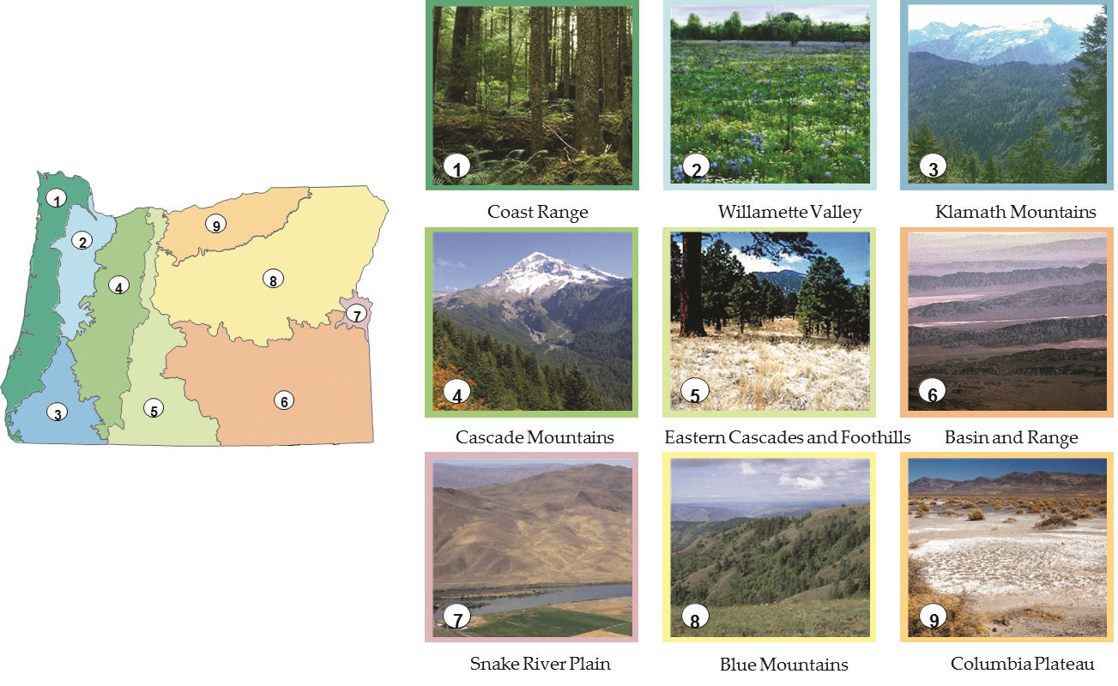

Source: Center for Geography Education in Oregon, Portland State University. The Student Atlas of Oregon. Used with permission.

