

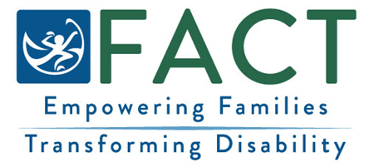

FAMILY SURVEY
We want to hear about your family’s experience with [insert Early Intervention / Early Childhood Special Education EI/ECSE Program name].
What to Know About the Survey
- The survey asks families about their experiences with Early Intervention and Early Childhood Special Education (EI/ECSE).
- Your responses are confidential.

How to Participate
- Families will be invited to complete the survey via secure text message or a paper survey in the mail.
- When you get the survey, please take a few minutes to fill it out.
After You Have Completed the Survey
- A summary of all families’ responses is included in a yearly report. No names or identifying information are included.

- Information from this report is used to help make EI/ECSE services better.
Questions?
Contact [insert EI/ECSE Program contact information].
FACT Oregon: (503) 786-6082 factoregon.org

