Oregon EDPLAN DATA INTEGRATION TOOLKIT

This toolkit provides the information needed to support successful data integration between a Student Information System and EDPlan. It includes helpful information such as an overview of the goals for data integration, check list including the steps that need to be taken and how to get help.

What is EDPlan SIS Data Integration?
Enables regular communication between LEA SIS systems and EDPlan for IEP/IFSP File. It’s important for LEAs to establish automated data feeds from their SIS into EDPlan. This data is key for creating cohorts of students for IEP/IFSP File Reviews in EDPlan. If your LEA does not have an SIS materials will be shared about how to manually add students to EDPlan.

Check lists

Import File Creation
 | Item
☐ | Review Import Specifications and File Formats
☐ | Create the export based on the import specifications
☐ | Confirm the Column Headers Match the Import Specifications
☐ | Confirm the data values match the Import Specifications
☐ | Confirm the file name is correct: Students- abcdef
☐ | If sending Text Files, confirm the delimiter is correct: Tab Delimited; and the file extension is .txt
☐ | If sending Excel Files, the extension is .xls

sFTP Access and Support
 | Item
☐ | Reach out to OREDPlanIntegrations@pcgeducation.zendesk.com for your LEA’s sFTP credentials.
☐ | Generate a test file and verify it matches the Import Specifications (see Import File Creation above) and manually upload the file into the root folder of the sFTP site.
☐ | Reach out to OREDPlanIntegrations@pcgeducation.zendesk.com to create a support ticket to let the support team know a file has been updated and is ready for PCG QA. The PCG support team will review the file and verify the file format and data is compatible for ingestion into EDPlan. If any edits need to be made you will be notified via email reply. The Support team will also ask for an email address where Import Summary emails can be sent to notify your district of successful imports, or when any data may need to be cleansed.
☐ | Once the PCG Support Team has notified you that your file is approved for ongoing imports, schedule the file to auto send / auto export to the Imports folder in the sFTP site. The Imports folder is swept every 10 minutes and files are processed for import. If you are not able to schedule files to auto send to an sFTP files can be manually uploaded to the Imports folder.

sFTP Access

How to Access

Using an FTP Client:
- Install an FTP client: Download and install a client like FileZilla or WinSCP.
  - WinSCP and FileZilla are the most commonly used FTP client access sites
- Enter connection details: Open the client and enter the following:
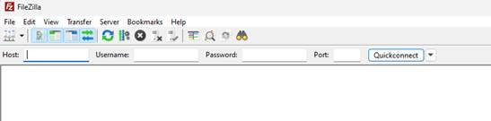
  - Host: The server's IP address or domain name.
  - Port: Typically 21 for standard FTP or 22 for SFTP (SSH File Transfer Protocol).
  - Username: Your FTP username.
  - Password: Your FTP password.
- Connect: Click the connect button (usually labeled "Quickconnect" or "Connect").
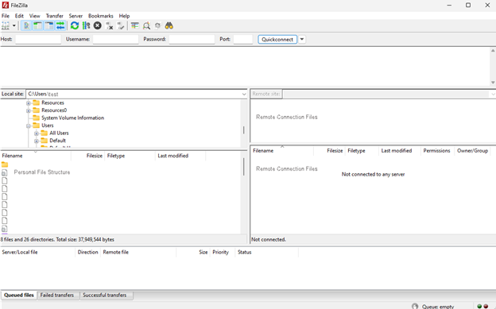
- Navigate to the desired directory: Use the client's interface to navigate to the folder where you want to upload or download files.
- Upload or download files:
  - Dragging and dropping: Simply drag and drop files from your local machine to the remote directory, or vice versa.
- Disconnect: Once you're done transferring files, disconnect from the server.

Validating Data Integration and Support Provided

Initial District Support
The PCG Support team will communicate, review the districts file and verify the file format and data is compatible for ingestion into EDPlan. We will communicate and work through district specific challenges in order to produce a students import.

Ongoing Import Support

Import Summary Review
After a data file processes, an email is automatically sent providing a summary of the Import. These should be periodically reviewed to confirm the data is importing. This summary will also provide a list of any data issues with the import that may need to be addressed. Additionally there is a page in EDPlan that provides an interactive summary of the import status. To access that follow the steps below:

Data QA / Spot Check
If you are getting reports that data is not appearing in EDPlan, the first step is to confirm the data was sent in the file and no import errors were generated by that data. Once you’ve confirmed the data is in the file, verify in EDPlan the data is not appearing. This will be in different locations depending on the type of data that is missing. Once you have verified the data is not in EDPlan reach out to EDPlan Support.

Need Help?
If throughout the process, a district needs individual support on producing the information, the formatting or general integration questions please email OREDPlanIntegrations@pcgeducation.zendesk.com.

