Submission of Materials for ESEA Monitoring
The Elementary and Secondary Education Act, reauthorized in 2015 as the Every Student Succeeds Act (ESSA), was passed as a civil rights law to provide funding and resources to states, districts, and school leaders to enhance their capacity to meet the strengths and needs of educators and students in their community. Each Title program under ESSA has a specific purpose to provide focused resources to support students who are historically, or currently, marginalized and/or are experiencing barriers to an academically enriching curriculum in a safe and inclusive environment. The Federal Systems Team administers many of the grant programs under ESSA and partners with districts in the implementation and oversight of these programs.

What materials do I submit?
The quantity and type of materials required for submission vary by program and are designed to provide evidence of the district’s use of funds and compliance with programmatic requirements. The district should submit materials from the previous school year.
The Submission List outlines the evidence, by indicator, to be submitted for each program. Please submit PDFs whenever possible, however, Excel, Word and graphic formats (e.g., JPEG) can also be accommodated. Programs monitored include:
- Title I, Part A Improving the Academic Achievement of the Disadvantaged
- Title I, Part D Subpart 2 Neglected or Delinquent or At-Risk Children
- Title II, Part A Supporting Effective Instruction
- Title IV, Part A Student Support and Academic Enrichment (SSAE)
- Title V, Part B Rural Education Achievement Program & Rural Low Income Schools
- Title VII Education for Homeless Children and Youth program
- Equitable Services to Private Schools
- Foster Care

When are materials due?
To provide ODE staff ample time to prepare, districts are asked to complete submission of materials two weeks prior to the desk monitoring date.

How do I submit materials?
All materials must be submitted electronically In OneDrive. Please send an email to federalprograms@ode.oregon.gov with the names and email addresses of any district staff who will be uploading materials to the district folders created by ODE. ODE will restrict access to the folders to only those staff members the district designates.
Once email addresses have been provided to ODE, each person who is given access will receive a notification via email and should follow these steps:
- Click on the OPEN link within the email from ODE.
- Click on the SEND CODE link to request the Verification Code.
Note: The Verification Code email will come from “noreply@sharepointonline.com” and may be routed to your SPAM folder.
- Open the Verification email and enter the code.

Where do I put materials?
After completing the steps above, staff will be able to access the folder structure named for their district. ODE has designed the folder structure (see below) to align with the title programs being monitored.
Additional folders are embedded within each program folder. Materials should be uploaded to the folder that corresponds with the monitoring indicator to which it relates.
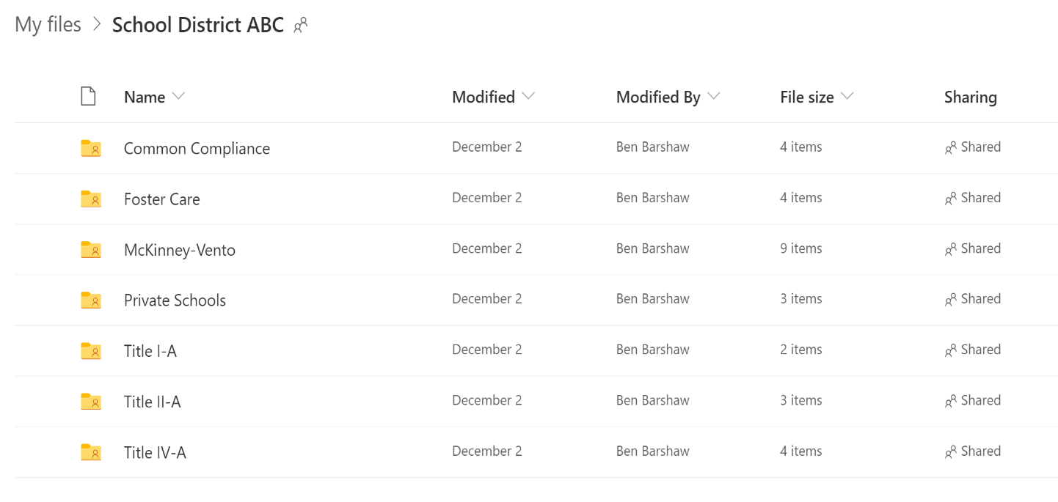

Special Directions for Title I, Part A
Title I-A programs fall into two categories – School Wide and Targeted Assistance. Within the Title I-A folder structure districts will find a folder for each of these types of programs.
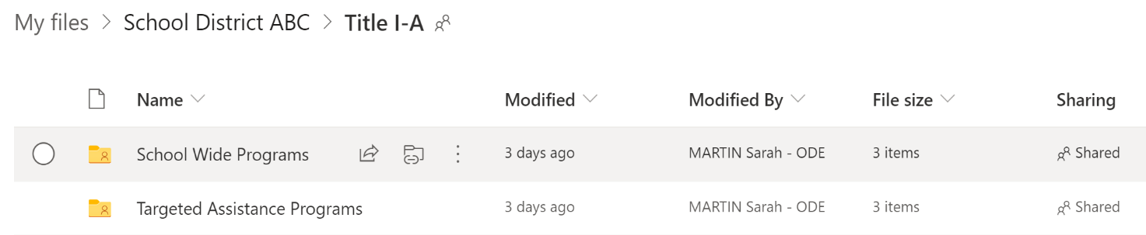
Embedded in each of these program folders are placeholder folders for schools. ODE has identified which schools’ materials should be submitted and has named the folders accordingly.
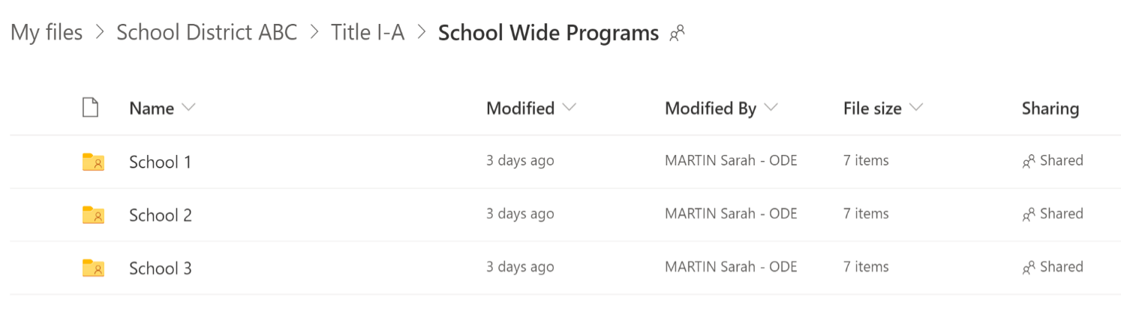
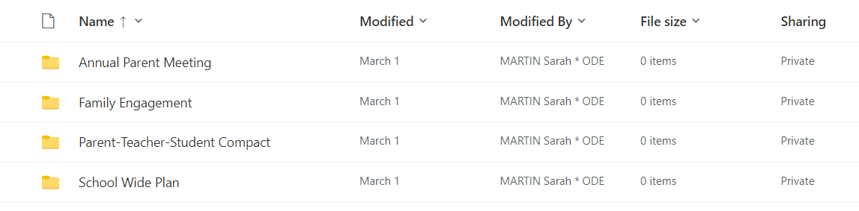
All the required evidence should be uploaded for each school identified.

Who can help me?
For questions about using OneDrive, contact federalprograms@ode.oregon.gov
If you have questions or need support regarding the materials submission process, please contact your district’s monitoring lead:
- Jen Engberg - jennifer.engberg@ode.oregon.gov; (971) 208-0326
- Sarah Martin - sarah.martin@ode.oregon.gov; (971) 208-0333
- Amy Tidwell – amy.tidwell@ode.oregon.gov; (503) 580-0078

