

Enhancing Student Opportunities Data Collections

Coordinated Early Intervening Services Collection

User Guide
September 2025
OREGON DEPARTMENT OF EDUCATION
Office of Student Services
255 Capitol Street NE
Salem, OR 97310-0203

Contents
What’s New 1
September 2025 1
Getting Access on the District Website 2
Overview 4
Submission Steps 5
Step 1: CEIS DATA 5
Step 2: USE OF IDEA FUNDS FOR CEIS 9
Step 3: Review 13
Contact Information 13
ODE Help Desk & Data Security and Privacy Overview 14
Contact Information 14
Services 14
Help Desk vs. Data Team – who to call? 14
ODE Help Desk: What to Expect 14
Data Security and Privacy 15
Student Data Security: Handle with Care 15
ODE Policies 15
Information Security Questions 15

What’s New
Changes for the Coordinated Early Intervening Services collection for 2025-2026.

September 2025
- CEIS Data tab changes:
  - Will display the IDEA Fund year selected for CEIS that the district indicated in the Use of IDEA Funds for CEIS tab the prior year.

Getting Access on the District Website
The Coordinated Early Intervening Service (CEIS) collection is accessed within the IDEA Data Manager. If you do not already have access, please contact your district’s Security Administrator.
If you do not know who your District Security Administrator is, go to the District Home page, and on the right-hand side beneath QUICK LINKS, click Find Security Administrator.
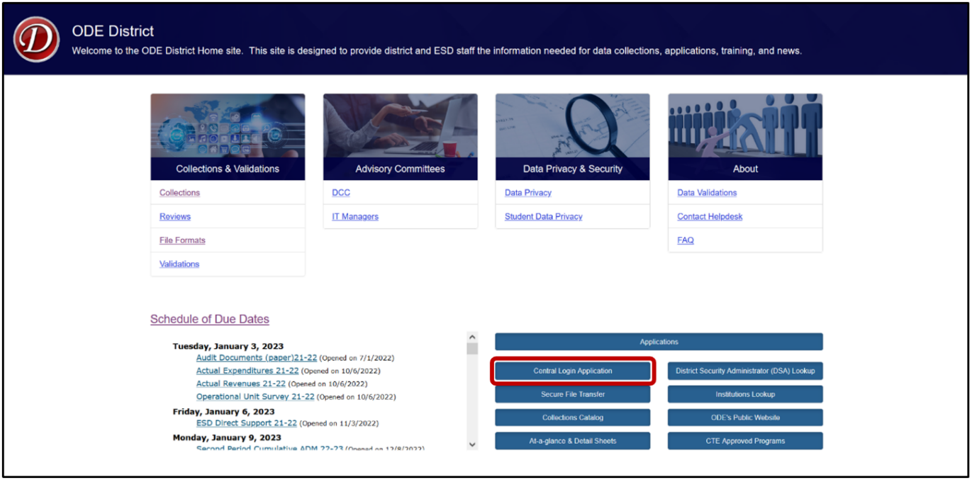
On the Search for Security Administrator page, follow the instructions on the screen.
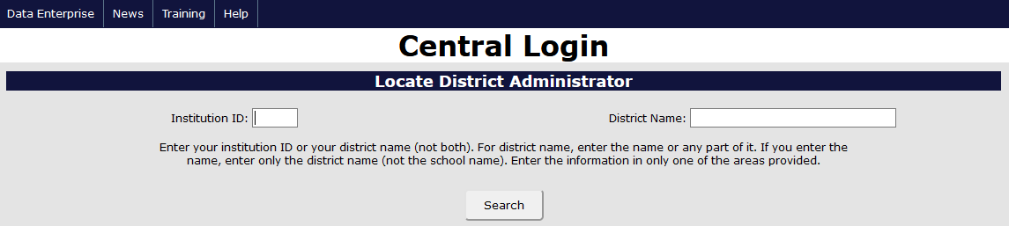
When requesting access to applications such as collections or the IDEA Data Manager, data submitters must request Primary Submitter and Modify rights. Users should verify with their District Security Administrator that they have both permissions. Without both, users will not have the ability to view, submit or edit data.

Once logged into the District website, select IDEA Data Manger in the Applications List.
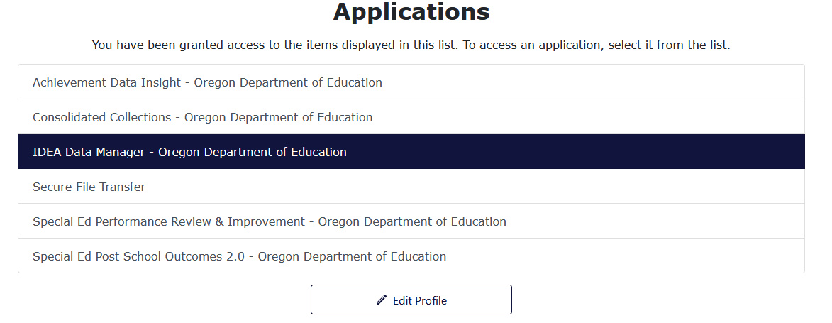
Once in the IDEA Data Manger, select Other Collections in the Left Navigation Menu. From there, select CEIS to access the data entry tabs.
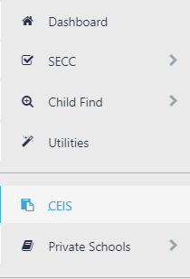

Overview
All districts must complete, submit and verify a submission for the Coordinated Early Intervening Services (CEIS) Collection. The CEIS collection contains three tabs:
Tab 1. OVERVIEW. This provides an overview of the collection.
Tab 2. CEIS DATA. Data entry for the PRIOR school year.
Tab 3. USE OF IDEA FUNDS FOR CEIS. Data entry for the CURRENT school year.
Note: the information reported on this tab will tie to the data your district will collect and report in Tab 2 (CEIS Data) next year.
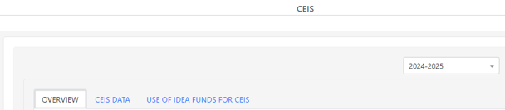
Both tabs 2 and 3 must be submitted and verified for your submission to be considered complete.
To see prior year data, use the School Year drop menu on the top right. Click the drop arrow to expand the menu.
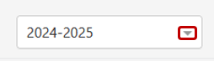
After clicking the arrow, the drop menu will display the prior years available to view. These prior year screens are view only and are not editable as the collection windows are closed.
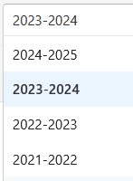

Submission Steps

Step 1: CEIS DATA
This tab collects information concerning CEIS during the prior year. The data entry screen is hidden when No is selected, and is not hidden when Yes is selected. If changing selection to Yes, the data entry screen will appear.
If Voluntary CEIS:
- Indicate if your district voluntarily used up to 15% of its IDEA funds for CEIS. If your district indicated it would reserve funds in prior year collection, “Yes” will be preselected for your district.
- If No, click the Save button in the bottom right, then the Submit & Verify Button. Proceed to Step 2: Use of IDEA Funds for CEIS.
- If Yes, answer questions A through C (see below).
If Required CCEIS:
- If your district was identified for significant disproportionality for the respective school year, “Yes” will be preselected for your district.
- Answer questions A through C (see below).
A. Enter CEIS Student Count. This is the total number of students who received CEIS from your district during the prior school year. This is an unduplicated count. Note that this count cannot be zero if funds were used for CEIS. Count each student who received CEIS using IDEA funds.
If Voluntary CEIS:
Districts will only enter data into the “Count of students without disabilities” field. The “Count of students with disabilities” is not editable for Voluntary CEIS districts. As users enter data, the Student Counts field will automatically calculate the student total.
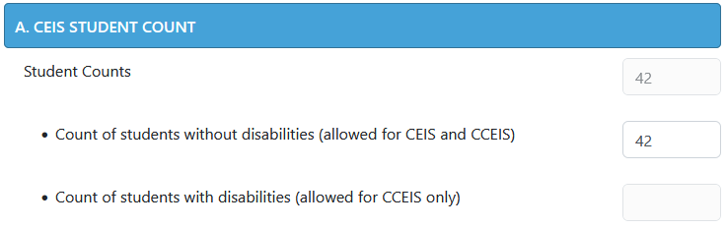

If Required CCEIS:
Districts will enter data into both “Count of students without disabilities” and “Count of students with disabilities” fields, both of which are required for CCEIS/Required districts. If no students were served for one of the two student groups, enter 0. As districts enter data, the Student Counts field will automatically calculate the student total.
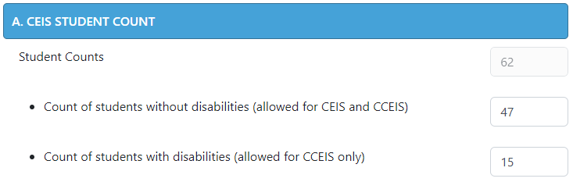
B. Enter Special Education Student Count. This is the total number of students who received special education services under Part B of IDEA in the prior AND CEIS during the current and/or preceding two-years. This is an unduplicated count. Count each student only once.
The example below is for the 2025-2026 collection, where the total number of special education students is from the 2024-2025 school year, and the three prior years for receiving CEIS were 2022-2023, 2023-2024 and 2024-2025.
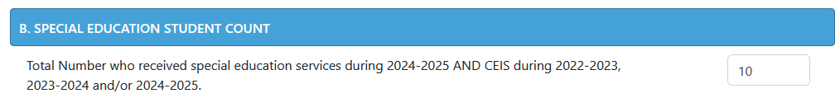

C. Enter Actual Expenditures For CEIS. This is the total amount of prior year IDEA Funds your district expended/is expending. This amount can be expended in one year or over two years. Note the exact amount your district is expending for CEIS is required for the federal reporting purposes.
This section will display the IDEA Fund year selected for CEIS that the district indicated in the Use of IDEA Funds for CEIS tab the prior year. If a district selected IDEA Fund Year 2024-2025 for CEIS the prior school year, then the application will display “IDEA Fund Year Selected for CEIS: 2024-2025.”
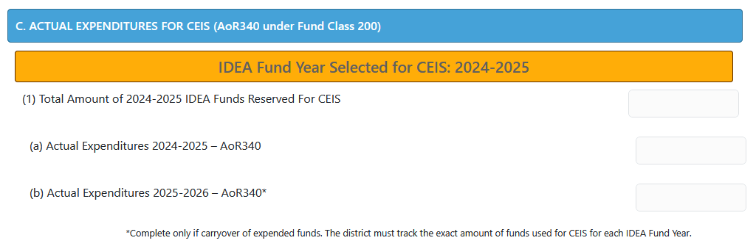
The example below is for the 2025-2026 collection, regarding the 2024-2025 IDEA Funds expenditures, which can be expended during 2024-2025 or during 2024-2025 and 2025-2026.
- Enter Total Amount of 2024-2025 IDEA Funds Reserved For CEIS (C1). This is the total amount of IDEA Flow-Through Funds that your district set aside for voluntary or required CEIS in the prior year.
- Enter Actual Expenditures for 2024-2025 (C1a). This the total amount that your district expended in 2024-2025. It can be the total indicated in C1 or a portion if your district is expending these funds over two years.
- Enter Actual Expenditures for 2025-2026. Enter “0” if the total amount reserved for CEIS was expended in 2024-2025 (C1b). If expending the funds over two years, enter the remainder to be expended. C1a plus C1b must equal C1. If C1a plus C1b does not equal C1, then the system will generate a warning message.
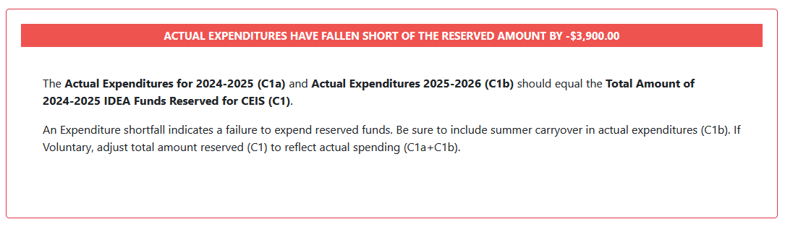

- Check the Total Amount of 2024-2025 IDEA Funds Reserved For CEIS. If a red bar with a note appears, an incorrect value was entered. Verify and correct amounts entered for C1, C1a or C1b.
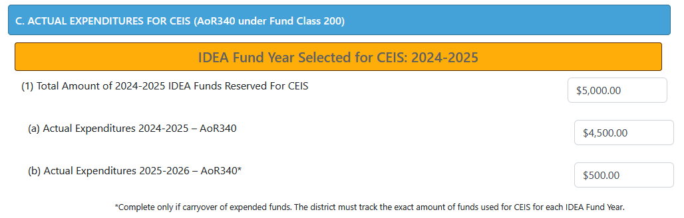
- Click the Save button in the bottom right, and if no errors are displayed in red in the top right, click the Submit & Verify button.
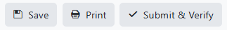
- Proceed to Step 2. Use of IDEA Funds for CEIS.

Step 2: USE OF IDEA FUNDS FOR CEIS
This tab collects information concerning the district’s planned use of IDEA funds for CEIS during the current school year. The IDEA Flow-Through estimates and 15% cap are shown at the top of this tab. Like the CEIS Data tab, this screen is hidden when No is selected, and is not hidden when Yes is selected.
Plan Approval of CCEIS
Required/CCEIS districts will see a note at the top of the tab regarding plan approval. When a district clicks Save and then Submit and Verify button, ODE staff will review the CCIES plan and then will select the Yes or No flag.
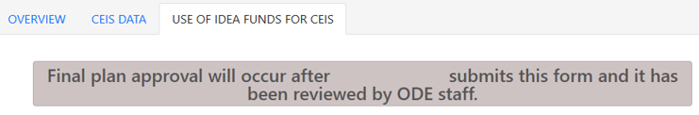
When a plan is approved by ODE staff, the system will display the date the plan was approved. Districts will not be able to modify their plan after it has been approved by ODE staff. If edits are required, contact a member of the data team to request a reset of the plan approval. Once reset, the Use IDEA of Funds for CEIS tab will editable. After the district is done, click the Save and then Submit and Verify buttons so ODE can review the plan for approval.
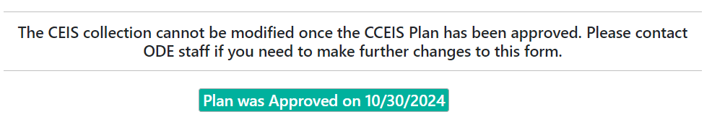
When a plan is not approved by ODE, the system will display an Action Required box with a message from ODE on why the plan was not approved. District staff will update the plan accordingly, then click the Save and Submit and Verify buttons so ODE can review the plan for approval.
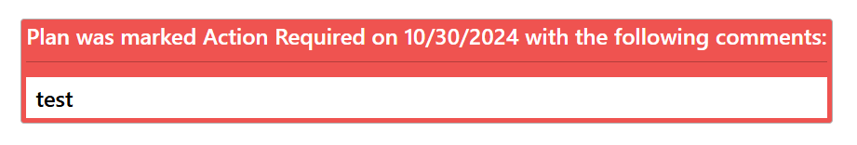
An email will be sent to district staff indicating if the plan has been approved or if action is required. If action is required, the email will also contain the Action Required message.
A. IDEA Funds Reserved For CEIS
If Voluntary CEIS:
- If “No, Not Required” click the Save button in the bottom right, and if no errors are displayed in red in the top right, click on the Submit & Verify button.
- If “Yes, Voluntary” answer questions B through C (see below).
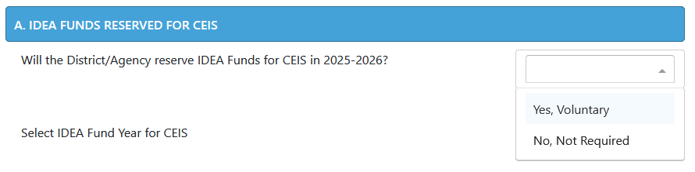
If Required CEIS:
- If your district was identified for significant disproportionality, “Yes, Required” will be preselected and not editable by your district.
- Answer questions B through C.
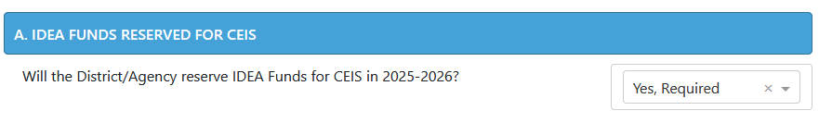
Then uses will select the CEIS Fund Year the district plans to use. The Flow Through Allocation and 15% cap will display the fund year the district selects.
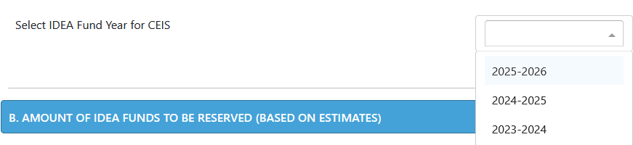
B. Enter the Total amount of IDEA Funds the District/Agency will reserve for CEIS.*
If Voluntary CEIS, this cannot exceed the capped amount shown, which is 15% of your IDEA Funds. The district will need to determine how much of the 15% they will reserve for CEIS.
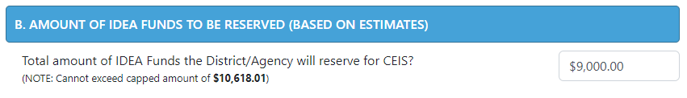
If Required CEIS, the district must expend the entire capped amount shown, which is 15% of your IDEA Funds.
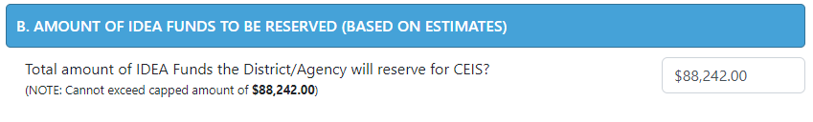
*Note that in the event that your estimated flow-through amount changes, the capped amount will change and your district will need to adjust actual expenditures for CEIS accordingly.
C. Enter information for CEIS Activities Planned.
- Grade levels: Select low grade from dropdown then select high grade from dropdown. This is the grade range that will be the focus of the CEIS Activities planned.
- Group served: Select Group to be served from dropdown. Note if Voluntary, “Students without Disabilities” must be selected. If Required, either can be selected.
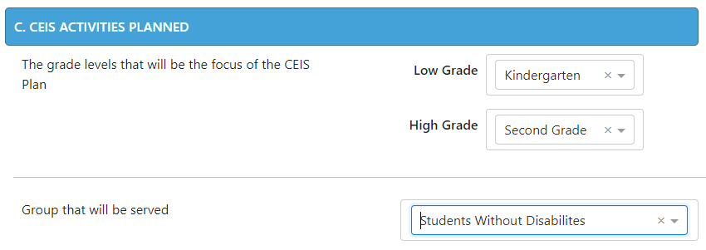
- Select Academic/behavioral area or areas that will be the focus of the CEIS Plan. Note that up to four areas may be selected.
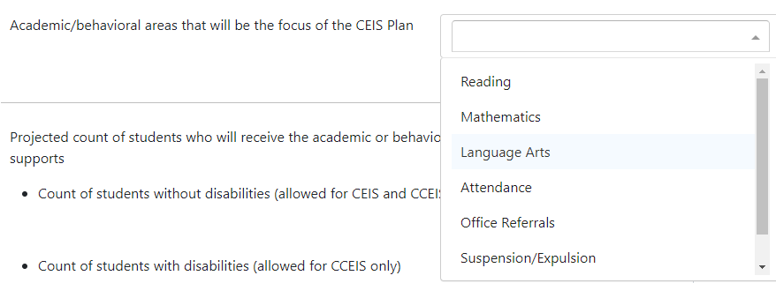
- Enter Projected Count of Students. This is an estimate and not expected to be the exact count of students receiving services and supports. The exact count will be reported next year on the CEIS Data tab.
        - Districts that are Voluntarily spending IDEA funds for CEIS will enter their projected count in the “Students without disabilities (allowed for CEIS and CCEIS)” field.
          - The “Count of students with disabilities (allowed for CCEIS only)” field will be grey and defaulted to zero. This field is not editable for Voluntary/CEIS.
          - The “projected count of students” field will populate a total for both fields. This field is not editable.
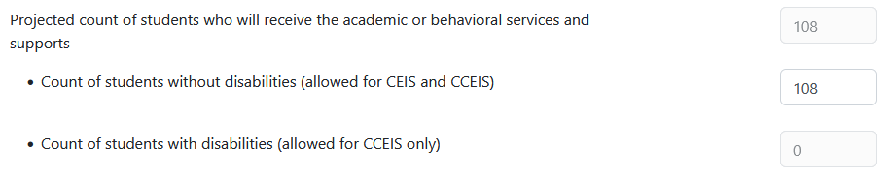
        - Districts that are Required to spend IDEA funds for CCEIS will enter their projected count in the both fields.
          - The “Count of students with disabilities (allowed for CCEIS only)” field is required. If the district projects zero students, then enter 0.
          - The “projected count of students” field will populate a total for both fields. This field is not editable.
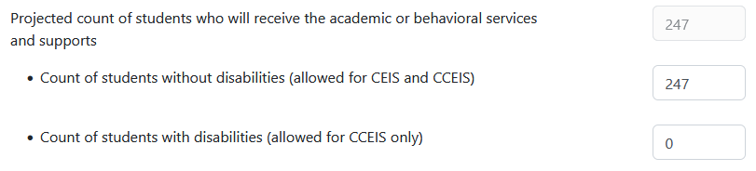
- Enter Activity Type and Description. You may enter up to five activities. Select the activity type and provide a general description of the activity. Descriptions should be brief but descriptive enough to convey the activity to be implemented for CEIS. Note: If Required CCEIS, the activities should relate to identified area(s) of significant disproportionality that CEIS funds is addressing.
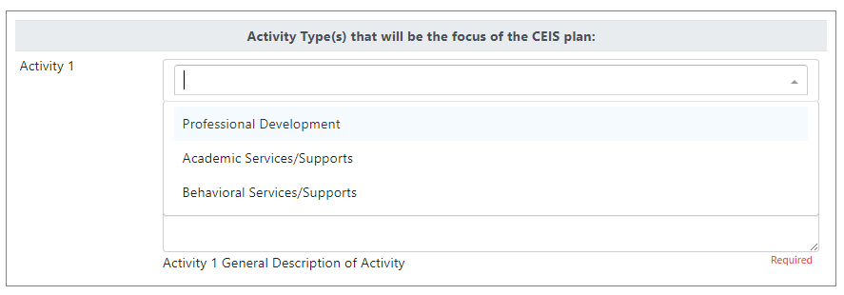
- Click the Save button in the bottom right, and if no errors are displayed in red in the top right, click on the Submit & Verify button.
- Proceed to Step 3. Review

Step 3: Review
Check your responses to all questions on both tabs.
- If no errors, your submission is now complete.
- If errors, correct, then click on the Save and Submit & Verify buttons again.
Printing. Your submission information may be printed by clicking on the Print button.

Contact Information
For further assistance, please contact:
- Cynthia Garton, 503-508-7492 or cynthia.garton@ode.oregon.gov
- Jackie McKim, 971-240-0234 or jackie.mckim@ode.oregon.gov

ODE Help Desk & Data Security and Privacy Overview

Contact Information
ODE Helpdesk ODE.Helpdesk@ode.oregon.gov (503) 947-5715

Services
ODE Help Desk can

- Provide technical assistance with how to submit your data
- Check to see if your data has submitted
- Provide assistance with questions about access rights and permissions
ODE Help Desk can not
- Submit your data for you
- Make changes to your data
- Answer content area questions

Help Desk vs. Data Team – who to call?
Question | Answer
How to report a student? | Data Team
Why won’t my data submit? | Data Team (will refer to HelpDesk if needed)
Audit/Error Corrections? | Data Team
How can I get a new user added? | ODE Help Desk

ODE Help Desk: What to Expect
The ODE Help Desk is at ODE.Helpdesk@ode.oregon.gov or (503) 947-5715

Data Security and Privacy

The student data that you collect, handle, and submit is protected student data governed by:
- Family Educational Rights and Privacy Act (FERPA) (34 CFR Part 99)
- Oregon Identity Theft Protection Act
- And in some cases, the Health Insurance Portability and Accountability Act (HIPAA), such as the transfer of records between agencies
Consequences: Loss of protected data can have financial impact to your school, district, or ESD, including fines and cost of remediation!

Student Data Security: Handle with Care
Basic tips to protect student level data
- Use Secure File Transfer. Never send information that would identify an individual student via email, not even to the ODE Help Desk or a member of the Data Team. Emails sent to and from the ODE are considered public record.
  - In order to provide information to ODE, it is advisable to send only the student’s SSID number
  - Never send student’s name, birth date, telephone number, grade or anything else that could be used to identify a specific student.
  - On ODE’s Secure File Transfer users can send secure documents to ODE Staff.
  - The Consolidated Collections manual has instructions how to send a Secure File Transfer.
- Never share your username and password
  - You are responsible for everything done in the system using your username and password
  - Avoid storing your password in an obvious place (desk drawers, under keyboards, sticky notes on monitors are all bad places to store passwords)
- Use a Passphrase instead of a Password
  - Passphrases are sentences you can remember and include spaces and punctuation.
  - Example: Trust the force, Luke!
  - Example: Scotty, beam us up.
- Lock your computer monitor (Window key +L) when you leave your desk
  - Avoid leaving your monitor open and unattended
- Never store or transport student data on an unencrypted thumb drive/flash drive
  - Portable drives are one of the biggest risk factors for losing large volumes of data
 | The privacy and security of student data depends upon you.  People are the most important part of information security

ODE Policies
Handling Confidential Information
Information Asset Classification

Information Security Questions
Contact ODE Chief Information Security Officer and Team at ODE.Infosec@ode.oregon.gov.

