
Abbreviated School Day Application Manual
September 2024
Oregon Department of Education
Office of Enhancing Student Opportunities
255 Capitol Street NE
Salem, OR 97310-0203

It is the policy of the State Board of Education and a priority of the Oregon Department of Education that there will be no discrimination or harassment on the grounds of race, color, religion, sex, marital status, sexual orientation, national origin, age or disability in any educational programs, activities or employment. Persons having questions about equal opportunity and nondiscrimination should contact the Deputy Superintendent of Public Instruction at the address above; phone 503-947-5600; or fax 503-378-4772.

Table of Contents
What’s New 1
September 2024 1
General Information 2
Purpose 2
Introduction 2
Contact List 2
Training & Materials 2
ODE Help Desk & Data Security and Privacy Overview 4
ODE Helpdesk Contact Information 4
Services 4
Help Desk vs. Data Team – who to call? 4
ODE Help Desk: What to Expect 4
Data Security and Privacy 5
Student Data Security: Handle With Care 5
ODE Policies 5
Information Security Questions 5
Navigating the Abbreviated School Day Application 6
Login Information 6
Dashboard 8
Record Counts 8
Messages 9
Basic Record Navigation 9
Menu/Buttons 9
Viewing Abbreviated School Day Program Records 10
Submitting Data to the Abbreviated School Day Application 11
Submitting New Abbreviated School Day Program Records 12
Abbreviated School Day Application Fields 14
Uploading a Consent Form PDF 16
Viewing Consent Documents 17
Update History 17
Other Student Record Information 17
Editing an Existing Record 18
Coding Key Fields 20
Resident District Student 20
Resident District - District Placed in Private School 20
Resident District - Schools with Different Lengths of Day 21
Resident District - Online Asynchronous 21
Resident District - Virtual Charter School 22
Resident District Student - Other Local or Regional Correctional Facilities (Not ACEP, YCEP, or JDEP) 22
Long Term Care and Treatment (LTCT) program (Contractor Submission) 23
Hospital Program Student (Contractor Submission) 23
Pediatric Nursing Facility (PNF) 24
State Placed Juvenile Detention Education Program (JDEP) Student (Contractor Submission) 24
State Placed Youth Corrections Education Program (YCEP) (Contractor Submission) 25
Program Reason Code Scenario Help 26
Online Asynchronous 26
Virtual Charter School 26
Schools with Different Lengths of Day 26
Long Term Care and Treatment (LTCT) program 26
District Placed in Private School 27
On Track to Graduate 27
Verification Process 28
Production Download 29
Steps for Accessing a Production Download 29
Frequently Asked Questions 32
Appendices 33
Program Reason Codes 33
Program Stop Reason Codes 33

What’s New

September 2024
- New Abbreviated School Day Program Application
  - New Dashboard look
  - New data entry format
- New monthly verification requirement
- Updates to Program Reason Codes
  - Removed Reason Codes:
    - 03 - Student/Parent Choice Alter Education Program
    - 04 - Graduation Credits Obtained
    - 05 - Court Order
  - New Reason Codes:
    - 07 - Adult Transition Needs
    - 08 - Charter School Schedule
    - 09 - Virtual Asynchronous Instruction
    - 10 - Special School or Program
    - 11 - Virtual Public Charter School
  - Renamed Code 01 to Social/Emotional/Behavioral Needs
- New Program Stop Reason Codes
- New Download Reports

General Information

Purpose
The Abbreviated School Day Application collects student level records who are on an Abbreviated School Day Program. SB 819 was signed into law on July 13, 2023 and outlines the provisions relating to Abbreviated School Day Programs.
It is open year around for each school year. Records are reported on students who are on an IEP, 504 or referred for an evaluation for IEP or 504 who are on an Abbreviated School Day Program.

Introduction
The purpose of this document is to be an easy reference tool for individuals responsible for reporting data related to the Abbreviated Day Application. If this manual does not provide the guidance necessary to answer a specific data collection question, please contact ODE collection staff. It is extremely important that data submitted for all collections are accurate, valid, and reliable.
Icon | Description
 | An information circle indicates an informational note.
 | A light bulb indicates a useful tip.
 | A warning triangle indicates a warning, and the user should use caution.

Contact List
Cara McMurry Research Analyst (503) 689-2783 cara.mcmurry@ode.oregon.gov
Elizabeth Jankowski Education Specialist (503) 881-9798 elizabeth.jankowski@ode.oregon.gov
Data Support Data Team (in lieu of Cara) ode.oss-datateam@ode.oregon.gov

Training & Materials
Collection documents, including the collection manual and training resources are located on the on the District Application page.
Important - Please Read
Rules for Submitting Timely & Accurate Abbreviated School Day Data
- Keep your data up to date at all times. As soon as a record is reportable, enter it.
- Read all the instructions and documentation related to the data collection.
- Submit data as early as possible, but do not rush! Technology, weather, and other factors beyond district control can suddenly keep a district from submitting a record.
- Train at least one backup person to submit, validate, and correct data for each data collection. Key people may get sick, injured, or leave without notice. Do not forget to have the District Security Administrator grant appropriate permissions to the backup staff member. Your District’s Security Administrator can be found on the ODE District website.
- Make a plan. Collect and report records throughout the school year as they become reportable for this application.
- If you have questions, contact the data collection owner at the ODE as soon as possible. ODE data owners are here to help you.
Following these rules throughout the year will help reduce the risk of your district being late and/or inaccurate.

ODE Help Desk & Data Security and Privacy Overview

ODE Helpdesk Contact Information
ODE Helpdesk ODE.Helpdesk@ode.state.or.us (503) 947-5715

Services
ODE Help Desk can

- Provide technical assistance with how to submit your data
- Check to see if your data has been submitted
- Provide assistance with questions about access rights and permissions
ODE Help Desk can not
- Submit your data for you
- Make changes to your data
- Answer content area questions

Help Desk vs. Data Team – who to call?
Question | Answer
How to report a student? | Data Team
Why won’t my data submit? | Data Team (will refer to HelpDesk if needed)
Audit/Error Corrections? | Data Team
How can I get a new user added? | ODE Help Desk

ODE Help Desk: What to Expect
When you call or email ODE Help Desk, the best way to contact the ODE Help Desk is at ODE.helpdesk@state.or.us or (503) 947-5715.

Data Security and Privacy

The student data that you collect, handle, and submit is protected student data governed by:
- Family Educational Rights and Privacy Act (FERPA) (34 CFR Part 99)
- Oregon Identity Theft Protection Act
- And in some cases, the Health Insurance Portability and Accountability Act (HIPAA), such as the transfer of records between agencies
Consequences: Loss of protected data can have financial impact to your school, district, or ESD, including fines and cost of remediation!

Student Data Security: Handle With Care
Basic tips to protect student level data
- Use Secure File Transfer. Never send information that would identify an individual student via email, not even to the ODE Help Desk or a member of the Data Team. Emails sent to and from the ODE are considered public record.
  - In order to provide information to ODE, it is advisable to send only the student’s SSID number
  - Never send student’s name, birth date, telephone number, grade or anything else that could be used to identify a specific student.
  - On ODE’s Secure File Transfer users can send secure documents to ODE Staff.
  - The Consolidated Collections manual has instructions how to send a Secure File Transfer.
- Never share your username and password
  - You are responsible for everything done in the system using your username and password
  - Avoid storing your password in an obvious place (desk drawers, under keyboards, sticky notes on monitors are all bad places to store passwords)
- Use a Passphrase instead of a Password
  - Passphrases are sentences you can remember and include spaces and punctuation.
  - Example: Trust the force, Luke!
  - Example: Scotty, beam us up.
- Lock your computer monitor (Window key +L) when you leave your desk
  - Avoid leaving your monitor open and unattended
- Never store or transport student data on an unencrypted thumb drive/flash drive
  - Portable drives are one of the biggest risk factors for losing large volumes of data
The privacy and security of student data depends upon you.
People are the most important part of information security

ODE Policies
Handling Confidential Information
Information Asset Classification

Information Security Questions
Contact ODE Chief Information Security Officer and Team at ODE.Infosec@ode.state.or.us.

Navigating the Abbreviated School Day Application
The Abbreviated School Day application is located on the ODE District website.

Login Information
Access your applications list from the ODE District site at https://odedistrict.oregon.gov/Pages/default.aspx. Click on the Central Login Application button.
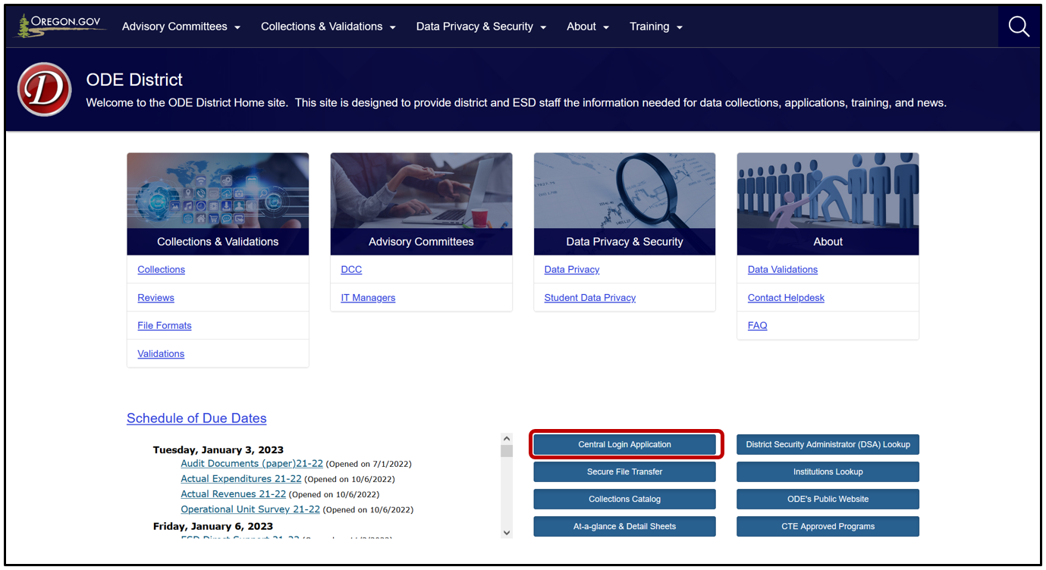
Enter your Username and Password, then click Login.
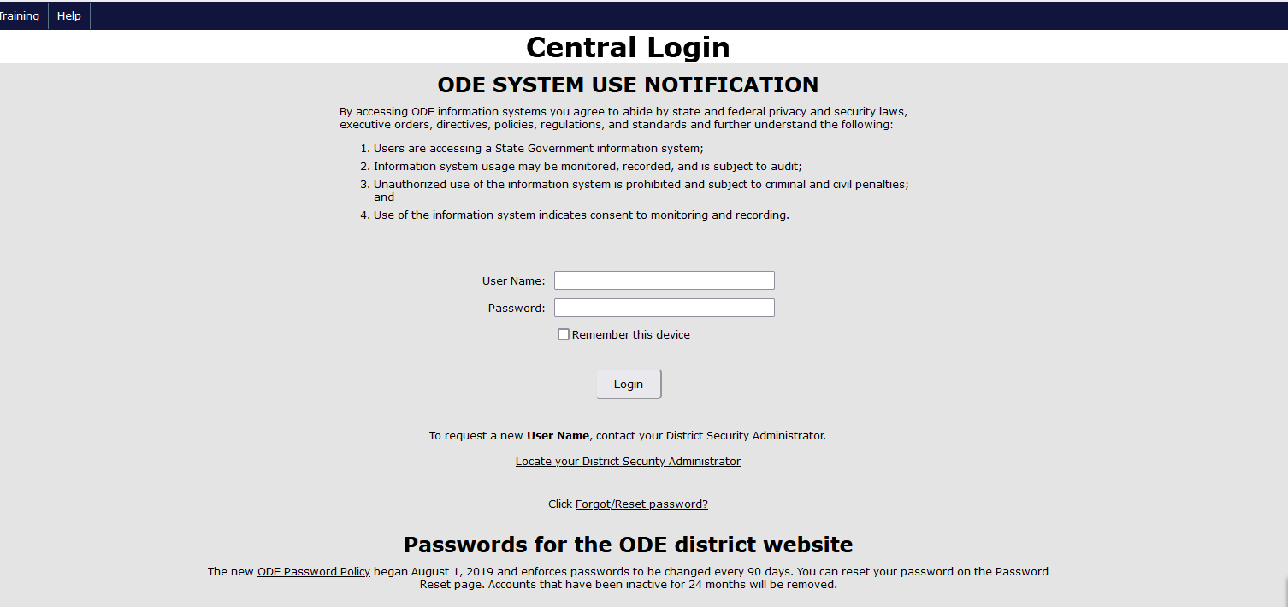

Logging in takes Users to their Applications List, (yours might appear differently).
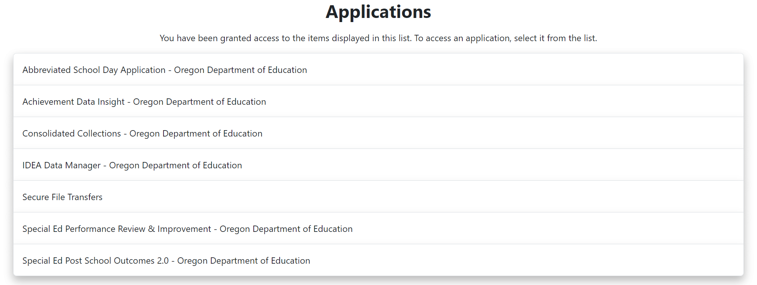
From the Applications list, click on Abbreviated School Day Application.
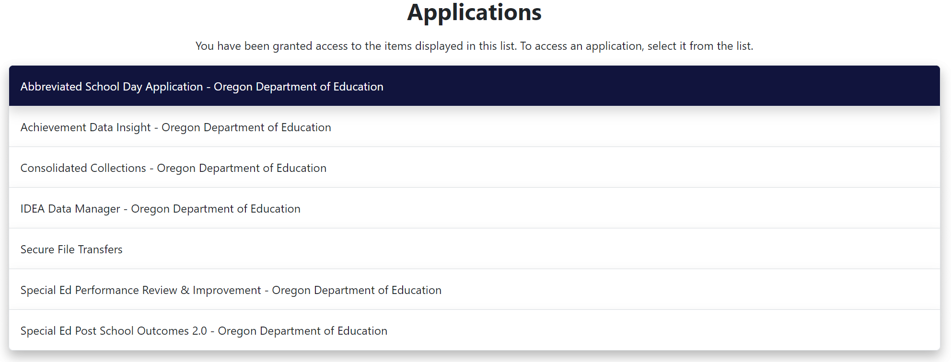

Dashboard
There are several important basic elements of the new Home dashboard.

Record Counts
Across the top of the screen, you will see a ribbon with five different summary counts. Each Open count summarizes the number of open records in the application based on the number of calendar days since the program Start Date. Four of the count summaries include only records without a Stop Date. The Total Records for Current School Year count includes all records, with or without a Stop Date for the current school year.
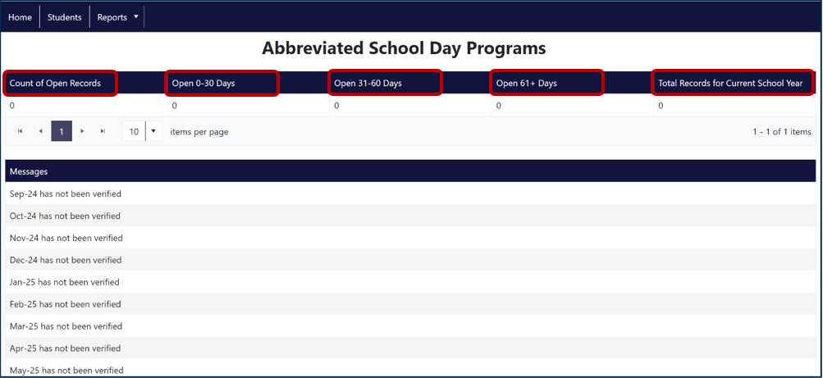

Messages
Below the Record Counts ribbon, users will see another ribbon labeled Messages. This is where users will see the monthly verification report status for the current school year. Districts will need to verify that the count of records submitted are correct by the end of each month, September through June.
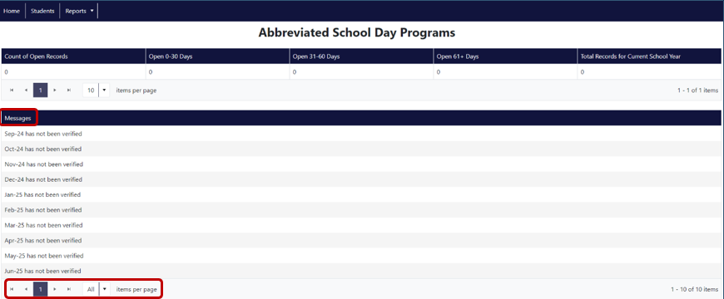

Basic Record Navigation
By clicking on Messages ribbon, users can sort the messages by month, descending or ascending. Users can also change the number of messages that appear in the grid by clicking on the drop-down next to “items per page.” There are options to see 10, 25, 50, 100, or all messages at once.
Users can also navigate through the pages of messages by clicking on the backwards and forwards arrows next to the drop-down.
|< will take you to the very first page
< will take you back one page
> will take you forward one page
>| will take you to the very last page

Menu/Buttons
In the top left corner of the Dashboard, there are three button/menu options that navigate to different sections of the Application:
- Home – Displays Messages
- Student – Displays the student records
- Reports – Menu options for Verification and Production Download Reports

Viewing Abbreviated School Day Program Records
In the top left corner of the Dashboard, click on the Student button.
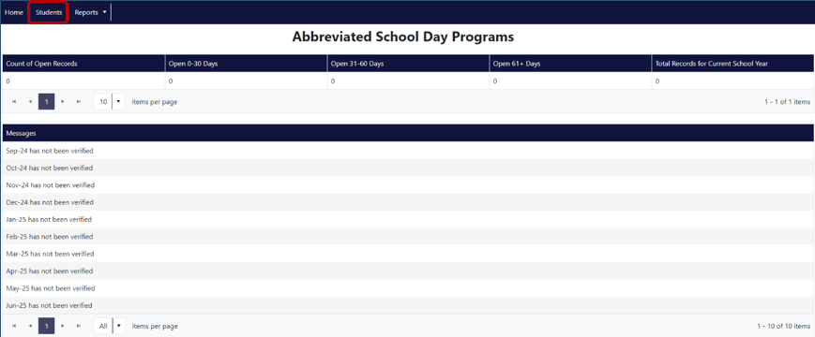
Users will be able to search for an existing Abbreviated School Day Program record or add a student requiring a new record. The Students dashboard will show the list of students who have been submitted for the current or previous school year.
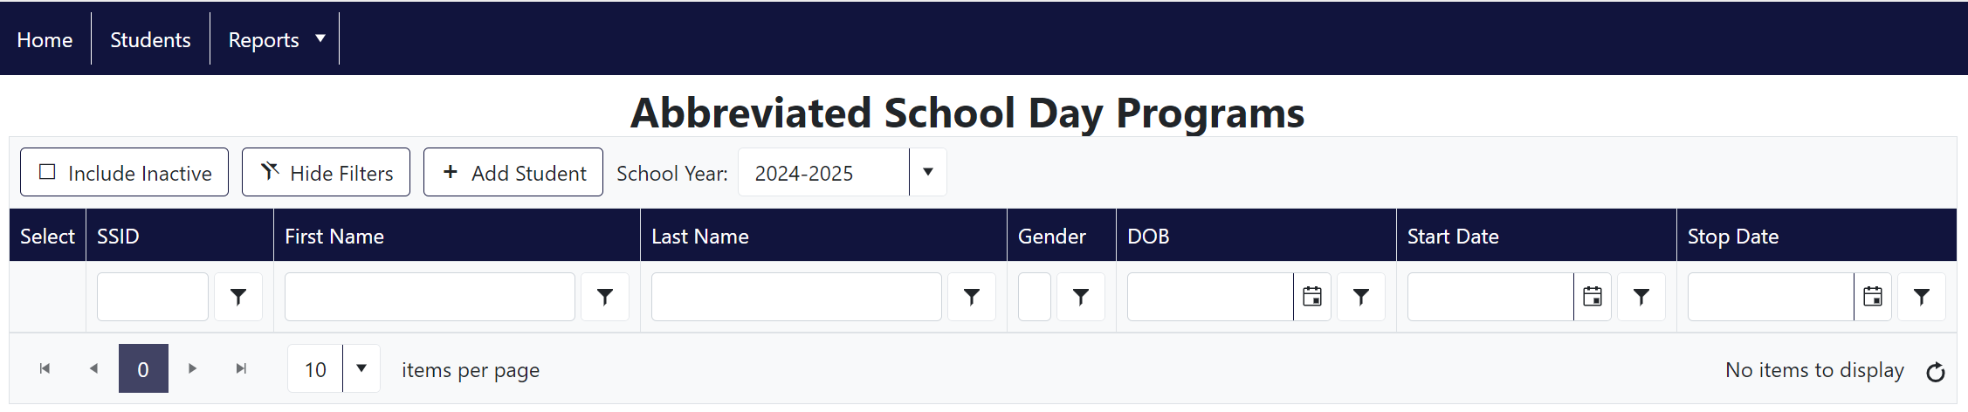
By clicking on any of the words in the ribbon, users can sort the records by SSID, First Name, Last Name, Gender, DOB, Program Start Date, or Program Stop Date, in descending or ascending order.
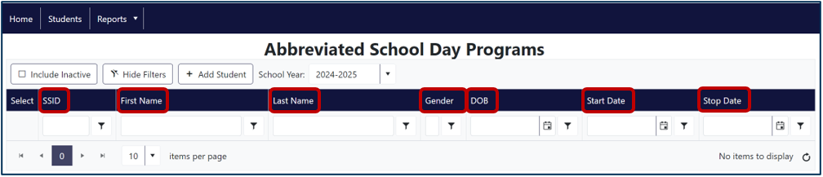

Submitting Data to the Abbreviated School Day Application
Abbreviated School Day records are submitted by the Resident District and submitting agencies for applicable programs. Report students on a Special Education IEP, 504 Plan, or referred for an initial evaluation for special education or 504 Plan, who are on an Abbreviated School Day Program. An Abbreviated School Day Program per SB 819 is defined as:
- An education program in which the school district restricts access for a student with a disability to hours of instruction or educational services to less than the number of hours of instruction or educational services that are provided to the majority of other students who are in the same grade within the student’s resident school district
- That results in a student with a disability having an abbreviated school day for more than 10 school days per school year.
Criteria for Reporting a Record:
A record becomes reportable to this collection when a student who is on an IEP, 504, or referred for an evaluation for either, is considered on an abbreviated school day program for greater than 10 days. On day 11, the student is reported in the application.
If Count of Days Are 11 Consecutive Days:
Report one record by entering the first day the student was on an abbreviated school day as the Abbreviated School Day Program Start Date. Do not enter day 11 as the Abbreviated School Day Start Date.
If Count of Days are 11 Cumulative Days:
Report multiple records, one for each instance leading up to a count of 11 days total.
Report all records that meet the criteria from July 1 to June 30.
- The application is open year around, so records meeting the criteria should be reported as soon as possible. The same day or the next day is best.
- Only one open record allowed per student in school year. A student can have multiple records reported, but only one with BLANK Abbreviated School Day Program Stop Date.
Submitting Agencies (see Coding Key Fields for more information):
- Resident Districts
- Contractors (districts and ESDs) on behalf of resident districts for the following programs:
- Long Term Care and Treatment (LTCT) non-resident of program
- Youth Correctional Education Program (YCEP)
- Juvenile Detention Education Program (JDEP)
- Hospital Programs
- Pediatric Nursing Facilities (PNF)
Records that are exempt and not reported to this collection:
- Home schooled
- Parent Placed Private Schools
- Excluded from or limited access to school due to court order
- Component of discipline imposed
- Exposure to disease
- Public health emergency, i.e., restricted access or school closures as a result
Please contact ODE staff if you have questions or need help.

Submitting New Abbreviated School Day Program Records
To add a new Abbreviated School Day Program Record, click Add Student to search for a student.
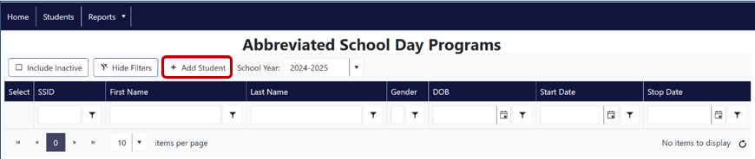
The application will generate a pop-up menu allowing users to search for a student within the Resident District by SSID, Last Name, First Name, Date of Birth, and/or Gender.
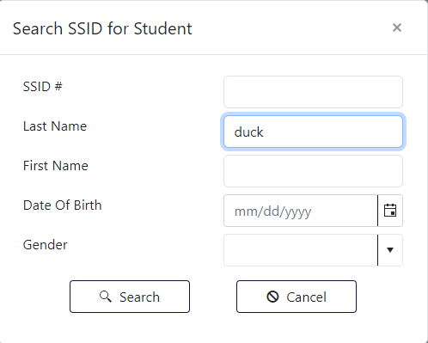

Users can search one or a combination of fields to find the correct student. SSID is preferable since it is a unique identifier. It is important that the correct student is selected as users will not be able to delete records from the Application. This example shows a list of possible record matches produced, with the last name of Duck.
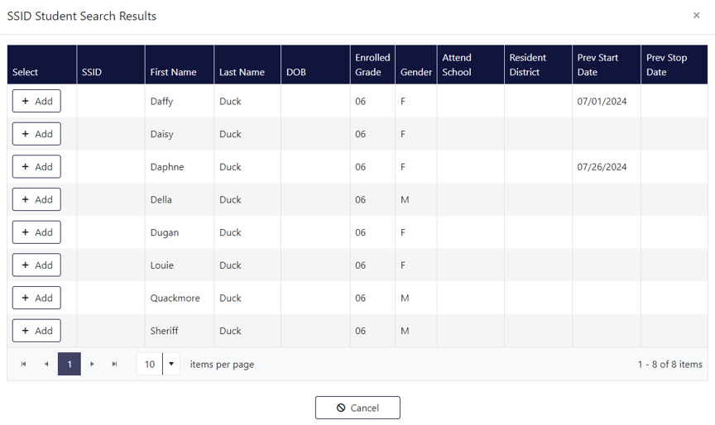
Users need to ensure they click the correct student by checking the SSID, last name, and DOB against their records. To view and edit an existing open record, click Edit. The Application will open a data entry screen containing the Abbreviated School Day Program fields.
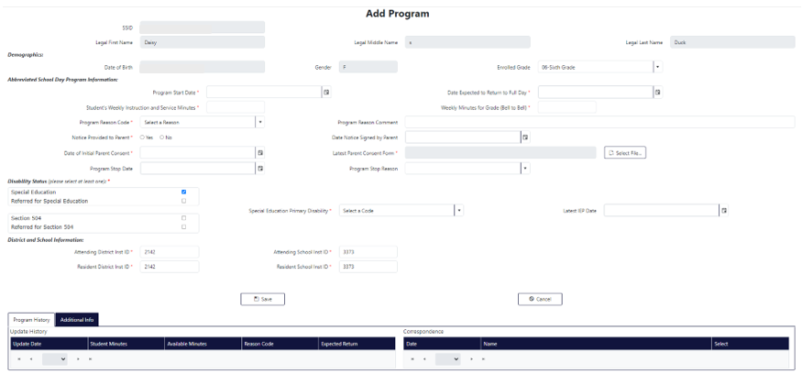

Abbreviated School Day Application Fields

Program Start Date (Required)
The date the student started on an Abbreviated School Day Program.

Date Expected to Return to Full Day (Required)
The date the student is expected to return to a full school day.

Student’s Weekly Instruction and Service Minutes (Required)
The weekly minutes of student while on an Abbreviated School Day Program.
Note: This is the total weekly instructional and educational service minutes provided to the student, that is less than the total weekly instructional and educational service minutes provided to other students in the same grade in the resident district (for comparison, see Weekly minutes available to other students in the same grade at the Resident District)

Weekly minutes for grade (Bell to Bell) (Required)
Weekly minutes available to other students in the same grade at the Resident District.
Note: This is the total weekly instructional and educational service minutes provided to other students in the same grade in the resident district, i.e., the total bell to bell minutes for the week.

Program Reason Code (Required)
The code indicating the reason the student is on an Abbreviated School Day Program. See list of Program Reason Codes in Appendices.

Program Reason Comment
If the Reason Code is 06 (Other), district is required to provide comment further describing the Abbreviated School Day Program reason.

Notice Provided to Parent (Required)
Yes/No Flag that indicates district provided the parent of the student written notice regarding the district’s legal requirements for an Abbreviated School Day Program per ORS 343.161(4).

Date Notice Signed by Parent (Required)
Date district obtained required parental signature of acknowledgement of receipt of required Abbreviated School Day Program Information per ORS 343.161(4).

Date of Initial Parent Consent (Required)
The date parent signed required consent to place student on an Abbreviated School Day Program per SB 819.

Latest Parent Consent Form (Required)
The latest paperwork associated with the Abbreviated School Day Program pertaining to the Signed Parent Consent and Acknowledgement of receipt of program information. Must be a PDF.

Disability Status (Required to select at least one of four listed)
Indicates whether the student is in Special Education or on a Section 504 plan or has been referred for evaluation for Special Education or Section 504. Check one or two of the four boxes as appropriate.
- Special Education: Check this box if the student is eligible for special education and has an IEP.
- Referred for Special Education: Check this box if the student was referred and is being evaluated for a special education disability.
- Section 504: Check this box if the student
- Referred for Section 504: Check this box if the student is eligible and being served for a disability under Section 504.
Note: A student can be on a 504 as well as an IEP plan at the same time.

Special Education Primary Disability
Select the primary special education disability if the Special Education box is checked. If the Special Education box is not checked, select 00-Not Applicable.

Last IEP Date
The date that the student’s most recent Individual Education Plan was completed. This field is required if the Special Education box is checked.

Program Stop Date
The date the student was last on an Abbreviated School Day Program. Leave blank if student is still on an Abbreviated School Day Program.

Program Stop Reason
The reason for which the student’s Abbreviated School Day Program was stopped. Leave blank if student is still on an Abbreviated School Day Program. See list of Program Stop Reason Codes in Appendices.
IMPORTANT! Once the record is saved, the Program Start Date and the Date of Initial Parent Consent will not be editable. Please ensure these fields are correct before saving the record. All other fields are editable, including the Latest Parent Consent Form. If a record is created with errors in these two fields, the district will not be able to delete the record. Please contact the Research Analyst or Data Support listed in the Contact List for assistance in deleting a record.

District and School Information (Required)
ODE assigned Institution ID for the Resident and Attending District and Resident and Attending School.
Note: Make sure these Institution IDs are accurate. If a student changes resident districts or schools during the school year, their SSID information will reflect the current institution information entered into the SSID system. If a student moves to another district, then a Program Stop Date and Program Stop Reason will need to be entered. See Coding Key Fields for more information.

Uploading a Consent Form PDF
When districts need to upload a new consent document, click on the top left menu item, Students, then click Edit next to the student name. See Submitting New Abbreviated School Day Program Records for navigation instructions.
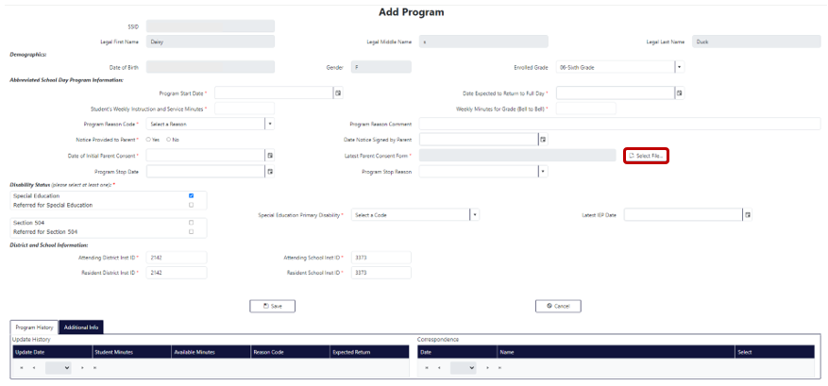
From here, click Select File to upload the document.
The final step for entering a record is to click the Save button. Caution, all Consent PDFs uploaded are saved to the database and cannot be deleted. If a record is NOT SAVED, the information will NOT be saved to the database and users will need to re-enter the record.
If for any reason you need to cancel the entry of a record—not having all the information at hand, realizing the record is a duplicate, realizing the record is less than 11 cumulative or consecutive school days, etc., click Cancel at the bottom left of the page.
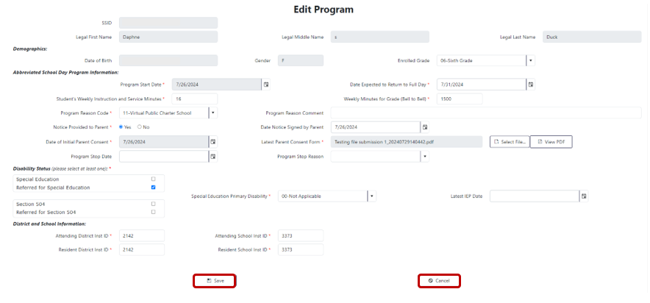

Viewing Consent Documents
To view all consent documents submitted for one student, scroll to the bottom of the Edit Program screen.
In Program History, under Correspondence users can see a list of Parent Consent Forms submitted in chronological order. To view the PDF, click View.
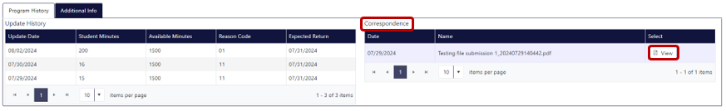

Update History
Next to Correspondence is Update History, which lists all the updates made to a record over the course of the school year. Each editable field will show any changes made, plus the date they were made. Fields that can be edited after record creation and will show in Program History are Student's Weekly Instruction and Service Minutes, Weekly Minutes for Grade (Bell to Bell), Program Reason Code, and Date Expected to Return to Full Day.

Other Student Record Information
On the bottom of the Edit Program screen is the Additional Information tab, next to Program History, which contains data related to the student from the SSID system. These fields are never editable within the Abbreviated School Day Application. To edit this data, users will need to work with the SSID system person at the district if they do not have permissions to it to edit or modify records.
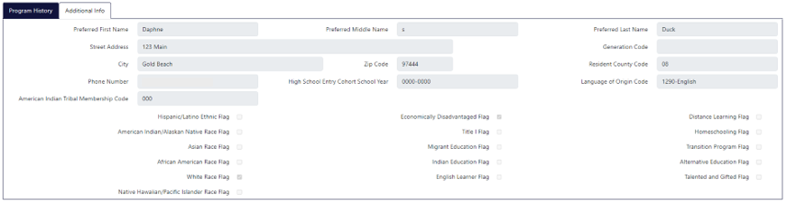
Editing Data in the Abbreviated School Day Application
A new feature this year is the ability to edit multiple data entry fields within the application.

Editing an Existing Record
To edit an existing record for a student, first navigate to the Student System search by clicking the Students button.
Locate the student whose record you wish to edit by scrolling through the records or by searching any of the fields with a search box below them. Users can search by SSID, First Name, Last Name, Gender, Date of Birth, the program Start Date, or the program End Date. Click Edit next to the desired student record.
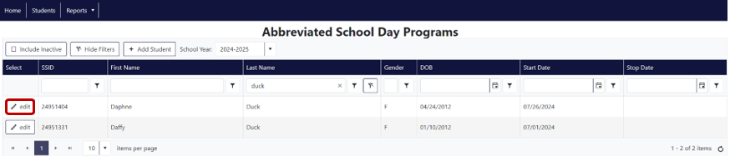
The application will generate a pop-up warning if the student has an open record. The pop-up asks if you would like to add a historical record or update the open record. To add a historical record, click Add. To edit the existing open record, click Edit. To leave the record, click Cancel.
Below are the editable fields:
- Student's Weekly Instruction and Service Minutes
- Program Reason Code
- Notice Provided to Parent
- Program Stop Date
- Disability Status
- Attending District ID
- Resident District ID
- Attending School ID
- Resident School ID
- Latest IEP Date
- Special Education Primary Disability
- Program Stop Reason
- Date Notice Signed by Parent
- Program Reason Comment
- Weekly Minutes for Grade (Bell to Bell)
- Date Expected to Return to Full Day
Users can update any of the white fields (gray isn’t editable) or add a new Consent Form using the instructions in Uploading a Consent Form PDF.
To finalize the edits, click Save. If you would like to delete your edits and come back to the record at a different time, click Cancel. The record will remain as it did before it was opened for editing.
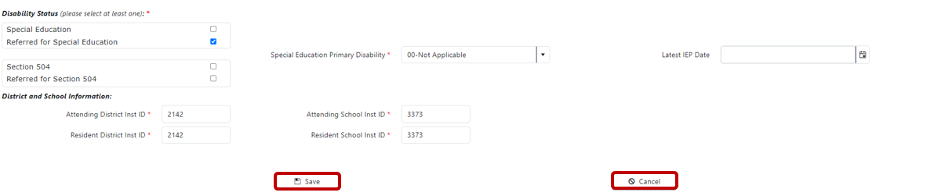

Coding Key Fields
The following provides general guidance for different reporting scenarios. If users encounter any difficulties reporting these data, please reach out to Cara McMurry or one of the ODE Staff Contacts.

Resident District Student
Student resides within your district boundaries and attends school in or outside your district’s boundaries.
The resident district is responsible for submitting these students.
Field | Correct Code/Identifier
Logon at ODE District Website | - Agency submitting data
Resident District ID | - Submitting Agency ID (the district responsible for FAPE)
Resident School ID | - This field may be your district ID or a public school ID located within your district boundaries.
Attending District ID | - District ID where the student is receiving instruction.
Attending School ID | - Public school ID within district or another district’s boundaries
Program Reason Code | - Choose appropriate code: 01, 02, 06 or 07

Resident District - District Placed in Private School
Student is district placed in a private school. The student’s weekly instructional or educational services are less than the number of hours of instruction or educational services that are provided to the majority of other students who are in the same grade within the student’s resident school district.
The resident district is responsible for submitting these students.
Field | Correct Code/Identifier
Logon at ODE District Website | - Agency submitting data
Resident District ID | - Submitting Agency ID (the district responsible for FAPE)
Resident School ID | - This field may be your district ID or a public school ID located within your district boundaries.
Attending District ID | - District ID where the student is receiving instruction and where state assessments are administered.
Attending School ID | - Public school ID within attending district boundaries or district placed private school. If no private school ID exists, enter District ID)
Program Reason Code | - 10 - Special School or Program

Resident District - Schools with Different Lengths of Day
Student is in 5th grade at an elementary school that is 10 minutes shorter than 5th grade at the middle school. This case counts as an Abbreviated School Day but is outside the list of specific reason codes, so use of code 06-Other is appropriate.
The resident district is responsible for submitting these students.
Field | Correct Code/Identifier
Logon at ODE District Website | - Agency submitting data
Resident District ID | - Submitting Agency ID (the district responsible for FAPE)
Resident School ID | - This field may be your district ID or a public school ID located within your district boundaries.
Attending District ID | - District ID where the student is receiving instruction and where state assessments are administered.
Attending School ID | - Public school ID within attending district boundaries or district placed private school. If no private school ID exists, enter District ID)
Program Reason Code | - 06 - Other
Program Reason Comment | - Comment required when using Code 06 - Other

Resident District - Online Asynchronous
Student attends an online school or program which is online asynchronous. This school or program is fully asynchronous and virtual.
The resident district is responsible for submitting these students.
Field | Correct Code/Identifier
Logon at ODE District Website | - Agency submitting data
Resident District ID | - Submitting Agency ID (the district responsible for FAPE)
Resident School ID | - This field may be your district ID or a public school ID located within your district boundaries.
Attending District ID | - District ID where the student is receiving instruction and where state assessments are administered.
Attending School ID | - Public school ID within attending district boundaries or district placed private school. If no private school ID exists, enter District ID)
Program Reason Code | - 09 - Virtual Asynchronous Instruction

Resident District - Virtual Charter School
Student attends a virtual public charter school. This institution is a virtual public charter school as recognized by ORS #338.
The resident district is responsible for submitting these students.
Field | Correct Code/Identifier
Logon at ODE District Website | - Agency submitting data
Resident District ID | - Submitting Agency ID (the district responsible for FAPE)
Resident School ID | - This field may be your district ID or a public school ID located within your district boundaries.
Attending District ID | - District ID where the student is receiving instruction and where state assessments are administered.
Attending School ID | - Public school ID within attending district boundaries or district placed private school. If no private school ID exists, enter District ID)
Program Reason Code | - 11 - Virtual Public Charter School

Resident District Student - Other Local or Regional Correctional Facilities (Not ACEP, YCEP, or JDEP)
Definition: When the student is placed in a local or regional correctional facility located within the school district that is not an ACEP, YCEP, or JDEP (ORS 339.129).
Coding Example:
Student resides within your district boundaries and receives education programs in a correctional environment that is not an ACEP, YCEP, or JDEP.
The resident district is responsible for submitting these students.
Field | Correct Code/Identifier
Logon at ODE District Website | - Agency submitting data
Resident District ID | - Submitting Agency ID (the district responsible for FAPE)
Resident School ID | - This field may be your district ID or a public school ID located within your district boundaries.
Attending District ID | - District ID where the student is receiving instruction and where state assessments are administered.
Attending School ID | - Public school ID within attending district boundaries or private school ID. If no private school ID exists, enter District ID)
Program Reason Code | - Choose appropriate code

Long Term Care and Treatment (LTCT) program (Contractor Submission)
Note: if a student is a resident at an LTCT, it is not reportable to the Abbreviated School Day Application because they are a resident at a LTCT program. Do not report.
Student attends 20 hours a week at a Long Term Care and Treatment (LTCT) program. Student is reportable to the Abbreviated School Day Application as they are not a resident of a LTCT program.
The school district or ESD that contracts with ODE to provide educational services submits these students.
Field | Correct Code/Identifier
Logon at ODE District Website | - Agency submitting data (Contractor only)
Resident District ID | - District where LTCT is located
Resident School ID | - District where LTCT is located
Attending District ID | - (3559) ODE LTCT District
Attending School ID | - LTCT Program ID from Supplement A
Program Reason Code | - 10 - Special School or Program

Hospital Program Student (Contractor Submission)
Definition: When the student resides in and receives their special education services in a Hospital Program. ORS 343.261
Coding Example:
The student receives their education in a Hospital Program.
Only the school district or ESD that contracts with ODE to provide educational services submits these students.
Field | Correct Code/Identifier
Logon at ODE District Website | - Agency submitting data (Contractor only)
Resident District ID | - District where Hospital Program is located
Resident School ID | - District where Hospital Program is located
Attending District ID | - (5401) ODE Hospital Program District
Attending School ID | - Hospital Program ID from Supplement B
Program Reason Code | - Choose appropriate code

Pediatric Nursing Facility (PNF)
Definition: A pediatric nursing facility is a licensed nursing facility where at least 50 percent of whose residents entered the facility before the age of 14, and all of whose residents are under the age of 21 (ORS 343.941). Currently there is only one PNF, and Portland SD 1J reports the data for this facility.
Coding Example:
The student receives their education in a pediatric nursing facility.
Only the school district or ESD that contracts with ODE to provide educational services submits these students (see note above).
Field | Correct Code/Identifier
Logon at ODE District Website | - Agency submitting data (Contractor only)
03 – Resident District ID | - Submitting Agency ID (the district responsible for FAPE) (2180)
04 – Resident School ID | - Submitting Agency ID
05 – Attending District ID | - (5269) ODE PNF District
06 – Attending School ID | - PNF Institution ID from Supplement B (5269)
Program Reason Code | - Choose appropriate code

State Placed Juvenile Detention Education Program (JDEP) Student (Contractor Submission)
Definition: When the student has been placed in a Juvenile Detention Center. ORS 336.585
Coding Example:
The student receives their education in a juvenile detention center.
Only the school district/ESD that contracts with ODE to provide educational services submits these students.
Field | Correct Code/Identifier
Logon at ODE District Website | - Agency submitting data (Contractor only)
03 – Resident District ID | - Submitting Agency ID
04 – Resident School ID | - Submitting Agency ID
05 – Attending District ID | - (3476) ODE JDEP District ID
06 – Attending School ID | - JDEP Facility ID from Supplement E
Program Reason Code | - Choose appropriate code

State Placed Youth Corrections Education Program (YCEP) (Contractor Submission)
Definition: When the student resides in an Oregon Youth Correctional Facility and receives their education services through a Youth Corrections Education Program. ORS 336.590
Coding Example:
The student receives their education in an Oregon Youth Correctional Facility.
Only the school district or ESD that contracts with ODE to provide educational services submits these students.
Field | Correct Code/Identifier
Logon at ODE District Website | - Agency submitting data (Contractor only)
03 – Resident District ID | - Submitting Agency ID
04 – Resident School ID | - Submitting Agency ID
05 – Attending District ID | - (3477) ODE YCEP District ID
06 – Attending School ID | - YCEP Facility ID from Supplement D
Program Reason Code | - Choose appropriate code

Program Reason Code Scenario Help
The following scenarios provides general guidance for reason codes that can be difficult to determine for certain situations. If users encounter additional difficulties determining the appropriate reason code to be reported, please reach out to Cara McMurry or one of the ODE Staff Contacts.

Online Asynchronous
Student attends a school or program which is online asynchronous. Online asynchronous instruction includes classes or programs that the student engages in on their own schedule.
This school or program is fully asynchronous and virtual.
09 - Virtual Asynchronous Instruction

Virtual Charter School
Student attends a virtual public charter school (see Public Charter Schools for list) where the minutes for the student are less than the majority of other students in the same grade within the student’s district.
This institution is a virtual public charter school as recognized by ORS #338.
11 - Virtual Public Charter School.

Schools with Different Lengths of Day
Student is in 5th grade at an elementary school that is 10 minutes shorter than 5th grade at the middle school.
This case counts as an Abbreviated School Day but is outside the list of specific reason codes, so use of code 06-Other is appropriate.
06 – Other (Comment is required)

Long Term Care and Treatment (LTCT) program
Example 1:
Student attends 20 hours a week at a Long Term Care and Treatment (LTCT) program. The student’s weekly instruction or educational services are less than the number of hours of instruction or educational services that are provided to the majority of other students who are in the same grade within the district’s boundaries where the LTCT is located.
Student is reportable to the Abbreviated School Day Application as they are not a resident of a LTCT program.
10 - Special School or Program
Example 2:
Student is a resident at a Long-Term Care and Treatment (LTCT) program.
This student is not reportable to the Abbreviated School Day Application because they are a resident at a LTCT program. Do not report.

District Placed in Private School
Student is district placed in a private school. The student’s weekly instruction or educational services are less than the number of hours of instruction or educational services that are provided to the majority of other students who are in the same grade within the student’s resident school district.
The student is reportable to the Abbreviated School Day Application.
10 - Special School or Program.

On Track to Graduate
Student is on track to graduate with a high school diploma or modified diploma and takes one class per semester that is asynchronous while at school with school staff available to them. This class is offered on voluntary basis to all students including students with disabilities. This class satisfies a credit requirement and is for credit recovery or is not available to this student.
This student is not reportable to the Abbreviated School Day Application. Do not report.

Verification Process
Verification is required at the end of each month. ODE cannot consider the monthly submission complete until the submitting district verifies it as complete. All districts are required to complete the verification process on the Reports tab.
- On the first of each month, each district can expect a reminder to verify email from ODE.
- After 5 business days from the first notice, if the district has still not verified, they can expect a second email from ODE.
- After 8 business days from the first notice, if the district has still not verified, they can expect a third email or call from ODE.
- If after 13 business days from the first notice the district has still not verified, they can expect a call from the IDEA Program Manager and/or the District Support Specialist.
Do not hesitate to contact ODE contacts listed in this document for assistance in verifying submissions.
From anywhere in the Abbreviated School Day application, hover over the Reports menu tab and then click on Verification. Make sure the School Year dropdown displays the correct school year. This dropdown will automatically advance to the next school year on July 1.
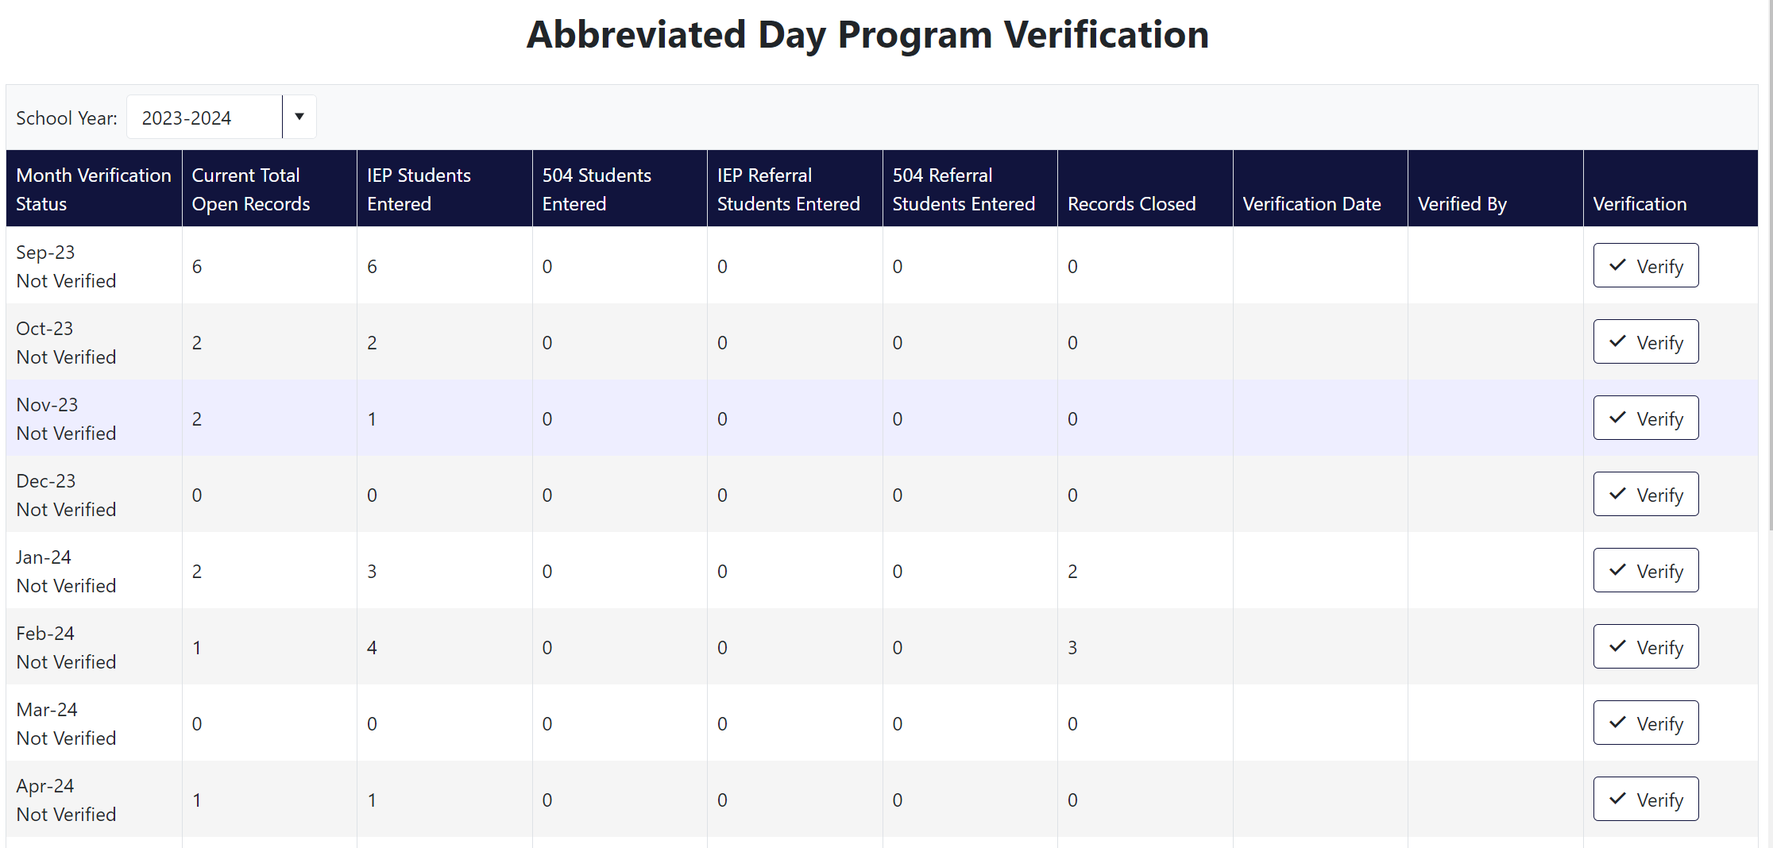
Review the counts of records submitted. If accurate, simply click Verify for the month in which users are verifying.
When these final steps have been completed, districts attest that they submitted accurate and complete data for the month.

Production Download
Production Download is a set of reports of records submitted to the Abbreviated School Day Program Application within certain parameters. This function is in the Reports tab in the top left button bar of any screen within the application.

Steps for Accessing a Production Download
- Select Reports tab. Then click Production Download.
Users can make different selections to narrow down the scope of the download report.
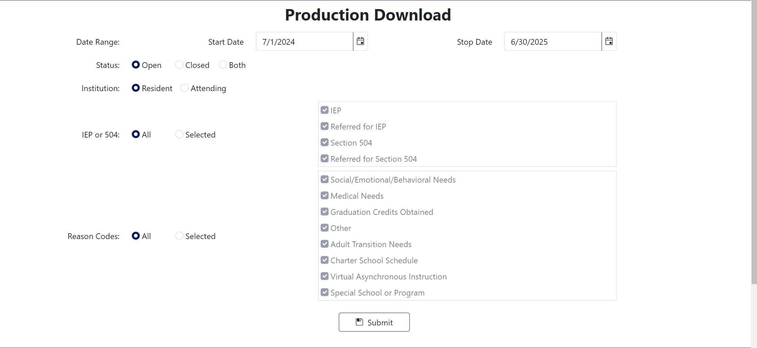
- Set the date range for records desired in the download report. The application will default to July 1 to June 30 of the current school year
- Select the Status of records desired—Closed, Open, or Both.
- Select the Institution, either Resident or Attending. Selecting Resident will create a report with students whose Resident District match the submitting agency. Selecting Attending will create a report with students whose Attending District matches the submitting agency.
- Select IEP or 504, either All to include all students or choose Selected to select any of the options in the box to the right.
- Select Reason Codes, either All to include all students or choose Selected to select any options in the box to the right.
- Double-check the selections for the download report to ensure desired options are chosen. Click Submit to download the report.

The Abbreviated School Day Application will send the user an email, using the email address associated with the user’s login/account. Click the link in this email.
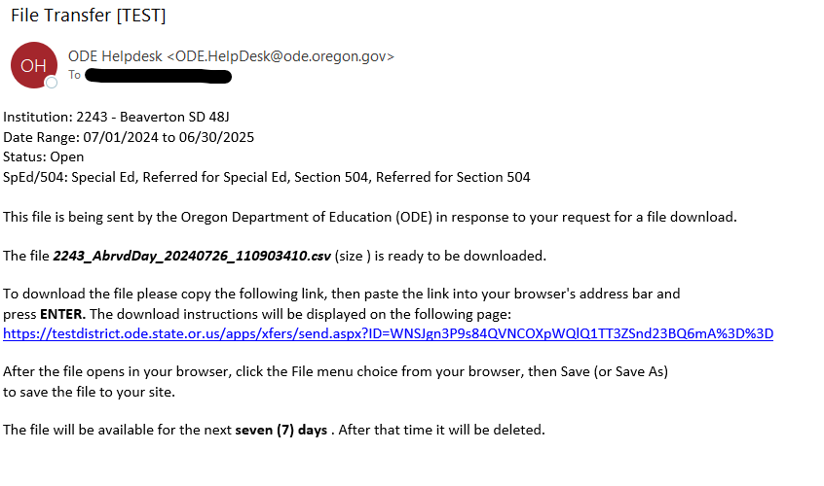
The link will take users to a Secure File Transfer page on the ODE District website. Enter the user’s email address, the same address the email was sent to, and click the Submit Email Address button.
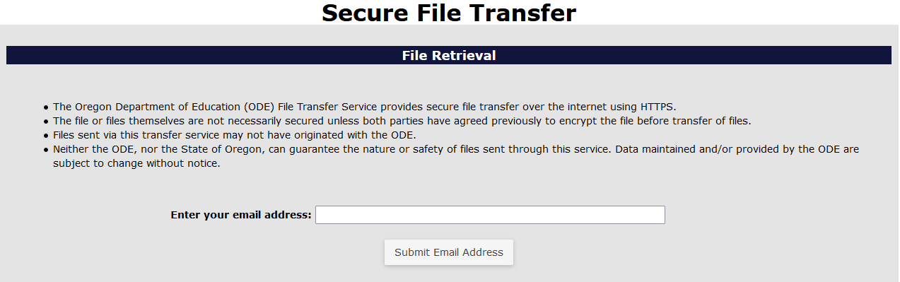

After the Submit Email Address button is clicked, the page will generate a Download button. Click the Download button to download the zip file of the Production Download Report.
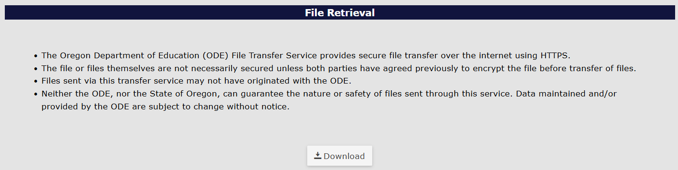
The system will generate a download box in the top right of the bowser. Users can click on the file name or the folder icon. Clicking the file name will open a CSV workbook. Clicking the folder icon will open the Downloads folder where the file has been saved.
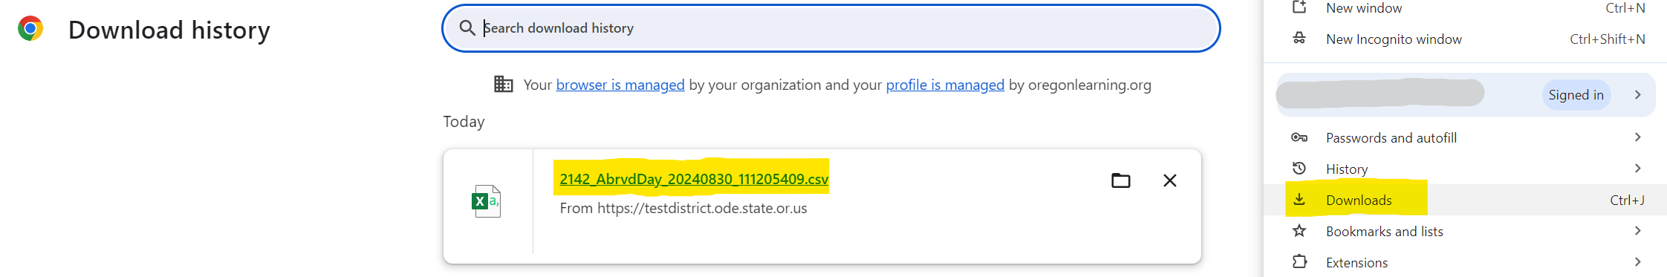

Frequently Asked Questions
Q: How do I log into the district site?
A: Visit ODE’s District webpage. Your District’s Security Administrator must give you access and permissions for the Abbreviated Day Application.
Q: How do I locate my District Security Administrator?
A: If you do not know who your District Security Administrator is, go to the District Home page, look for the collection of buttons with Applications at the top on the right-hand side, and click District Security Administrator (DSA) Lookup. On the Search for Security Administrator page, enter an institution ID or District Name, then click the Search button.
Q: Where do I find the Abbreviated School Day Application once I have logged into the site?
A: From the Application List, select Abbreviated School Day Program Application.
Q: How do I attach the latest parent consent document (PDF) to a student’s record in the Abbreviated School Day Application?
A: Please see the section on Uploading a PDF.
Q A student is no longer on an abbreviated school day program. Should I remove them from my submission?
A: Enter an Abbreviated School Day Program Stop Date and save the record. Once a record has a Stop Date it is no longer editable.
Q: How can I find another school’s or district’s Institution ID number?
A: 1. Go to the Institutions Lookup page
2. In the second field, for Institution Name, enter the school district name; and click Search.

Appendices

Program Reason Codes
Code | Name | Description
01 | Social/Emotional/Behavioral Needs | To help the student meet their IEP or 504 goals related to behavior
02 | Medical Needs | To help students meet their medically related needs
06 | Other | Student is on an abbreviated school day program for other reason detailed in comment
07 | Adult Transition Needs | Student’s transition plan does not include a full-day schedule
08 | Charter School | Parental choice for child to attend charter school whose instructional minutes are less than sponsoring district
09 | Virtual Asynchronous Instruction | Child attends instructional model with components of asynchronous instruction
10 | Special School or Program | Team decision for child to attend special school or program where meaningful access is less than the comparison group
11 | Virtual Public Charter School | Virtual Public Charter School / Parental choice for child to attend a Virtual Public Charter School as recognized by ORS #338

Program Stop Reason Codes
Code | Name
01 | Returned to full-time instruction and educational services
02 | Moved out of District
03 | Dropped out of school
04 | No longer in Special Education
05 | No longer on a 504 Plan
06 | No longer in referral status (not eligible for IEP)
07 | No longer in referral status (not eligible for 504)
08 | Graduated with Regular Diploma
09 | Received Modified Diploma, no longer in school
10 | Received Extended Diploma or Certificate of Attendance, no longer in school

https://www.ode.state.or.us/instid/

