Table of Contents
Learner Dashboard Overview 1
Use the Learner Dashboard 2
Training Information 2
Messages 3
Phishing Information 3
Badges 4
Team Dashboard 4
Select a Team 6
Training Progress 7
Optional Learning 7
Phishing Test Results 8
Team Details for the Past Year 9

Learner Dashboard Overview

The Learner Dashboard is a dashboard designed for users in the Learner Experience (LX). On the learner dashboard, users can view their training progress along with other statistics.
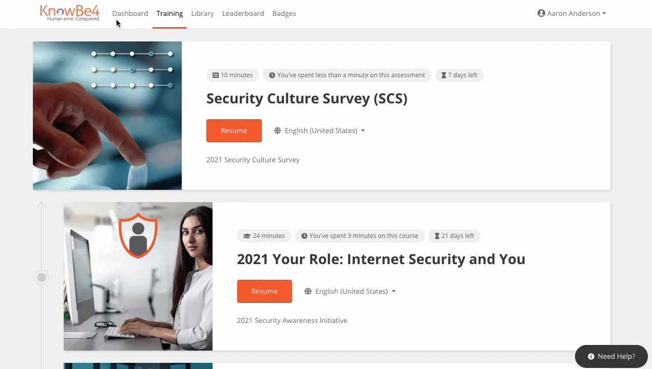

Use the Learner Dashboard
When the Learner Dashboard is enabled, users can view information about their training progress, incomplete training, and assignments. They can view additional phishing information as well.

Training Information
Users will see three training tiles: Training Progress, Incomplete Training, and a list of their most recent assignments.
The Training Progress tile shows the percentage of completed training assignments and includes a link to the training section of the LX.
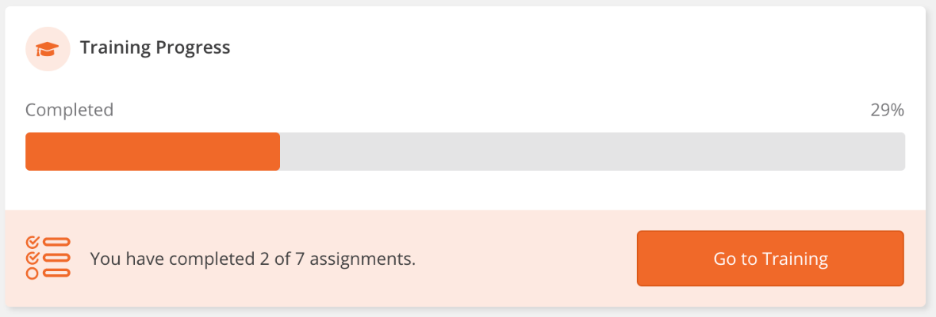

The assignment list displays the user’s five most recent training assignments, along with the training status and when the training is due. Users can click on a row to be taken to that specific training assignment.
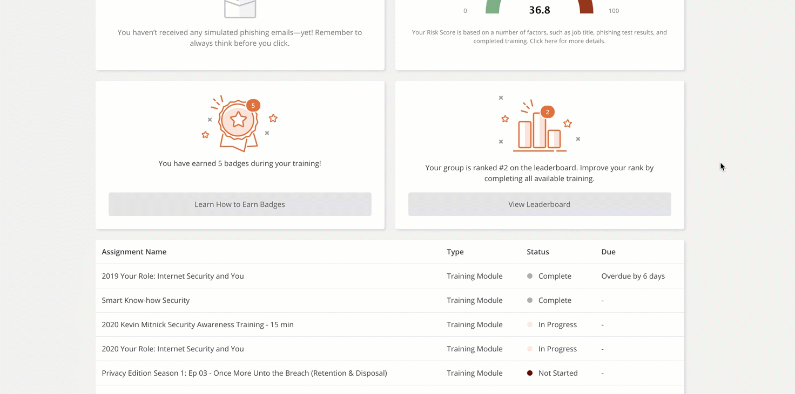

Messages
If your organization has used the User Messaging feature, any user who has received a message will see the Messages tile on their Dashboard. This tile indicates the number of unread messages a user has. Users can click View Messages to go to the Messages tab.
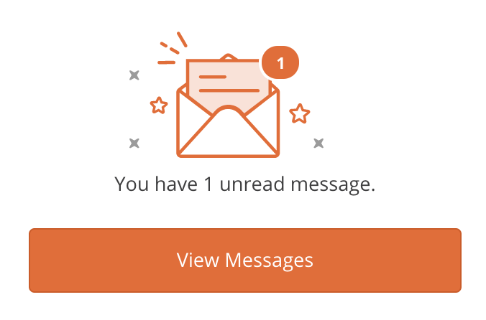

Phishing Information
Users will see the Phishing Test Results tile on their Learner Dashboard.
This tile shows the number of phishing emails the user reported and the number of failures on phishing tests, compared to the total number of simulated phishing emails they received.
When a user reports a simulated phishing email without failing the phishing test, it is counted as a Reported Phishing Email.
Any negative interaction with a simulated phishing email, such as replying, downloading attachments, and clicking a link within the email are counted as Phishing Failures.
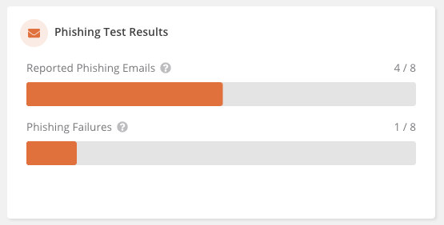

Badges
The Badges tile shows how many badges that the user has earned. The user can also click Learn How to Earn Badges to go to the Badges tab.
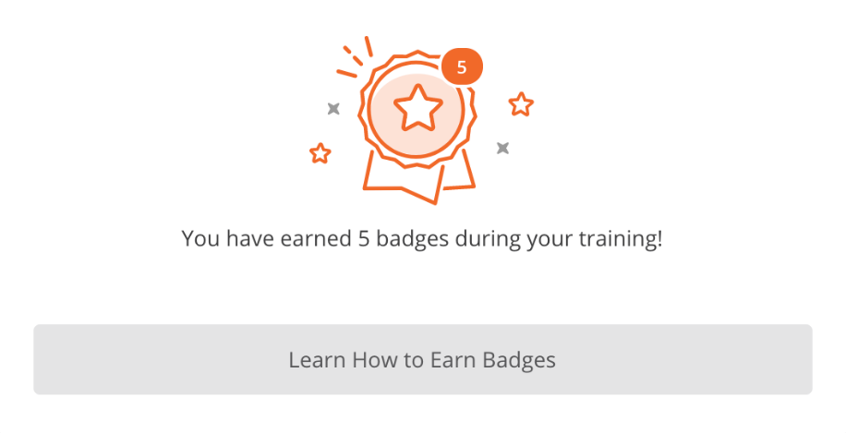

Team Dashboard
Team Dashboards are designed for managers to view information about their team, such as their team's training progress, and phishing results. If your organization has enabled Team Dashboards and you lead a team, you can view your Team Dashboard on the Dashboard tab of your Learner Experience.
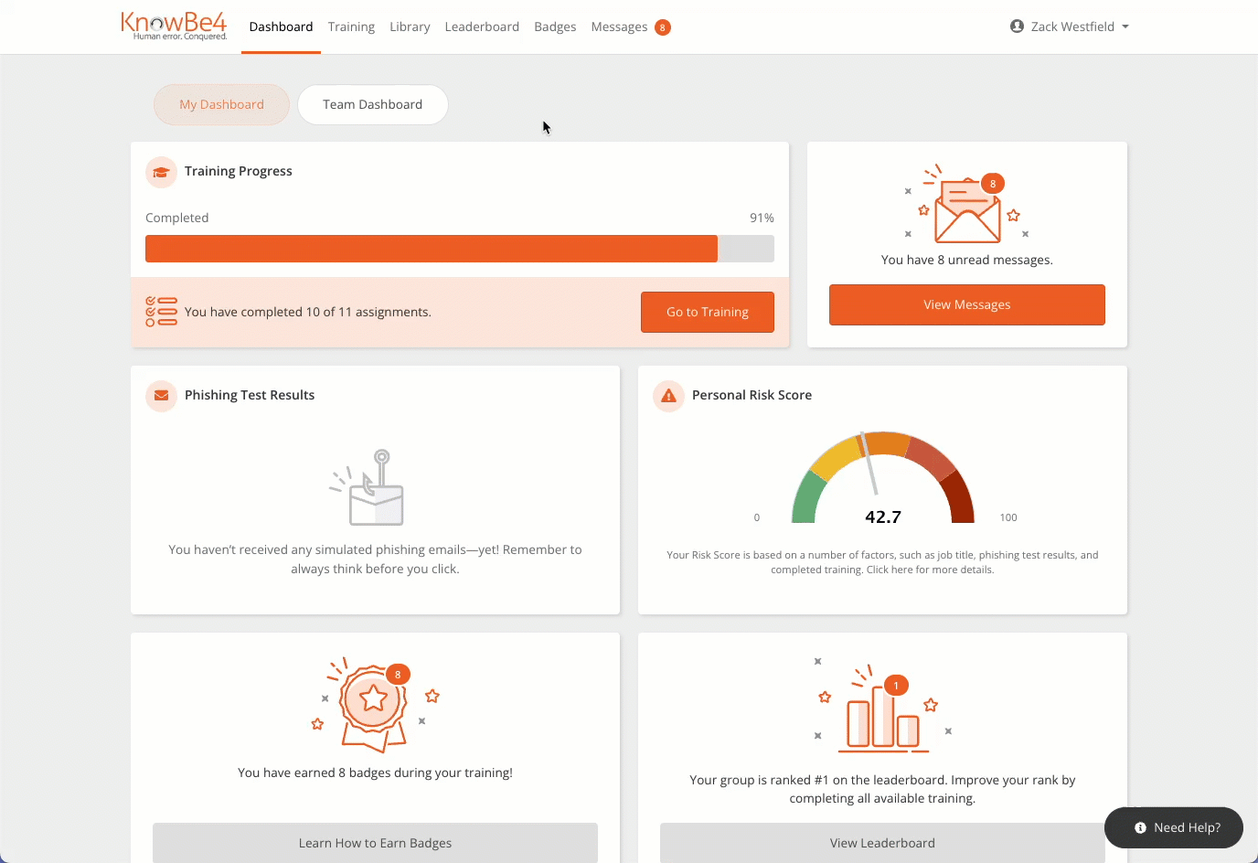

For more information about the Team Dashboard, click the links below or review the screenshots for each tab below:

- Select a Team
- Team Details
- Training Progress
- Optional Learning
- Phishing Test Results
- Team Risk Score

Select a Team
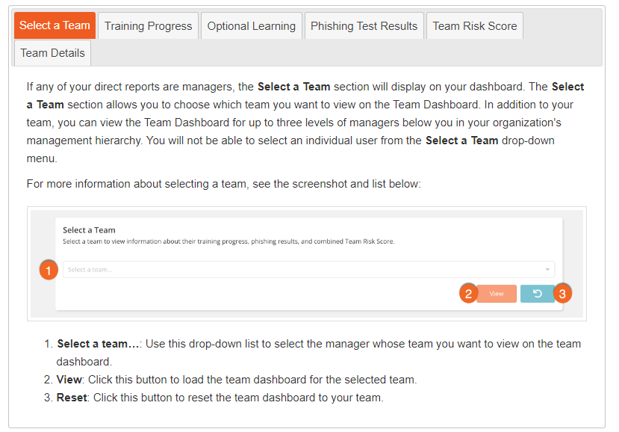

Training Progress
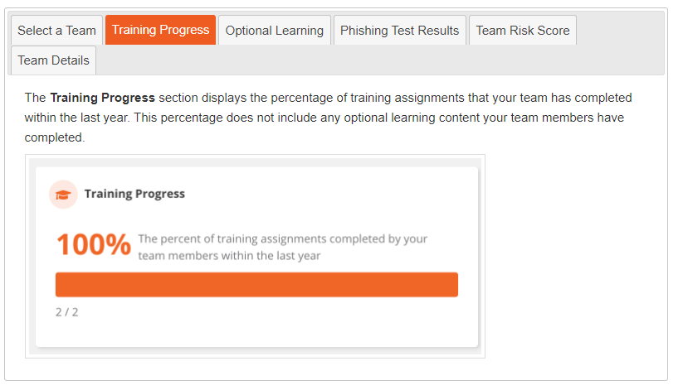

Optional Learning
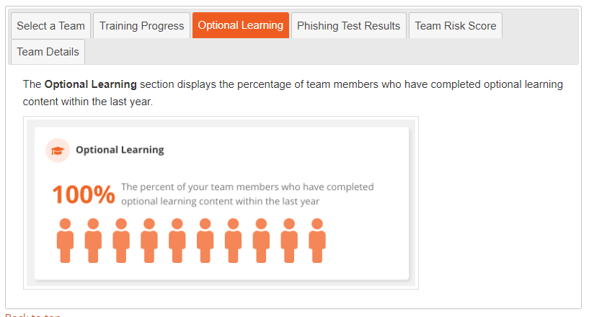

Phishing Test Results
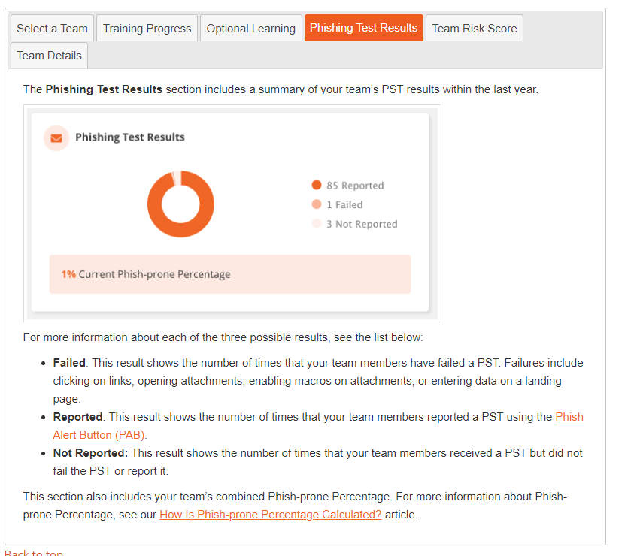

Team Details for the Past Year
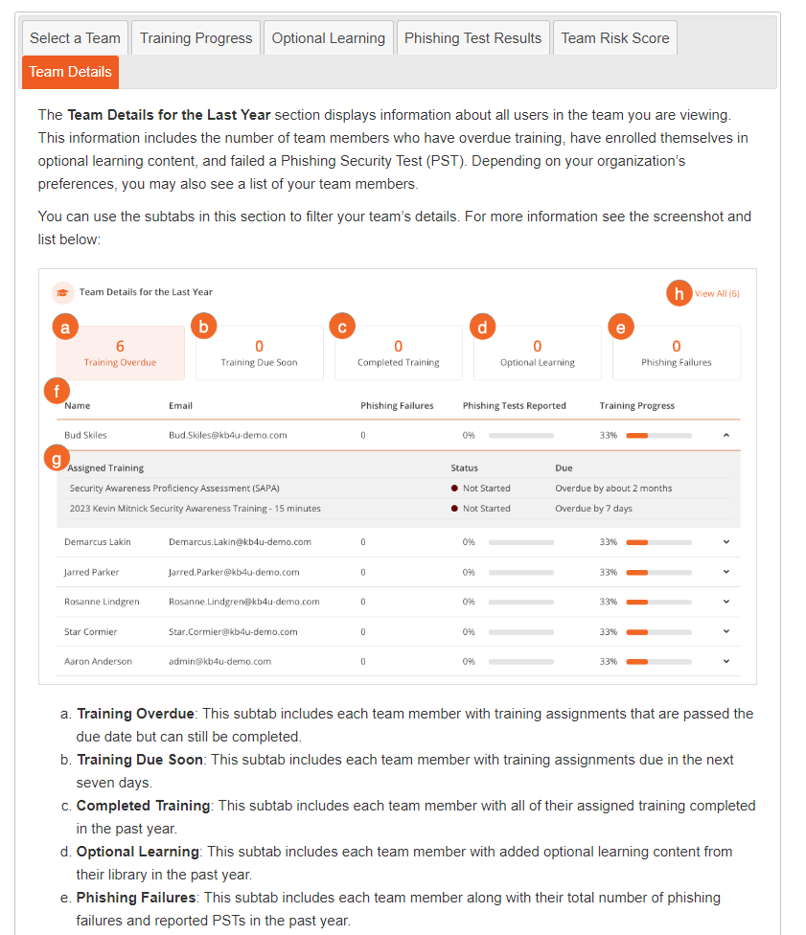

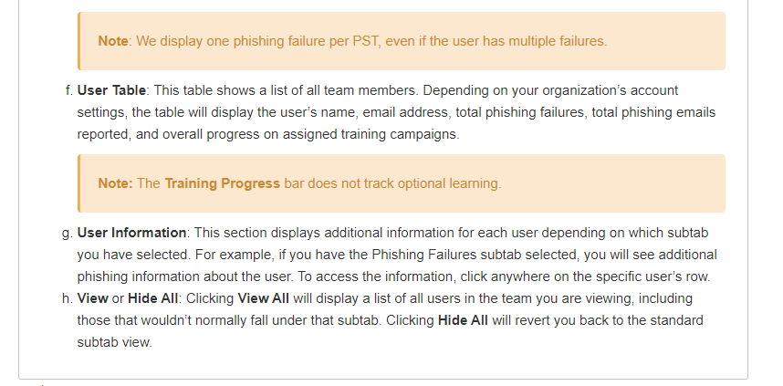
*We do not enable the Risk Score because a large part of the data needed to calculate the risk score is kept in Workday so the risk score data in the Knowbe4 console is incomplete.

