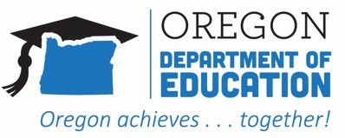
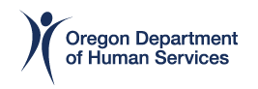

Pandemic EBT for Summer 2022

Go-Live Toolkit

April 2023



Table of Contents

How to use this toolkit 3
Who should receive outreach materials? 4
Outreach Flyer 5
Email Template (Individualized) 6
Social Media Posts 7
Twitter 7
Facebook 7
Instagram 7
Program Infographic 8
FAQ for Families 9
Appendix 10

How to use this toolkit
This Pandemic EBT Go-Live Toolkit is intended to bring awareness of the P-EBT for Summer 2022 Program to Oregon parents, caretakers, community partners, and the public.

Now that the program is active and benefits are being issued, the key goals of P-EBT outreach is to:

  - Increase public awareness about the P-EBT Program to eligible families and communities. The following resources detail what P-EBT is, how and when eligible children will receive benefits, how P-EBT benefits can be used to purchase food, etc.

  - Help aid P-EBT POCs and Community Partners in distributing Go-Live Toolkit materials. Each item has been outlined with a recommendation on how to easily disseminate the information.

  - Direct families, community partners, ODE/ODHS staff, and the general public to the P-EBT website (PEBT.oregon.gov) and P-EBT Call Center at (844) ORE-PEBT or (844) 673-7328 for answers to general questions and program updates.

A key principle of the P-EBT Go-Live Toolkit is to have consistent, clear communication about the P-EBT program, eligibility requirements, and disbursement of benefits.

Remember that there is no application for eligible children to receive P-EBT benefits. The primary goal is to increase awareness about the program among likely-eligible children and their families to ensure they have the necessary information to access these benefits.

As benefits are currently being issued, it is important to use the correct messaging and timing to inform families about P-EBT. It is best to use multiple communication channels and emphasize the available resources for families with additional questions. Let individuals know that in addition to reviewing the P-EBT website PEBT.oregon.gov they can contact the P-EBT Call Center at (844) ORE-PEBT or (844) 673-7328

Thank you for your assistance and support in this collaborative effort of the P-EBT for Summer 2022 program.

Program Infographic
Distribution Recommendation: Download/save the following P-EBT Program infographic to include in school newsletters, email, print and pass out to families, or choose other forms of communication (dependent on your school or organization). This should be distributed among applicable families and the public as it is a brief overview the program and provides additional resources.
How to Download: See the full version attached in the email.
When to Publish? You can start today!

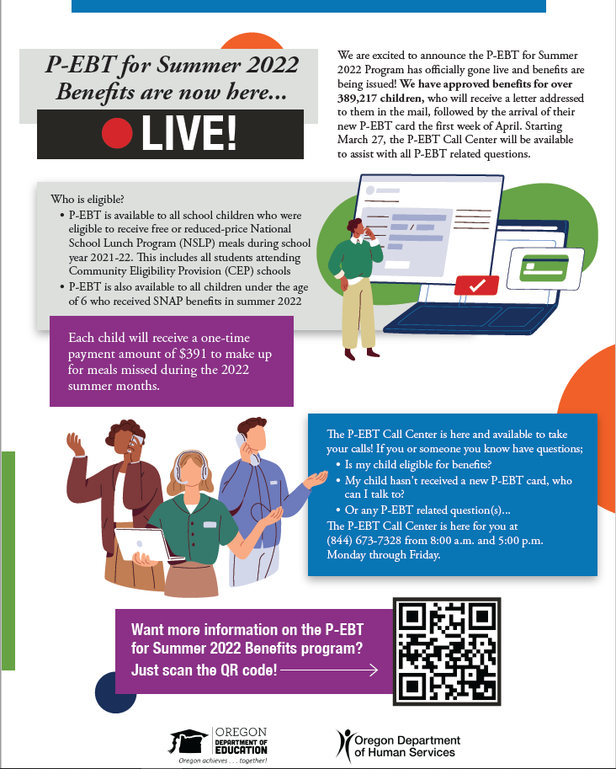

Outreach Flyer
Distribution Recommendation: The following flyers can be printed and distributed by-hand to families and community partners. They can also be given to any individuals who ask you specific questions about the program.
How to Download: To select the image below for use, right click the image and select “Save as picture…”. Choose a file name and location on your computer, file type should be PNG
When to Publish? You can start today!

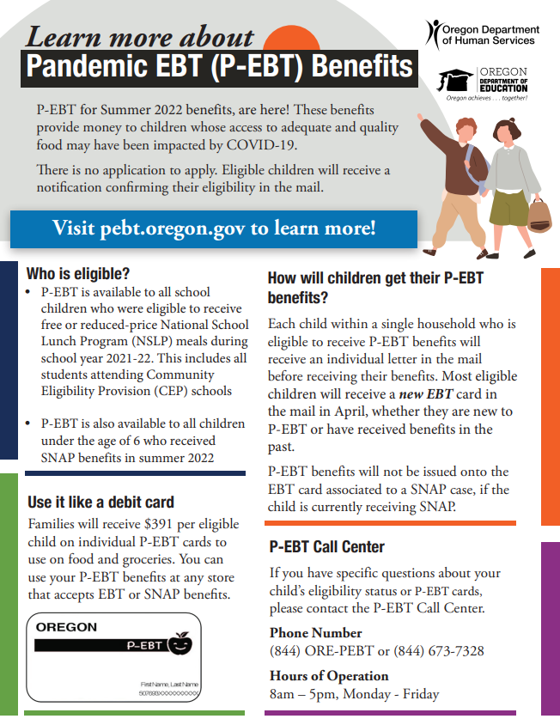

Social Media Posts
Distribution Recommendation: The following social media posts can be shared on your school, district wide, or community partners social media accounts. Each post will display a intended social media platform, date to publish, a caption, and an image (where applicable).
How to Download: When making a post, simply copy and paste the caption. To collect an image for use, right click the image and select “Save as picture…”. Select a file name and location of your choice, with the file type of PNG.

Twitter
When to Publish | Caption
April 2 – April 15, 2023 | #COVID19 Pandemic EBT (P-EBT) benefits are available #again for eligible Oregon #families! Families with children who were enrolled in #SNAP, #ChildNutritionProgram, or attended #Community Eligibility Provision (CEP) in summer 2022 can learn more contact #PEBT Call Center or PEBT.oregon.gov
April 16 – May 1, 2023 | The #PEBT Call Center is available to answer questions about your child’s #PEBT eligibility status. Families with children receiving #SNAP, #ChildNutritionProgram, or #FosterCare can call (844) ORE-PEBT for more information.
May 2 – May 15, 2023 | #PEBT cards are on the way! If you are a #family with #children receiving #SNAP, #ChildNutritionProgram, or #FosterCare make sure you check your mailbox. Learn more about Pandemic EBT (P-EBT): PEBT.oregon.gov
May 2 – May 15, 2023 | #PEBT benefits have been issued to most children eligible. If you haven’t received your new #PEBT Card or have questions, call the #PEBT Call Center NOW!

Facebook & Instagram
When to Publish? March 27 - April 15, 2023
Caption: P-EBT for Summer 2022 benefits are here! Is your family eligible? Contact #P-EBT Call Center at (844) ORE-PEBT (1-844-673-7328) to learn more.
Visual:
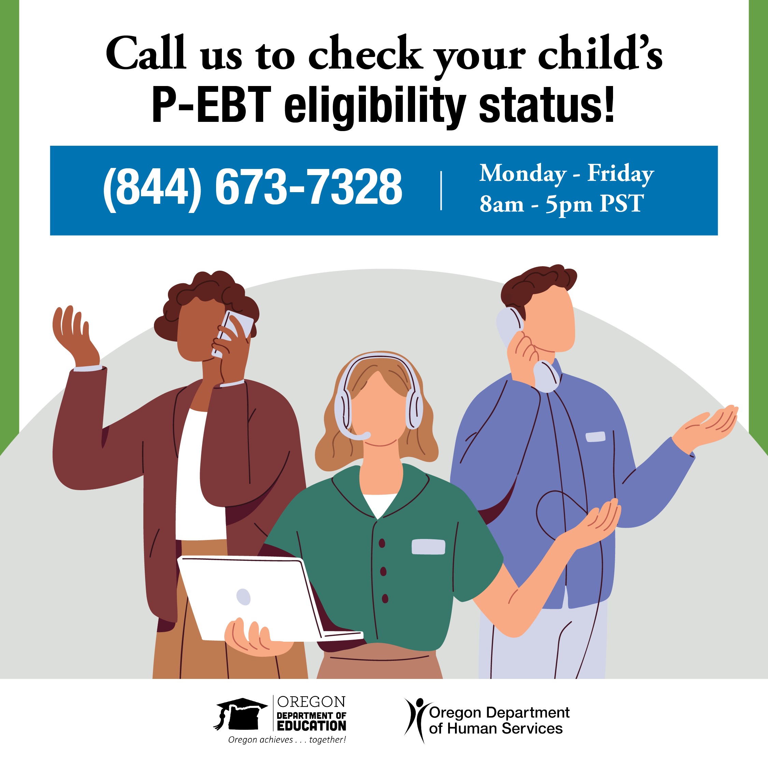

When to Publish? April 16 – May 1, 2023
Caption: Is your family eligible for P-EBT benefits? Contact the #P-EBT Call Center at (844) ORE-PEBT (1-844-673-7328) to learn more.
Visual:
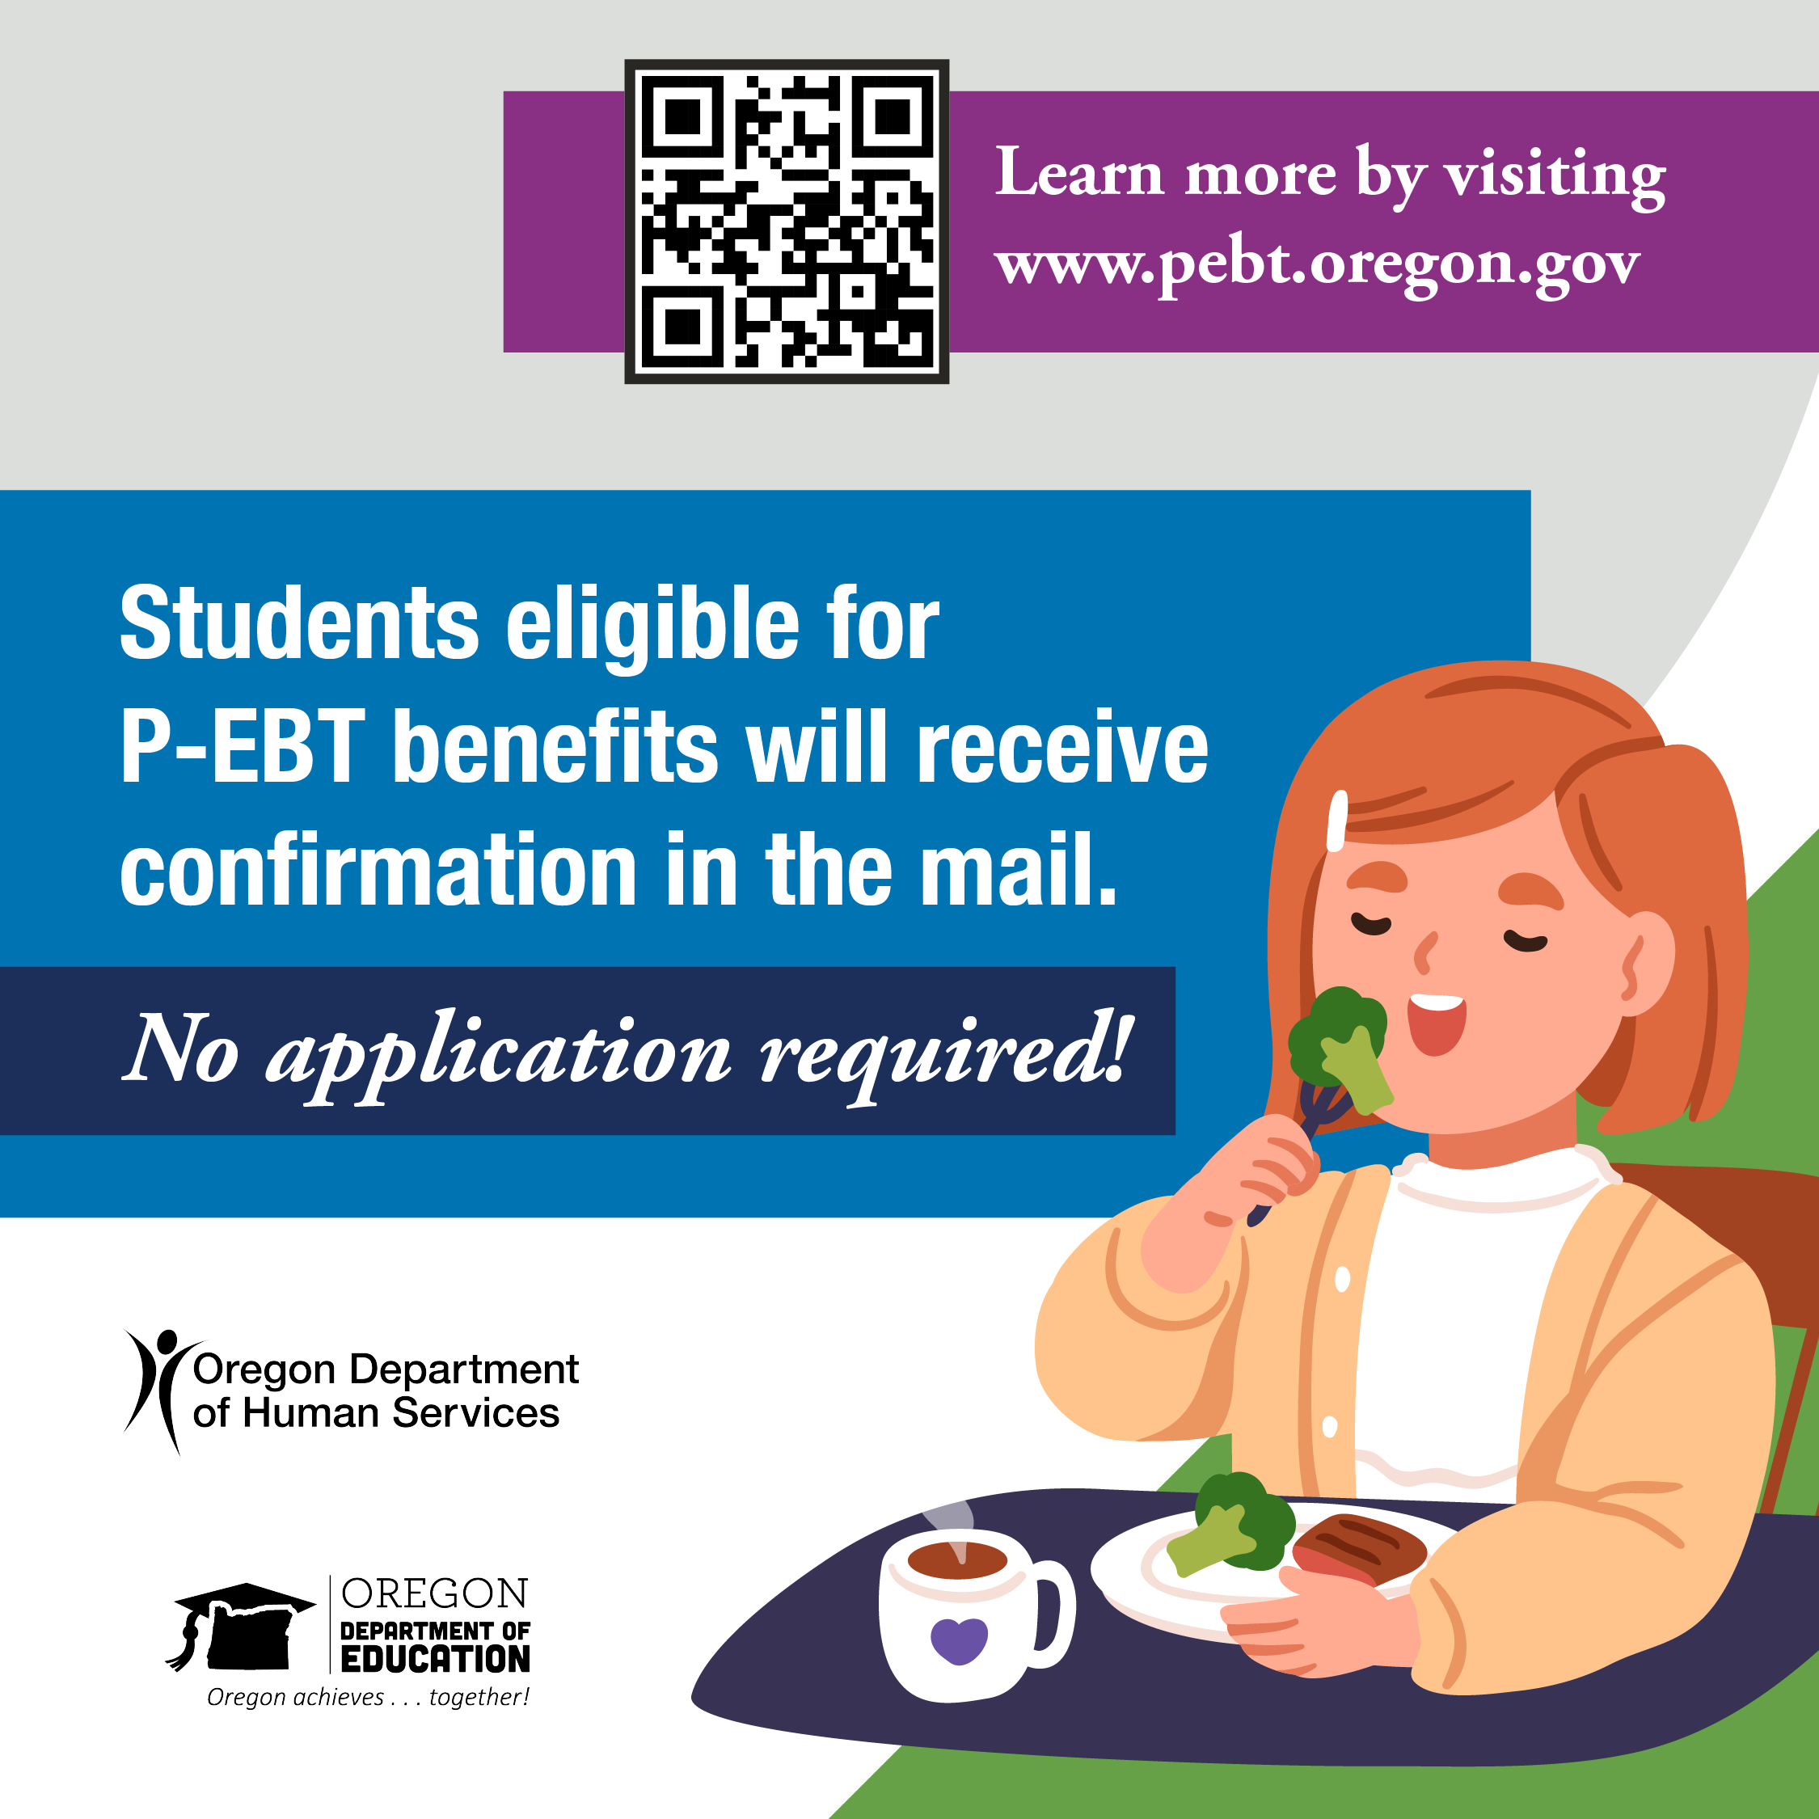

When to Publish? May 2 - May 15, 2023
Caption: Have you received your new P-EBT Card? The #P-EBT Call Center is here help! Contact us now at (844) ORE-PEBT (1-844-673-7328) to learn more.
Visual:
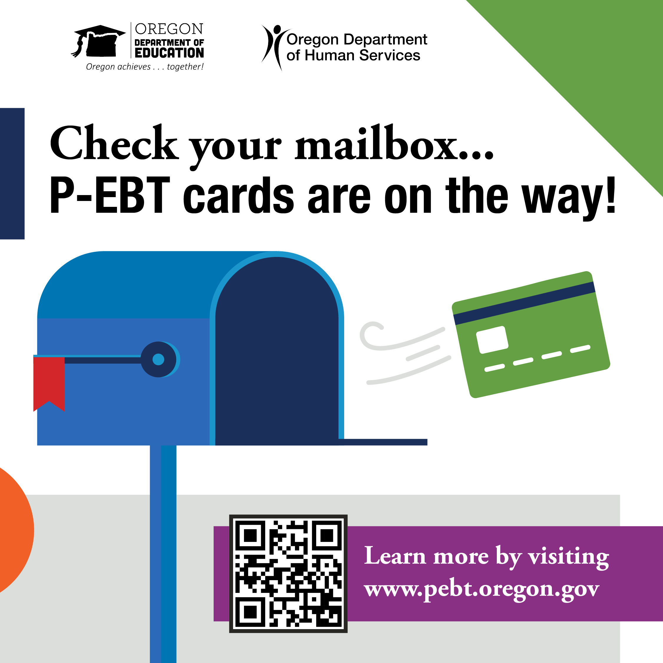

Program Poster TV
Distribution Recommendation: Download/save the following P-EBT Program infographic to display in your lobby, in high traffic areas visual to families, or using other forms of communication (dependent on your organization).
How to Download: To select the image below for use, right click the image and select “Save as picture…”. Choose a file name and location on your computer, file type should be PNG.
When to Publish? You can start today!

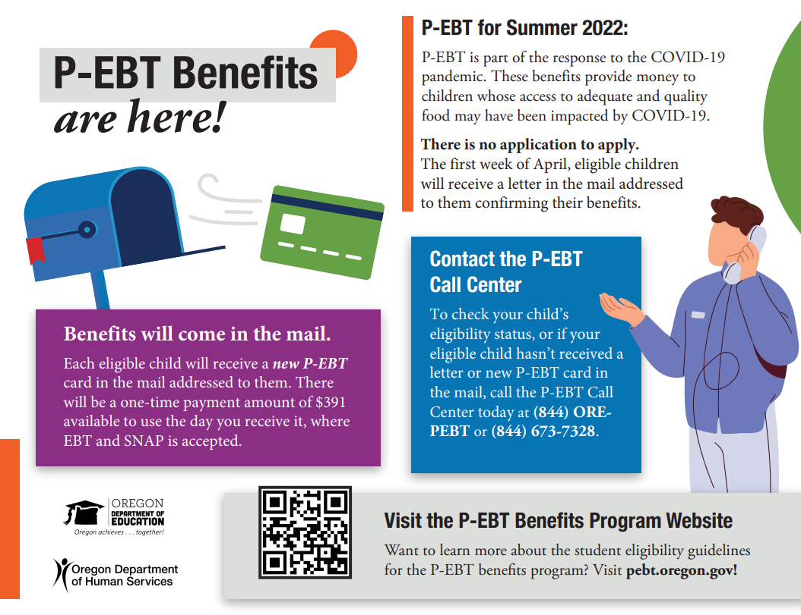

FAQ for Families
Distribution Recommendation: These FAQs can be printed or emailed to parents, staff, or families with specific questions about the P-EBT program. You do not need to distribute among all families, as this includes more detailed information about the program.

Click here for the full 4-page “FAQ for Families” document in English
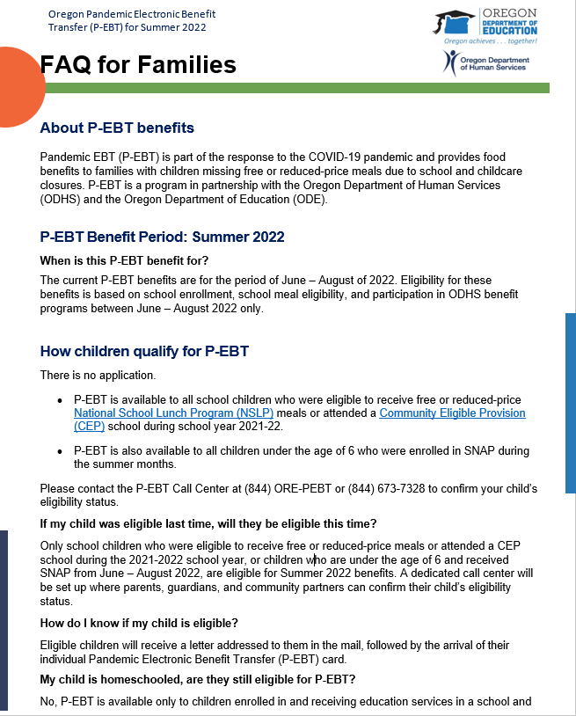
Click here for the full 4-page “FAQ for Families” document in the Spanish
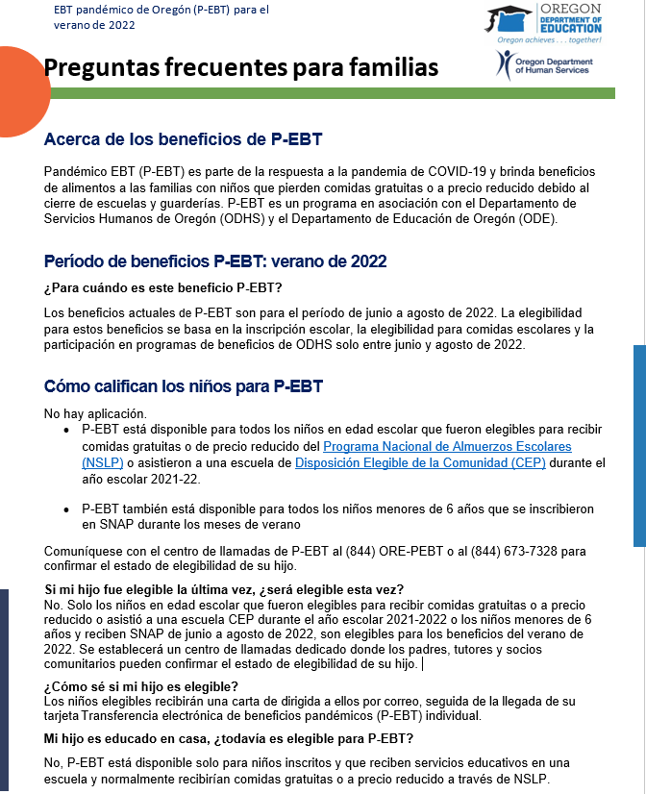

P-EBT Promotional Video
Distribution Recommendation: The following video can be posted to your school, school district, and/or community partner’s social media accounts and websites.

How to Distribute: When making the video available for public release, simply copy and paste the link below.

When to Publish? You can start today!

Caption: Did you know PEBT for Summer 2022 benefits may be on the way?

Content:

Voiceover Track
Do you know about P-EBT for Summer 2022 Benefits?
No worries, let us tell you more about it.
The P-EBT for Summer 2022 Program, are benefits that gives eligible children money for food who missed meals from May to August of 2022.
School age children who received free or reduce meals and children ages 6 and under who were enrolled in SNAP during the Summer 2022 months are eligible for these P-EBT benefits
All children eligible for Summer 2022 P-EBT benefits will receive a one - time benefit amount of $391.
The benefits work just like your current EBT card.
Each eligible child will receive a PEBT card in the mail in his/or name, just follow the steps on your card to set up a PIN, and you can begin using it at most of your favorite stores immediately.
Make sure you use your benefits at least once a year, so you don't lose them.
P-EBT cards expire one year from the date of the last transaction.
For more information about PEBT benefits, or
If you believe your child is eligible for benefits and you have not received a P-EBT card
the P-EBT Call Center is NOW AVAILABLE to you
just call 1-877-328-9677, Monday through Friday, 8:00 a.m. to 5:00 p.m.
or you can email us <insert email>
and a call center agent will be there to answer any P-EBT questions you have.

Click here to view the P-EBT video: Oregon P-EBT for Summer 2022 Promotional Video

