Verify Access and Account Details for OrCPP Members

Overview
After successfully resetting a password and logging into OregonBuys, it is necessary to verify access and account details.

Verification Process
- Click on the grey Person Icon in the upper right corner.
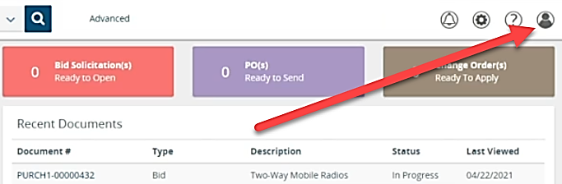
- Select the My Account option.
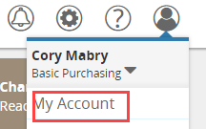

- Choose the Edit button in the My Information section.
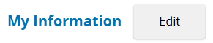
- On the My Information screen:
  - Verify accuracy of information in each of the fields, making changes as needed.
  - In the Login Question field, select a question for the dropdown menu.
  - In the Login Answer field, provide an answer. Note: Record the answer to assist in future login issues.
  - Enter the newly created password in the Current Password field.
  - Click Save & Exit
